CASE STUDY: HA-MO-21-09

Chronic Myeloid Leukaemia - Chronic phase

23 year old male, follow-up of recent unexpected abnormal FBC.

WCC: 167 x 109/L

RCC: 3.64 x 1012/L

Hb: 106 g/L

MCV: 88 fL

MCH: 29 pg

MCHC: 334 g/L

Plt: 1747 x 109/L

This film shows a highly elevated white cell count, with a prominent neutrophilia, left shift and basophilia. Blasts, eosinophils and nucleated red cells were also significant features, with increased polychromasia and occasional spherocytes also present. The platelet count was markedly elevated, with large and giant platelets, and naked megakaryocyte nuclei present.

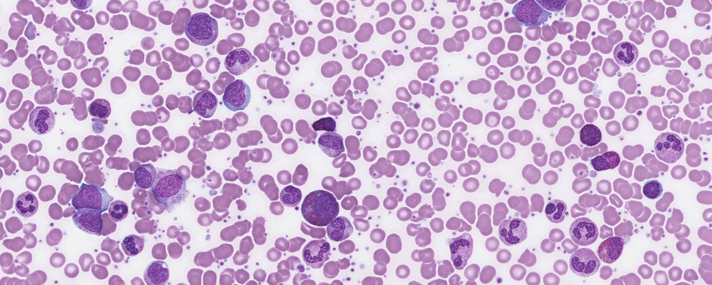

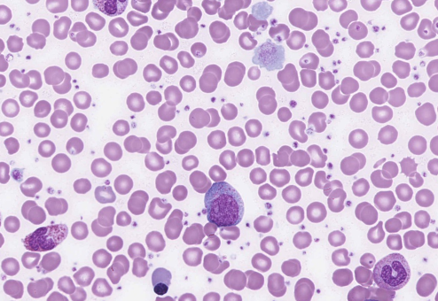

Considering the clinical information provided and the morphological features described, this case is most likely chronic myeloid leukaemia in chronic phase (CML-CP).

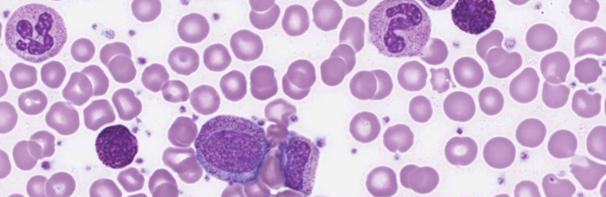

The neutrophilia, left shift, and basophilia were considered diagnostic features and scored 10. The presence of blasts, eosinophilia and nucleated red blood cells, considered major features, attracted scores of 5. The platelets also showed some morphological changes, i.e. giant platelets, naked megakaryocyte nuclei and occasional micromegakaryocytes (included in the "megakaryocytes" descriptor). These were considered minor features and scored accordingly.

CML-CP is a myeloproliferative neoplasm in which granulocytes are the major proliferative component. It arises in the haemopoietic stem cell and is characterised by the presence of the BCR-ABL1 fusion gene. In CML, BCR-ABL1 is found in all myeloid lineages and in some lymphoid and endothelial cells. The natural history of CML is biphasic or triphasic: and initial indolent chronic phase followed by an accelerated phase, a blast phase, or both.1

Most patients with CML are diagnosed in chronic phase, which usually has an insidious onset and discovered when a WBC count performed routinely is found to be abnormal. In chronic phase, the peripheral blood film shows leucocytosis due to neutrophils in various stages of maturation, classically with peaks in the proportions of myelocytes and segmented neutrophils. Significant granulocytic dysplasia is absent, and blasts typically account for <2% of the total WBC. A blast proportion of <10% is still indicative of chronic phase provided there are no other criteria for accelerated phase. Absolute basophilia and eosinophilia are common, and absolute monocytosis may be present. Platelet counts are normal, or increased to ≥ 1000 x 109/L.1

The majority of participants submitted the most likely diagnosis of CML-CP and scored 5. CML accelerated phase was also considered acceptable. The reported blast count was borderline at 9% of the total WBC count, and the clinical notes for this patient suggested that this was his initial presentation. Other diagnoses submitted indicated a recognition of fewer consistent features present and were scored accordingly. This patient's bone marrow was markedly hypercellular. There was a marked increase in granulopoiesis, which was left-shifted, as well as megakaryopoiesis. The blasts comprised 7% of nucleated cells in the marrow aspirate, eosinophils 21% and basophils 19%. The findings are consistent with chronic myeloid leukaemia, chronic phase. FISH analysis showed the presence of the BCR-ABL dual fusion gene, confirming a diagnosis of Chronic Myeloid Leukaemia.

**1.WHO Classification of Tumours of Haematopoietic and Lymphoid Tissues, Swerdlow, S et al, revised 4th edition, 2017**

|  |  |  |  |  |  |  |  |  |  |  |
| --- | --- | --- | --- | --- | --- | --- | --- | --- | --- | --- |
|  | **HA-MO-21-09** | | | | | | | | | |
| **RBC Features** | Polychromasia increased | Polychromasia increased | Polychromasia increased | Polychromasia increased |  | Polychromasia increased | Polychromasia increased | Nucleated red blood cells | Spherocytes | Acanthocytes |
|  |  | Nucleated red blood cells | Nucleated red blood cells |  | Spherocytes | Nucleated red blood cells | Polychromasia increased | Polychromasia increased | Spherocytes |
|  |  | Spherocytes |  |  | Acanthocytes | Spherocytes |  |  | Nucleated red blood cells |
|  |  |  |  |  |  |  |  |  |  |
| **WBC Features** | Blast cells | Promyelocytes / metamyelocytes / myelocytes | Promyelocytes / metamyelocytes / myelocytes | Eosinophilia | Blast cells | Basophilia | Promyelocytes / metamyelocytes / myelocytes | Promyelocytes / metamyelocytes / myelocytes | Eosinophils – abnormal granulation | Basophilia |
| Neutrophilia | Basophilia | Blast cells | Promyelocytes / metamyelocytes / myelocytes | Eosinophilia | Neutrophilia | Blast cells | Blast cells | Basophilia | Blast cells |
| Promyelocytes / metamyelocytes / myelocytes | Neutrophilia | Neutrophilia | Blast cells | Promyelocytes / metamyelocytes / myelocytes | Promyelocytes / metamyelocytes / myelocytes |  | Smear / smudge cells | Promyelocytes / metamyelocytes / myelocytes | Neutrophilia |
| Eosinophilia |  | Eosinophilia |  | Basophilia | Blast cells |  | Neutrophils - hypergranulation | Blast cells | Promyelocytes / metamyelocytes / myelocytes |
| **Platelet Features** | Giant platelets / significant numbers of large platelets. *ICSH definition | Megakaryocytes | Giant platelets / significant numbers of large platelets. *ICSH definition | Giant platelets / significant numbers of large platelets. *ICSH definition | Giant platelets / significant numbers of large platelets. *ICSH definition | Naked megakaryocyte nuclei |  | Giant platelets / significant numbers of large platelets. *ICSH definition | Giant platelets / significant numbers of large platelets. *ICSH definition | Naked megakaryocyte nuclei |
|  |  | Naked megakaryocyte nuclei |  | Naked megakaryocyte nuclei | Giant platelets / significant numbers of large platelets. *ICSH definition |  | Megakaryocytes |  | Giant platelets / significant numbers of large platelets. *ICSH definition |
|  |  |  |  |  |  |  |  |  |  |
| **Primary Diagnosis** | Chronic myeloid leukaemia – chronic phase | Chronic myeloid leukaemia – chronic phase | Chronic myeloid leukaemia – accelerated phase | Chronic myeloid leukaemia – chronic phase | Chronic myeloid leukaemia – blast phase | Chronic myeloid leukaemia – accelerated phase | Chronic myeloid leukaemia – chronic phase | Chronic myeloid leukaemia – accelerated phase | Chronic myeloid leukaemia – accelerated phase | Chronic myeloid leukaemia – accelerated phase |

|  |  |  |  |  |  |  |  |  |  |
| --- | --- | --- | --- | --- | --- | --- | --- | --- | --- |
| High scoring response | | | | Moderate scoring response | Low scoring response | Lowest scoring response | | Response given no score | |
|  | **HA-MO-21-09** | | | | | | | | | | | | |
| **RBC Features** |  |  | Polychromasia increased | | Microcytes | | Polychromasia increased | | Nucleated red blood cells | | Polychromasia increased | Nucleated red blood cells | Poikilocytosis (not otherwise coded) |
|  |  |  | | Polychromasia increased | | Nucleated red blood cells | | Spherocytes | |  | Polychromasia increased | Hypochromia |
|  |  |  | | Nucleated red blood cells | | Spherocytes | | Polychromasia increased | |  |  | Basophilic stippling |
|  |  |  | | Spherocytes | |  | | Tear drop cells | |  |  | Polychromasia increased |
| **WBC Features** |  |  | Promyelocytes / metamyelocytes / myelocytes | | Blast cells | | Blast cells | | Promyelocytes / metamyelocytes / myelocytes | | Promyelocytes / metamyelocytes / myelocytes | Promyelocytes / metamyelocytes / myelocytes | Promyelocytes / metamyelocytes / myelocytes |
|  |  | Blast cells | | Eosinophilia | | Promyelocytes / metamyelocytes / myelocytes | | Blast cells | | Blast cells | Basophilia | Basophilia |
|  |  | Eosinophilia | | Promyelocytes / metamyelocytes / myelocytes | | Eosinophilia | | Eosinophilia | | Basophilia | Neutrophilia | Eosinophilia |
|  |  | Basophilia | | Basophilia | | Basophilia | | Neutrophilia | |  | Blast cells | Blast cells |
| **Platelet Features** |  |  | Giant platelets / significant numbers of large platelets. *ICSH definition | | Giant platelets / significant numbers of large platelets. *ICSH definition | | Naked megakaryocyte nuclei | | Platelet clumps | |  | Megakaryocytes | Giant platelets / significant numbers of large platelets. *ICSH definition |
|  |  |  | | Naked megakaryocyte nuclei | | Giant platelets / significant numbers of large platelets. *ICSH definition | | Giant platelets / significant numbers of large platelets. *ICSH definition | | Giant platelets / significant numbers of large platelets. *ICSH definition |  |  |
|  |  |  | |  | |  | | Inaccurate platelet count | |  |  |  |
| **Primary Diagnosis** |  |  | Chronic myeloid leukaemia – chronic phase | | Chronic myeloid leukaemia – chronic phase | | Chronic myeloid leukaemia – chronic phase | | Chronic myeloid leukaemia – chronic phase | | Chronic myeloid leukaemia – chronic phase | Chronic myeloid leukaemia – chronic phase | Chronic myeloid leukaemia – chronic phase |

|  |  |  |  |  |
| --- | --- | --- | --- | --- |
| High scoring response | Moderate scoring response | Low scoring response | Lowest scoring response | Response given no score |

|  |  |  |  |  |  |  |
| --- | --- | --- | --- | --- | --- | --- |
| |  | | --- | | **RCPA results. Report 24Aug2021** | | | | | | | |
| **HA-MO-21-09** | | | | | |
| **RBC Features** | Nucleated red blood cells | Polychromasia increased |  |  |  |
|  | Spherocytes |  |  |  |
|  |  |  |  |  |
|  |  |  |  |  |
| **WBC Features** | Promyelocytes / metamyelocytes / myelocytes | Blast cells |  |  |  |
| Basophilia | Eosinophilia |  |  |  |
| Neutrophilia |  |  |  |  |
|  |  |  |  |  |
| **Platelet Features** | Giant platelets / significant numbers of large platelets. *ICSH definition |  |  |  |  |
| Megakaryocytes |  |  |  |  |
| Naked megakaryocyte nuclei |  |  |  |  |
| **Primary Diagnosis** | Chronic myeloid leukaemia – chronic phase | Chronic myeloid leukaemia – accelerated phase | Myeloproliferative neoplasm, unclassifiable | Chronic myeloid leukaemia - blast phase | Essential thrombocythaemia |
|  |  | myeloproliferative neoplasm in accelerated phase |  |  |

|  |  |  |  |  |
| --- | --- | --- | --- | --- |
| High scoring response | Moderate scoring response | Low scoring response | Lowest scoring response | Response given no score |

|  |  |  |  |
| --- | --- | --- | --- |
| **CLOSED 08/09/2021** | **Submissions** | **Total** | % |
| **All Staff** | **19** | **46** | 41.3 |
| **Morph Trained** | 12 | 22 | 54.5 |
| **Incomplete** | 2 |  | 4.3 |
| **Routine** | 3 | 12 | 25.0 |
| **SANDY** | **1** | **3** | 33.3 |
| **CORE** | **3** | **8** | 37.5 |
| **Flow** | **0** | **6** | 0.0 |

