CASE STUDY: HA-MO-21-07

Sezary Syndrome

51 year old male, heavy smoker, extensive cutaneous lesions.

WCC: 11.4 x 109/L

RCC: 5.7 x 1012/L

Hb: 177 g/L

MCV: 92 fL

MCH: 30.9 pg

MCHC: 335 g/L

Plt: 305 x 109/L

The most significant feature of this film was the presence of abnormal lymphocytes with a high nucleocytoplasmic ratio, cerebriform nuclei and weakly basophilic cytoplasm with occasional 'blebs'. The red cells showed a variety of mild changes including polychromasia, target cells and the presence of occasional Howell-Jolly bodies. The platelets generally showed normal morphology, with the presence of large/giant platelets.

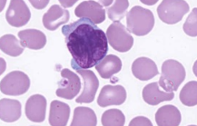

The white cell features described are consistent with Sezary Syndrome. The majority of participants reported the abnormal lymphocytes, considered the diagnostic feature and scored 10. The neutrophils showed mild hypergranulation, which was scored as a minor feature. The reported results did not indicate a lymphocytosis or neutrophilia.The presence of large/giant platelets was acknowledged with the scoring. 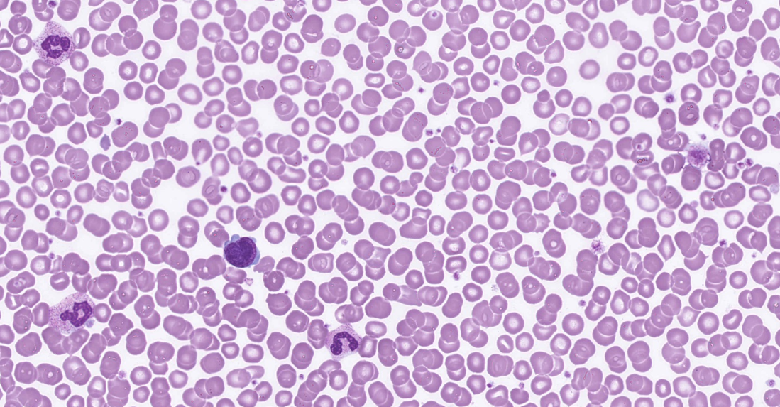

Sezary Syndrome (SS) is defined by the triad of erythroderma, generalised lymphadenopathy and the presence of clonally related neoplastic T cells with cerebriform nuclei (Sezary cells) in skin, lymph nodes and peripheral blood. In addition, one or more of the following criteria are required:1

1.an absolute Sezary cell count of >1000/μL

2.an expanded CD4+ T-cell population resulting in CD4/CD8 ratio of ≥10

3.a loss of one or more T cell antigens

This is a rare disease, accounting for <5% of all cutaneous T-cell lymphomas. It occurs in adults, typically presents in patients aged >60 years and has a male predominance.1

Considering the morphological features described and the clinical notes provided, the most likely diagnosis was considered to be Sezary syndrome, and allocated a score of 5. Adult T cell leukaemia/lymphoma was also considered acceptable as a 'diagnosis with the majority of the expected features' and was scored 4. Other submitted diagnoses which indicated minor lymphoid features were scored accordingly. This patient with previously diagnosed Sezary syndrome, presented for review. He had a recurrence of lymphoma cells in his peripheral blood and worsening cutaneous symptoms. He also had secondary erythrocytosis due to smoking and dehydration (he was negative for the more common mutations of JAK2). Although his red cell morphology showed post-splenectomy changes, there was no record of a splenectomy in his notes.

The patient's immunophenotype showed an abnormal T cell population (~87%) CD2+ (low), CD3+, CD4+, CD5+, CD8- with a loss of CD7. These results are consistent with Sezary syndrome.

**1. WHO Classification of Tumours of Haematopoietic and Lymphoid Tissues, Swerdlow, S et al, revised 4th edition, 2017**

|  |  |  |  |  |  |  |  |  |  |  |
| --- | --- | --- | --- | --- | --- | --- | --- | --- | --- | --- |
|  | HA-MO-21-07 | | | | | | | | | |
| **RBC Features** |  | Target cells | Target cells | Polychromasia increased | Hyposplenic / asplenic changes | Howell Jolly bodies | Hyposplenic / asplenic changes | Howell Jolly bodies | Spherocytes | Howell Jolly bodies |
|  | Tear drop cells | Howell Jolly bodies | Howell Jolly bodies |  | Spherocytes | Polychromasia increased | Target cells | Target cells | Spherocytes |
|  | Spherocytes | Spherocytes | Rouleaux |  | Target cells |  | Irregularly contracted cells |  | Hyposplenic / asplenic changes |
|  | Polychromasia increased | Hyposplenic / asplenic changes |  |  | Hyposplenic / asplenic changes |  |  |  |  |
| **WBC Features** | Lymphocytes – abnormal | Lymphocytes – abnormal | Lymphocytes – abnormal | Lymphocytes – abnormal | Lymphocytes – abnormal | Lymphocytes – abnormal | Lymphocytes – abnormal | Auer rods | Basophilia | Lymphocytes – abnormal |
|  | Neutrophils - hypergranulation | Neutrophil – Hypogranulation. |  |  | Neutrophils - hypergranulation | Large granular lymphocytosis | Blast cells | Neutrophil – Hypogranulation. | Promyelocytes / metamyelocytes / myelocytes |
|  |  |  |  |  | Promyelocytes / metamyelocytes / myelocytes |  | Lymphocytes – abnormal | Lymphocytes – abnormal |  |
|  |  |  |  |  |  |  | Lymphocytosis |  |  |
| **Platelet Features** | No significant morphological platelet abnormality | No significant morphological platelet abnormality | No significant morphological platelet abnormality | No significant morphological platelet abnormality | Giant platelets / significant numbers of large platelets. *ICSH definition | No significant morphological platelet abnormality | No significant morphological platelet abnormality | Giant platelets / significant numbers of large platelets. *ICSH definition | No significant morphological platelet abnormality | No significant morphological platelet abnormality |
| **Primary Diagnosis** | Sezary syndrome | Sezary syndrome | Lymphoma | Sezary syndrome | Sezary syndrome | Sezary syndrome | Lymphoma | Sezary syndrome | Lymphoma | Sezary syndrome |

|  |  |  |  |  |
| --- | --- | --- | --- | --- |
| High scoring response | Moderate scoring response | Low scoring response | Lowest scoring response | Response given no score |

|  |  |  |  |  |  |  |  |  |  |
| --- | --- | --- | --- | --- | --- | --- | --- | --- | --- |
|  | HA-MO-21-07 | | | | | | | | |
| **RBC Features** | Stomatocytes | Howell Jolly bodies | Polychromasia increased | Hyposplenic / asplenic changes | Hyposplenic / asplenic changes | Microcytes | Polychromasia increased | Polychromasia increased | Poikilocytosis (not otherwise coded) |
|  | Target cells | Howell Jolly bodies | Target cells | Spherocytes | Spherocytes | Rouleaux | Target cells | Spherocytes |
|  |  | Target cells | Howell Jolly bodies | Howell Jolly bodies | Polychromasia increased |  | Spherocytes | Polychromasia increased |
|  |  | Spherocytes | Spherocytes | Target cells | Hypochromia |  |  |  |
| **WBC Features** | Blast cells | Lymphocytes – abnormal | Lymphocytes – abnormal | Lymphocytes – abnormal | Lymphocytes – abnormal | Neutrophils – hypersegmented | Lymphocytes – abnormal | Neutrophils - hypergranulation | Neutrophils - hypergranulation |
|  |  | Neutrophils - hypergranulation | Neutrophils - hypergranulation |  | Lymphocytes – abnormal |  | Blast cells | Lymphocytes – abnormal |
|  |  |  | Promyelocytes / metamyelocytes / myelocytes |  | Neutrophils - hypergranulation |  | Lymphocytes – abnormal |  |
|  |  |  |  |  |  |  |  |  |
| **Platelet Features** | Giant platelets / significant numbers of large platelets. *ICSH definition | No significant morphological platelet abnormality | No significant morphological platelet abnormality | No significant morphological platelet abnormality | No significant morphological platelet abnormality | Giant platelets / significant numbers of large platelets. *ICSH definition | No significant morphological platelet abnormality | No significant morphological platelet abnormality | Giant platelets / significant numbers of large platelets. *ICSH definition |
| **Primary Diagnosis** | Sezary syndrome | Lymphoma | Sezary syndrome | Sezary syndrome | Sezary syndrome | Sezary syndrome | Lymphoma | Sezary syndrome | Sezary syndrome |

|  |  |  |  |  |
| --- | --- | --- | --- | --- |
| High scoring response | Moderate scoring response | Low scoring response | Lowest scoring response | Response given no score |

|  |  |  |  |  |  |
| --- | --- | --- | --- | --- | --- |
| **RCPA results. Report 24Aug2021** | | | | | |
|
| **HA-MO-21-07** | | | | | |
| **RBC Features** | Hyposplenic / asplenic changes | Target cells |  |  |  |
|  | Spherocytes |  |  |  |
|  | Polychromasia increased |  |  |  |
|  | Howell Jolly bodies |  |  |  |
| **WBC Features** | Lymphocytes – abnormal | Neutrophils - hypergranulation |  |  |  |
|  |  |  |  |  |
|  |  |  |  |  |
|  |  |  |  |  |
| **Platelet Features** | Giant platelets / significant numbers of large platelets. *ICSH definition | No significant morphological platelet abnormality |  |  |  |
| **Primary Diagnosis** | Sezary syndrome | Adult T cell leukaemia / lymphoma | Lymphoma | T-cell prolymphocytic leukaemia | Mantle cell lymphoma |

|  |  |  |  |  |  |  |  |  |
| --- | --- | --- | --- | --- | --- | --- | --- | --- |
| High scoring response | | Moderate scoring response | | Low scoring response | | Lowest scoring response | | Response given no score |
| **CLOSED 08/09/2021** | | **Submissions** | | **Total** | | % | |
| **All Staff** | | **19** | | **46** | | 41.3 | |
| **Morph Trained** | | 12 | | 22 | | 54.5 | |
| **Incomplete** | | 2 | |  | | 4.3 | |
| **Routine** | | 3 | | 12 | | 25.0 | |
| **SANDY** | | **1** | | **3** | | 33.3 | |
| **CORE** | | **3** | | **8** | | 37.5 | |
| **Flow** | | **0** | | **6** | | 0.0 | |

