Case: HA-MA-21-04

|  |
| --- |
| 45 yo male, previous malaria  WCC: 5.4x 109/L  RCC: 3.9x 1012/L  Hb: 130 g/L  Plt: 74 x 109/L |

**Plasmodium malariae**

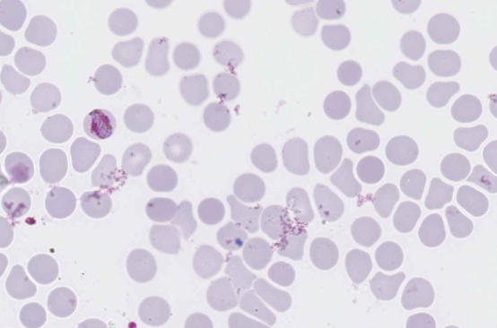

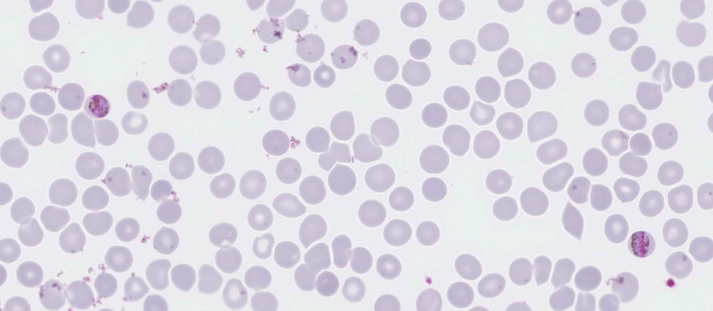

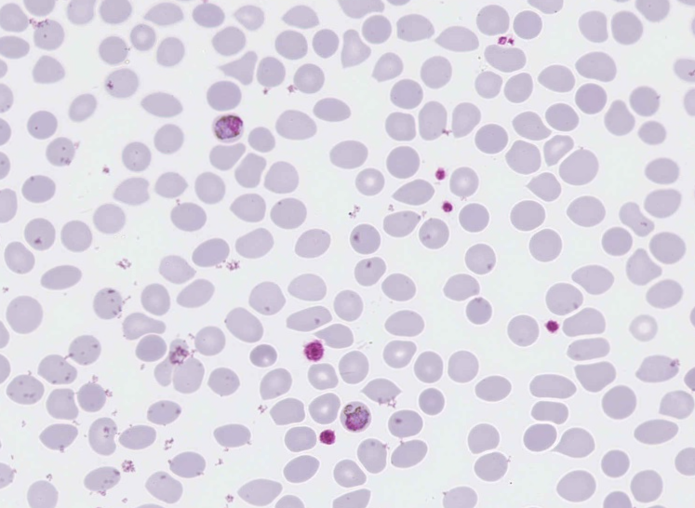

Features that identify P. malariae in the thick and thin digital images are the following:

1. This was a good example of P. malariae which is reflected with 99% of participants submitting a correct diagnosis.

2. Infected red blood cells are not enlarged, and in fact are often smaller than the un-infected cells.

3. Mature trophozoites, occasional early trophozoite.

4. Heavy malaria pigment present at all stages.

5. Frequent band forms present.

6. There are trophozoites, the occasional schizont and possibly gametocytes present in thick and thin films. It is difficult to distinguish gametocytes from late trophozoites in P. malariae and as such all were awarded equal marks.

Majority of laboratories correctly identified P. malariae which was awarded 5 marks. The diagnoses of mixed infection with P. malariae received a score of 2 as there were not features typical of other species on the films.

Case: HA-MA-21-05

34 yo female, recent travel to Sierra leone, visited GP with Respiratory symptoms. Past history of malaria as a child & felt like symptoms had returned. Now compliant with Prophylaxis when in Sierra leone.

WCC: 7.3x 109/L

RCC: 4.17x 1012/ L

Hb: 123 g/L

MCV: 84.5 fL

Plt: 315 x 109/L

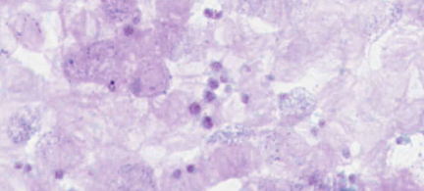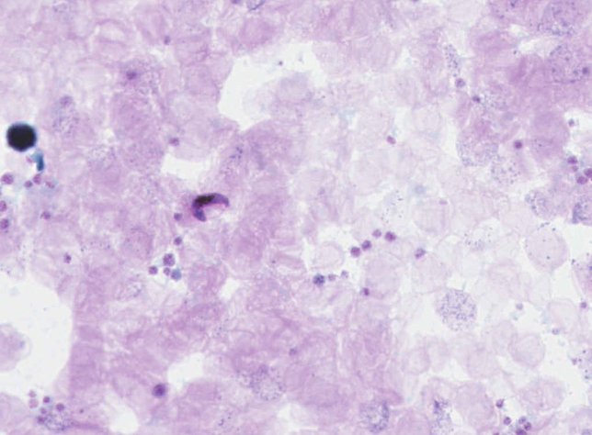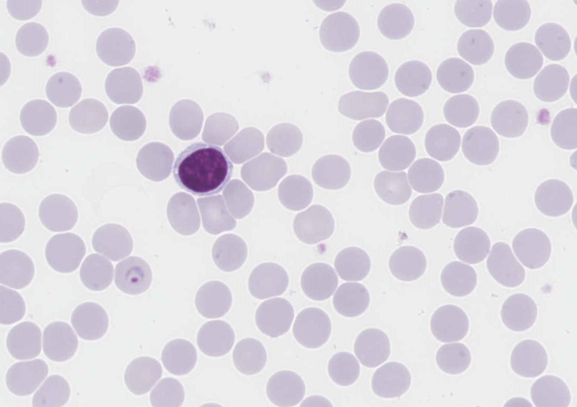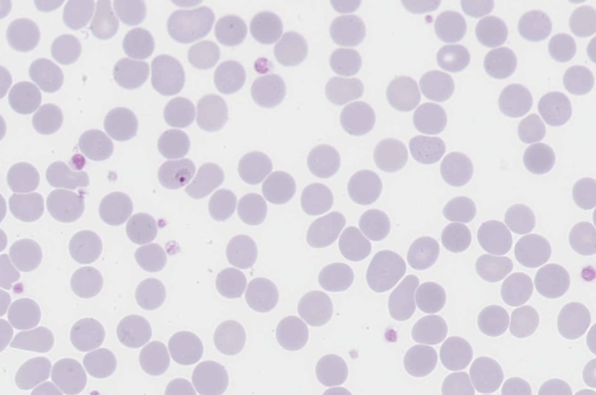

**Plasmodium falciparum**

Features that identify P. falciparum in the thick and thin digital images are the following:

1. Infected red blood cells are not enlarged.

2. Characteristic crescent shaped gametocytes are identified on both thick and thin films.

3. There were early and mature trophozoites present with the early trophozoites in the majority.

4. The early trophozoites had the characteristic single chromatin dot with the cytoplasm in a fine ring shape.

5. There were some Maurer's clefts present.

6. Occasional marginal or accolé forms present.

7. A very rare schizont was visible on the thick film.

8. All features are consistent with P. falciparum infection.

9. 94% of participants correctly identified the P. falciparum species. A few participants chose a diagnosis of mixed infection. However, in the absence of a definitive second species these diagnoses received lower scores