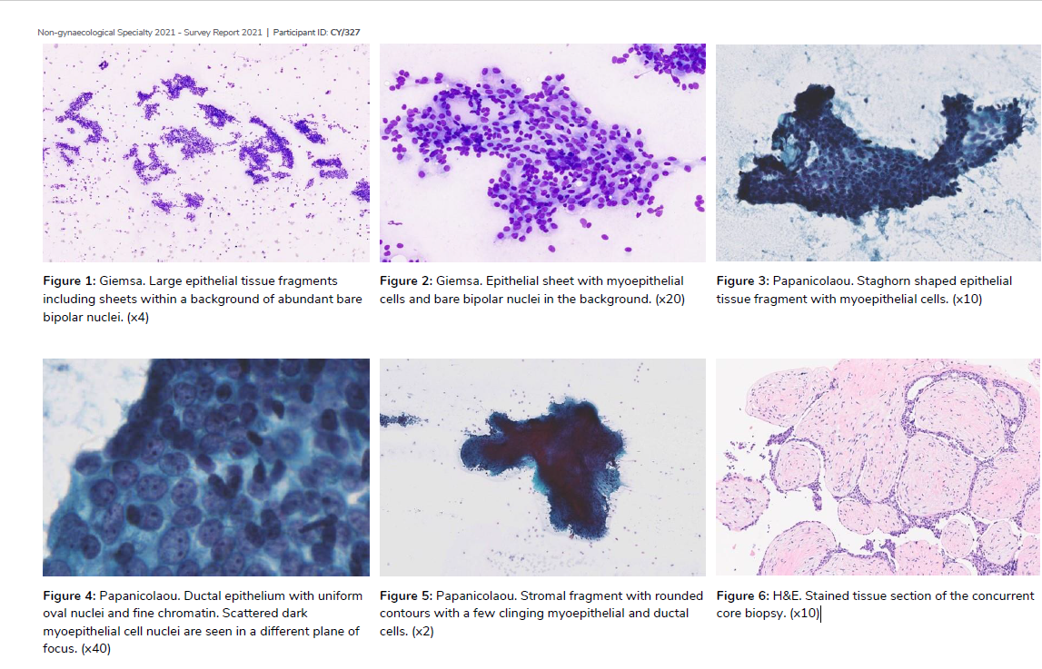

**Cytology**

Virtual images can be viewed here

These smears are highly cellular, comprising of large hyperplastic ductal epithelial tissue fragments overlaid with myoepithelial cells. The ductal epithelium frequently shows hyperplastic changes, forming 3-dimentional structures with epithelial cells streaming around irregular secondary lumina. Complex stellate papillary tissue fragments containing fibroelastotic stromal cores are present, and in some the stroma surrounds epithelial tubules producing a meshwork architecture. No significant cytopathological atypia is seen. The background contains abundant bare bipolar nuclei and proteinaceous material.

These findings are of an intraductal papilloma with epithelial hyperplasia.

**Histology**

Not available. Benign follow up for >6 months.

**Discussion**

The expected smear pattern of an intraductal papilloma is of large epithelial tissue fragments with myoepithelial cells and bare bipolar nuclei, a variable number of cohesive smaller epithelial fragments and few dispersed single cells, stellate papillary stromal fragments and meshwork fragments, apocrine sheets, siderophages and histiocytes and a variable number of bare bipolar nuclei in a proteinaceous background. The presence of stellate papillary and meshwork fragments with fibroelastotic stroma have been shown to be highly specific to papilloma, and different to the fine branching fibrovascular architecture seen in papillary ductal carcinoma in situ, which also shows more marked dispersal, mild to moderate nuclear enlargement and atypia, and a lack of myoepithelial cells and bare bipolar nuclei.