HA-MO-22-01

**Hb SS/Sickle cell disease**

31 year old female with intermittent painful episodes

WCC: 9.5 x 109/L

RCC: 3.15 x 1012/L

Hb: 101 g/L

MCV: 91.7 fL

MCH: 31.9 pg

MCHC: 348 g/L

Plt: 345 x 109/L

Case HA-MO-22-01 showing sickle cells, boat cells and some hyposplenic features.

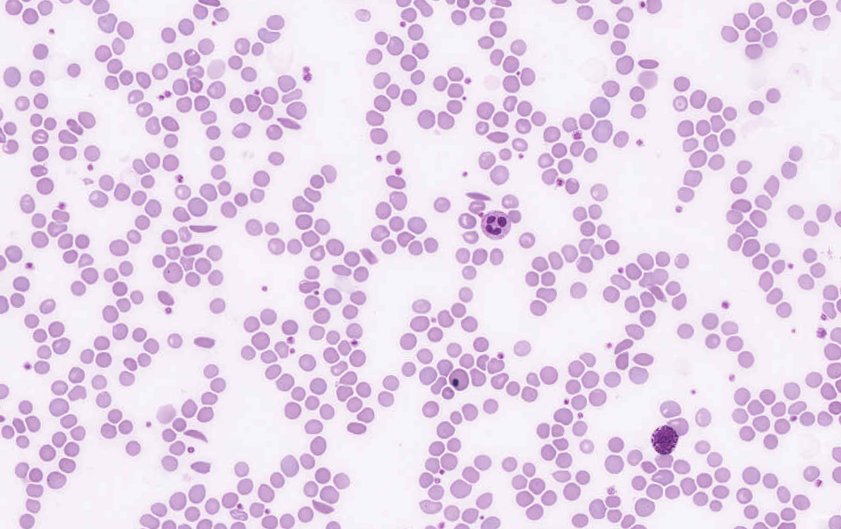

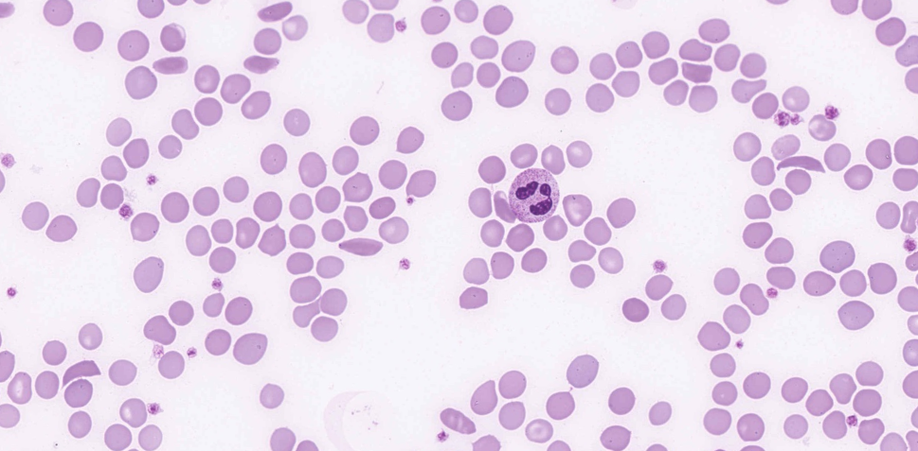

The majority of participants reported the presence of sickle cells, which was considered to be the essential diagnostic feature and scored 10 (see Figure 1).The hyposplenic/asplenic features described previously collectively scored 5, being major features of the film, while the individual features ofhyposplenism as well as nucleated RBC and increased polychromasia scored 2, each being considered a ‘minor’ feature on its own but relevant to the diagnosis. A number of participants reported crystallised haemoglobin. A few cells with condensed haemoglobin were seen however the classic Hb SC poikilocytes were not present. Several participants reported the presence of a basophilia. The median basophil count produced by the corresponding manual differential survey (HA-BF-22-01) was 2.0%, which was a “borderline high” result according to the normal ranges given by the donating laboratory, so although not relevant to the diagnosis, basophilia was scored as a minor feature. The blood film of this patient showed a variety of red cell features, including sicklecells and boat cells, and evidence of hyposplenism i.e. Howell Jolly bodies and target cells. Polychromasia was increased and small numbers of nucleated red cells were evident, which is consistent with a response to haemolysis. The white cells showed some minor changes but were essentially unremarkable, and occasional giant platelets were noted.

Considering the morphological features described, the most likely diagnosis was Hb SS/Sickle cell disease. Hb SC was also considered a concordant response because of the presence of numerous target cells. It should be noted that hyposplenism is reported to be more frequent in Hb SS than Hb SC. Approximately half of the patients with Hb SC have splenomegaly, and hyposplenic changes are seen in 25% of patients.1Hb S/beta thalassaemia was less likely because this patient’s MCV was not low and hyposplenism is not common in Hb S/beta thalassaemia, however, this response was considered an appropriate differential diagnosis, indicating recognition of some of the morphological features present. Sickle cell disease (SCD) refers to a group of haemoglobinopathies that include mutations in the gene encoding the beta subunit of haemoglobin i.e. an abnormal Hb S molecule (a2βS2) in which glutamic acid at position 6 of the β-globin chain of haemoglobin is changed to valine. Within the umbrella of SCD, many subgroups exist, of which the most common are sickle cell anaemia (Hb SS), Hb SC and HbS/β-thalassemia. Sickle cell anaemia (SCA), in which the Hb S can be up to 100%, is by far the most severe and well described.2,3

The fundamental event that underlies the complex pathophysiology and consequences of SCA is the polymerisation of Hb S that occurs under low oxygen tension. Polymerisation of the de-oxygenated Hb S alters the structure and function of the red blood cells (RBC).These damaged (typically sickled shaped) RBCs are not only less ?exible compared to normal RBCs, but also highly adhesive. Repeated cycles of sickling and unsickling shortens the lifespan of the damaged sickle RBCs to about 1/6th that of normal RBCs.2 The outcome is the occlusion of blood vessels in almost every organ of the body and chronic haemolytic anaemia, the two hallmarks of the disease, that result in recurrent episodic acute clinical events, of which acute pain is the most common, and accumulative organ damage. The pain is so severe that it is often referred to as “vaso-occlusive sickle crisis”.

All variants of SCD share the same pathophysiology leading to polymerisation of the Hb S component,2,3.The sickle RBCs do not just interact with the vascular endothelium but trigger activation of neutrophils, monocytes and platelets.

Neutrophils play a central role in vaso-occlusion through their interactions with both erythrocytes and endothelium, upregulating expression of cytoadhesion molecules such as P-and E-selectins, which are current therapeutic targets2.

This patient is a known sickle cell anaemia (Hb SS). Her Hb S was 40%, which is a reflection of the monthly transfusions she receives to manage her condition. Her donor sample was collected prior to her transfusion.

1.Color atlas of Hemoglobin disorders, CAP Haematology and Clinical Microscopy Resource committee. Hoyer JD, Kroft SH, 2003

2.Recent Advances in the Treatment of Sickle Cell Disease, Cisneros, G et al, Frontiers in Physiology, May 2020, Volume 11, Article 435

3.Sickle Cell Anemia, Mangla, A et al, NCBI Bookshelf, 2022, StatPearls Publishing LLC

|  |  |  |  |  |  |  |  |  |  |  |  |
| --- | --- | --- | --- | --- | --- | --- | --- | --- | --- | --- | --- |
|  | **HA-MO-22-01** | | | | | | | | | | |
| RBC Features | Sickle cells | Sickle cells | Sickle cells | Sickle cells | Sickle cells | Sickle cells | Sickle cells | Sickle cells | Sickle cells | Target cells | Sickle cells |
| Target cells | Hyposplenic / asplenic changes | Target cells | Elliptocytes / ovalocytes | Target cells | Hyposplenic / asplenic changes | Hyposplenic / asplenic changes | Hyposplenic / asplenic changes | Howell Jolly bodies | Sickle cells | Target cells |
| Hyposplenic / asplenic changes | Polychromasia increased | Howell Jolly bodies | Target cells | Nucleated red blood cells | Polychromasia increased | Polychromasia increased | Nucleated red blood cells | Target cells | Elliptocytes / ovalocytes | Howell Jolly bodies |
|  | Target cells | Nucleated red blood cells |  |  | Nucleated red blood cells | Nucleated red blood cells |  | Nucleated red blood cells | Polychromasia increased | Nucleated red blood cells |
| WBC Features | No significant morphological white blood cell abnormality | No significant morphological white blood cell abnormality | Neutrophils - hypergranulation | No significant morphological white blood cell abnormality | Neutrophils - hypergranulation | No significant morphological white blood cell abnormality | Basophilia |  | Lymphocytes - reactive | No significant morphological white blood cell abnormality | No significant morphological white blood cell abnormality |
|  |  |  |  | Cytoplasmic vacuolation |  |  |  |  |  |  |
|  |  |  |  | Promyelocytes / metamyelocytes / myelocytes |  |  |  |  |  |  |
| Platelet Features | No significant morphological platelet abnormality | Giant platelets / significant numbers of large platelets |  | No significant morphological platelet abnormality | Giant platelets / significant numbers of large platelets | Giant platelets / significant numbers of large platelets | Inaccurate platelet count | Giant platelets / significant numbers of large platelets | No significant morphological platelet abnormality | No significant morphological platelet abnormality | Giant platelets / significant numbers of large platelets |
|  |  |  |  |  |  | Giant platelets / significant numbers of large platelets |  |  |  |  |
| Primary Diagnosis | Hb SS (sickle cell anaemia) | Hb S / beta thalassaemia | Hb SS (sickle cell anaemia) | Hb SS (sickle cell anaemia) | Hb S / beta thalassaemia | Hb SS (sickle cell anaemia) | Hb S / beta thalassaemia | Hb SS (sickle cell anaemia) | Hb SS (sickle cell anaemia) | Hb SS (sickle cell anaemia) | Hb S / beta thalassaemia |

|  |  |  |  |  |  |  |  |
| --- | --- | --- | --- | --- | --- | --- | --- |
| Highest scoring response | | Moderate scoring response | | Lowest scoring response | | Response given no score | |
| RBC Features | Hyposplenic / asplenic changes | | Sickle cells | Sickle cells | Hyposplenic / asplenic changes | | Hyposplenic / asplenic changes | | Sickle cells | Sickle cells | Sickle cells | Target cells | Sickle cells | Sickle cells |
| Sickle cells | | Target cells | Target cells | Nucleated red blood cells | | Sickle cells | | Target cells | Target cells | Hyposplenic / asplenic changes | sickle cells | Target cells | Target cells |
| Polychromasia increased | | Hyposplenic / asplenic changes | Nucleated red blood cells | Sickle cells | | Target cells | | Nucleated red blood cells | Nucleated red blood cells | Target cells | Hyposplenic / asplenic changes | Nucleated red blood cells | Macrocytes round |
|  | | Nucleated red blood cells |  | Target cells | | Nucleated red blood cells | | Howell Jolly bodies | Hyposplenic / asplenic changes | Nucleated red blood cells | Polychromasia increased | Hypochromia | Polychromasia increased |
| WBC Features | No significant morphological white blood cell abnormality | | Neutrophils - hypergranulation |  | No significant morphological white blood cell abnormality | | Promyelocytes / metamyelocytes / myelocytes | | No significant morphological white blood cell abnormality | Promyelocytes / metamyelocytes / myelocytes | No significant morphological white blood cell abnormality | Basophilia | Basophilia | Neutrophils - hypergranulation |
|  | |  |  |  | |  | |  | Blast cells |  |  | Neutrophils - hypergranulation | Promyelocytes / metamyelocytes / myelocytes |
|  | |  |  |  | |  | |  |  |  |  |  |  |
| Platelet Features | Giant platelets / significant numbers of large platelets | | No significant morphological platelet abnormality |  | No significant morphological platelet abnormality | | No significant morphological platelet abnormality | | Giant platelets / significant numbers of large platelets | No significant morphological platelet abnormality | Giant platelets / significant numbers of large platelets | Giant platelets / significant numbers of large platelets | Giant platelets / significant numbers of large platelets | Giant platelets / significant numbers of large platelets |
|  | |  |  |  | |  | |  |  |  |  |  |  |
| Primary Diagnosis | Hb SS (sickle cell anaemia) | | Hb SS (sickle cell anaemia) | Hb SS (sickle cell anaemia) | Hb S / beta thalassaemia | | Hb SC | | Hb SS (sickle cell anaemia) | Hb SS (sickle cell anaemia) | Hb SS (sickle cell anaemia) | Hb SS (sickle cell anaemia) | Hb S / beta thalassaemia | Hb SC |

|  |  |  |  |
| --- | --- | --- | --- |
| Highest scoring response | Moderate scoring response | Lowest scoring response | Response given no score |

