CASE HA-MO-22-02

**Acute Promyelocytic Leukaemia**

33 year old male with severe abdominal pain

WCC: 20.3 x 109/L

RCC: 3.46 x 1012/L

Hb: 116 g/LMCV: 93 fL

MCH: 34 pg

MCHC: 360 g/L

Plt: 42 x 109/L

Case HA-MO-22-02 showing abnormal promyelocytes and schistocytes

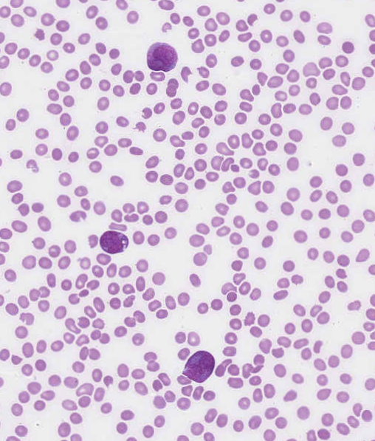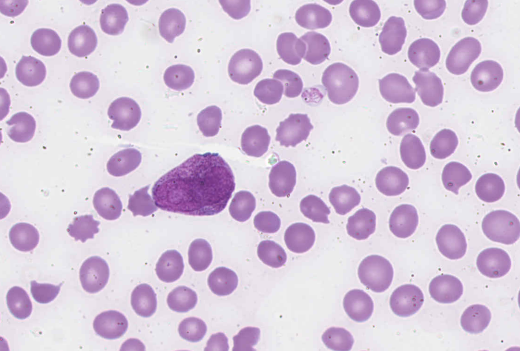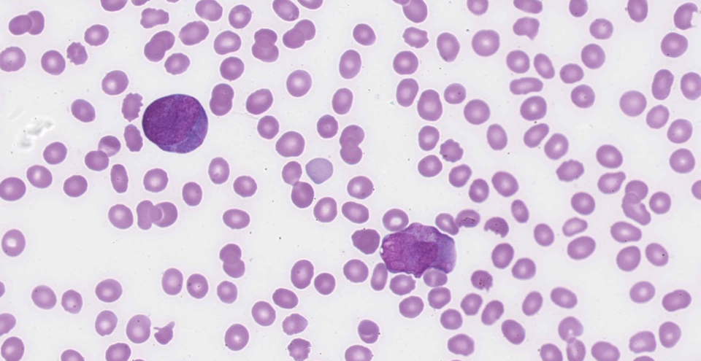

The main feature of this film is the presence of abnormal promyelocytes, several of which contained Auer rods. Blast cells, left shift and neutropenia were also evident. The red cell changes seen included increased polychromasia, schistocytes, and occasional nucleated red blood cells. The platelets were morphologically normal, although reduced. The vast majority of participants identified the abnormal promyelocytes and Auer rods which were the essential diagnostic features of the film and scored 10.The blasts and neutropenia were considered major features and scored 5, as were increased polychromasia and schistocytes. Other minor white cell and red cell changes submitted were scored accordingly. An inaccurate platelet count, most probably due to the presence of the schistocytes, was acknowledged with the scoring. The abnormal promyelocytes with Auer rods indicate that the most likely diagnosis is acute promyelocytic leukaemia (APL).This response was submitted by the vast majority of participants and was considered concordant. Due to the overwhelming presence of abnormal promyelocytes and the and the red cell changes seen -which together are associated with a very rapid fatal course of the disease -acute myeloid leukaemia was considered a minor discordance in this setting.

APL with PML/RARA is an acute myeloid leukaemia in which abnormal promyelocytes predominate. Both hypergranular type and hypogranular variant are seen. The nuclear size and shape of the abnormal promyelocytes of hypergranular APL are irregular and greatly variable, and are often kidney-shaped or bilobed. The cytoplasm is marked by densely packed large granules which stain bright pink, red or purple with Romanowski stains. The granules may be so large and/or numerous that they can obscure the nuclear-cytoplasmic margin. Auer rods, occurring singly or in bundles, are present in most cases.1

Microgranular (hypogranular) APL is characterised by apparent paucity or absence of granules, and predominantly bilobed nuclei. The hypogranular appearance of the cytoplasm is due to the submicroscopic size of the azurophilic granules. Bundles of Auer rods can be identified in most cases. The leucocyte count is frequently markedly elevated, in contrast to hypergranular APL, with numerous abnormal microgranular promyelocytes. Both hypergranular and microgranular APL are frequently associated with disseminated intravascular coagulation (DIC) and increased fibrinolysis. Coagulopathy is associated with significant early death rates in APL patients.

This patient’s genetic testing indicated the presence of PML::RARA t(15;17) (q22;q11).

His fibrinogen level was low, and the D-Dimer was markedly elevated, indicating a co-existing DIC.

1.WHO Classification of Tumours of Haematopoietic and Lymphoid Tissues, Swerdlow, S et al,revised 4thedition, 2017

|  |  |  |  |  |  |  |  |  |  |  |  |  |
| --- | --- | --- | --- | --- | --- | --- | --- | --- | --- | --- | --- | --- |
|  | **HA-MO-22-02** | | | | | | | | | | | |
| RBC Features | Schistocytes | Schistocytes | Polychromasia increased | Schistocytes | Schistocytes |  | Schistocytes |  | Schistocytes | Elliptocytes / ovalocytes | Schistocytes |
| Polychromasia increased | Bite cells |  | Elliptocytes / ovalocytes | Tear drop cells |  | Bite cells |  | Polychromasia increased | Schistocytes | Bite cells |
| Nucleated red blood cells | Polychromasia increased |  | Irregularly contracted cells | Nucleated red blood cells |  | Blister cells |  | Bite cells | Nucleated red blood cells | Polychromasia increased |
|  | Irregularly contracted cells |  |  | Polychromasia increased |  | Polychromasia increased |  | Nucleated red blood cells | Irregularly contracted cells | Irregularly contracted cells |
| WBC Features | Promyelocytes - abnormal | Blast cells | Blast cells | Blast cells | Blast cells |  | Auer rods |  | Promyelocytes - abnormal | Blast cells | Blast cells |
|  |  |  |  | Promyelocytes / metamyelocytes / myelocytes |  | Blast cells |  |  | Promyelocytes / metamyelocytes / myelocytes |  |
|  |  |  |  |  |  | Promyelocytes - abnormal |  |  | Promyelocytes - abnormal |  |
| Platelet Features | No significant morphological platelet abnormality | No significant morphological platelet abnormality |  | No significant morphological platelet abnormality | Giant platelets / significant numbers of large platelets |  | No significant morphological platelet abnormality |  | Inaccurate platelet count | Inaccurate platelet count | No significant morphological platelet abnormality |
| Primary Diagnosis | Acute promyelocytic leukaemia | Acute promyelocytic leukaemia |  | Acute leukaemia | Acute promyelocytic leukaemia |  | Acute promyelocytic leukaemia |  | Acute promyelocytic leukaemia | Acute promyelocytic leukaemia | Acute promyelocytic leukaemia |

|  |  |  |  |
| --- | --- | --- | --- |
| Highest scoring response | Moderate scoring response | Lowest scoring response | Response given no score |

|  |  |  |  |  |  |  |  |  |  |  |  |
| --- | --- | --- | --- | --- | --- | --- | --- | --- | --- | --- | --- |
| RBC Features | Polychromasia increased | Bite cells | Schistocytes | Schistocytes | Schistocytes | Schistocytes | Schistocytes | Schistocytes | Schistocytes | Schistocytes | Polychromasia increased |
| Schistocytes | Schistocytes | Spherocytes | Echinocytes |  | Polychromasia increased | Nucleated red blood cells | Nucleated red blood cells | Polychromasia increased | Nucleated red blood cells | Schistocytes |
|  | Polychromasia increased | Polychromasia increased | Polychromasia increased |  |  | Polychromasia increased |  | Nucleated red blood cells | Polychromasia increased | Nucleated red blood cells |
|  | Echinocytes |  | Nucleated red blood cells |  |  |  |  | Bite cells | Microcytes |  |
| WBC Features | Blast cells | Blast cells | Blast cells | Promyelocytes - abnormal | Neutropenia | Blast cells | Promyelocytes - abnormal | Blast cells | Promyelocytes - abnormal | Auer rods | Promyelocytes - abnormal |
|  | Promyelocytes - abnormal | Promyelocytes - abnormal | Blast cells | Blast cells | Neutrophils - hypergranulation | Blast cells | Promyelocytes / metamyelocytes / myelocytes | Blast cells | Blast cells | Auer rods |
|  | Neutrophils - hypergranulation | Auer rods | Promyelocytes / metamyelocytes / myelocytes | Promyelocytes - abnormal |  | Auer rods | Promyelocytes - abnormal | Neutropenia | Promyelocytes - abnormal | Other inclusions |
|  |  |  |  | Promyelocytes / metamyelocytes / myelocytes |  | Promyelocytes / metamyelocytes / myelocytes | Neutropenia |  | Promyelocytes / metamyelocytes / myelocytes |  |
| Platelet Features | No significant morphological platelet abnormality | Inaccurate platelet count |  | No significant morphological platelet abnormality | No significant morphological platelet abnormality |  | Inaccurate platelet count | Inaccurate platelet count |  | No significant morphological platelet abnormality | Inaccurate platelet count |
| Primary Diagnosis | Acute promyelocytic leukaemia | Acute promyelocytic leukaemia | Acute promyelocytic leukaemia | Acute promyelocytic leukaemia | Acute promyelocytic leukaemia | Acute promyelocytic leukaemia | Acute promyelocytic leukaemia | Acute promyelocytic leukaemia | Acute promyelocytic leukaemia | Acute promyelocytic leukaemia | Acute promyelocytic leukaemia |

|  |  |  |  |
| --- | --- | --- | --- |
| Highest scoring response | Moderate scoring response | Lowest scoring response | Response given no score |

