HA-MA-22-01

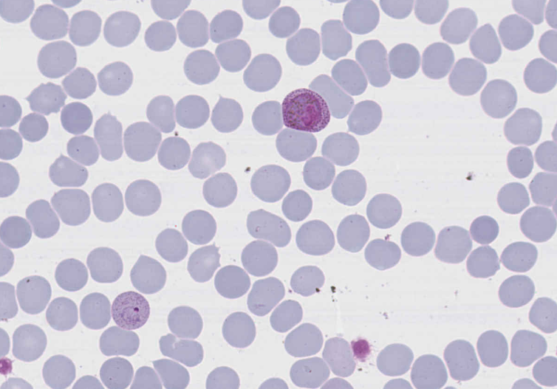

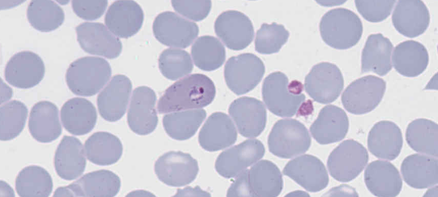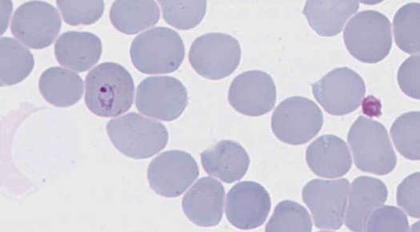

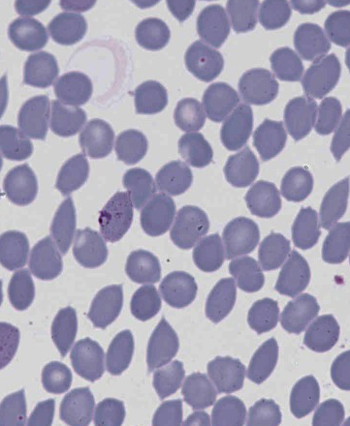

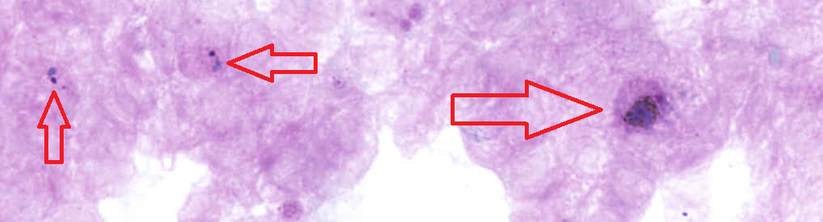

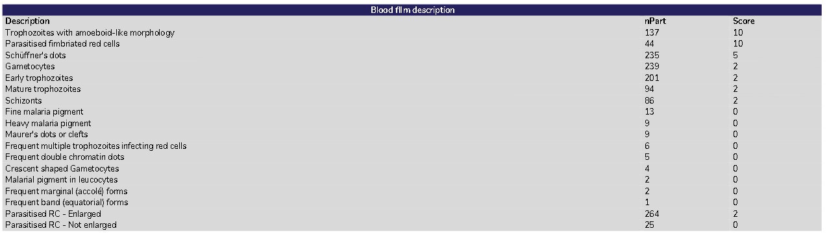

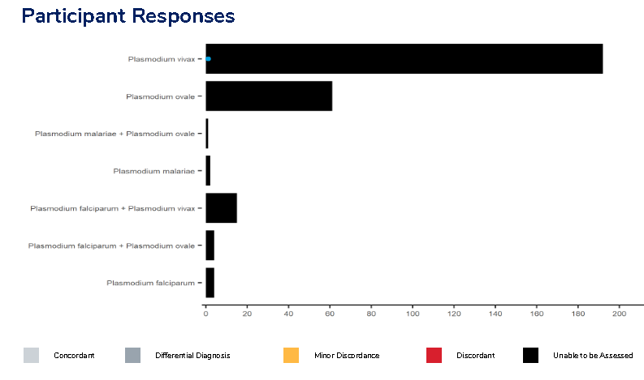

**Case Study HA-MA-22-01: Not Assessed**

Due to a lack of consensus among participants this case was not assessed for diagnosis and is deemed an educational exercise. The advisory committee assessment of this case notes morphological overlap between P.ovale and P.vivax. This case was diagnosed with P.ovale at presentation. There was no molecular testing available in this instance. The morphology of the slide leans towards a P.ovale however, given the lack of consensus P.vivax cannot be excluded. Identification of either species, at initial diagnosis would not have significant clinical impact due to the treatment being the same for both species.

Features on the thick and thin films that identify Plasmodium ovale:

1.Infected RBCs are larger than uninfected RBCs but not as marked as typically seen in P.vivax.

2.Strong Schuffner's dots are present at all stages and concentrated predominantly at the periphery of the host cell. Generally they are larger and darker than those seen in P.vivax.

3.There are some oval, elongated and fimbriated infected red cells present more easily located in thicker parts of the thin film. The fimbriation is generally restricted to one or two sides of the host cell. There is also the typical “comet” or “rocket” shaped host cells present.

4.The mature/late trophozoites are compact, heavily pigmented and occupy approximately one third of the moderately enlarged RBC.

5.There are early trophozoites, gametocytes and an occasional schizont present.

1. World Health Organization, 2022. WHO guidelines for malaria, 3 June 2022 (No. WHO/UCN/GMP/2022.01 Rev. 2). World Health Organization.

|  |  |  |  |  |  |  |  |  |  |  |  |  |  |
| --- | --- | --- | --- | --- | --- | --- | --- | --- | --- | --- | --- | --- | --- |
|  | **HA-MA-22-01** | |  |  |  |  |  |  |  |  |  |  |  |
| RBC Features | Gametocytes | Gametocytes | Parasitised red cells larger than uninfected cells | Schüffner's dots | Parasitised red cells larger than uninfected cells | Schüffner's dots |  | Parasitised red cells larger than uninfected cells | Gametocytes | Parasitised red cells larger than uninfected cells | Early trophozoites | Parasitised red cells larger than uninfected cells |  |
| Schüffner's dots | Parasitised red cells larger than uninfected cells | Schüffner's dots | Parasitised red cells larger than uninfected cells | Heavy malaria pigment | Parasitised red cells larger than uninfected cells |  | Schüffner's dots | Parasitised red cells larger than uninfected cells | Schüffner's dots | Gametocytes | Schüffner's dots |  |
| Parasitised red cells larger than uninfected cells | Gametocytes | Gametocytes | Early trophozoites | Early trophozoites | Gametocytes |  | Trophozoites with amoeboid-like morphology | Trophozoites with amoeboid-like morphology | Schizonts | Parasitised red cells larger than uninfected cells | Early trophozoites |  |
| Trophozoites with amoeboid-like morphology | Parasitised fimbriated red cells | Early trophozoites | Gametocytes | Schüffner's dots |  |  | Gametocytes |  | Trophozoites with amoeboid-like morphology | Schüffner's dots | Gametocytes |  |
|  |  |  |  |  |  |  | Early trophozoites |  |  |  |  |  |
|  |  |  |  |  |  |  | Mature trophozoites |  |  |  |  |  |
| Primary Diagnosis | Malaria - Plasmodium vivax | Malaria - Plasmodium vivax | Malaria - Plasmodium vivax | Malaria - Plasmodium vivax | Malaria - Plasmodium vivax | Malaria - Plasmodium vivax |  | Malaria - Plasmodium vivax | Malaria - Plasmodium vivax | Malaria - Plasmodium vivax | Malaria - Plasmodium vivax | Malaria - Plasmodium vivax | Malaria – Plasmodium falciparum |

|  |  |  |  |
| --- | --- | --- | --- |
| Highest scoring response | Moderate scoring response | Lowest scoring response | Response given no score |

|  |  |  |  |  |  |  |  |  |  |  |  |  |  |
| --- | --- | --- | --- | --- | --- | --- | --- | --- | --- | --- | --- | --- | --- |
|  |  |  |  |  |  |  |  |  |  |  | **RCPA Report 11/05/2022** | | |
| Early trophozoites | Trophozoites with amoeboid-like morphology | Early trophozoites | Trophozoites with amoeboid-like morphology | Parasitised red cells larger than uninfected cells | Parasitised red cells larger than uninfected cells | Early trophozoites | Parasitised fimbriated red cells | Parasitised red cells larger than uninfected cells | Gametocytes | RBC Features | Trophozoites with amoeboid-like morphology | Schüffner's dots | Gametocytes |
| Gametocytes | Parasitised red cells larger than uninfected cells | Gametocytes | Gametocytes | Maurer's dots or clefts | Schüffner's dots | Gametocytes | Gametocytes | Early trophozoites | Parasitised red cells larger than uninfected cells | Parasitised fimbriated red cells |  | Early trophozoites |
| Parasitised red cells larger than uninfected cells | Gametocytes | Parasitised red cells larger than uninfected cells | Parasitised red cells larger than uninfected cells | Trophozoites with amoeboid-like morphology | Early trophozoites | Fine malaria pigment | Parasitised red cells larger than uninfected cells | Schüffner's dots | Schüffner's dots | Parasitised red cells larger than uninfected cells |  | Mature trophozoites |
| Schüffner's dots |  | Parasitised fimbriated red cells | Early trophozoites |  | Gametocytes | Schizonts |  | Gametocytes | Trophozoites with amoeboid-like morphology |  |  | Schizonts |
|  |  |  | Schüffner's dots |  |  | Parasitised red cells larger than uninfected cells |  |  |  |  |  |  |
|  |  |  |  |  |  | Parasitised fimbriated red cells |  |  |  |  |  |  |
| Malaria - Plasmodium vivax | Malaria - Plasmodium vivax | Malaria - Plasmodium vivax | Malaria - Plasmodium vivax | Malaria - Plasmodium vivax | Malaria - Plasmodium vivax | Malaria - Plasmodium ovale | Malaria - Plasmodium vivax | Malaria - Plasmodium vivax | Malaria - Plasmodium vivax | Primary Diagnosis | **Not assessed** | Malaria - Plasmodium ovale | Malaria - Plasmodium vivax |

HA-MA-22-01

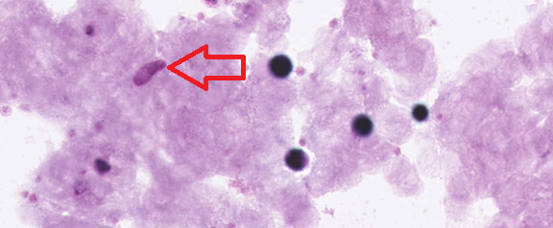

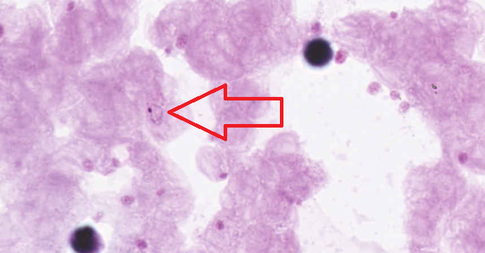

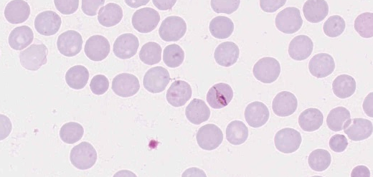

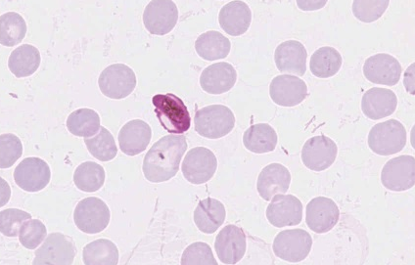

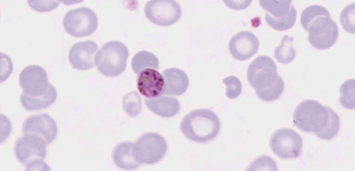

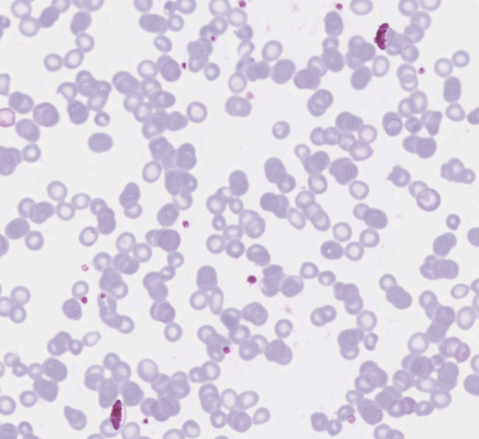

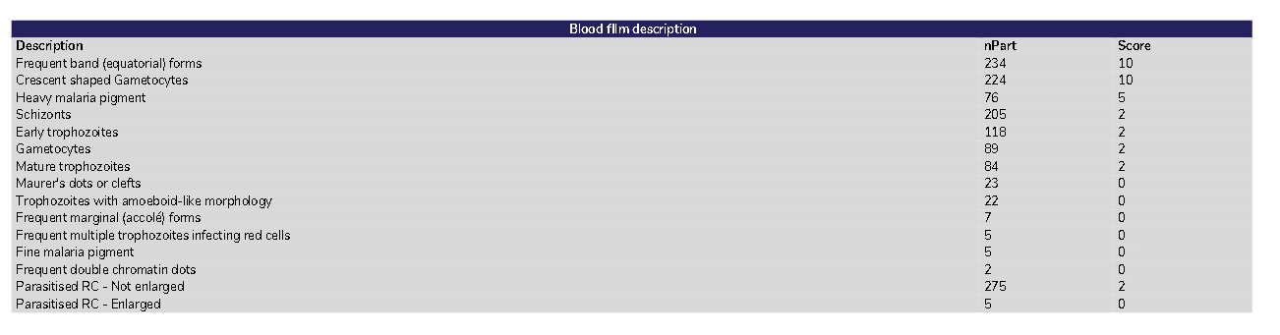

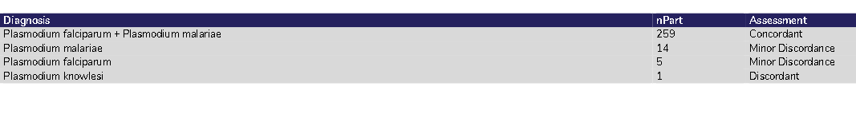

**Case Study HA-MA-22-02: Plasmodium falciparum+ Plasmodium malariae**

Features on the thin and thick films identifying Plasmodium falciparum:

1.The characteristic crescent or banana shaped gametocytes were easily seen in both the thick and thin films. An occasional gametocyte exhibiting Laveran’s bib is also present on the thin film.

2.The infected red cells are not enlarged compared to the uninfected red cells.

3.Rare ring forms can be easily identified particularly on the thin film.

4.Maurer's clefts were visible in the few trophozoites seen. As it was not a prominent feature it was not given a score.

Features on the thin and thick films that identify Plasmodium malariae:

1.The infected red cells are smaller than the uninfected red cells. The host red cells look darker with the early trophozoites but become paler as the trophozoites grow.

2.There are band or equatorial forms present -especially towards the tail of the film. These are not exclusive to P.malariae but are often a feature.

3.There is heavy malaria pigment in all the stages. In the early trophozoites it is finer but increases as the parasite grows. In the early schizonts it is present in clumps throughout the host red cell cytoplasm, but as the merozoites form the pigment coalesces into the centre of the cell to form the characteristic "daisy" arrangement.

4.There are all stages present in the thick and thin films. Most prominently there were schizonts on thick and thin film as well as the developing trophozoites. The gametocytes were generally round with scattered brown pigment and almost filled the infected red cell.

5.The cytoplasm of the early trophozoites is quite thick and in most cases very irregular with only a few trophozoites exhibiting a "ring" shape.

|  |  |  |  |  |  |  |  |  |  |  |  |  |  |
| --- | --- | --- | --- | --- | --- | --- | --- | --- | --- | --- | --- | --- | --- |
|  | **HA-MA-22-02** | |  |  |  |  |  |  |  |  |  |  |  |
| RBC Features | Parasitised red cells not enlarged | Crescent shaped Gametocytes | Crescent shaped Gametocytes | Frequent band (equatorial) forms | Parasitised red cells larger than uninfected cells | Crescent shaped Gametocytes |  | Parasitised red cells not enlarged | Gametocytes | Crescent shaped Gametocytes | Frequent band (equatorial) forms | Crescent shaped Gametocytes | Parasitised fimbriated red cells |
| Frequent band (equatorial) forms | Frequent double chromatin dots | Parasitised red cells not enlarged | Schizonts | Gametocytes | Frequent band (equatorial) forms |  | Frequent band (equatorial) forms | Schizonts | Parasitised red cells not enlarged | Crescent shaped Gametocytes | Schizonts | Gametocytes |
| Mature trophozoites | Parasitised red cells not enlarged | Gametocytes | Early trophozoites | Trophozoites with amoeboid-like morphology | Gametocytes |  | Schizonts | Crescent shaped Gametocytes | Frequent band (equatorial) forms | Schizonts | Frequent band (equatorial) forms | Schüffner's dots |
| Gametocytes | Frequent band (equatorial) forms | Frequent band (equatorial) forms | Gametocytes | Frequent band (equatorial) forms | Parasitised red cells not enlarged |  | Early trophozoites | Parasitised red cells not enlarged |  | Parasitised red cells not enlarged | Gametocytes | Crescent shaped Gametocytes |
| Crescent shaped Gametocytes | Frequent marginal (accolé) forms |  | Parasitised red cells not enlarged | Crescent shaped Gametocytes | Early trophozoites |  | Crescent shaped Gametocytes |  |  |  | Parasitised red cells not enlarged |  |
|  |  |  | Crescent shaped Gametocytes |  |  |  |  |  |  |  |  |  |
| Primary Diagnosis | Malaria – mixed infection | Malaria – mixed infection | Malaria – mixed infection | Malaria – mixed infection | Malaria – mixed infection | Malaria – mixed infection |  | Malaria – mixed infection | Malaria – mixed infection | Malaria – mixed infection | Malaria – mixed infection | Malaria – mixed infection | Malaria - Plasmodium ovale |

|  |  |  |  |  |  |  |  |  |  |  |  |  |  |
| --- | --- | --- | --- | --- | --- | --- | --- | --- | --- | --- | --- | --- | --- |
|  |  |  |  |  |  |  |  |  |  |  | **RCPA Report 11/05/2022** | | |
| Early trophozoites | Crescent shaped Gametocytes | Frequent band (equatorial) forms | Crescent shaped Gametocytes | Crescent shaped Gametocytes | Crescent shaped Gametocytes | Crescent shaped Gametocytes | Gametocytes | Parasitised red cells not enlarged | Crescent shaped Gametocytes | RBC Features | Frequent band (equatorial) forms | Heavy malaria pigment | Schizonts |
| Gametocytes | Frequent band (equatorial) forms | Crescent shaped Gametocytes | Gametocytes | Frequent band (equatorial) forms | Parasitised red cells not enlarged | Parasitised red cells not enlarged | Parasitised red cells not enlarged | Crescent shaped Gametocytes | Frequent multiple trophozoites infecting red cells | Crescent shaped Gametocytes |  | Early trophozoites |
| Frequent band (equatorial) forms |  | Frequent double chromatin dots | Parasitised red cells not enlarged | Gametocytes | Frequent band (equatorial) forms | Gametocytes | Crescent shaped Gametocytes | Mature trophozoites | Schizonts | Parasitised red cells not enlarged |  | Gametocytes |
| Parasitised red cells not enlarged |  | Heavy malaria pigment | Frequent band (equatorial) forms | Schizonts | Gametocytes | Early trophozoites | Frequent double chromatin dots | Gametocytes | Frequent band (equatorial) forms |  |  | Mature trophozoites |
| Heavy malaria pigment |  |  | Early trophozoites | Parasitised red cells not enlarged | Schizonts | Frequent band (equatorial) forms |  |  |  |  |  |  |
| Mature trophozoites |  |  |  |  |  | Schizonts |  |  |  |  |  |  |
| Malaria - Plasmodium malariae | Malaria – mixed infection | Malaria – mixed infection | Malaria – mixed infection | Malaria – mixed infection | Malaria – mixed infection | Malaria – mixed infection | Malaria – mixed infection |  | Malaria – mixed infection | Primary Diagnosis | Malaria – mixed infection | Plasmodium falciparum and Plasmodium malariae |  |

HA-MA-22-03 Result review

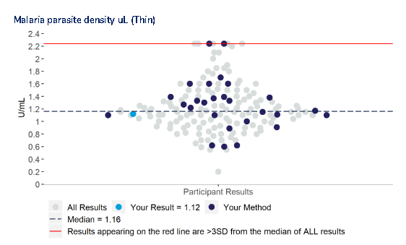

|  |  |  |  |  |  |  |  |  |  |  |  |  |  |  |  |  |  |  |
| --- | --- | --- | --- | --- | --- | --- | --- | --- | --- | --- | --- | --- | --- | --- | --- | --- | --- | --- |
|  | **HA-MA-22-03** | |  |  |  |  |  |  |  |  |  |  |  |  |  | **RCPA Report 11/05/2022** | | |
| PARASITE COUNT (#) | 120 | 113 | 118 | 114 | 96 | 126 | 44090 | 112 | 100 | 124 | 141 | 118 | 111 | 124 |  | ASP | Min | Max |
| PARASITE DENSITY (%) | 1.21 | 1.13 | 1.18 | 1.15 | 9.6 | 1.27 | 0.97 | 1.12 | 1.00 |  | 1.42 | 1.19 | 1.12 | 1.24 | PARASITE DENSITY (%) | Median 1.16 +/- 3SD | 0.26 | 2.06 |