**HA-MO-22-03**

**Mantle Cell Lymphoma**

78 year old male with night sweats, nausea and enlarged lymph nodes.

WCC: 8.7 x10^9/L

RCC:3.71x10^12/L

Hb: 112 g/L

MCV: 91.3fL

MCH:30.2pg

MCHC: 331g/L

PLT: 89 x10^9/L

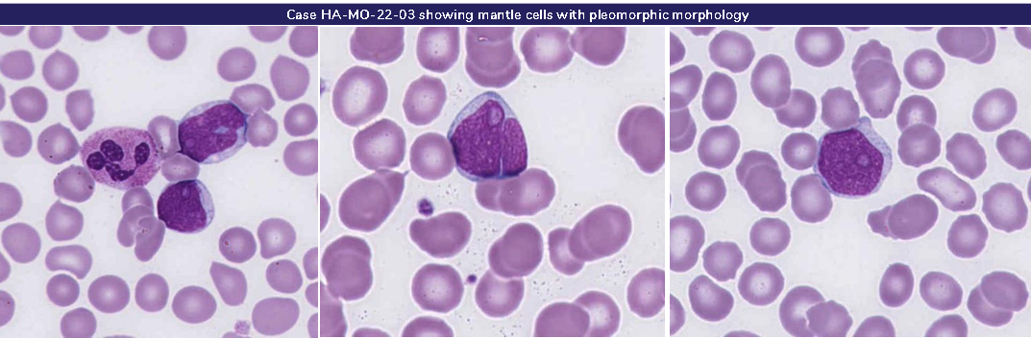

The main feature of this film was the presence of a small population of abnormal lymphocytes. The abnormal lymphocytes were predominantly medium to large sized with open chromatin, many with prominent nuclear clefts and a few cells with multiple nucleoli. The cytoplasm was pale. The corresponding blood film differential survey (HA-BF-22-02) revealed an expected result of 11% abnormal lymphocytes. Minor red cell changes were present, and giant platelets were noted. These morphological features were most consistent with a mature lymphoid neoplasm, most likely mantle cell lymphoma (MCL).

The majority of participants reported the abnormal lymphocytes, which were considered essential diagnostic feature. Mild neutrophil hypersegmentation and left shift as well as the minor red cell changes were also acknowledged. The giant platelets were scored as a minor feature.

Cytologic variants of MCL have been recognised, including small cell, marginal zone-like, pleomorphic and blastoid. In the small cell subtype the cells are small round lymphocytes with more clumped chromatin, either admixed or predominant, closely resembling a small lymphocytic lymphoma. The marginal zone-like variant shows prominent foci of cells with abundant pale cytoplasm resembling marginal zone or monocytoid B cells, mimicking a marginal zone lymphoma. In the blastoid variant, the cells resemble lymphoblasts with dispersed chromatin, and a high mitotic rate. In the pleomorphic variant, the cells are pleomorphic, with many large cells that have oval to irregular nuclear contours, generally pale cytoplasm and often prominent nucleoli in at least some of the cells.1

Both the pleomorphic and blastic variants are associated with a high proliferation rate and a poor outcome.1,2

The morphological features of this case are suggestive of a pleomorphic variant. The participant responses for this case were divided, with MCL and follicular lymphoma assessed as concordant based on the morphological features. Lymphoma was considered an acceptable alternate diagnosis that cannot be ruled out based on morphology. Adult T-cell leukaemia/lymphoma (ATLL) is a mature T-cell proliferation neoplasm.1 Although not the most likely diagnosis in this case, ATLL can present with highly pleomorphic lymphoid cells. As such, ATLL was graded as a minor discordance.

Morphologically some MCLs can appear blastic, the current case is not an example of this subtype. It is noted that 149 participants returned blast cells in their WBC descriptions most of whom submitted a concordant diagnosis. The description of blast cells is in contrast to the final concordant diagnostic interpretations and, as a result, received a score of 0. Participants should review their results appropriately in view of these findings.

This patient’s immunophenotyping demonstrated a clonal B cell population (~43%) that was CD5+, CD19+, CD20+(bright),CD22+,CD38+,FMC7+ and Kappa light chain restricted. These cells did not express CD10, CD23 or CD200.This immunophenotype is most consistent with Mantle Cell Lymphoma

.1. WHO Classification of Tumours of Haematopoietic and Lymphoid Tissues, Swerdlow, S et al,revised 4th edition, 20172. Mantle Cell Lymphoma With Mantle Zone Growth Pattern, Yuan, G et al, Am J Clin Pathol, 2019;152:132-145

|  |  |  |  |  |  |  |  |  |  |  |  |  |
| --- | --- | --- | --- | --- | --- | --- | --- | --- | --- | --- | --- | --- |
|  | **HA-MO-22-03** | | | | | | | | | |  |  |
| RBC Features | No significant morphological red blood cell abnormality | Irregularly contracted cells | Elliptocytes / ovalocytes | Pencil cells | Elliptocytes / ovalocytes | Elliptocytes / ovalocytes | Tear drop cells | No significant morphological red blood cell abnormality |  | Elliptocytes / ovalocytes | Elliptocytes / ovalocytes | Pencil cells |
|  | Pencil cells | Echinocytes | Microcytes | Tear drop cells |  | Elliptocytes / ovalocytes |  |  |  |  | Irregularly contracted cells |
|  | Irregularly contracted cells |  |  |  |  |  |  |  |  |  | Tear drop cells |
|  |  |  |  |  |  |  |  |  |  |  |  |
| WBC Features | Lymphocytes - abnormal | Lymphocytes - abnormal | Blast cells | Lymphocytes - abnormal | Lymphocytes - abnormal | Blast cells | Lymphocytes - abnormal | Blast cells | Lymphocytes - abnormal | Lymphocytes - abnormal | Blast cells | Lymphocytes - abnormal |
|  | Neutrophils - hypersegmented |  | Neutrophils - hypersegmented |  | Lymphocytes - abnormal | Neutrophils - hypersegmented | Lymphocytes - abnormal | Neutrophils - hypergranulation |  | Promyelocytes / metamyelocytes / myelocytes | Neutrophils - hypersegmented |
|  | Blast cells |  | Neutrophils - hypergranulation |  |  |  | Promyelocytes / metamyelocytes / myelocytes | Promyelocytes / metamyelocytes / myelocytes |  | Lymphocytes - abnormal | Lymphocytes - reactive |
|  |  |  | Promyelocytes / metamyelocytes / myelocytes |  |  |  |  |  |  | Lymphocytes - reactive |  |
| Platelet Features | No significant morphological platelet abnormality | Inaccurate platelet count | No significant morphological platelet abnormality | Giant platelets / significant numbers of large platelets | No significant morphological platelet abnormality | No significant morphological platelet abnormality | Inaccurate platelet count | No significant morphological platelet abnormality |  | No significant morphological platelet abnormality | No significant morphological platelet abnormality | Inaccurate platelet count |
| Primary Diagnosis | Lymphoma | Lymphoma |  | Lymphoma | Lymphoma | Lymphoma | Lymphoma | Lymphoma | Lymphoma | Lymphoma | Adult T-cell leukaemia / lymphoma | Lymphoblastic leukaemia / lymphoma, NOS (Acute lymphoblastic leukaemia) |

|  |  |  |  |
| --- | --- | --- | --- |
| Highest scoring response | Moderate scoring response | Lowest scoring response | Response given no score |

|  |  |  |  |  |  |  |  |  |  |  |  |  |  |
| --- | --- | --- | --- | --- | --- | --- | --- | --- | --- | --- | --- | --- | --- |
|  | **HA-MO-22-03** | | | | |  |  | **RCPA Report 30/06/2022** | | |  |  |  |
| RBC Features | Rouleaux | Elliptocytes / ovalocytes | Elliptocytes / ovalocytes | Hypochromia | Pencil cells |  | RBC Features | Elliptocytes / ovalocytes |  |  |  |  |  |
| Elliptocytes / ovalocytes |  |  | Microcytes | Rouleaux |  | No significant morphological red blood cell abnormality |  |  |  |  |  |
|  |  |  | Echinocytes |  |  |  |  |  |  |  |  |
|  |  |  | Elliptocytes / ovalocytes |  |  |  |  |  |  |  |  |
| WBC Features | Lymphocytes - abnormal | Blast cells | Blast cells | Lymphocytes - abnormal | Blast cells |  | WBC Features | Lymphocytes - abnormal | Promyelocytes / metamyelocytes / myelocytes |  |  |  |  |
| Neutrophils - hypergranulation | Lymphocytes - abnormal | Lymphocytes - abnormal | Neutrophils - hypersegmented | Lymphocytes - abnormal |  |  | Neutrophils - hypersegmented |  |  |  |  |
|  |  | Promyelocytes / metamyelocytes / myelocytes | Neutrophils - hypergranulation |  |  |  |  |  |  |  |  |
|  |  |  | Promyelocytes / metamyelocytes / myelocytes |  |  |  |  |  |  |  |  |
| Platelet Features | Giant platelets / significant numbers of large platelets | No significant morphological platelet abnormality | No significant morphological platelet abnormality | Giant platelets / significant numbers of large platelets |  |  | Platelet Features | No significant morphological platelet abnormality | Giant platelets / significant numbers of large platelets |  |  |  |  |
| Primary Diagnosis | Lymphoma | Lymphoma | Lymphoma | Lymphoma | Lymphoma |  | Primary Diagnosis | Mantle cell lymphoma | Follicular lymphoma | Differential Diagnosis | Lymphoma | Minor Discordance | Adult T-cell leukaemia / lymphoma |

|  |  |  |  |
| --- | --- | --- | --- |
| Highest scoring response | Moderate scoring response | Lowest scoring response | Response given no score |

