# Purpose

This document guides scientists in the interpretation and actioning of specimen test error codes in IH-COM and when specimens are eligible for repeating.

This procedure also outlines documentation of inconclusive antibody investigations and notifications to laboratory and hospital clinical staff.

# Scope & Responsibilities

This document is intended for scientists working within Blood Bank in the interpretation and actioning of specimen test error codes in IH-COM and how product requirements or clinical recommendations / notifications are to be documented.

# Definitions

ARCBS – Australian Red Cross Blood service

BBMAN – Test code added to blood bank accessions. Used to document time taken for investigation and scanning of all investigative paperwork.

BBPHONE – Blood Bank phone test code used to document phone communications.

# Procedure

**Part A: IHCOM result Issues or error codes:**

|  |  |  |
| --- | --- | --- |
| Well Result or Flag | Description / Cause | Actions |
| DP | Dual red cell population |  |
| wR | * This does **NOT** refer to a weak reaction * Non-homogeneous area above the red cell pellet. | * Inspect card result manually. * Result may be negative, be affected by dust on column, etc. * If no liquid specimen liquid pipetting issue and / or cassette gel integrity problem result may be manually interpreted by visual reading. * If a weak reaction is suspected then treat as per a weak reaction (±) |
| wF | Doubtful result or Gel not clear. | * Check column for foreign particles. * Interpret and document results by manual reading |
| LIQ | Liquid distribution check Inspect visually | * Check liquid levels of gel columns. If levels are low or variable reject results and rerun. * If errors persist or are observed on multiple specimens contact Bio-Rad Tech support. |
| W | Well not found for interpretation | * Repeat specimen testing |
| E | No Reaction available in well or no liquid above gel | * Repeat test. * If multiple examples inspect cassettes to determine if it is a cassette / batch issue. * If cassettes appear normal inspect instrument to see if any issue with instrument pipetting. |
| ? | No result interpretation possible | * Inspect column manually and interpret and score reactions visibly. * If weak reactions suspected or uncertain, follow up Investigation is to be performed by a more sensitive method e.g. Peg IAT |
| ± | Weak Positive reaction | * Weak reactions are to be treated as positive. * Weak reactions are never to be run to “check if they are really there”. * Investigation is to be performed by a more sensitive method e.g. Peg IAT to enhance a potential weak antibody. * If the IH500 result is determined as a weak positive but repeat Peg IAT antibody screen and panel are negative treat as a possible low incidence. Issue random red cells by full serological crossmatch. Refer specimen to ARCBS Reference laboratory to confirm. |

**Part B: Inconclusive Investigations**

When investigating positive reactions additional specimens or investigations at ARCBS Lifeblood Reference may be required. To communicate an incomplete investigation to the treating clinician:

1. Extended panel investigations were unable to explain the cause of a positive antibody screen.
2. Notify the laboratory clinical registrar of unknown specificity and potential requirement additional specimens for investigation and / or referral to the ARCBS Lifeblood reference laboratory.
3. The laboratory or treating clinician can be directed to order an “Extended Group and save”. This order prompts the collection of 3 EDTA specimens for the Blood Bank to facilitate extended testing and / or referral to the ARCBS reference lab.
4. Pending arrival of the additional specimens the antibody screen on the current group and save accession has the result comment: UNKAB added and F9 pressed to expand to the comment below.

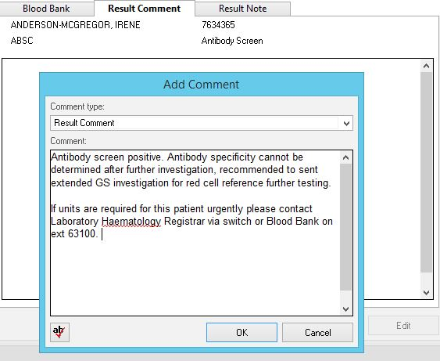

1. Blood Bank senior or rotational second in charge is to be informed and be made aware of patient and pending specimens for additional testing.
2. If specimens are being sent to the ARCBS Lifeblood reference laboratory then fill out the Reference laboratory request documentation (located in Blood Bank filing cabinet) and add the test code in Pathnet DOE:

* ARCBS Antibody Investigation – Used for specimen referrals for extended / specialised allo antibody investigations or allogeneic adsorption.
* ARCBS Genotyping: Provides for a predictive phenotype when a patient has pre-existing transfusion or autoimmune reactions preventing routine phenotyping

1. Once additional investigations have been completed on follow up specimens document findings on all panel paperwork and scan all results into the accession BBMAN.
2. Refer to Blood Bank senior scientist or rotational second in charge for any required patient comments to be made into Cerner Pathnet Patient Inquiry.

**Part C: Documentation of Clinical Referrals to Haematology Registrars or Other Clinicians**

The addition of the BBPHONE test code provides documentation of communications relating to notifications of clinical situations, requests for additional specimens, or advice or directions given, etc.

1. Notification of MTP activations where appropriate.
2. Issues in Blood product restrictions affecting support of hospital services.
3. Difficulty in meeting a patients red cell / blood product transfusion requirement.
4. Decision on blood product supports e.g. Irradiation required yes or no.
5. Documentation of clinical decisions, e.g. Requirement for or non Irradiated product.
6. Notification of ED / Trauma, Theatre patients with clinically significant red cell antibodies and blood products required before crossmatching can be completed.
7. Notification of significant transfusion reactions (e.g. Haemolytic reactions, anaphylaxis, blood transfused to incorrect patient, etc.)

# Related Documents

[CD_HA_0405](http://AHSHAREDAPP02/Fasttrack/Portal/CD_HA_0405.docx) Reporting Group and saves

[CD_HA_0452](http://AHSHAREDAPP02/Fasttrack/Portal/CD_HA_0452.docx) Reporting Antibody Panel Investigations

# References

NIL