**Instructions for Accessing Self-Guided Training Material**

1. Go to <https://www.cepheid.com/>
2. Hover over the **Support** tab, then click **Training & Education**.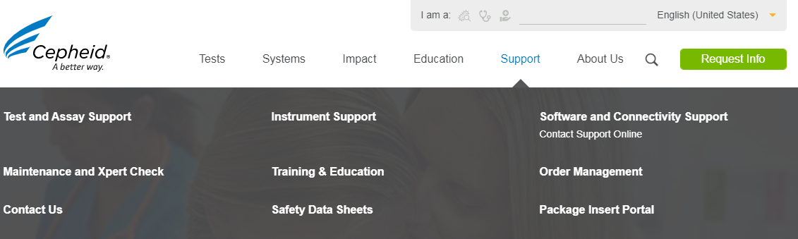

|  |  |
| --- | --- |
| Note | If you accidentally click on the support tab, scroll down the page to the Support section, then click on Customer Training & Education. |

1. Fill out the form to access the training materials.  
   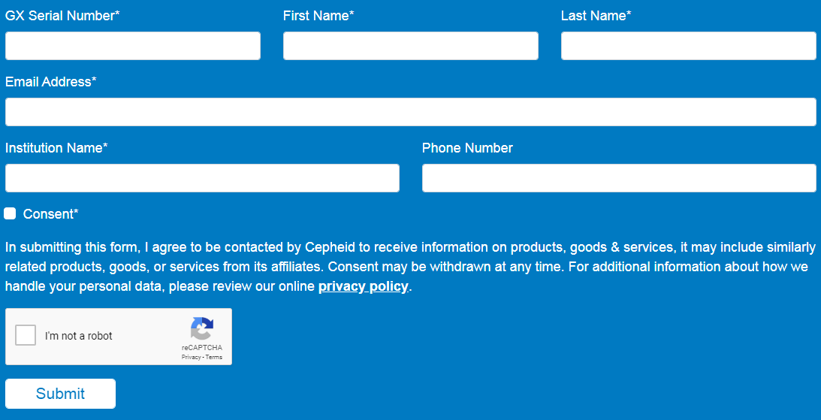

All training materials can be accessed from this page.   


**Assay Training Tab:** Includes all assay specific training materials (PowerPoint presentations, cartridge preparation cards, sample collection guides, recorded webinars)

**Instrument and Software Training:** Includes system and software related materials (how to create a test, cartridge labeling guide, GeneXpert and Infinity reference guides)

**Training Assessments Tab:** Includes assessments of knowledge of Cepheid materials (Self-Guided Cepheid Training Evaluation, Assay Competency Checklist, etc.)

1. For test-specific training, click on the tab labeled **Assay Training**.  
   
2. From the drop-down menu, select the assay that you must complete the training for.  
   Example: Xpert® Xpress Strep A  
   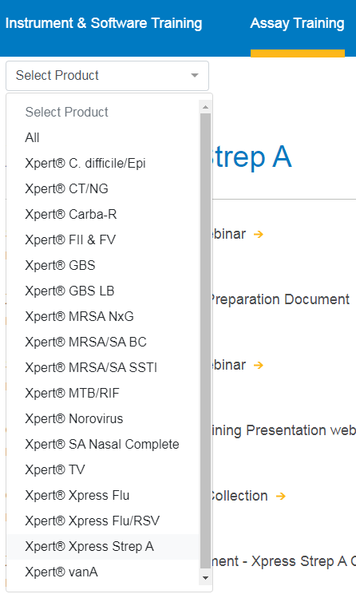
3. All the available training materials for this assay are listed below.  
   Click on the applicable webinar to watch the training video.

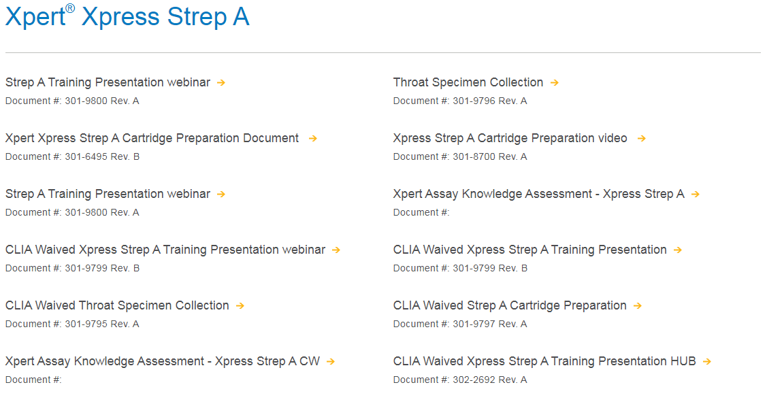

1. Once you have finished watching the webinar, navigate to the **Training Assessments** tab and select **Self-Guided Cepheid Training Evaluation.**  
   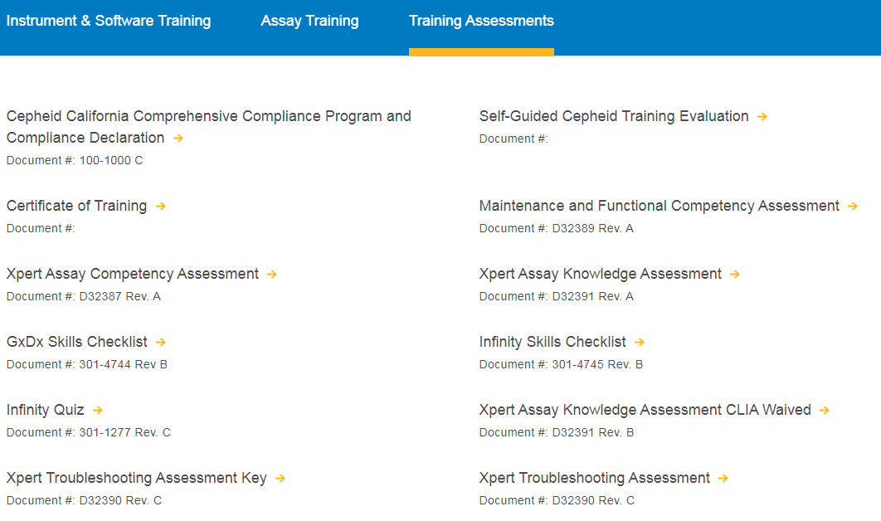
2. Complete the survey to request credit for viewing the webinar.  
   