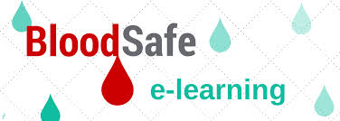

**New Transfusion Competency Module**

The Basic and Intermediate Transfusion units of MTS have been removed for the January – June 2016 period.

In place of these units can you please visit <https://bloodsafelearning.org.au/> and complete the “Patient Blood Management” module.

The eLearning courses on this site have been designed to develop the participant’s knowledge of safe clinical transfusion practice and effective patient blood management.

You will need to register via the “New Registration” button.

If you have any questions feel free to see Dion or Michelle.