

|  |  |  |  |
| --- | --- | --- | --- |
| Title: | Microscope Use in Provider Performed Testing | | |
| Department/Service Line: | Laboratory | | |
| Approver(s): | CLIA Director | | |
| Location/Region/Division: | Baylor Scott & White Health | | |
| Document Number: | BSWH.LAB.PPT.002.R_V1 | | |
| Last Review/Revision Date: | See Signatures | Origination Date: | 08/2015 |

# sCOPE

This document applies to providers that use a microscope for provider performed testing within Baylor Scott & White Health.

# DEFINITIONS

None

|  |
| --- |
|  |
| method/Utility |
| Microscopes are precision instruments. Achieving an accurate result with microscopic techniques requires an understanding of the operating characteristics and limitations of the equipment used. Therefore, analyzing specimens with the microscope requires training, knowledge of standard precautions, and an understanding of the capabilities, use, and care of the microscope. |

# PROCEDURE

**Parts of the Microscope**

**Lenses**

* The objective lens magnifies the specimen a defined amount. The objective produces the primary image and the eyepiece magnifies it. The total magnification of the image is the product of the magnification of the objective multiplied by the magnification of the eyepiece.
* The oculars (eyepieces) are placed in the top openings of the observation tubes of the microscope and magnify the primary image projected by the objective.

**Stand**

The stand rests on the base of the microscope and carries the arm and the stage on which the specimen is placed.

**Stage**

The horizontal platform on which the specimen slide is placed.

**Coarse and Fine Adjustment Knobs**

Used to bring the slide into focus by moving the stage toward or away from the objectives.

**Condenser**

The condenser is mounted under the stage to concentrate and focus light from the light source. It can be raised or lowered by means of a condenser knob below the stage. The aperture iris diaphragm can be opened or closed to control the amount of light striking the specimen.

**Illumination**

The built in light source is usually a tungsten bulb or tungsten-halogen bulb. A switch or dimmer may be used to control the intensity of the light. Lowering the intensity before turning off the microscope lengthens the life of the bulb.

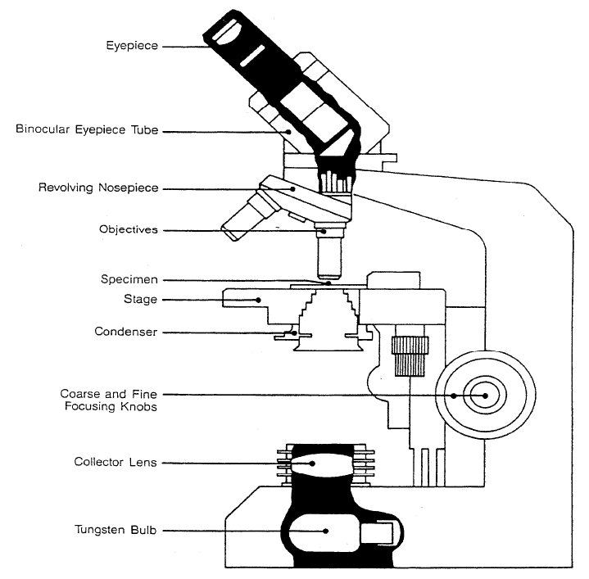

**Operation**

**Low Power Objective (10x)**

1. Place a properly labeled specimen slide on the stage.
2. Lower the condenser and turn the lamp to low. Open both the aperture diaphragm and the field diaphragm.
3. With the 10x objective in place and while observing from the *side of the slide and not through the eyepiece*, use the coarse adjustment knob to slowly raise the stage until the slide comes close to the objective.
4. Look through the eyepiece and use the coarse and/or fine adjustment until the image is sharply in focus.
5. Close the field diaphragm almost completely and raise the condenser until the edges of the diaphragm are sharply focused (the condenser is usually at its highest position). Then, open the field diaphragm slowly, stopping just as it disappears from view.
6. Open and close the aperture diaphragm to optimize contrast. Contrast is increased by closing the aperture. If more light is needed, turn up the lamp.

**High Power Objective (40x)**

1. Focus and center the specimen with the 10x objective as instructed above.
2. Rotate the nosepiece slowly to bring the 40x objective into the light path.
3. Use the FINE adjustment knob to bring the specimen into focus.
4. *Note*: Never raise the stage with the coarse adjustment knob when using the 40x lens. Doing so may cause the lens to hit the slide and break.

**Care of the Microscope**

* Microscopes are inspected, cleaned, and checked each day of patient use. For daily cleaning use a high quality lens paper. Document daily maintenance on the Microscope Maintenance Log.
* Annual microscope maintenance may be performed by Biomed or a contracted third party.
* Cover the microscope when not in use and leave the 10x objective in position.

# ATTACHMENTS

Microscope Maintenance Log for PPM Procedures (BSWH.LAB.PPT.002.A_V1)

# RELATED DOCUMENTS

Provider Performed Testing Program (BSWH.LAB.PPT.001.P_V1)

# REFERENCES

1. CLSI. *Physician and Nonphysician Provider-Performed Microscopy Testing; Approved Guideline – Second Edition.* CLSI document POCT10-A2. Wayne, PA: Clinical and Laboratory Standards Institute; 2011.

|  |
| --- |
| Revision History |
| |  |  |  |  |  | | --- | --- | --- | --- | --- | | **Version #** | **Effective Date** | **Description of Change** | **Revised By** | **Removed Date** | |  |  |  |  |  | |  |  |  |  |  | |  |  |  |  |  | |  |  |  |  |  | |  |  |  |  |  | |  |  |  |  |  | |

|  |  |  |  |  |
| --- | --- | --- | --- | --- |
| approvals | | | | |
| <Instructions – Following each signatory type (e.g., Author), remove the phrase “Typed Name and Credentials” replacing them with the individual’s name and credentials. For example, Jane Doe, MT(ASCP), or John Doe, Lead Tech Chemistry, etc. Complete for only those signatories required in the specific facility. Remove rows for signatories not required.> | | | | |
| **Title** (of the document) | Microscope Use in Provider Performed Testing | **Number** | BSWH.LAB.PPT.002.R_V1 | |
| *[Typed Name of Facility]* | | | | |
| **Name** | | | | **Date** |
| *Author: PPT Working Group* | | | | 7/20/15 |
| *Subject Matter Expert: [Typed Name and Credentials]* | | | |  |
| *Manager: [Typed Name and Credentials]* | | | |  |
| *CLIA Director: [Typed Name and Credentials]* | | | |  |
|  | | | | |
| routine review (central texas division only) | | | | |
|  | | | | |

|  |  |  |  |  |  |  |  |
| --- | --- | --- | --- | --- | --- | --- | --- |
| **Reviewed**  **(check)** | **Revised**  **(check)** | **Date** | **Initial First Name, Last Name** | **Reviewed**  **(check)** | **Revised**  **(check)** | **Date** | **Initial First Name, Last Name** |
|  |  |  |  |  |  |  |  |
|  |  |  |  |  |  |  |  |
|  |  |  |  |  |  |  |  |
|  |  |  |  |  |  |  |  |
|  |  |  |  |  |  |  |  |