

|  |  |  |  |
| --- | --- | --- | --- |
| Title: | KOH Prep for Dermatophytes (Provider Performed) | | |
| Department/Service Line: | Laboratory | | |
| Approver(s): | CLIA Director | | |
| Location/Region/Division: | Baylor Scott & White Health | | |
| Document Number: | BSWH.LAB.PPT.003.R_V1 | | |
| Last Review/Revision Date: | See Signatures | Origination Date: | 08/2015 |

# sCOPE

This document applies to providers that perform KOH testing for Dermatophytes within Baylor Scott & White Health.

# DEFINITIONS

*When used in this document with initial capital letter(s), the following word(s)/phrase(s) have the meaning(s) set forth below unless a different meaning is required by context. Additional defined terms may be found in the BSWH P&P Definitions document.*

**KOH** – Potassium Hydroxide (10%)

**EHR** – Electronic Health Record

|  |
| --- |
|  |
| method/Utility |
| Potassium hydroxide (KOH) clears mucous and cellular debris making mycotic elements more visible to aid in the diagnosis of fungal infection. |

# PROCEDURE

**Specimen**

Skin scrapings, hair or scalp scrapings, and nail shavings or clippings collected in a sterile cup. Skin and nail scrapings can be collected with a scalpel or the edge of a glass microscope slide.

For vaginal fluids refer to Wet Prep Procedure (CTX.LAB.PPT.005.R_V1).

**Reagents/Equipment**

* Microscope (10x and 40x Objectives)
* Microscope Slide, glass
* Coverslip, glass
* 10% KOH
* Slide Warmer (optional)

**Reagent Storage**

All reagents are stored at room temperature and used within manufacturer’s stated expiration date.

**Quality Control**

There is no available Quality Control material. Pictorial examples of mycotic elements are presented at the end of this written procedure.

**Testing Procedures**

**Slide Preparation and Microscopic Examination**

1. Label microscopic slide with two patient identifiers.
2. Place 1-3 drops of 10% KOH onto slide.
3. Place a fragment of the specimen into the KOH and tease the material to create a thin preparation. Thick skin or nail must be minced prior to KOH addition, or the KOH will not be able to adequately dissolve background material.
4. Place coverslip over the preparation.
5. Optionally, the slide may be heated using a slide warmer to speed the dissolving process, especially for nail or thick specimens.
6. Allow preparation to rest for 5-30 minutes prior to microscopic examination to allow cellular tissue, skin, and other debris to dissolve.
7. Exam on 10x and 40x objectives for the presence of fungal elements.

***Examination and Procedural Notes:***

* Use of contaminated reagent may cause a false positive exam for yeast.
* Too thick of a preparation may obscure elements and can cause a false negative reading.

**Results**

* Present: Presence of fungal elements (hyphae or yeast).
* Absent: No fungal elements seen.

**Reporting Results**

All testing and results should be documented in the EHR.

**Pictorial Examples**

**Positive for Fungal Elements**

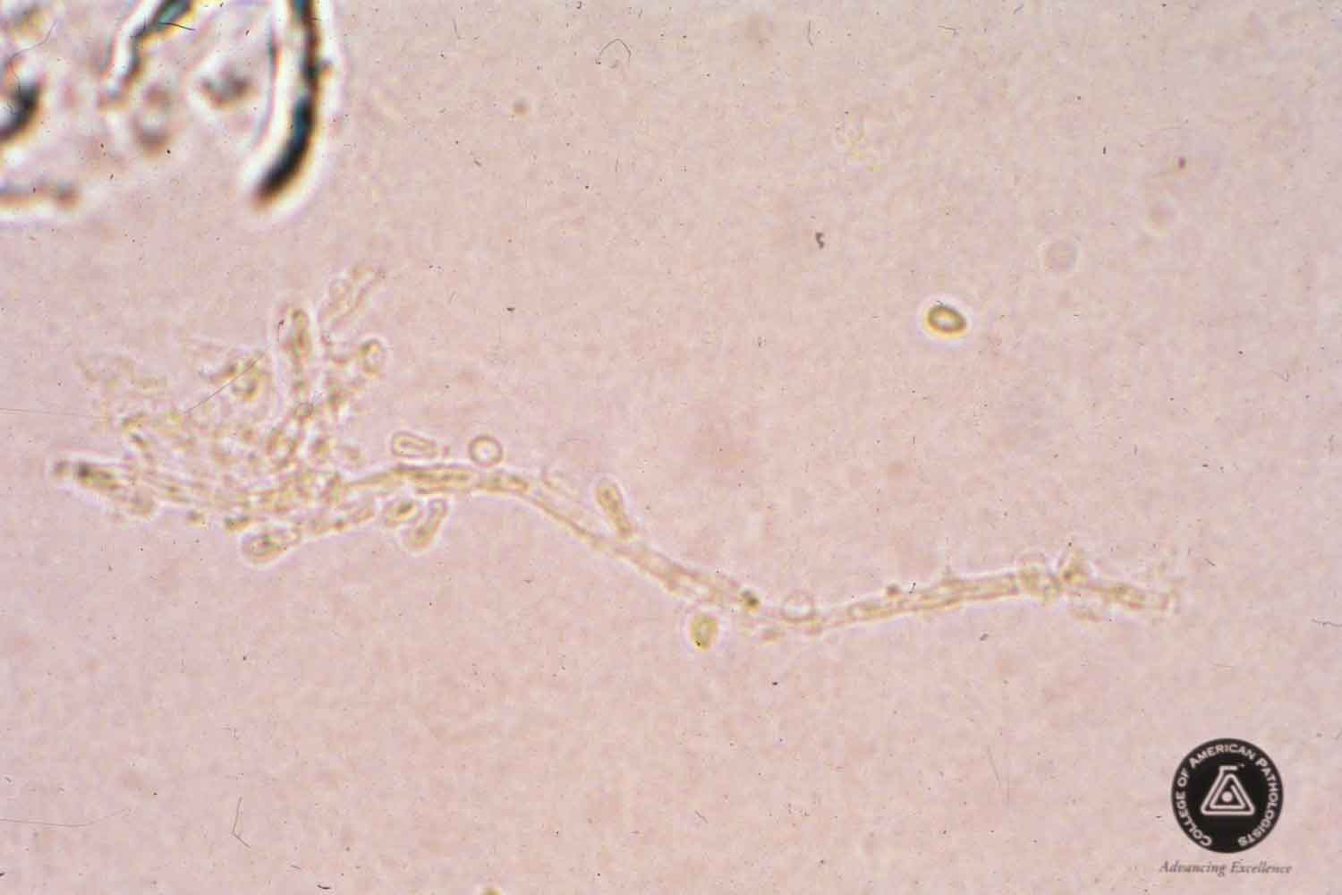

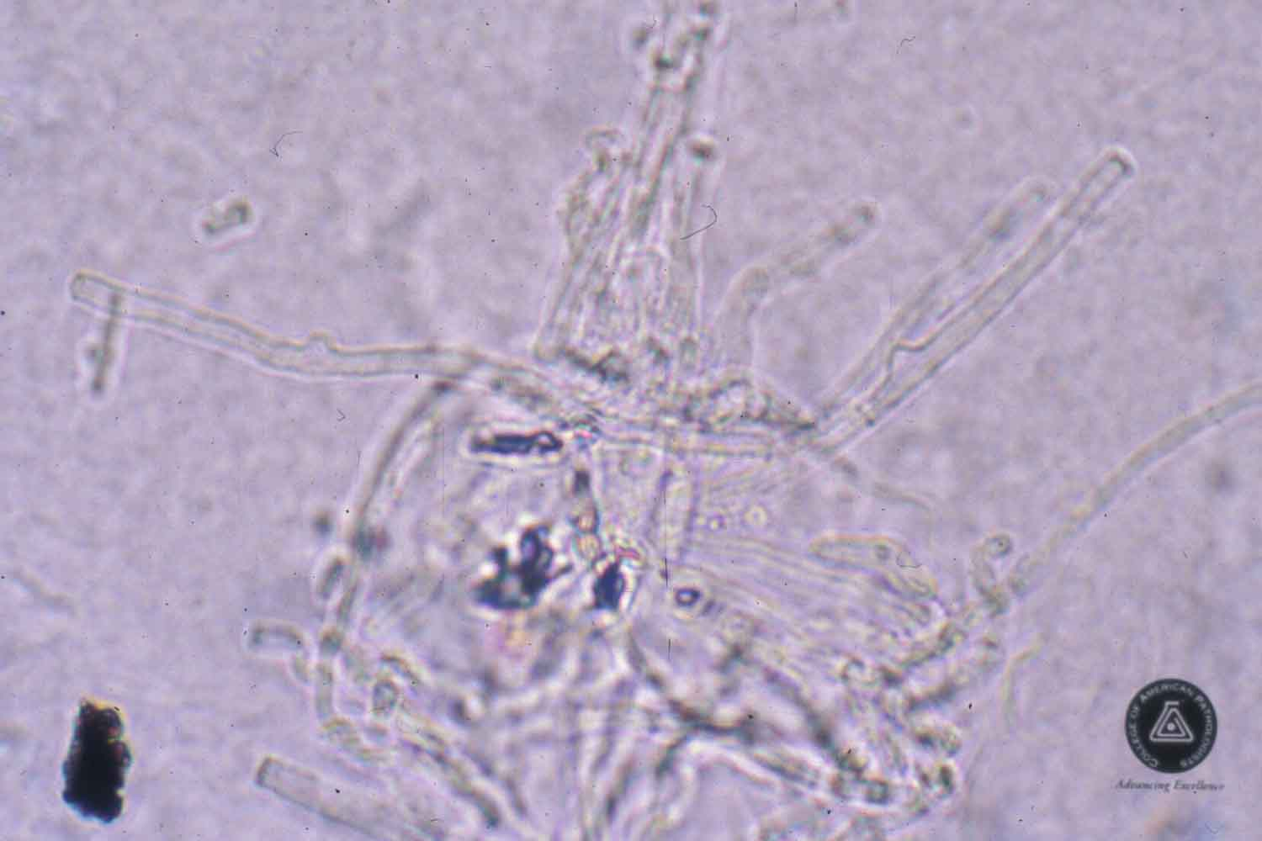

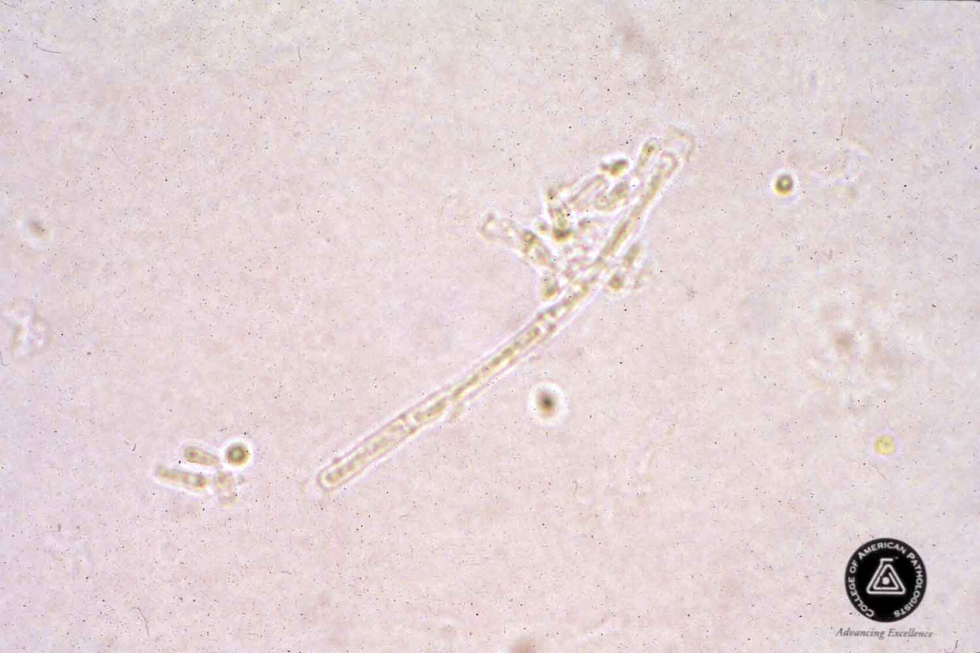

# ATTACHMENTS

Initial Training and Competency Form: KOH Prep for Dermatophytes (BSWH.LAB.PPT.003.A_V1)

# RELATED DOCUMENTS

Provider Performed Testing Program (BSWH.LAB.PPT.001.P_V1)

Microscope Use in Provider Performed Testing (BSWH.LAB.PPT.002.R_V1)

# REFERENCES

1. CLSI. *Physician and Nonphysician Provider-Performed Microscopy Testing; Approved Guideline – Second Edition.* CLSI document POCT10-A2. Wayne, PA: Clinical and Laboratory Standards Institute; 2011.
2. UMHS Microbiology KOH Preparation procedure, N. Bus, 1995. UTMB POCT Procedures: KOH Prep, [www.utmb.edu/poc/](http://www.utmb.edu/poc/)

|  |
| --- |
| Revision History |
| |  |  |  |  |  | | --- | --- | --- | --- | --- | | **Version #** | **Effective Date** | **Description of Change** | **Revised By** | **Removed Date** | |  |  |  |  |  | |  |  |  |  |  | |  |  |  |  |  | |  |  |  |  |  | |  |  |  |  |  | |  |  |  |  |  | |
|  |

|  |  |  |  |  |
| --- | --- | --- | --- | --- |
| approvals | | | | |
| <Instructions – Following each signatory type (e.g., Author), remove the phrase “Typed Name and Credentials” replacing them with the individual’s name and credentials. For example, Jane Doe, MT(ASCP), or John Doe, Lead Tech Chemistry, etc. Complete for only those signatories required in the specific facility. Remove rows for signatories not required.> | | | | |
| **Title** (of the document) | KOH Prep for Dermatophytes (Provider Performed) | **Number** | BSWH.LAB.PPT.003.R_V1 | |
| *[Typed Name of Facility]* | | | | |
| **Name** | | | | **Date** |
| *Author: PPT Working Group* | | | | 7/20/15 |
| *Subject Matter Expert: [Typed Name and Credentials]* | | | |  |
| *Manager: [Typed Name and Credentials]* | | | |  |
| *CLIA Director: [Typed Name and Credentials]* | | | |  |
|  | | | | |
| routine review (central texas division only) | | | | |
|  | | | | |

|  |  |  |  |  |  |  |  |
| --- | --- | --- | --- | --- | --- | --- | --- |
| **Reviewed**  **(check)** | **Revised**  **(check)** | **Date** | **Initial First Name, Last Name** | **Reviewed**  **(check)** | **Revised**  **(check)** | **Date** | **Initial First Name, Last Name** |
|  |  |  |  |  |  |  |  |
|  |  |  |  |  |  |  |  |
|  |  |  |  |  |  |  |  |
|  |  |  |  |  |  |  |  |
|  |  |  |  |  |  |  |  |