

|  |  |  |  |
| --- | --- | --- | --- |
| Title: | Wet Prep (Provider Performed) | | |
| Department/Service Line: | Laboratory | | |
| Approver(s): | CLIA Director | | |
| Location/Region/Division: | Baylor Scott & White Health | | |
| Document Number: | BSWH.LAB.PPT.005.R_V1 | | |
| Last Review/Revision Date: | See Signatures | Origination Date: | 08/2015 |

# sCOPE

This document applies to providers that perform wet prep testing within Baylor Scott & White Health.

# DEFINITIONS

*When used in this document with initial capital letter(s), the following word(s)/phrase(s) have the meaning(s) set forth below unless a different meaning is required by context. Additional defined terms may be found in the BSWH P&P Definitions document.*

**Clue Cell** –Epithelial cell covered with bacteria giving a fuzzy appearance often found in the presence of *Gardnerella vaginalis*, a gram-negative rod.

**EHR** – Electronic Health Record

**KOH** – Potassium Hydroxide (10%)

**NaCl** – Physiologic Saline (0.9%)

***Trichomonas* –** A mobile parasite characterized by a pear shaped body and flagella.

**WBC** – White Blood Cell

**Yeast –** Fungi that may be seen as single or budding form with or without pseudohyphae.

|  |
| --- |
|  |
| method/Utility |
| Diagnosis of genitourinary tract infections caused by yeast overgrowth, bacterial vaginosis, and/or trichomoniasis can sometimes be made by saline wet mount. |

# PROCEDURE

**Specimen**

Collect a sampling of vaginal secretions on a cotton or Dacron-tipped sterile swab passed through and along the area of concern.

Immediately after collection, place specimen in a small amount (0.5 mL) of saline in a test tube. Label tube with two unique patient identifiers. Complete microscopic examination within 1 hour of collection.

Specimens should not be refrigerated prior to examination as this decreases the motility of *Trichomonas*.

**Reagents/Equipment**

* Microscope (10x and 40x Objectives)
* Microscope Slide, glass
* Coverslip, glass
* Test tube
* Disposable Pipettes
* Sterile Swabs
* 0.9% NaCl
* 10% KOH

**Reagent Storage**

All reagents are stored at room temperature and used within manufacturer’s stated expiration date.

**Quality Control**

There is no available Quality Control material. Pictorial examples of *Trichomonas*, yeast, and clue cells are presented at the end of this written procedure.

**Testing Procedures**

**Wet Prep Slide Preparation**

1. Label microscopic slide with two patient identifiers.
2. Place small amount of patient specimen solution onto clean, glass slide and cover slip. Alternately, smear the collected swab on a slide, add a drop of saline, and cover slip.

**Wet Prep with KOH Slide Preparation**

1. Label microscopic slide with two patient identifiers.
2. Place one drop of patient specimen suspension on clean glass slide.
3. Add one drop of 10% KOH to the specimen.
4. Sniff the preparation immediately, using your hand to waft the odor toward your nose. This is called the "whiff" test. A “fishy" or amine odor suggests bacterial vaginosis or trichomoniasis.
5. Place a coverslip over the specimen. Avoid trapping air bubbles under the cover slip.

**Microscopic Examination**

1. On low power (10x objective), low light examine for presence bacteria, fungal elements (yeast, budding yeast, pseudohyphae), motile *Trichomonas*, and human cellular elements.
2. Re-examine the slide on high power (40x objective) to evaluate the presence or absence of cells, weakly motile *Trichomonas*, yeast, and pseudohyphae.
3. Report *Trichomonas*, Yeast, Clue cells, and WBCs as Present or Absent

***Examination and Procedural Notes:***

* *Trichomonas* must exhibit motility to not be confused with a WBC. False negatives may be observed if performed after 1 hour of collection.
* Yeast is observed as single or budding forms with or without branching. Cotton strand may resemble yeast hyphae.
* To be considered a Clue Cell, bacteria must extend past the cell’s cytoplasmic borders.
* Absence of organisms does not rule out infections.
* Poor specimen collections can cause false negative specimens.

**Reporting Results**

All testing and results should be documented in the EHR.

**Pictorial Examples**

***Trichomonas***

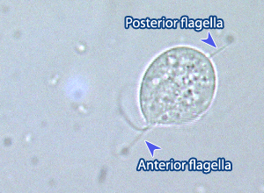

**Yeast**

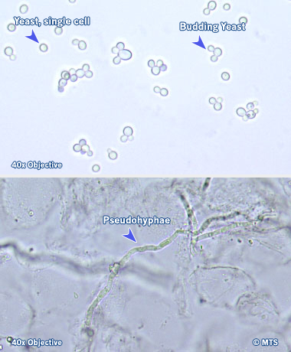

**Clue Cells**

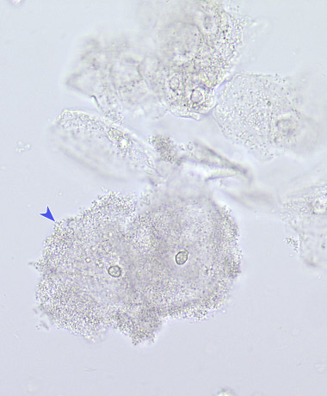

**White Blood Cell**

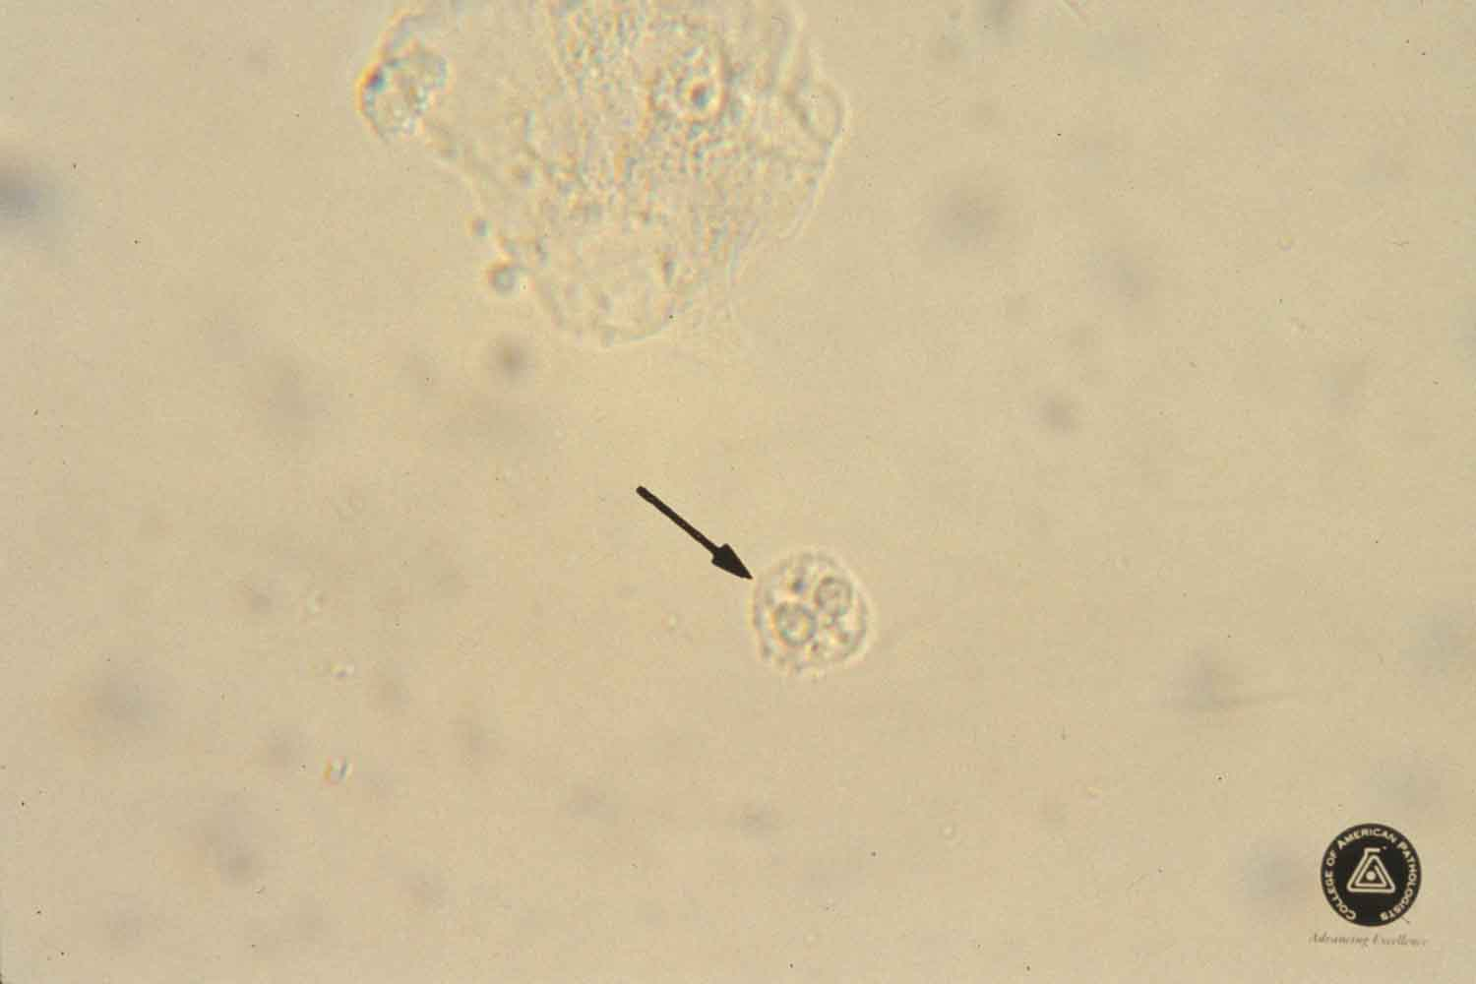

# ATTACHMENTS

Initial Training and Competency Form: Wet Prep (BSWH.LAB.PPT.005.A_V1)

# RELATED DOCUMENTS

Provider Performed Testing Program (BSWH.LAB.PPT.001.P_V1)

Microscope Use in Provider Performed Testing (BSWH.LAB.PPT.002.R_V1)

# REFERENCES

1. MTS, University of Washington, Department of Laboratory Medicine, Vaginal Wet Prep, online [www.medtraining.org](http://www.medtraining.org)
2. CLSI. *Physician and Nonphysician Provider-Performed Microscopy Testing; Approved Guideline – Second Edition.* CLSI document POCT10-A2. Wayne, PA: Clinical and Laboratory Standards Institute; 2011.

|  |  |  |  |  |
| --- | --- | --- | --- | --- |
| Revision History | | | | |
| |  |  |  |  |  | | --- | --- | --- | --- | --- | | **Version #** | **Effective Date** | **Description of Change** | **Revised By** | **Removed Date** | |  |  |  |  |  | |  |  |  |  |  | |  |  |  |  |  | |  |  |  |  |  | |  |  |  |  |  | |  |  |  |  |  | | | | | |
| approvals | | | | |
| <Instructions – Following each signatory type (e.g., Author), remove the phrase “Typed Name and Credentials” replacing them with the individual’s name and credentials. For example, Jane Doe, MT(ASCP), or John Doe, Lead Tech Chemistry, etc. Complete for only those signatories required in the specific facility. Remove rows for signatories not required.> | | | | |
| **Title** (of the document) | Wet Prep (Provider Performed) | **Number** | BSWH.LAB.PPT.005.R_V1 | |
| *[Typed Name of Facility]* | | | | |
| **Name** | | | | **Date** |
| *Author: PPT Working Group* | | | | 7/20/15 |
| *Subject Matter Expert: [Typed Name and Credentials]* | | | |  |
| *Manager: [Typed Name and Credentials]* | | | |  |
| *CLIA Director: [Typed Name and Credentials]* | | | |  |
|  | | | | |
| routine review (central texas division only) | | | | |
|  | | | | |

|  |  |  |  |  |  |  |  |
| --- | --- | --- | --- | --- | --- | --- | --- |
| **Reviewed**  **(check)** | **Revised**  **(check)** | **Date** | **Initial First Name, Last Name** | **Reviewed**  **(check)** | **Revised**  **(check)** | **Date** | **Initial First Name, Last Name** |
|  |  |  |  |  |  |  |  |
|  |  |  |  |  |  |  |  |
|  |  |  |  |  |  |  |  |
|  |  |  |  |  |  |  |  |
|  |  |  |  |  |  |  |  |