

|  |  |  |  |
| --- | --- | --- | --- |
| Title: | Pinworm Exam (Provider Performed) | | |
| Department/Service Line: | Laboratory | | |
| Approver(s): | CLIA Director | | |
| Location/Region/Division: | Baylor Scott & White Health | | |
| Document Number: | BSWH.LAB.PPT.007.R_V1 | | |
| Last Review/Revision Date: | See Signatures | Origination Date: | 08/2015 |

# sCOPE

This document applies to providers that perform pinworm testing within Baylor Scott & White Health.

# DEFINITIONS

None

|  |
| --- |
|  |
| method/Utility |
| Clear, cellulose tape preparation or Swube Paddles are methods widely used for the detection of human pinworm infections. Adult *Enterobius vermicularis* worms inhabit the large intestine and rectum; however, the eggs are not normally found in fecal material. The adult female migrates out of the anal opening and deposits the eggs on the perianal skin, usually during the night. |

# PROCEDURE

**Specimen**

Eggs and occasionally adult female worms, can be collected by touching the sticky surface of cellulose (clear) tape or sticky side of a Swube paddle to the anal region. The cellulose tape preparation or Swube paddle are submitted to the laboratory, where they are examined under the microscope. The specimen is collected from the skin of the perianal area first thing in the morning, before the patient has bathed or used the toilet. Preparations should be taken for at least 4-6 consecutive days with negative results before a patient is considered free of the infection.

Specimens collected using frosted tape cannot be used as pinworms and eggs cannot be observed.

**Reagents/Equipment**

* Microscope (10x Objective)
* Microscope Slide, glass
* Tape, clear cellulose (not frosted)
* Tongue depressor
* Swube Paddle

**Reagent Storage**

All reagents are stored at room temperature and used within manufacturer’s stated expiration date.

**Quality Control**

There is no available Quality Control material. Pictorial example of *Enterobius vermicularis* eggs is presented at the end of this written procedure.

**Testing Procedures**

**Cellulose Tape Slide Preparation and Microscopic Examination**

1. Place a strip of clear cellulose tape (adhesive side down) on a microscope slide as follows:
   1. Starting approximately 1.5 cm. from one end, run the tape toward the same end, and wrap the tape around the slide to the opposite end.
   2. Tear the tape even with the end of the slide.
   3. Attach a label to the tape at the end torn flush with the side.
2. To obtain a sample from the perianal area, peel back the tape by gripping the labeled end, and, with the tape looped (adhesive side downward) over a wooden tongue depressor that is held firmly against the slide and extended about 2.5 cm. beyond it, press the tape firmly several times against the right and left perianal folds.

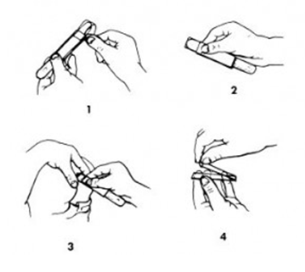

1. Smooth the tape back on the slide, adhesive side down.
2. Label slide with two unique patient identifiers.
3. Examine the slide directly on low power (10x objective).

**Swube Paddle and Microscopic Examination**

1. Remove the paddle from the tube transport device.
2. Press the sticky end of the paddle several times against the right and left perianal folds.
3. Return the paddle to the tube transport device.
4. Label paddle with two unique patient identifiers.
5. Examine the sticky portion of the paddle on low power (10x objective).

***Examination and Procedural Notes:***

* Typical pinworm eggs are thick-shelled and football shaped with one flattened side, and may contain a partially or fully developed larva.
* Adult female worms are occasionally seen. Worms are approximately 1 cm. in length, white, and have a pointed tail.
* Pinworm eggs are usually infectious. The use of glass slides and tape may expose the personnel to these eggs. Gloves are to be worn when preparing the slide for examination.

**Results**

* Positive – Any evidence of pinworms and/or eggs.
* Negative – No pinworms or eggs seen.

**Reporting Results**

All testing and results should be documented in the EHR.

**Pictorial Example**

Pinworm Egg

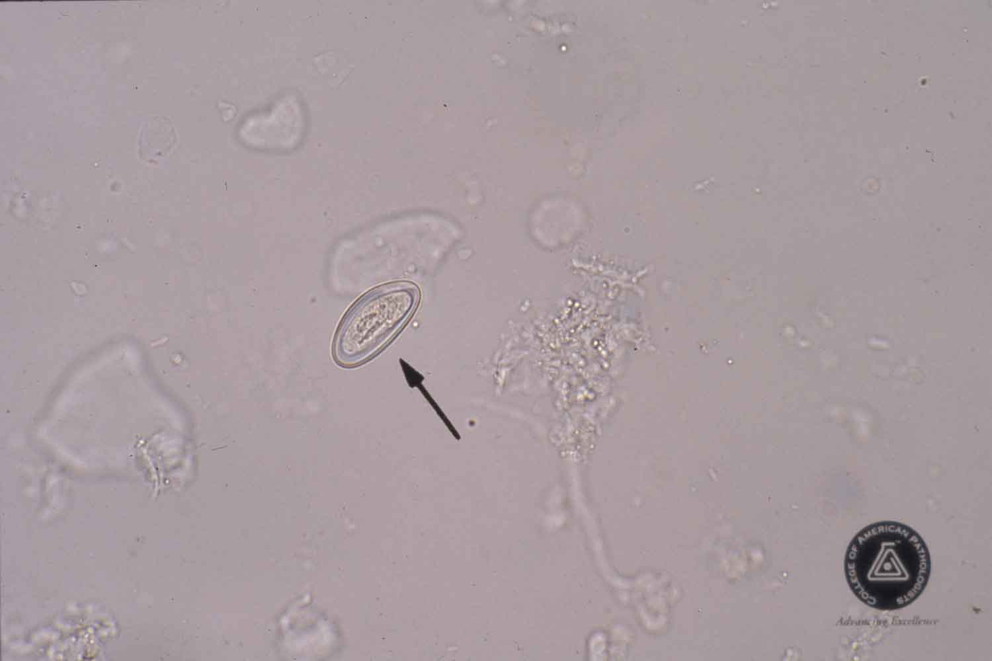

Adult Worm

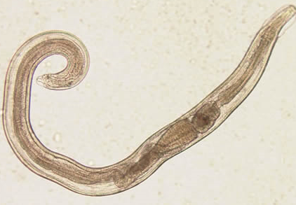

# ATTACHMENTS

Initial Training and Competency Form: Pinworm (BSWH.LAB.PPT.007.A_V1)

# RELATED DOCUMENTS

Provider Performed Testing Program (BSWH.LAB.PPT.001.P_V1)

Microscope Use in Provider Performed Testing (BSWH.LAB.PPT.002.R_V1)

# REFERENCES

1. CLSI. *Physician and Nonphysician Provider-Performed Microscopy Testing; Approved Guideline – Second Edition.* CLSI document POCT10-A2. Wayne, PA: Clinical and Laboratory Standards Institute; 2011.

|  |
| --- |
| Revision History |
| |  |  |  |  |  | | --- | --- | --- | --- | --- | | **Version #** | **Effective Date** | **Description of Change** | **Revised By** | **Removed Date** | |  |  |  |  |  | |  |  |  |  |  | |  |  |  |  |  | |  |  |  |  |  | |  |  |  |  |  | |  |  |  |  |  |  approvals  |  |  |  |  |  | | --- | --- | --- | --- | --- | | <Instructions – Following each signatory type (e.g., Author), remove the phrase “Typed Name and Credentials” replacing them with the individual’s name and credentials. For example, Jane Doe, MT(ASCP), or John Doe, Lead Tech Chemistry, etc. Complete for only those signatories required in the specific facility. Remove rows for signatories not required.> | | | | | | **Title** (of the document) | Pinworm Exam (Provider Performed) | **Number** | BSWH.LAB.PPT.007.R_V1 | | | *[Typed Name of Facility]* | | | | | | **Name** | | | | **Date** | | *Author: PPT Working Group* | | | | 7/20/15 | | *Subject Matter Expert: [Typed Name and Credentials]* | | | |  | | *Manager: [Typed Name and Credentials]* | | | |  | | *CLIA Director: [Typed Name and Credentials]* | | | |  |  |  | | --- | |  | | routine review (central texas division only) | |  |  |  |  |  |  |  |  |  |  | | --- | --- | --- | --- | --- | --- | --- | --- | | **Reviewed**  **(check)** | **Revised**  **(check)** | **Date** | **Initial First Name, Last Name** | **Reviewed**  **(check)** | **Revised**  **(check)** | **Date** | **Initial First Name, Last Name** | |  |  |  |  |  |  |  |  | |  |  |  |  |  |  |  |  | |  |  |  |  |  |  |  |  | |  |  |  |  |  |  |  |  | |  |  |  |  |  |  |  |  | |
|  |