

|  |  |  |  |
| --- | --- | --- | --- |
| Title: | Nasal Smears for Eosinophils (Provider Performed) | | |
| Department/Service Line: | Laboratory | | |
| Approver(s): | CLIA Director | | |
| Location/Region/Division: | Baylor Scott & White Health | | |
| Document Number: | BSWH.LAB.PPT.008.R_V1 | | |
| Last Review/Revision Date: | See Signatures | Origination Date: | 08/2015 |

# sCOPE

This document applies to providers that perform nasal smears for eosinophils testing within Baylor Scott & White Health.

# DEFINITIONS

*When used in this document with initial capital letter(s), the following word(s)/phrase(s) have the meaning(s) set forth below unless a different meaning is required by context. Additional defined terms may be found in the BSWH P&P Definitions document.*

**EHR** – Electronic Health Record

|  |
| --- |
|  |
| method/Utility |
| Microscopic examination of nasal discharge using a direct smear is used to provide a differential diagnosis for the presence of WBCs. In nasal smears, the identification of eosinophils is correlated with allergic rhinitis. When the condition is due to nonallergic causes, the discharge shows a predominance of neutrophils or acellular mucus. Infectious processes show a predominance of neutrophils. |

# PROCEDURE

**Specimen**

For collection purposes, the patient discharges their nasal passages into a nonabsorbent material such as waxed paper, plastic wrap, or an unused laboratory specimen transport bag.

Specimen should be maintained at room temperature until examined. To prevent drying, assemble all necessary equipment for examination prior to initiating specimen collection.

**Reagents/Equipment**

* Microscope (10x and 40x Objectives)
* Microscope Slide, glass
* Cotton-tipped swab
* Nonabsorbent collection material
* Commercially prepared Hansel stain

**Reagent Storage**

All reagents are stored at room temperature and used within manufacturer’s stated expiration date.

**Quality Control**

There is no available Quality Control material. Pictorial examples of both eosinophils and neutrophils are presented at the end of this written procedure.

**Testing Procedures**

**Slide Preparation**

1. Label microscopic slide with two patient identifiers.
2. Using a cotton swab, transfer a sample of the produced mucus onto a glass microscope slide ensuring a thin smear is made.
3. Note: A thin smear is essential. This can be verified by checking whether standard print can be read through the smear. Place the slide over standard print. If the print can still be read through the slide, prep is acceptable for staining. Identifying elements of cellular detail will be difficult to determine if the smear is too thick.
4. Allow smear to air-dry.
5. Stain smear with Hansel stain following manufacturer’s instructions for use.

**Microscopic Examination**

1. On low power (10x objective), examine the slide for the presence of eosinophils.
   * Eosinophils are recognized by their bright orange-red, spherical granules. Typically they contain a bilobed nucleus separated by a thin filament, but occasionally more than two lobes may be seen. Granules are larger than neutrophilic granules.
   * Neutrophils are recognized by their segmented or lobulated (two to five lobes) nuclei connected by a thin filament of chromatin. The abundant cytoplasm is pale pink or colorless and contains many fine, lilac-colored, neutrophilic granules.

**Results**

* Present: Presence of eosinophils or neutrophils
* Absent: No eosinophils or neutrophils seen

***Examination and Procedural Notes:***

Poor staining can cause false-negative recognition of eosinophils.

**Reporting Results**

All testing and results should be documented in the EHR.

**Pictorial Examples**

**Nasal Eosinophils**

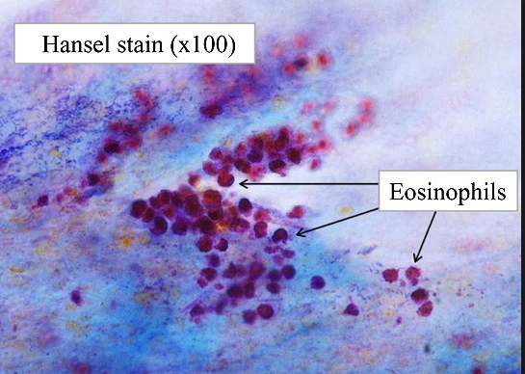 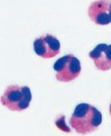

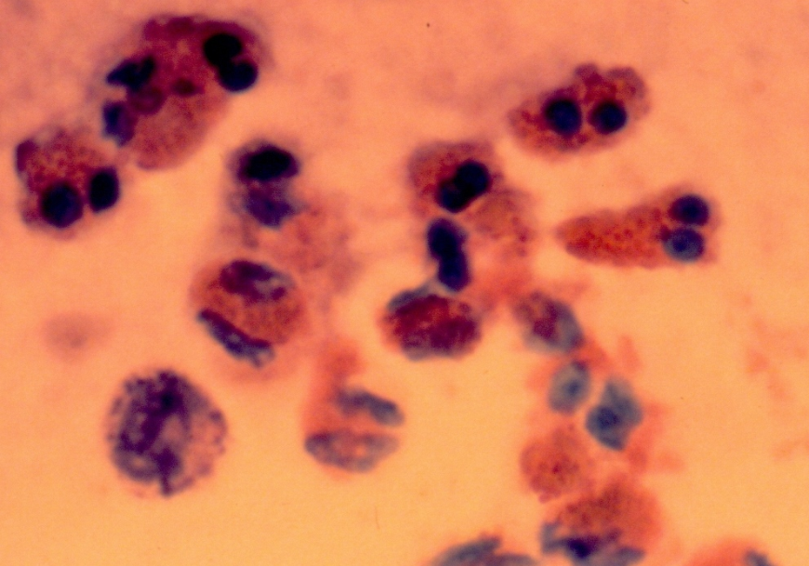

**Nasal Neutrophils**

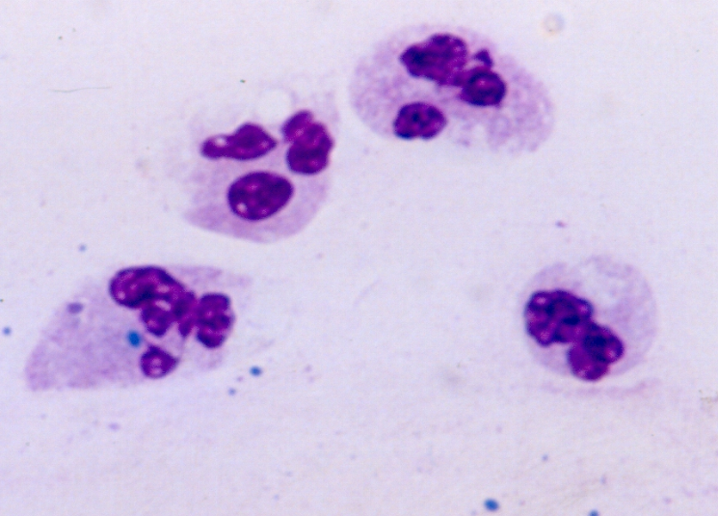

# ATTACHMENTS

Initial Training and Competency Form: Nasal Smears for Eosinophils (BSWH.LAB.PPT.008.A_V1)

# RELATED DOCUMENTS

Provider Performed Testing Program (BSWH.LAB.PPT.001.P_V1)

Microscope Use in Provider Performed Testing (BSWH.LAB.PPT.002.R_V1)

# REFERENCES

1. CLSI. *Physician and Nonphysician Provider-Performed Microscopy Testing; Approved Guideline – Second Edition.* CLSI document POCT10-A2. Wayne, PA: Clinical and Laboratory Standards Institute; 2011.

|  |
| --- |
| Revision History |

|  |  |  |  |  |
| --- | --- | --- | --- | --- |
| **Version #** | **Effective Date** | **Description of Change** | **Revised By** | **Removed Date** |
|  |  |  |  |  |
|  |  |  |  |  |
|  |  |  |  |  |
|  |  |  |  |  |
|  |  |  |  |  |
|  |  |  |  |  |

|  |  |  |  |  |
| --- | --- | --- | --- | --- |
| approvals | | | | |
| <Instructions – Following each signatory type (e.g., Author), remove the phrase “Typed Name and Credentials” replacing them with the individual’s name and credentials. For example, Jane Doe, MT(ASCP), or John Doe, Lead Tech Chemistry, etc. Complete for only those signatories required in the specific facility. Remove rows for signatories not required.> | | | | |
| **Title** (of the document) | Nasal Smears for Eosinophils (Provider Performed) | **Number** | BSWH.LAB.PPT.008.R_V1 | |
| *[Typed Name of Facility]* | | | | |
| **Name** | | | | **Date** |
| *Author: PPT Working Group* | | | | 7/20/15 |
| *Subject Matter Expert: [Typed Name and Credentials]* | | | |  |
| *Manager: [Typed Name and Credentials]* | | | |  |
| *CLIA Director: [Typed Name and Credentials]* | | | |  |
|  | | | | |
| routine review (central texas division only) | | | | |
|  | | | | |

|  |  |  |  |  |  |  |  |
| --- | --- | --- | --- | --- | --- | --- | --- |
| **Reviewed**  **(check)** | **Revised**  **(check)** | **Date** | **Initial First Name, Last Name** | **Reviewed**  **(check)** | **Revised**  **(check)** | **Date** | **Initial First Name, Last Name** |
|  |  |  |  |  |  |  |  |
|  |  |  |  |  |  |  |  |
|  |  |  |  |  |  |  |  |
|  |  |  |  |  |  |  |  |
|  |  |  |  |  |  |  |  |