**Tech name**: __________________________ **Date**: ____________

1. **Identify the Red Blood Cells in the picture.**

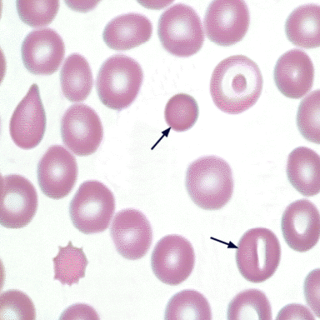

A

B

* 1. A. spherocyte B. stomatocyte
  2. A. macrocytic B. schistocyte
  3. A. spherocyte B. acanthocyte
  4. A. schistocyte B. stomatocyte

1. 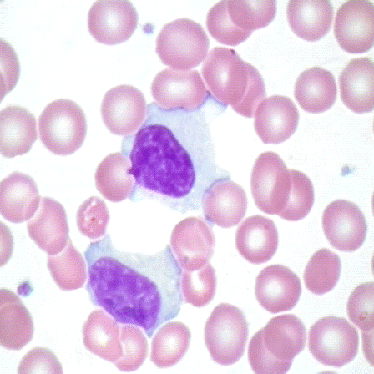**Identify the White Blood Cells in the picture.**
   1. Monocyte
   2. Plasma Cell
   3. Reactive Lymphocyte
   4. Megakaryocyte
2. 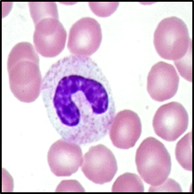**Identify the White Blood Cell in the picture.**
   1. Myelocyte
   2. Metamyelocyte
   3. Band
   4. Neutrophil
3. 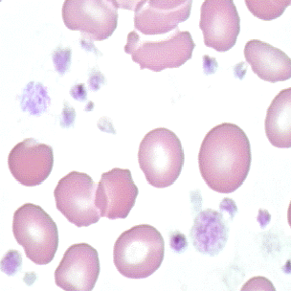**Identify the cell in the picture.**
   1. Platelet Satellitism
   2. Large Platelet
   3. Hypogranular Platelet
   4. Normal Platelet
4. **[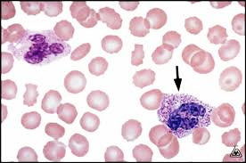](https://www.google.com/url?sa=i&url=http%3A%2F%2Fwww.cap.org%2Fapps%2Fdocs%2Fcommittees%2Fhematology%2Fhematology_discussion_2011_kpa.pdf&psig=AOvVaw1fYd4PORQmVsGzbq7gd9Db&ust=1596648057062000&source=images&cd=vfe&ved=0CAIQjRxqFwoTCODRvuOHgusCFQAAAAAdAAAAABAV)Identify the cell in the picture.**
   1. Eosinophil
   2. Basophil
   3. Neutrophil
   4. Neutrophil with toxic granulation

**Score**____________ **Pass** **Fail**

**Reviewed by**: ____________________ **Date**: ________