

|  |  |  |  |
| --- | --- | --- | --- |
| Title: | Wet Prep (Provider Performed) BUMC | | |
| Department/Service Line: | Laboratory | | |
| Approver(s): | CLIA Director | | |
| Location/Region/Division: | Baylor Scott & White Health | | |
| Document Number: | BUMC.LAB.POC.6005.R_V1 | | |
| Last Review/Revision Date: | See Signatures | Origination Date: | 08/2015 |

# sCOPE

This document applies to providers that perform wet prep testing within Baylor University Medical Center.

# DEFINITIONS

*When used in this document with initial capital letter(s), the following word(s)/phrase(s) have the meaning(s) set forth below unless a different meaning is required by context. Additional defined terms may be found in the BSWH P&P Definitions document.*

**Clue Cell** –Epithelial cell covered with bacteria giving a fuzzy appearance often found in the presence of *Gardnerella vaginalis*, a gram-negative rod.

**EHR** – Electronic Health Record

**NaCl** – Physiologic Saline (0.9%)

***Trichomonas* –** A mobile parasite characterized by a pear shaped body and flagella.

**WBC** – White Blood Cell

**Yeast –** Fungi that may be seen as single or budding form with or without pseudohyphae.

|  |
| --- |
|  |
| method/Utility |
| Microscopic observation of saline wet mount of clinical specimens may be useful for the rapid detection of the presence of yeast, bacterial vaginosis, and/or trichomoniasis. |

# PROCEDURE

**Personal Protective Equipment**

Appropriate personal protective equipment (gloves, gowns, masks, and eye protectors, etc.) is provided in work areas in which blood and body substances are handled and in circumstances during which exposure is likely to occur.

**Specimen**

* Collect a sampling of vaginal secretions on a cotton or Dacron-tipped sterile swab passed through and along the area of concern.
* Immediately after collection, place specimen in a small amount (0.5 mL) of saline in a test tube. Label tube with two unique patient identifiers. Complete microscopic examination within 1 hour of collection.
* Specimens should not be refrigerated prior to examination as this decreases the motility of *Trichomonas*.

**Reagents/Equipment**

* Microscope (10x and 40x Objectives)
* Microscope Slide, glass
* Coverslip, glass
* Test tube
* Sterile Swabs
* 0.9% NaCl

**Reagent Storage**

All reagents are stored at room temperature and used within manufacturer’s stated expiration date.

**Quality Control**

There is no available Quality Control material. Pictorial examples of *Trichomonas*, yeast, and clue cells are presented at the end of this written procedure.

**Testing Procedures**

**Wet Prep Slide Preparation**

1. Label microscopic slide with two patient identifiers.
2. Place small amount of patient specimen solution onto clean, glass slide and cover slip. Alternately, smear the collected swab on a slide, add a drop of saline, and cover slip.

**Microscopic Examination**

1. On low power (10x objective), low light examine for presence bacteria, fungal elements (yeast, budding yeast, pseudohyphae), motile *Trichomonas*, and human cellular elements.
2. Re-examine the slide on high power (40x objective) to evaluate the presence or absence of cells, weakly motile *Trichomonas*, yeast, and pseudohyphae.
3. Report *Trichomonas*, Yeast, Clue cells, and WBCs as Present or Absent

***Examination and Procedural Notes:***

* *Trichomonas* must exhibit motility to not be confused with a WBC. False negatives may be observed if performed after 1 hour of collection.
* Yeast is observed as single or budding forms with or without branching. Cotton strand may resemble yeast hyphae.
* To be considered a Clue Cell, bacteria must extend past the cell’s cytoplasmic borders.
* Absence of organisms does not rule out infections.
* Poor specimen collections can cause false negative specimens.

**Reporting Results**

All testing and results should be documented in the EHR.

**Pictorial Examples**

***Trichomonas***

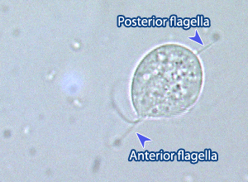

**Yeast**

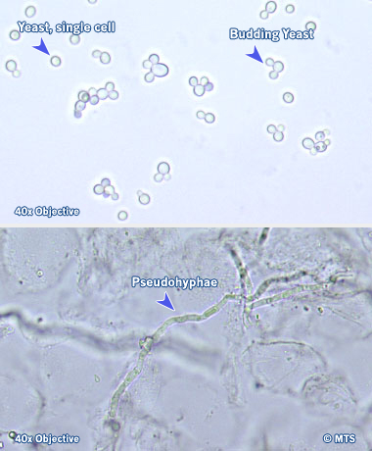

**Clue Cells**

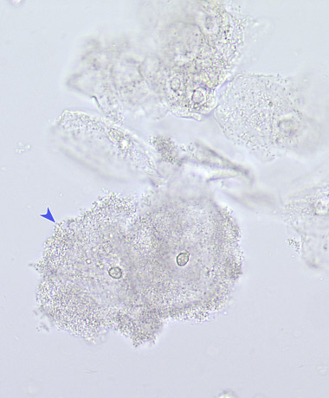

**White Blood Cell:** Under high power, neutrophilic WBCs appear as colorless, granular cells about 14 u in diameter (two to three times the size of an RBC)

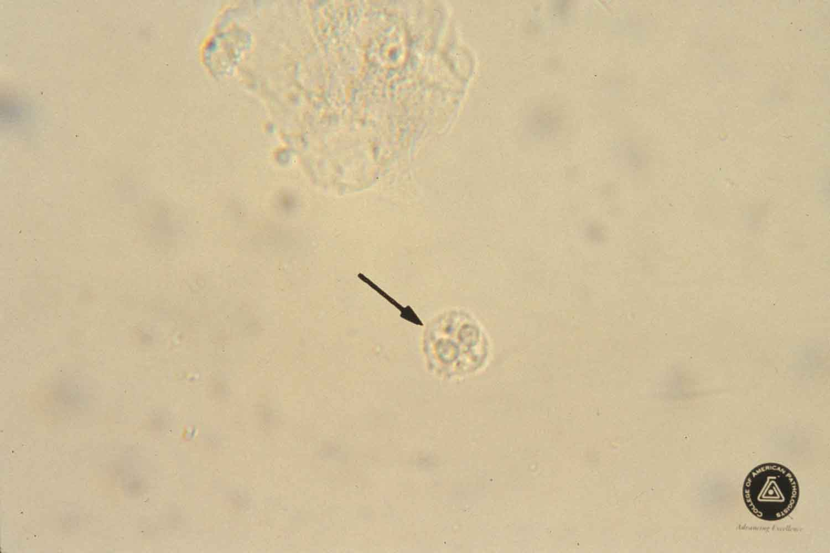

# ATTACHMENTS

None.

# RELATED DOCUMENTS

Provider Performed Testing Program BUMC (BUMC.LAB.POC. 6001.P)

Microscope Use in Provider Performed Testing (BSWH.LAB.PPT. 002.R)

Manual POC Test Result Entry in Epic (BSWH.LAB.POC.002.R)

Correcting a Manually Reported POC Test Result in Epic (BSWH.LAB.LIS.SOF.0101.R)

# REFERENCES

1. MTS, University of Washington, Department of Laboratory Medicine, Vaginal Wet Prep, online [www.medtraining.org](http://www.medtraining.org)
2. CLSI. *Physician and Nonphysician Provider-Performed Microscopy Testing; Approved Guideline – Second Edition.* CLSI document POCT10-A2. Wayne, PA: Clinical and Laboratory Standards Institute; 2011.

|  |
| --- |
| Revision History |
| |  |  |  |  |  | | --- | --- | --- | --- | --- | | **Version #** | **Effective Date** | **Description of Change** | **Revised By** | **Removed Date** | | 1 |  | New |  |  | |  |  |  |  |  | |  |  |  |  |  | |  |  |  |  |  | |  |  |  |  |  | |  |  |  |  |  | |