

|  |  |  |  |
| --- | --- | --- | --- |
| Title: | Manual POC Test Result Entry in Epic for the Inpatient Setting | | |
| Department/Service Line: | Laboratory | | |
| Approver(s): | CLIA Director | | |
| Location/Region/Division: | Baylor Scott & White Health | | |
| Document Number: | BSWH.LAB.POC.002.R_V2 | | |
| Last Review/Revision Date: | See Signatures | Origination Date: | 5/2019 |

# sCOPE

This document applies to personnel manually resulting POC test results into the HIS in the Inpatient setting within Baylor Scott & White Health.

# DEFINITIONS

*When used in this document with initial capital letter(s), the following word(s)/phrase(s) have the meaning(s) set forth below unless a different meaning is required by context. Additional defined terms may be found in the BSWH P&P Definitions document.*

**HIS** – Hospital Information System

**POC** – Point of Care

|  |
| --- |
|  |
| method/Utility |
| The purpose of this procedure is to describe the proper process for manually resulting POC tests within Epic in the inpatient setting. |

# PROCEDURE

|  |
| --- |
|  |

**Provider Performed Point of Care Test**

1. Order the appropriate POC test in Epic.
2. Enter correct collection date and time by updating the info in the red box below.

1. Document who performed the test by selecting Provider.

1. If applicable to the test, select “Valid” for Control. (Contact Laboratory if internal QC failed. Do not result test.)
2. Choose appropriate source and test result(s). Enter Lot Number and Expiration Date as applicable.

1. Select “Ordering Provider” to indicate Performed by.

1. Answer Yes, to Provider Performed Test.

1. Choose Accept to complete the test/order.

1. The order can now be signed by selecting Sign Orders.
2. Results will file in Epic under the Labs tab in Chart Review.

**Nurse/PCT Performed Point of Care Test**

1. Locate task from the Patient Worklist. Select Send Result to Lab.

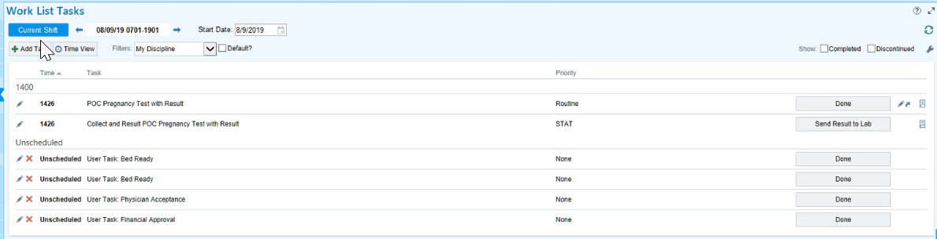

1. Enter collection date and time.

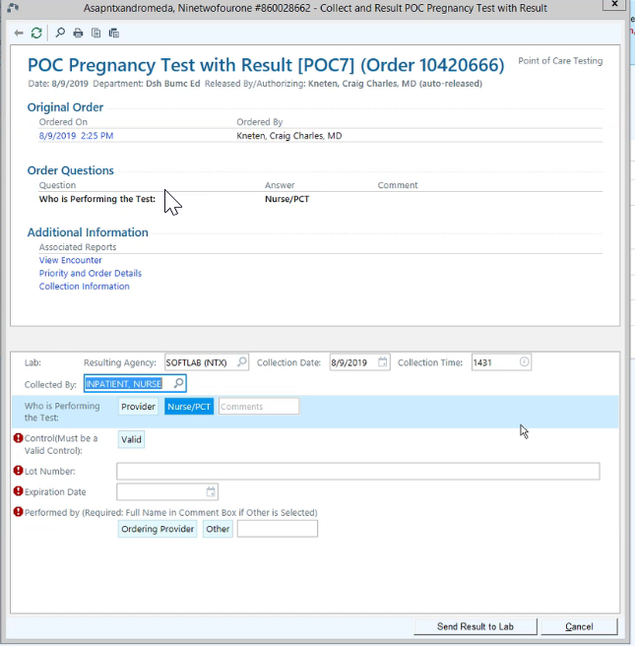

1. Collected By will default to current user. This can be edited if needed.
2. Who is Performing the Test will default to Nurse/PCT.
3. If applicable to the test, select “Valid” for Control. (Contact Laboratory if internal QC failed. Do not result test.)

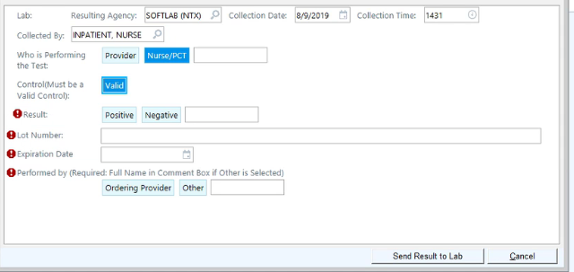

1. Choose appropriate test result(s). Enter Lot Number and Expiration Date as applicable.

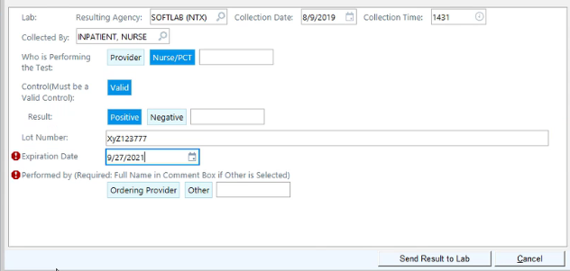

1. For Performed By, Choose Other. First and last name are required.

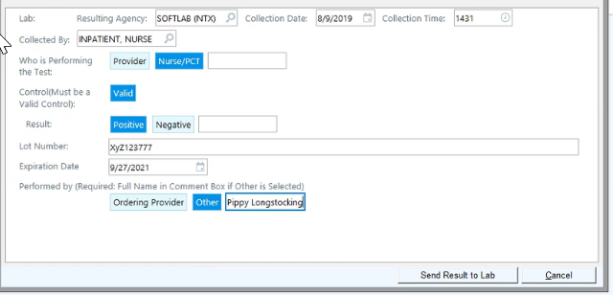

1. Select Send Result to Lab to complete resulting.



# ATTACHMENTS

None.

# RELATED DOCUMENTS

[Manual POC Test Result Entry in Epic for the Outpatient Setting (BSWH.LAB.POC.003.R)](https://bswlabs.policymedical.net/policymed/anonymous/docViewer?stoken=65ac53bf-b30b-4644-9f59-a8838ddeaf51&dtoken=d7cc80d6-d87d-45af-b303-d774d5d8ce89)

[Correcting a Manually Reported POC Test Resulted in Epic (BSWH.LAB.LIS.SOF.0101.R)](https://bswlabs.policymedical.net/policymed/anonymous/docViewer?stoken=65ac53bf-b30b-4644-9f59-a8838ddeaf51&dtoken=59828f9f-bfdc-45c5-80fe-ccc951c24483)

[POC Quality Management Policy (BSWH.LAB.POC.001.P)](https://bswlabs.policymedical.net/policymed/anonymous/docViewer?stoken=65ac53bf-b30b-4644-9f59-a8838ddeaf51&dtoken=565bf555-8f52-4614-9e08-7a7f55d4979c)

[Provider Performed Testing Program (BSWH.LAB.PPT.001.P)](https://bswlabs.policymedical.net/policymed/anonymous/docViewer?stoken=65ac53bf-b30b-4644-9f59-a8838ddeaf51&dtoken=ff88ec69-b756-439d-84ea-e732b827b772)

# REFERENCES

None.

|  |
| --- |
| Revision History |
| |  |  |  |  |  | | --- | --- | --- | --- | --- | | **Version #** | **Effective Date** | **Description of Change** | **Revised By** | **Removed Date** | | 2 | See Signatures | Updated for reporting of Source. | R. Steward | NA | |  |  |  |  |  | |  |  |  |  |  | |  |  |  |  |  | |  |  |  |  |  | |  |  |  |  |  | |
|  |