

|  |  |  |  |
| --- | --- | --- | --- |
| Title: | Wet Prep (Provider Performed) | | |
| Department/Service Line: | Laboratory | | |
| Approver(s): | CLIA Director | | |
| Location/Region/Division: | Baylor Scott & White Health | | |
| Document Number: | BSWH.LAB.PPT.005.R_V2 | | |
| Last Review/Revision Date: | See Signatures | Origination Date: | 08/2015 |

# sCOPE

This document applies to providers that perform wet prep testing within Baylor Scott & White Health.

# DEFINITIONS

*When used in this document with initial capital letter(s), the following word(s)/phrase(s) have the meaning(s) set forth below unless a different meaning is required by context. Additional defined terms may be found in the BSWH P&P Definitions document.*

**Clue Cell** –Epithelial cell covered with bacteria giving a fuzzy appearance often found in the presence of *Gardnerella vaginalis*, a gram-negative rod.

**EHR** – Electronic Health Record

**KOH** – Potassium Hydroxide (10%)

**NaCl** – Physiologic Saline (0.9%)

***Trichomonas* –** A mobile parasite characterized by a pear shaped body and flagella.

**WBC** – White Blood Cell

**Yeast –** Fungi that may be seen as single or budding form with or without pseudohyphae.

|  |
| --- |
|  |
| method/Utility |
| Diagnosis of genitourinary tract infections caused by yeast overgrowth, bacterial vaginosis, and/or trichomoniasis can sometimes be made by saline wet mount. |

# PROCEDURE

**Personal Protective Equipment**

Appropriate personal protective equipment (gloves, gowns, masks, and eye protectors, etc.) is provided in work areas in which blood and body substances are handled and in circumstances during which exposure is likely to occur.

**Specimen**

Collect a sampling of vaginal secretions on a cotton or Dacron-tipped sterile swab passed through and along the area of concern.

Immediately after collection, place specimen in a small amount (0.5 mL) of saline in a test tube. Label tube with two unique patient identifiers. Complete microscopic examination within 1 hour of collection.

Specimens should not be refrigerated prior to examination as this decreases the motility of *Trichomonas*.

**Reagents/Equipment**

* Microscope (10x and 40x Objectives)
* Microscope Slide, glass
* Coverslip, glass
* Test tube
* Disposable Pipettes
* Sterile Swabs
* 0.9% NaCl
* 10% KOH

**Reagent Storage**

All reagents are stored at room temperature and used within manufacturer’s stated expiration date.

**Quality Control**

There is no available Quality Control material. Pictorial examples of *Trichomonas*, yeast, and clue cells are presented at the end of this written procedure.

**Testing Procedures**

**Wet Prep Slide Preparation**

1. Label microscopic slide with two patient identifiers.
2. Place small amount of patient specimen solution onto clean, glass slide and cover slip. Alternately, smear the collected swab on a slide, add a drop of saline, and cover slip.

**Wet Prep with KOH Slide Preparation**

1. Label microscopic slide with two patient identifiers.
2. Place one drop of patient specimen suspension on clean glass slide.
3. Add one drop of 10% KOH to the specimen.
4. Sniff the preparation immediately, using your hand to waft the odor toward your nose. This is called the "whiff" test. A “fishy" or amine odor suggests bacterial vaginosis or trichomoniasis.
5. Place a coverslip over the specimen. Avoid trapping air bubbles under the cover slip.

**Microscopic Examination**

1. On low power (10x objective), low light examine for presence bacteria, fungal elements (yeast, budding yeast, pseudohyphae), motile *Trichomonas*, and human cellular elements.
2. Re-examine the slide on high power (40x objective) to evaluate the presence or absence of cells, weakly motile *Trichomonas*, yeast, and pseudohyphae.
3. Report *Trichomonas*, Yeast, Clue cells, and WBCs as Present or Absent

***Examination and Procedural Notes:***

* *Trichomonas* must exhibit motility to not be confused with a WBC. False negatives may be observed if performed after 1 hour of collection.
* Yeast is observed as single or budding forms with or without branching. Cotton strand may resemble yeast hyphae.
* To be considered a Clue Cell, bacteria must extend past the cell’s cytoplasmic borders.
* Absence of organisms does not rule out infections.
* Poor specimen collections can cause false negative specimens.

**Reporting Results**

All testing and results should be documented in the EHR.

**Pictorial Examples**

***Trichomonas***

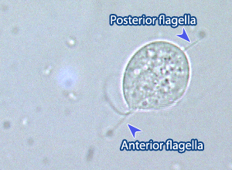

**Yeast**

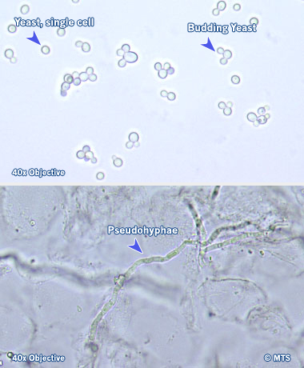

**Clue Cells**

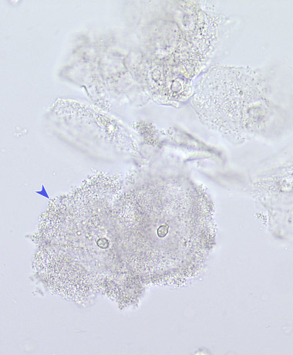

**White Blood Cell**

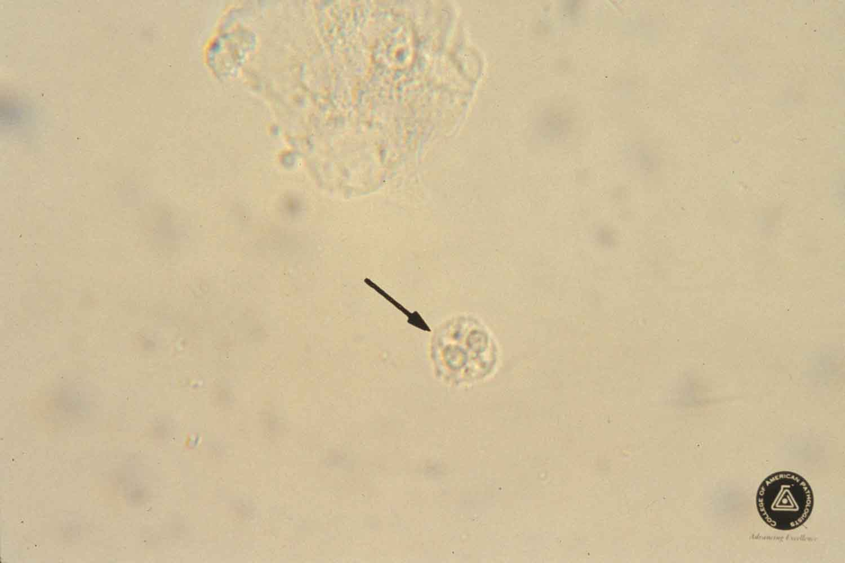

# ATTACHMENTS

Initial Training and Competency Form: Wet Prep (BSWH.LAB.PPT.005.A1)

# RELATED DOCUMENTS

[Provider Performed Testing Program (BSWH.LAB.PPT.001.P)](https://bswlabs.policymedical.net/policymed/anonymous/docViewer?stoken=65ac53bf-b30b-4644-9f59-a8838ddeaf51&dtoken=ff88ec69-b756-439d-84ea-e732b827b772)

[Microscope Use in Provider Performed Testing (BSWH.LAB.PPT.002.R)](https://bswlabs.policymedical.net/policymed/anonymous/docViewer?stoken=65ac53bf-b30b-4644-9f59-a8838ddeaf51&dtoken=e3e565e9-ea05-46be-8b4a-1b65ebe98dfb)

[Manual POC Test Result Entry in Epic for the Outpatient Setting (BSWH.LAB.POC.003.R)](https://bswlabs.policymedical.net/policymed/anonymous/docViewer?stoken=65ac53bf-b30b-4644-9f59-a8838ddeaf51&dtoken=d7cc80d6-d87d-45af-b303-d774d5d8ce89)

[Manual POC Test Result Entry in Epic for the Inpatient Setting (BSWH.LAB.POC.002.R)](https://bswlabs.policymedical.net/policymed/anonymous/docViewer?stoken=65ac53bf-b30b-4644-9f59-a8838ddeaf51&dtoken=8d9a5919-6ede-475d-9866-5b383bf38849)

# REFERENCES

1. MTS, University of Washington, Department of Laboratory Medicine, Vaginal Wet Prep, online [www.medtraining.org](http://www.medtraining.org)
2. CLSI. *Physician and Nonphysician Provider-Performed Microscopy Testing; Approved Guideline – Second Edition.* CLSI document POCT10-A2. Wayne, PA: Clinical and Laboratory Standards Institute; 2011.

|  |
| --- |
| Revision History |
| |  |  |  |  |  | | --- | --- | --- | --- | --- | | **Version #** | **Effective Date** | **Description of Change** | **Revised By** | **Removed Date** | | 2 | See Signatures | Merged Appropriate cells in A1 | R. Steward | NA | |  |  |  |  |  | |  |  |  |  |  | |  |  |  |  |  | |  |  |  |  |  | |  |  |  |  |  | |

|  |  |  |  |  |  |  |  |  |  |  |  |
| --- | --- | --- | --- | --- | --- | --- | --- | --- | --- | --- | --- |
| **Attachment Title:** | | | **Initial Training Form: Wet Prep** | | | | | | | | |
| **Attachment Number:** | | | BSWH.LAB.PPT.005.A1_V2 | | | | **Last Review/Revision Date:** | See Signatures | | | |
| Test: | | | Wet Prep | | | | |
| Provider Name: | | |  | | | | |
|  |  | |  |  |  | | |
| At the conclusion of this training, the provider will be able to do the following: | | | | | | | |
|  |  | |  |  |  | | | **Provider’s Initials** | **Trainer’s**  **Initials** | | |
| **SAFETY** | | | | | | | | | | | |
| Describe Personal Protective Gear. | | | | | | | |  |  | | |
| Know Location and Content of SDS for NaCl and KOH (if applicable). | | | | | | | |
| **MAINTENANCE** | | | | | | | | | | | |
| Describe daily maintenance of microscope. | | | | | | | |  |  | | |
| **SAMPLE COLLECTION AND REQUIREMENTS** | | | | | | | | | | | |
| Properly label specimens. | | | | | | | |  |  | | |
| Describe acceptable samples for testing. | | | | | | | |
| Know that microscopic examination must occur within 1 hour of collection. | | | | | | | |
| **REAGENTS** | | | | | | | | | | | |
| Store NaCl and KOH at room temp and use within manufacturer's stated exp date. | | | | | | | |  |  | | |
| **TESTING PROCEDURE** | | | | | | | | | | | |
| Use two patient identifiers, label slides as appropriate. | | | | | | | |  |  | | |
| Properly prepare patient slide (use KOH if applicable). | | | | | | | |
| Satisfactorily complete Wet Prep exam via online learning tool. | | | | | | | |
| **PROBLEM SOLVING** | | | | | | | | | | | |
| Describe why refrigeration or referral of the sample must not occur as *Trichomonas* loses motility within 1 hour. | | | | | | | |  |  | | |
| Understand that *Trichomonas* must exhibit motility as not to be confused with a WBC. | | | | | | | |
| **REPORTING** | | | | | | | | | | | |
| Understand that all testing and results should be documented in the patient's record. | | | | | | | |  |  | | |
| **MISCELLANEOUS** | | | | | | | | | | | |
| Understand the Proficiency Testing Process. | | | | | | | |  |  | | |
| Know the location of related policies and procedures. | | | | | | | |
| *I have had an opportunity to review and ask questions about policies and procedures related to testing above. I feel proficient about performing testing documented above.* | | | | |  | | | *Following successful completion of this training checklist, the employee is deemed competent to perform patient testing unsupervised.* | | | | |
|  | | |
|  |  | |  |  |  | | |  |  |  | | |
|  |  | |  |  |  | | |  |  |  | | |
| Provider Signature | | |  | Date |  | | | Trainer Signature | | Date | | |