

|  |  |  |  |
| --- | --- | --- | --- |
| Title: | Thromboelastograph (TEG) Quality Control | | |
| Department/Service Line: | Laboratory / Coagulation | | |
| Approver(s): | CLIA Director | | |
| Location/Region/Division: | NTX / BSWH | | |
| Document Number: | NTX.LAB.CG.0321.R_V2 | | |
| Last Review/Revision Date: | See Signatures | Origination Date: | 9/1/2012 |

# sCOPE

This procedure applies to technical staff performing patient testing on the Thromboelastograph Hemostasis Analyzer (TEG).

# DEFINITIONS

*When used in this document with initial capital letter(s), the following word(s)/phrase(s) have the meaning(s) set forth below unless a different meaning is required by context. Additional defined terms may be found in the BSWH P&P Definitions document.*

**TEG** – Thromboelastograph

**R** - Reaction Time

**K** - Kinetic Time

**MA** – Maximum Amplitude

**QC** – Quality Control

|  |
| --- |
|  |
| method/Utility |
| This procedure is to provide instructions for performing quality control testing on the Thromboelastograph Hemostasis Analyzer (TEG). Daily controls consist of a normal (Level I) and an abnormal (Level II) control which are both run on each channel of the TEG instrument. The normal and abnormal QC are performed every 8 hours of patient testing. |

# PROCEDURE

|  |
| --- |
|  |

**Prepare Level I and Level II Controls**

Reconstitute lyophilized controls.

1. Allow control vial(s) to reach room temperature. One control vial is enough for two channels.
2. Gently tap the vial to ensure the control is on the bottom of the vial.
3. Remove the seal and stopper of the control, avoiding sharp metal edges of outer cap. Into each vial slowly pour 1 vial of the diluent water provided in the control box. Ensure no spillage of water.
4. Re-insert stopper into the control vial.
5. Shake vigorously and let stand at room temperature for 5 minutes.
6. Shake the vial vigorously and let stand 5 more minutes at room temperature.
7. IMPORTANT: After the control material has been reconstituted, controls testing must be performed within 2 hours.

**Program the TEG Software**

1. Select “TEG” to enter the TEG Screen

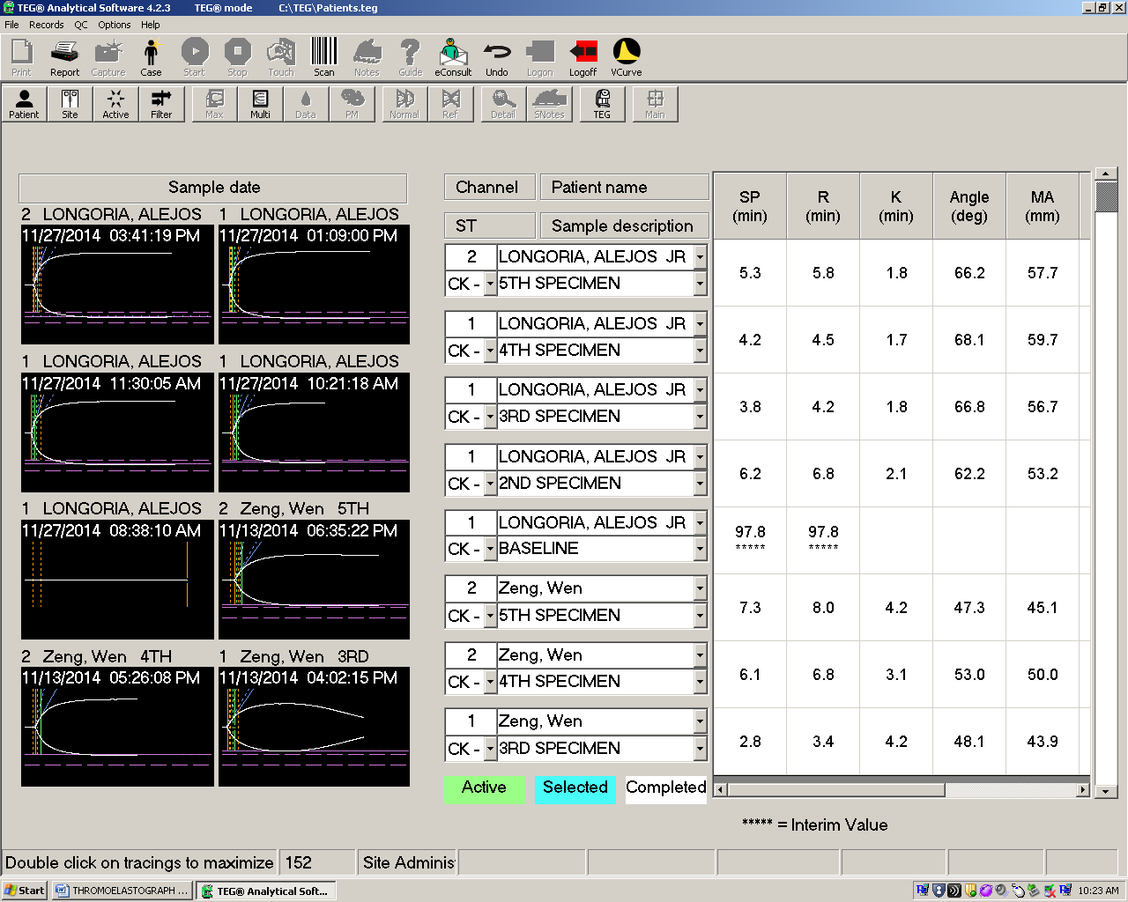

1. Select appropriate channel (s).
2. Below the “1” (highlighted in yellow) under the “Channel” and “ST (specimen type)” column, use the drop-down menu and select L1- Level I control.

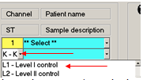

1. Under Patient Name/Sample description use the drop- down menu and select the current lot # of control in use.

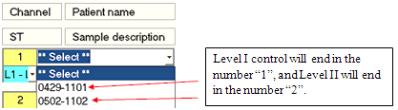

1. Repeat for all channels to be tested.
2. When complete, return cursor to first channel in use (Sample description area will be highlighted in blue).

**Perform Testing**

1. Load a plain cup and pin for each channel to be tested.
2. Pipette 20µl of 0.2M Calcium Chloride into each TEG cup.
3. Gently invert the Level I control 5 times.
4. Pipette 340 µl of reconstituted Level I control into each cup.
5. Raise the carrier until it is flush with the bottom of the TEG column.
6. Move the lever to the right into the “test” position.
7. Press F10 on the keyboard (START) to begin the sample.
8. **IMPORTANT:** Make sure correct channel is highlighted.
9. Repeat to start sample in next channel. The sample information display for that channel will change from yellow to green.
10. Repeat the above steps for Level II.

**Review Results**

1. Click Done to view results.

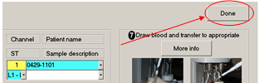

1. Allow the control samples to run approximately 15 to 20 minutes. The samples may be terminated after results are obtained for the following fields: SP, R, K, Angle, and MA. (Results are complete when the interim value *** has been removed under the numerical value of each test)

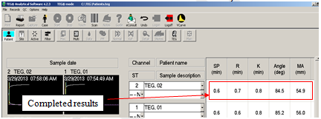

1. Terminate testing
2. Highlight the appropriate channel (indicated by the blue color)
3. Press STOP.

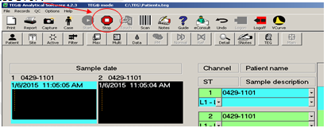

1. Review test results. The following values must be within range for each channel.
2. Level I control - R, K, Angle, and MA values
3. Level II control - R, Angle, and MA values (K is optional and not used at all Baylor Medical Centers)
4. Failure to obtain the expected values may be an indication of product deterioration or TEG analyzer or procedural problems. If expected values are not obtained:
5. Check temperature of channel
6. Ensure channel is clean and free of blood
7. Rerun using a fresh vial of control.
8. If results are still out of range, contact technical support and notify senior technologist, supervisor or laboratory manager.
9. Document any out of range quality control corrective action as determined by each individual Baylor Medical Center.
10. Do not use this channel for patient testing until the controls are within the specified ranges.
11. Tolerance Limits- Level I and Level II controls are assayed by the manufacturer and acceptable ranges are printed on the package insert. These rages are input into the software each time a new control is registered in the TEG database.
12. Document QC compliance as determined by each individual Baylor Medical Center.

# ATTACHMENTS

None

# RELATED DOCUMENTS

None

# REFERENCES

|  |
| --- |
|  |

1. TEG® 5000 System - User Manual, Haemonetics Corporation, Niles, IL, December 2010.
2. TEG Hemostasis System Level I Control, Package Insert, P/N 8001, 2011-04.
3. TEG Hemostasis System Level II Control, Package Insert, P/N 8002, 2011-04.

|  |
| --- |
| Revision History |
| |  |  |  |  |  | | --- | --- | --- | --- | --- | | **Version #** | **Effective Date** | **Description of Change** | **Revised By** | **Removed Date** | |  |  |  |  |  | |  |  |  |  |  | |  |  |  |  |  | |  |  |  |  |  | |  |  |  |  |  | |  |  |  |  |  | |
|  |