

|  |  |  |  |
| --- | --- | --- | --- |
| Title: | Thromboelastograph -- TEG | | |
| Department/Service Line: | Laboratory / Coagulation | | |
| Approver(s): | CLIA Director | | |
| Location/Region/Division: | NTX / BSWH | | |
| Document Number: | NTX.LAB.CG.0319.R_V3 | | |
| Last Review/Revision Date: | See Signatures | Origination Date: | 9/1/2012 |

# sCOPE

This procedure applies to technical staff performing patient testing on the Thromboelastograph Hemostasis Analyzer (TEG).

# DEFINITIONS

*When used in this document with initial capital letter(s), the following word(s)/phrase(s) have the meaning(s) set forth below unless a different meaning is required by context. Additional defined terms may be found in the BSWH P&P Definitions document.*

**R:** The time of latency from the time that the blood was placed in the TEG® Analyzer until the initial fibrin formation. R is prolonged by anticoagulants and is shortened by hypercoagulable states.

**K:** K is a measure of the speed to reach a clot strength of 20 mm.

**Angle:** Measures the rapidity (kinetics) of fibrin build-up and cross-linking, that is the speed of clot strengthening. The Angle is more comprehensive than K. Angle is decreased by anticoagulants that affect fibrinogen and platelet function.

An R value that is >2 minutes longer in the clear cup than in the blue cup is significant. When viewing the tracking, if the blue (heparinized) line splits first, the patient is probably on an anticoagulant. The clear cup contains just the patient’s blood, so it will take longer to split if the clotting factors are anticoagulated. The blue cup will neutralize any anticoagulant, so it should act more like a “normal” patient and will therefore split before the plain cup.

K and Angle both measure similar information and both are affected by the availability of fibrinogen, which determines the rate of clot buildup; in the presence of factor XIII, which enables cross-linking of fibrin to form a stable clot; and to a lesser extent, by platelets. Therefore, an elongated K and reduced Angle represent a low level of fibrinogen (factor XIII is rarely deficient) and can be corrected by administering cryoprecipitate or FFP. K is prolonged by anticoagulants that affect fibrinogen and platelet function.

**MA:** (Maximum Amplitude) - A direct function of the maximum dynamic properties of fibrin and platelet bonding and represents the ultimate strength of the fibrin clot. MA is affected by platelet number and function and, to a lesser extent, by fibrinogen level.

MA and (K, Angle) are correlated due to the interaction between fibrinogen level and platelets which together form the fibrin-platelet bonding to produce the final clot. Therefore, there is a compensated effect between fibrinogen level and platelets.

In case of cardiac surgery when MA is small, infusion with platelets alone may correct the coagulopathy in most cases because platelets are affected by most, if not all, cardiac surgical procedures. For platelet mapping the percent of MA reduction is calculated in the TEG software. The results are reported in percent MA reduction.

**LY30:** Measures the rate of amplitude reduction 30 minutes after MA and represents the ultimate stability of the clot. LY30 greater than 7.5% represents hyperfibrinolysis.

**G:** Measures the firmness of the clot (shear elastic modulus strength, SEMS) and is measured in dyn/cm2.

**Coagulation Index:** Linear combination of R, K, angle, and MA. Positive values (CI > +3.0) indicate the sample is hypercoagulable. Negative values (CI < -3.0) indicate that the sample is hypocoagulable.

|  |
| --- |
|  |
| method/Utility |
| The TEG is a non-invasive diagnostic instrument designed to monitor and analyze the coagulation state of a blood sample in order to assist in the assessment of patient clinical hemostasis conditions. The TEG analyzer provides a quantitative and qualitative indication of the coagulation state of a blood sample by monitoring, measuring, analyzing, and reporting coagulation parameter information. The TEG records the kinetic changes in a sample of whole blood or citrated blood as the sample clots, retracts, and/or lyses (breaks apart). |

# PROCEDURE

**Reagents and Materials**

|  |  |
| --- | --- |
| **Reagent** | **Storage** |
| Haemonetics Disposable Plain Cups and Pins | When not in use, store disposable cups and pins at room temperature in closed original container. Plain cups and pins do not expire. |
| Haemonetics Disposable Heparinase (Blue) Cups and Pins | When not in use, store heparinase disposable cups and pins in closed original container, inside the sealed zipper bag with the desiccant pack, at 2°C – 8°C. |
| Haemonetics Kaolin Vial | Prior to use, store kits at 2°C – 8°C.  Each vial is single use only and any remaining sample after reconstitution should be discarded. |
| Haemonetics Calcium Chloride (0.2M) | Vials may be stored refrigerated or at ambient room temperature (2°C – 25°C), before and after opening. The product should be brought to room  temperature before use. |

**Procedure**

1. **Enter the patient’s information into the TEG computer.**
2. Click on the CASE button on the task bar.



1. Click on the Add case button, then select DONE



1. Enter a Patient ID (i.e. medical record number, financial account number, etc.), and Patient Name. All other fields are optional. Click on DONE when complete.

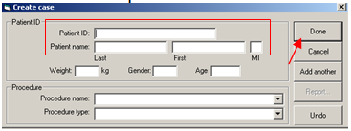

1. **Load the cups and pins**
2. Slide the carrier down to the platform, with the level in the Load position.
3. Place a plain cup, with the pin inside it, into the cup well.
4. Carefully slide the white carrier all the way up, being sure that the disposable pin is standing straight up in the cup so that the spindle tip can enter smoothly.
5. When the top of the white carrier is flush with the bottom of the column, push the pin firmly into place using the plastic pusher located at the bottom of the white carrier.
6. Counterbalance the analyzer by holding one hand on top of the instrument while pushing the pin with your other hand. Push the plastic pusher about 5 times.
7. While grasping the carrier with both hands, slide the white carrier halfway back down and push the cup firmly into the cup well, pushing firmly with both thumbs.
8. Move the carrier back down to the platform, being careful not to push it down too far and displace the cup.
9. Repeat the above steps to load the blue heparinase cup.

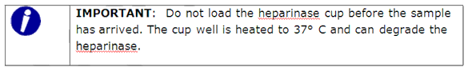

1. **Selecting Patients and Tests**
2. Select TEG from the taskbar

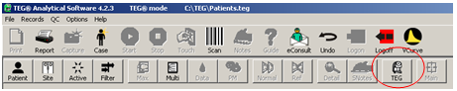

1. Once in the TEG selection screen, follow the steps below as indicated.

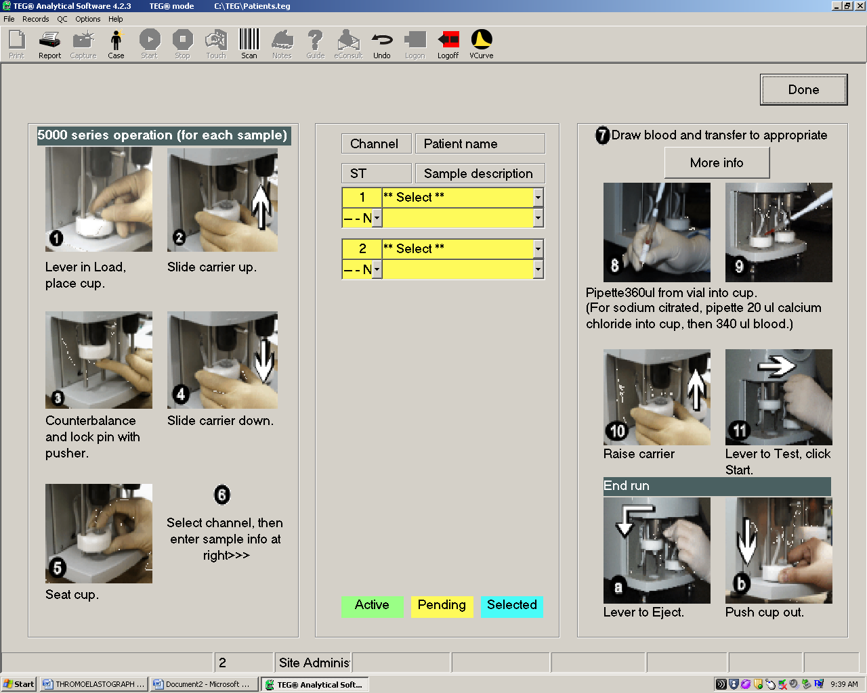 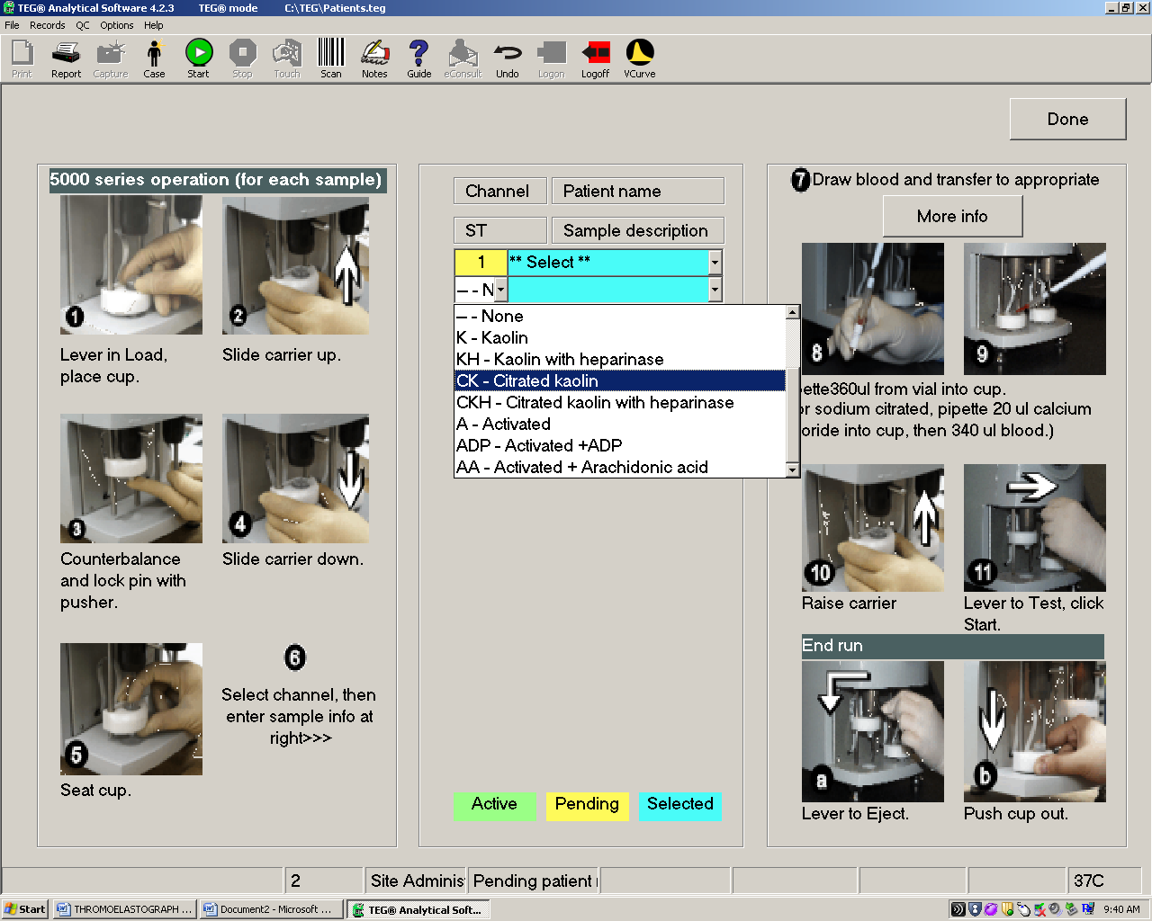

|  |  |
| --- | --- |
| Plain Cup | Select Sample Type   * Whole blood: “Kaolin” * Citrated blood: “Citrated Kaolin”   Click on the patient field and choose the name or enter the patient name and unique identifier.  Click on sample description and select baseline.  Click on appropriate channel and leave the cursor there (will be highlighted) |
| Heparinase Blue Cup | Select Sample Type   * Whole blood: “Kaolin with heparinase” * Citrated blood: “Citrated Kaolin with heparinase”   Click on the patient field and choose the name or enter the patient name and unique identifier.  Click on sample description and select baseline.  Click on appropriate channel and leave the cursor there (will be highlighted) |

1. **Prepare Samples**

***Citrated Specimen***

1. Requires one blue top (Sodium Citrate) tube. Tube must be hand delivered to the lab (dumb waiter systems are also acceptable) – not acceptable if received through the tube system.
2. Allow citrated specimens to sit 15 minutes after collecting before placing in Kaolin vial.
3. Dispense 1 ml of Citrated specimen into a Kaolin vial. Mix gently by inversion 4 to 5 times. Kaolin activated sample should be run within 4 to 6 minutes.
4. Set up cup(s)

|  |  |  |  |
| --- | --- | --- | --- |
| Sample Descriptions | Cup Type(s) | CaCl Volume | Sample Volume |
| Baseline | Plain (clear) Cup | 20 µL | 340 µL |
| Post OP | and/or |  |  |
| ICU | Heparinase (blue) Cup |  |  |

1. Pipette 20µl of CaCl into each cup.
2. Pipette 340µl from the Kaolin vial to the first cup.
3. Carefully lift the carrier on the appropriate channel and firmly push up against the channel.
4. Move the lever on the channel to the “test” position (right).
5. Press F10 to start.
6. Repeat for the second channel if the Heparinase cup is run.
7. After all samples are identified and started, click the DONE button in the upper right-hand corner.

***Whole Blood Specimen***

Specimen is collected in a syringe and must be received within 4 minutes of draw to begin processing.

|  |  |  |  |
| --- | --- | --- | --- |
| Sample Descriptions | Cup Type(s) | CaCl Volume | Sample Volume |
| On Pump | Heparinase (blue) Cup | N/A | 360 µL |
| Post Protamine | Plain (clear) Cup Heparinase (blu) Cup | N/A | 360 µL per cup |

On Pump Sample – Whole Blood

* 1. Load a blue heparinase cup in an available channel . The patient’s blood is fully heparinized at this point, and the sample in the plain cup would produce no coagulation.
  2. At the TEG screen enter the data for channel (see previous illustrations). Select Kaolin with Heparinase as the sample type, select the patient’s name from the data base, and select On Pump as the sample description. Leave the cursor on channel.
  3. When the sample arrives, add 1.0 ml to a Kaolin vial. Mix gently by inversion 4 to 5 times.
  4. Pipette 360 µl to the test cup, raise the carrier, move the lever to the “test” position, and press F10.
  5. Click DONE to enter the main screen.

Post Protamine Sample – Whole Blood

1. Protamine is administered to the patient to reverse the effects of heparin. Sample will be sent to lab for testing approximately 10 minutes post-protamine.
2. Load one plain cup and one blue cup.
3. At the TEG screen, program Channel 1 and Channel 2 as outlined above, except select Post Protamine as sample description.
4. When the sample arrives, add 1.0 ml from the syringe to a Kaolin vial, mix, and add 360 µl to cup. Raise the carrier on Channel 1, move the lever to “test”, and press F10 on the keyboard.
5. Repeat for Channel 2.
6. A preliminary report may be printed when results through the Maximum Amplitude (MA) are complete. Testing may be terminated when results are complete through the G value and are within normal range.
7. If G value is outside normal range allow testing to continue until lysis is complete.
8. **Viewing Results**
9. Double click on the appropriate channel to view testing.

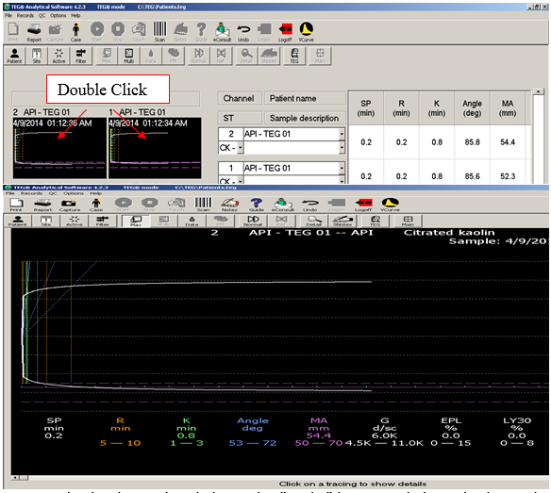

1. To view multiple channels, click on the “Multi” button, click each channel to be viewed, and click the DONE button.

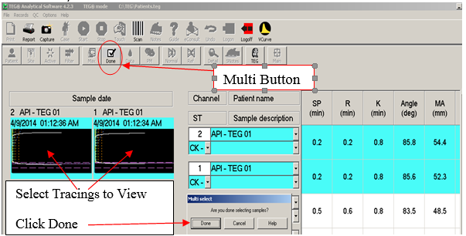

1. **Terminate Testing**
2. At the TEG Screen, highlight the sample to be terminated and click on the STOP button.

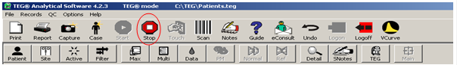

1. The program repeats the identifying information for the channel and asks for confirmation by clicking on the word YES. The data is automatically saved.
2. Slide the lever of the terminated sample to the left back to the load position and then press down on the lever to eject the pin. If the pin does not release, use some gauze and gently pull down to remove.
3. Slide the white carrier down to the platform. Be sure the pin has dropped into the cup.
4. Press the white carrier down firmly against the platform. This will release the cup form the carrier. When the disposable cup pops up, dispose of both the cup and pin using Standard Precautions.

**Platelet Mapping Procedure (Not performed at all Baylor Scott and White Facilities)**

1. Requires one blue top (Sodium Citrate) and one dark green top (Sodium or Lithium Heparin) tube. Tubes must be hand delivered to the lab – not acceptable if received through the tube system.

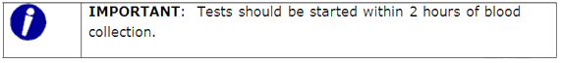

1. Blue Top Tube -- perform a regular baseline TEG with a clear cup. A heparinase cup is optional based upon conditional criteria of the facility. Follow standard TEG procedure for citrated samples.
2. Dark Green Top (used for all platelet mapping)
3. Prepare reagents as follows (allow vials to reach room temperature first).

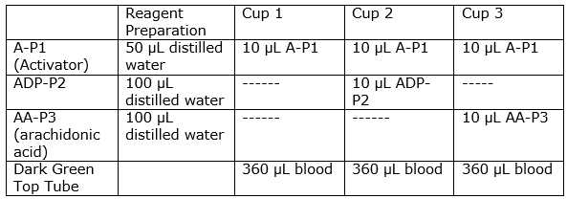

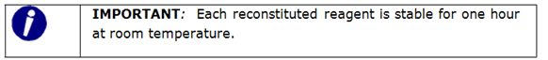

1. Load the three plain cups and pins into the TEG Instrument.
2. Pipette reagents into plain cups.
3. Pipette 360µL of blood (mixed 3 times without bubbles) into each cup and start test.

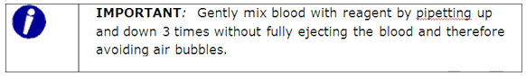

1. Allow samples to run until MA is done.
2. Print Platelet Mapping
3. NOTE: Select citrated or citrated heparinase specimen to calculate Platelet Inhibition. When R value is >2 minutes longer in the clear cup than the blue cup, use the CKH instead of the CK to calculate the Platelet Inhibition.
4. Click MULTI from the Main TEG Toolbar.
5. Select Citrated specimen, A-P1, and ADP (see previous illustrations for assistance with MULTI selections).
6. Click REPORT button from top toolbar, then print.

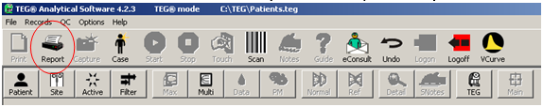

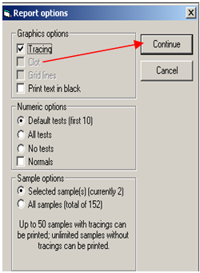 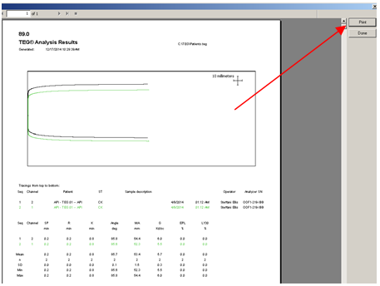

1. Click MULTI from the Main TEG Toolbar.
2. Select Citrated specimen, A-P1, and AA (see previous illustrations for assistance with MULTI selections).
3. Click REPORT button from top toolbar, then print

**Reporting Results**

1. Reports can be printed before testing is fully complete. While viewing the tracings, select REPORT icon at the top of the screen.
2. Click CONTINUE. Click PRINT to the right of the sample report, and click PRINT at the bottom of the print box. (See previous illustrations for assistance with MULTI selections and printing).
3. Enter results in LIS using Resulting Work list.
4. Reportable ranges for the TEG Hemostasis Analyzer are governed by the physical characteristics of the machine such as the oscillation angle of the cup and the length of the oscillation. The following table lists the reportable ranges for the TEG Hemostasis Analyzer.

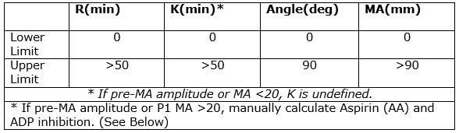

**TEG Calculations When P1 MA Exceeds 20mm**

1. When the MA of P1 is greater than 20 mm, the % inhibition will be falsely elevated, which will cause the physician to anticipate more bleeding than is likely to occur, or to delay surgery.
2. Calculate the platelet inhibition using a P1 value of 12mm (mean value).
3. Use the MA of the ADP, the CK, and the mean value of AA (12 mm) to calculate the % inhibition.
4. Calculations
5. ADP MA – P1 MA = X
6. CK MA – P1 MA = Y
7. 100- (X/Y x 100) = % inhibition for ADP
8. Repeat process using AA MA (in place of ADP MA) to calculate % inhibition for AA.

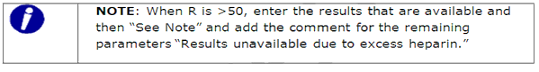

**Reference Ranges**

1. Numerical Results

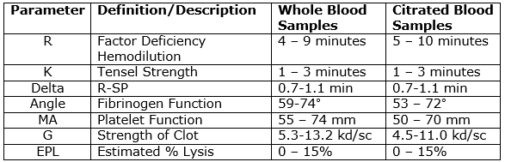

1. Qualitative Interpretation -- Pattern Recognition

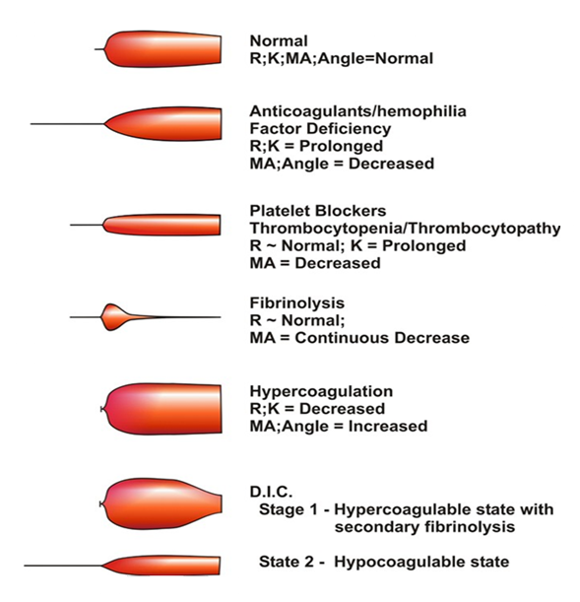

**Procedure Notes**

1. Disposable cups and pins have built in crush lines and fit snugly into the cup wells and onto the spindle tip. If not properly seated the testing will show an odd pattern and must be repeated.
2. The TEG Analyzer must be on a solid table where it cannot easily be moved. Do not bump the table while testing is being performed.
3. The temperature of the cup wells must be at 37° ± 1° C.
4. Room temperature should be between 15-30° C.
5. Two levels of controls should be run during each 8 hours of patient testing.
6. Whole blood specimens must be run within 4 minutes of collection. Citrated specimens must sit at least 15 minutes before placing in Kaolin. Specimens for platelet mapping are good for 2 hours. Specimens cannot be sent down the tube system.
7. If G result does not conform to normal range, allow to run to completion (lysis).

**Procedure Limitations**

1. Any test tracings that do not show the formation of a clot should be considered beyond clinical significance.
2. Test results should always be scrutinized in light of a specific patient’s condition or anticoagulant therapy. Any test result exhibiting inconsistency should be repeated or supplemented with additional test procedures.
3. Sources of error:
4. Not mixing samples in vials & cups
5. Not starting Kaolin activated samples within 4-6 minutes.
6. Traumatic sampling of blood will reflect the trauma of the phlebotomy and not coagulation of the patient.
7. A two-syringe technique is recommended to collect a blood sample. The first syringe is discarded because it is contaminated with tissue thromboplastin or, if it comes from an indwelling line, it is contaminated with heparin or stagnant blood. If the blood sample is difficult to draw because the needle or catheter is against the vessel wall, the endothelium may release plasminogen activators or prostacylins which can also produce artifacts on the TEG tracing.
8. Interfering substances (The TEG may be affected by hemo-dilution, cardioplegia solutions, hypothermia, platelet dysfunction, hypofibrinogenemia, other coagulopathies, and certain medications.

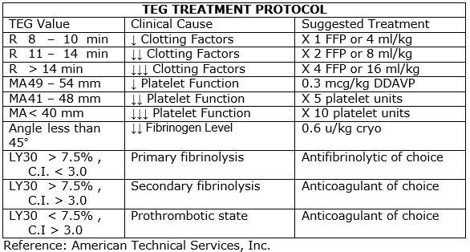

# ATTACHMENTS

|  |
| --- |
|  |

None.

# RELATED DOCUMENTS

None.

# REFERENCES

|  |
| --- |
|  |

1. Thrombelastograph Hemostasis Analyzer; 2002 Edition; Haemoscope Corporation, Niles IL.

|  |
| --- |
| Revision History |
| |  |  |  |  |  | | --- | --- | --- | --- | --- | | **Version #** | **Effective Date** | **Description of Change** | **Revised By** | **Removed Date** | | V2 | See Signatures | Amended process on how to enter the patient’s information in the TEG computer. Added “whole blood specimen” under Prepare Samples section. Updated sample type. Updated section “Prepare Specimen”. | Hematology Council | NA | | V3 | See Signatures | Corrected storage temperatures. | Raven Steward | NA | |  |  |  |  |  | |  |  |  |  |  | |  |  |  |  |  | |  |  |  |  |  | |
|  |