

|  |  |  |  |
| --- | --- | --- | --- |
| Title: | Body Fluid Analysis | | |
| Department/Service Line: | Laboratory | | |
| Approver(s): | CLIA Director | | |
| Location/Region/Division: | NTX | | |
| Document Number: | BRMCG.LAB.HEM.016.R_V5 | | |
| Last Review/Revision Date: | See Signatures | Origination Date: | 9/1/2012 |

# sCOPE

This procedure applies to technical staff working in the Hematology department.

# DEFINITIONS

*When used in this document with initial capital letter(s), the following word(s)/phrase(s) have the meaning(s) set forth below unless a different meaning is required by context. Additional defined terms may be found in the BSWH P&P Definitions document.*

**BAL**- A bronchoalveolar lavage is a "wash" of the upper respiratory tract mucosa to obtain cells for evaluating inflammation, infection or malignancy. Also called lavage or bronchial wash.

**BF**-Body fluid

**Bronchial lining cell-** A large cell, 15 to 25 um in diameter, which occurs as a contaminant in BAL, indicating

sampling from the bronchial tree. They are not commonly seen in BAL. These cells have a columnar shape, a round to oval nuclear shape, eccentrically placed, coarsely stippled chromatin, absent or inconspicuous nucleolus and pink cytoplasm with a row of cilia at one end.

**Diff**-Differential

**LIS**-Laboratory information system

**Macrophage**- Also called monocyte or histiocyte. A large phagocytic cell, 15 to 80 um in diameter, which is irregular in shape with shaggy margins and blob-like pseudopodia. The nucleus is round or oval with a distinct membrane and fine chromatin with a spongy, reticular pattern. One or more small nucleoli may be seen. The frayed, streaming cytoplasm is abundant, pale gray-blue, and often is granulated. Phagocytized material may often be seen in the cytoplasm.

**Mesothelial cell**- Lines the pleural, pericardial, and peritoneal surfaces. A large cell 12-20 um in diameter shed individually or in clusters. The nucleus is round to oval with a definitive nuclear membrane and regular contour. The N:C ratio is low and the nucleus is eccentrically placed. Cytoplasm is light to dark blue. In chronic effusion, mesothelial cells may proliferate with the cells becoming large with less condensed nuclear chromatin and nucleoli. Multiple nuclei may occur and overlap. However, they remain approximately of equal size and retain a definitive, smooth nuclear membrane.

**Nucleated cell**-Includes WBC’s, lining cells, malignant cells, etc.

**RBC**-Red blood cells

**TC**-Body fluid total nucleated cells

**WBC**-White blood cells

|  |
| --- |
|  |
| method/Utility |
| To perform analysis of body fluids or BAL.  Examination of various types of body fluid may yield valuable information for diagnosis and treatment of conditions in which the amount and cellularity of fluid increase due to pathologic changes in the body. Hematologic analysis includes a description of the fluid and performance of nucleated and RBC cell counts. If the fluid contains 8 or more nucleated cells, a differential is performed. Accumulation of body fluids may be seen in various conditions such as heart failure, infection, inflammation, hemorrhage or malignancy.  BAL is evaluated for inflammation, infection or malignancy. |

# PROCEDURE

**Specimen, Receipt and Distribution**

* Fluid is aspirated by a physician for analysis and documented on the Vital Specimen Log in Microbiology.
* Labels on sample and paperwork are checked for accuracy.
* Microbiology lab receives fluid, prints LIS labels and distributes fluid to appropriate departments.
* A minimum volume of 1 mL should be submitted for cell count and differential.
* Fluid for cell counts should be submitted in an EDTA tube; however, a count may be done from a heparinized sample or from a plain tube if no clotting occurs.

***Warning:*** All patient specimens should be treated as infectious body substances. Follow infection control plan. Recommended: gloves and lab coat.

**Storage**

* Body fluid is stored in at 2-8oC for 7 days in case additional tests are ordered.

**Equipment**

* XN 2000
* Disposable Neubauer hemocytometer
* Plain capillary tubes
* Sterile plastic disposable pipets
* Microscope with 10X and 40X objectives
* Tally counter
* Pipettes
* Cytocentrifuge
* Disposable cytospin chambers, holders, and filters
* Small test tubes
* Hyaluronidase
* Wright Stain
* New Methylene Blue (optional)

**Reagents**

* Cellpack DCL
* Storage: 2-35 °C
* Stability: Unopened: expiration date on package

Opened: 60 days

* Commercial Controls for Automated Counts: XN-CHECK
* Storage: 2 - 8° C
* Stability: Unopened: expiration date on bottle

Opened: 7 days

* 3% Acetic Acid Solution (ready-made)
* Storage: 20-35 °C
* Stability: Until expiration date on package

***Warning:*** Acetic acid is highly caustic and may cause burning and irritation to skin and eyes if contacted. If skin is contacted, wash for 15 minutes and seek immediate medical attention. Wear gloves, lab coat or apron and goggles (if needed) when handling concentrated acetic acid. Small spill may be diluted with water and cleaned up with paper towels. Spills greater than 100 ml should be cleaned up with the acid spill kit.

**Procedure – Body Fluid Cell Count**

If body fluid specimen collection time exceeds 2 hours at the time of receiving the specimen in the lab, footnote the following comment “Specimen was not received in the lab within 2 hours of collection. This delay may affect the body fluid count.”

**Automated Counts**

* Analyze on XN 2000 using the Body Fluid Mode if the fluid looks cellular macroscopically with the following exceptions:
* Samples containing clots, cellular debris, fungi or bacteria
* BAL samples that are very viscous
* Sample volumes < 300 µL
* Body Fluid Analysis can only be performed in the manual mode with the cap off.
  1. Press the grey mode button on the front of the instrument to eject the tube holder and enter manual mode.
  2. Select the Change Analysis Mode button on the control menu and select [Body Fluid] then click [OK]. Analyzer will automatically perform Autorinse and background check up to 3 times.
  3. If the background value is lower or equal to that shown below, the background check is completed. If the background value does not become lower or equal to the specified value, the message “Background Error” will be displayed on completion of the background check and an Autorinse should be performed.

|  |  |
| --- | --- |
| WBC – BF | 0.001 (x 103/µL) |
| RBC – BF | 0.003 (x 106/µL) |

Background Check

Acceptability

* 1. Select the Manual Analysis button on the control menu.
  2. Ensure that [Read ID] is checked, or manually scan barcode, and [Cap Open] is checked.
  3. Using a wooden stick, add hyaluronidase particles to all fluids except CSF.
  4. CSF Specimens: Refer to Cerebrospinal Fluid Specimen Procedure (BRMCG.LAB.HEM.021.R).
  5. Place thoroughly mixed vial with cap off in tube holder; press blue Start button.
  6. Perform an Autorinse and background check between each body fluid and before returning the instrument to [WB mode].
* Linearity limits for body fluids are:

|  |  |  |
| --- | --- | --- |
| WBC-BF | > 0.001 x103/µL | 16.986 x103/µL |
| RBC-BF | > 0.001 x106/µL | 5.329 x103/µL |

* For results exceeding linearity limits:
* Make an appropriate dilution with Cellpack DCL.
* Run dilution in BF mode as outlined above.
* Multiply result by appropriate diluting factor.
* A manual cell count must be performed for results below linearity limits.
* Enter automated nucleated cell count in the BNCT field and the automated RBC count in the BRCT field of the LIS BFCD template.

**Manual Counts**

* If automated cell count is below the reportable range, if the fluid contains cellular debris, or if there is a low volume of specimen, perform a manual nucleated cell count.
* Mix well and carefully load the body fluid onto both sides of hemocytometer. Allow the cells to settle in the chamber for at least one minute, but no longer than 15 minutes, before counting.
* Nucleated blood cells may be stained to aid in distinguishing red blood cells from nucleated cells by mixing equal parts body fluid and New Methylene Blue.
  + Incubate the mixture for 15 minutes at room temperature then load both chambers of the hemocytometer.
  + Count the nucleated cells in 5 large squats on each side and multiply the total by 2 to correct for dilution or use the calculation on the Manual Cell Count Worksheet.
* If a BAL is too viscous to run on the XN 2000, a dilution may be difficult to accurately prepare. Make a 1:10 dilution as best you can and perform a manual count. If the dilution is in doubt, add the comment "Counts may be inaccurate due to viscosity of specimen.”

***Low Counts:***

* Count the nucleated cells and/or RBC’s in five large squares on each side of hemocytometer.
* The RBC and WBC are tallied separately and the total of each cell type counted in the 10 squares is reported as the cell count/µL.
* Record cell counts from each side of hemocytometer on the Manual Cell Count Worksheet.
* If the cell count is <20/uL, the counts must match + 2 cells, or 50%.
* If the count is >20/uL, the counts must correlate within 20%.
* If counts do not match within above limits, repeat counts.
* Calculations are automatically performed by LIS with data entered in the BNUM, BNDIL, BNSQS and BNSQN fields of the LIS BFCD template.

***Increased Counts***

* Count cells in a smaller area on hemocytometer, such as:
* One large square on each side or
* Five of the small squares in large center square on each side.
* Make a dilution of the fluid in CellPack DCL diluent; mix well.
* Load onto both sides of hemocytometer.
* Choose the area to count depending on number of cells present.
* If the fluid is bloody and automated counts are not acceptable, mix equal parts fluid with 3% acetic acid to lyse the RBC’s.
  + After RBC’s are lysed (1-2minutes), load both sides of hemocytometer.
* Count the nucleated cells in five large squares on each side of hemocytometer.
* Record cell counts from each side of hemocytometer on the Manual Cell Count Worksheet.
* If the cell count is <20/uL, the counts must match + 2 cells, or 50%.
* If the count is >20/uL, the counts must correlate within 20%.
* If counts do not match within above limits, repeat counts.
* Calculations are automatically performed by LIS with data entered in the BNUM, BNDIL, BNSQS and BNSQN fields of the LIS BFCD template.

**Calculations**

* During an extended LIS downtime, calculations may need to be performed for manual counts.
  + All cell counts are reported in terms of 1 cu mm (1 uL) body fluid.
  + Any changes in dilution or area counted must be taken into consideration in determining cell counts.
* For other dilutions not specified in the procedure or on the Manual Cell Count Worksheet, use the following formula:

Total cells/µL = $\frac{total number of cells x dilution}{total number of squares counted x volume of each square (µL)}$

Example: $\frac{600 total cells x 20 dilution}{10 small squares x .004 µL per square}$ = 300,000 cells/µL

|  |  |
| --- | --- |
| **HEMOCYTOMETER GRID VOLUMES (for calculation)** | |
| **SQUARE** | **VOLUME (**µL**)** |
| Red | .1 |
| Yellow | .004 |

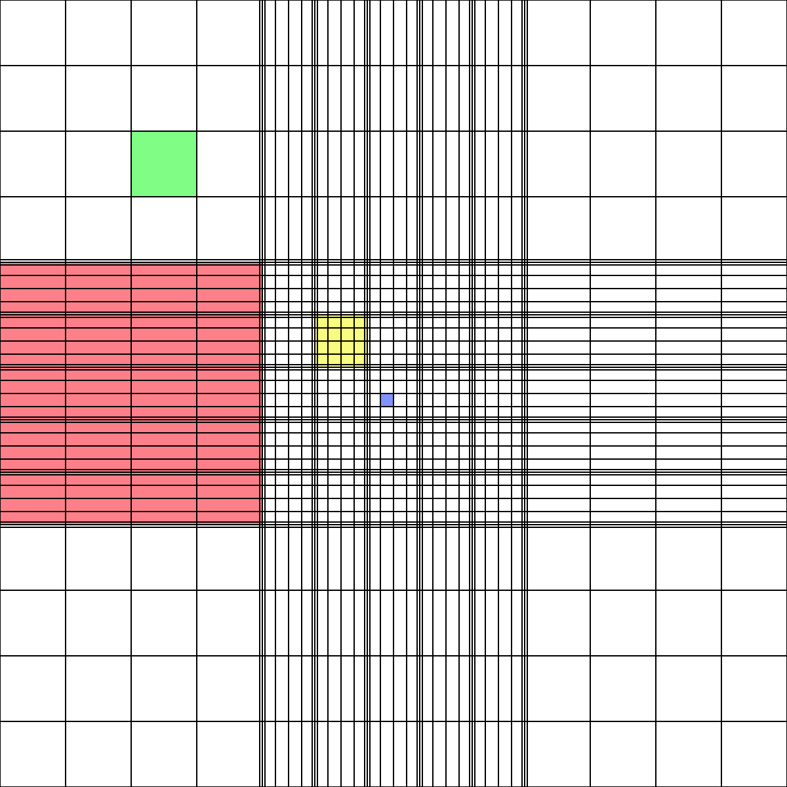

**LIS (SOFT) Resulting**

* Two BF orders in LIS
  + BFCT - BF Cell Count
  + BFCD - BF Cell Count and Diff
  + If BFCT is ordered but the nucleated cell count is >8 cells, cancel the BFCT and order a BFCD.
  + If BFCD is ordered and the nucleated cell count is <8 cells, perform differential. Do not cancel the differential unless the physician is contacted and does not require the differential due to low cell count.
* How to enter Body Fluid results in LIS:
  + Select Resulting Worklist from the LIS main menu.
  + Select BFCD template.
  + Select Pend + Nonver. Select OK (or press Enter).
  + From the worklist on the left side, select the BF order#. BF worksheet will appear on the right screen. Required fields are in bold.
    - SOR20 field: SOFT will automatically fill in with source
    - BQUAN field: enter total volume of fluid received
    - BCOLfield: enter color of fluid (choose from dropdown box)
    - BTURB field: enter turbidity (choose from dropdown box)
      * Clear – clear
      * Hazy – slight (barely visible turbidity)
      * Sl. Cloudy- print visible but not easily read through sample in tube
      * Cloudy – print not visible through sample in tube
      * Bloody – fluid cloudy with blood contamination
      * Turbid – marked cloudiness with particulate matter seen
    - BFCC: activate the diffpad by clicking on it and perform diff. Verify diff by selecting the diffpad Verify icon. Click VERIFY ALL after all required fields are resulted.

**Quality Control**

* Two levels of XN-CHECK QC are run every 24 hours and documented on the XN 2000 Maintenance sheet.
* For hemocytometer body fluid cell counts, at least one cell count control specimen is analyzed in duplicate for each eight hours of patient testing.
* Cell-Chex body fluid controls Level 1 and 2 are tested every 8 hours of patient testing.
  + Hold vials of the control horizontally between the palms of the hands and roll the vial back and forth for 30 seconds. Then hold vial on cap end and mix by rapid inversion, using 20 quick flicks of the wrist, to ensure the cells are completely resuspended. Invert the vials 8 to 10 times immediately before sampling.
  + Remove sample using a clean capillary tube or pipette tip.
  + Immediately close vial after sampling is complete. Wipe the threads of both the vial and the cap before replacing the cap and returning to refrigeration for maximum open-vial stability.
  + Perform count in the five large squares and on both sides of the hemocytometer.
  + If the cell count is <20/uL, the counts must match + 2 cells, or 50%.
  + If the count is >20/uL, the counts must correlate within 20%.
  + Record results on the QC log sheet. Results must agree with stated ranges on the QC log sheet of each level or must be repeated.
* Background checks on diluting fluids must be performed to check for contamination that could affect counts.
* Perform a hemocytometer count on diluent each 8 hours of use.
* Record results on the QC log sheet.
* Acceptable range is 0 – 2 nonspecimen particulates/µL.
* Change diluents or prepare new ones if counts exceed this limit and repeat.
* A procedural control is used for quality control of cell counts, in which cytospin cellular recovery is correlated to the automated or manual nucleated cell count according to the chart below.
  + This control is performed per specimen.
  + Follow the procedure Cytospin Procedure (BRMCG.LAB.HEM.023.R).
  + Record results on the Manual Cell Count Worksheet or on the printed XN 2000 results.

Cytospin Recovery

|  |  |
| --- | --- |
| Nucleated Cell Count | Cytospin Expected  Total Cell Recovery |
| 0 | 0 - 40 |
| 1 - 5 | 20 - 100 |
| 6 - 10 | 60 - 150 |
| 11 - 20 | 150 - 250 |
| >20 | >250 |

* Corrective action: If too few or too many nucleated cells are seen on the cytospin:
  + Repeat the hemocytometer count and/or
  + Prepare a new cytospin.
  + Document actions taken**.**

**Body Fluid Differential**

* Prepare a cytospin slide and stain with Wright stain.
* Scan the entire cytospin using 10X objective for proper cell distribution, cellularity, and clumps or sheets of cells.
* Perform 100-cell differential if possible, using 50X objective.
  + If WBC count is > 8 cells /µL, perform differential and count 100 cells.
  + If BFCD is ordered and the nucleated cell count is <8 cells, perform differential. Do not cancel the differential unless the physician is contacted and does not require the differential due to low cell count.
    - If less than 100 cells can be diffed, change the diff pad limit to the total number of nucleated cells counted.
* If unidentified cells are seen, enter comment with the number and description of cells in the Unidentified Cells field.
  + If unidentified cells are seen and cytology is not ordered, a pathologist will review the slide and decide if further testing needs to be done.
  + Malignant cells may be present in fluid from patients with metastatic disease, leukemia or lymphoma.
    - It may be difficult to differentiate reactive mesothelial cells from malignant cells.
    - Refer to reference materials for descriptions and photographs of normal and abnormal cell morphology in fluids.
  + Bronchoalveolar Lavage: Use the result field for mesothelial cells to record bronchial lining cells seen on the cytospin.
* Hematology supervisor will correlate results of the differential between Hematology and Pathology.

**Pathology Review**

All body fluids that do not have cytology ordered are sent for pathologist review.

* Print a copy of the patient’s body fluid results including cell count and differential.
* Fill out the appropriate information on the Pathology Review Form.
* Leave slides, patient results and Pathology Review Form in the slide holder in Hematology.
* Upon completion of review by a pathologist, the hematology lead tech or designee will file the results and add any comments noted by the pathologist. The performing technologist will review the slide if deemed necessary by the pathologist.

**Interpretation**

* The color of normal serous fluids is clear, straw or light yellow.
* Exudates are generally more turbid in appearance and have an increased nucleated cell count.
* Mesothelial cells form the lining of pleural, pericardial and peritoneal cavities, and a few are normally shed into these fluids.
  + Mesothelial cells may contain multiple nuclei and may be found in sheets or clusters. The nuclei of mesothelial cells are usually smaller and more uniform in size than malignant cells.
  + Malignant cells, which may also be found in sheets or clusters, usually have indistinct borders and a high N/C ratio.
  + Mesothelial cells may also undergo reactive changes and could be mistaken for malignant cells.
* Lymphocytosis may be seen in some viral diseases, and neutrophilia may be seen in bacterial infections.
* Monocytes, also called histiocytes or macrophages, are commonly found in all types of body fluids. Atypical or reactive changes may be seen.
* The major cells recovered in BAL include monocytes, lymphocytes, segmented neutrophils and

eosinophils. Bronchial lining cells may be seen less commonly.

* Refer smear to pathologist when in doubt.

**Limitations**

* Differentiating red blood cells from nucleated blood cells may be difficult, especially if the RBC’s are crenated.
* Bloody fluids are difficult to count accurately because they may be partially or completely clotted.
  + If the fluid is partially clotted, perform count on the remaining fluid.
    - In BNCT and BRCT fields, enter count.
    - In LIS, under the RBC and WBC counts, footnote with the canned comment “@DEBR”: “Results may be inaccurate due to cellular clumping and/or debris in the specimen. Consideration should be given to this fact when interpreting results.”
  + If the body fluid is completely clotted, vortex the fluid to get enough fluid to make a cytospin.
    - Perform differential on the cytospin.
    - In the BNCT and BRCT fields, type in “See Note” and enter comment “Count could not be performed due to clotted specimen.”

# ATTACHMENTS

None

# RELATED DOCUMENTS

Cerebrospinal Fluid (BRMCG.LAB.HEM.021.R)

Cytospin Procedure (BRMCG.LAB.HEM.023.R)

# REFERENCES

1. Kjeldsberg, C.R., and Knight, J.A., BODY FLUIDS-Laboratory Examination of Cerebrospinal, Seminal, Serour & Synovial Fluids: A Textbook Atlas, ASCP Press, 3rd Ed, 1993. Chicago, Illinois
2. Strasinger, S.K., Urinalysis and Body Fluids, Chapter 8, F.A. Davis, 1985
3. Hematology and Coagulation Checklist, College of American Pathologist, Waukegan, IL, Current version

|  |
| --- |
| Revision History |
| |  |  |  |  |  | | --- | --- | --- | --- | --- | | **Version #** | **Effective Date** | **Description of Change** | **Revised By** | **Removed Date** | | 1 | 9/1/2012 | New Procedure and Format | Amanda Schafer |  | | 2 | 9/1/2015 | Adjust the procedure to reflect New Sysmex instrument | Nevine Michael |  | | 3 | 6/1/2017 | Clarified instruction, combined BF procedures, added QC acceptability limits | Charlotte Ratliff |  | | 4 | 1/28/19 | Corrected headers; add correlation between Heme and Path diff | Eric Holloway |  | | 5 | 8/2023 | Added instructions for Cell Chex control. | Shahzad Ali |  | |