

|  |  |  |  |
| --- | --- | --- | --- |
| Title: | Cerebrospinal Fluid Specimen (CSF) | | |
| Department/Service Line: | Laboratory | | |
| Approver(s): | CLIA Director | | |
| Location/Region/Division: | NTX | | |
| Document Number: | BRMCG.LAB.HEM.021.R_V5 | | |
| Last Review/Revision Date: | See Signatures | Origination Date: | 10/1/2012 |

# sCOPE

This procedure applies to technical staff working in the Hematology department.

# DEFINITIONS

*When used in this document with initial capital letter(s), the following word(s)/phrase(s) have the meaning(s) set forth below unless a different meaning is required by context. Additional defined terms may be found in the BSWH P&P Definitions document.*

**CSF** – Cerebrospinal fluid

**Diff** – differential

**LIS** – Laboratory information system

**RBC**- Red blood cells, appear small, round, and have distinct outlines with yellowish halos and clear centers. If crenated, the cells may have many fine-pointed projections. A reddish hue may be noted.

**TC** – Total cells

**WBC** – White blood cells, appear granular or have defined solid nuclei

|  |
| --- |
|  |
| method/Utility |
| To perform analysis of CSF.  The examination of CSF can yield important diagnostic information in cases of inflammation, infection, malignancy, or injury to the brain or spinal cord. Analysis includes a physical description of the fluid, quantity submitted, WBC and RBC counts. A Wright-stained cytospin is examined on each CSF and a manual differential is performed if ordered, if indicated by increased WBC count (> 5 WBC/µL), or if abnormal cells are seen. Timely examination is important for cell counts because the WBC count will begin to decrease within an hour of collection. |

# PROCEDURE

**Specimen, Receipt and Distribution**

* CSF is collected by a physician for analysis and documented on the Vital Specimen Log in Microbiology.
  + CSF specimens should always be walked to the lab and not sent through the tube station.
  + Labels on sample and paperwork are checked for accuracy.
* Microbiology lab receives fluid, prints LIS labels and distributes fluid to appropriate departments.
  + A minimum volume of 0.5 mL CSF, containing no anticoagulant, should be submitted for cell count and differential.
  + If orders are not in the LIS notify the patient’s nurse and request testing be ordered. If orders are not placed within 15 minutes, begin performing cell count to obtain optimal results. If orders are not placed within 30 minutes of notifying the patients’ nurse, contact the charge nurse for the unit.
  + Document fluid type, total volume, and whether cytology was requested in the LIS.
  + If there is not enough specimen for all testing ordered, contact the physician to determine the priority of testing.
  + Use sterile pipettes to aliquot specimens; do not mix specimens from different tubes together.
  + Unless requested otherwise by the physician the appropriate tube distribution is:
    - Tube 1: Chemistry and Immunology (CSF Protein, glucose, bacterial antigens, etc.)
    - Tube 2: Hematology (cell counts and cytospin ) DO NOT SPIN
    - Tube 3: Microbiology (cultures)
    - Tube 4: any additional testing as requested by physician DO NOT SPIN
    - If a low volume of CSF is received, use aseptic technique to aliquot CSF into labeled tube for cell count and differential to maintain sterility for additional tests ordered.

***Warning:*** All patient specimens should be treated as infectious body substances. Follow infection control plan. Recommended: gloves and lab coat

***Warning:*** Follow CJD protocol for all CSF from known or suspected Creutzfeldt-Jakob disease patients.

**Storage**

* Specimens should be delivered to the laboratory promptly, optimally within 30 minutes of collection.
* CSF is stored at 2-8 oC for at least 7 days in case additional tests are ordered.

**Equipment**

* XN 2000
* Disposable Neubauer hemocytometer
* Plain capillary tubes
* Sterile plastic disposable pipettes
* Microscope with 10X and 40X objectives
* Tally counter
* MLA Pipettes
* Cytocentrifuge
* Disposable cytospin chambers, holders, and filters
* Small test tubes
* Wright Stain
* New Methylene Blue (optional)

**Reagents**

* Cellpack DCL
  + Storage: 2-35oC
  + Stability: Unopened: expiration date on package

Opened: 60 days

* Commercial Controls for Automated Counts: XN-CHECK
* Storage: 2 - 8° C
* Stability: Unopened: expiration date on bottle

Opened: 7 days

* 3% Acetic Acid Solution (ready-made)
  + Storage: 20-35oC
  + Stability: Until expiration date on package

***Warning:*** Acetic acid is highly caustic and may cause burning and irritation to skin and eyes if contacted. If skin is contacted, wash for 15 minutes and seek immediate medical attention. Wear gloves, lab coat or apron and goggles (if needed) when handling concentrated acetic acid. Small spill may be diluted with water and cleaned up with paper towels. Spills greater than 100 ml should be cleaned up with the acid spill kit.

**Procedure – CSF Cell Count**

**Automated Counts**

* Analyze on XN 2000 using the Body Fluid Mode if the fluid looks cellular macroscopically with the following exceptions:
* Samples containing clots, cellular debris, fungi or bacteria
* Sample volumes < 300 µL
* Body Fluid Analysis can only be performed in the manual mode with the cap off.
  1. Press the grey mode button on the front of the instrument to eject the tube holder and enter manual mode.
  2. Select the Change Analysis Mode button on the control menu and select [Body Fluid] then click [OK]. Analyzer will automatically perform Autorinse and background check up to 3 times.
  3. If the background value is lower or equal to that shown below, the background check is completed. If the background value does not become lower or equal to the specified value, the message “Background Error” will be displayed on completion of the background check and an Autorinse should be performed.

|  |  |
| --- | --- |
| WBC – BF | 0.001 (x 103/µL) |
| RBC – BF | 0.003 (x 106/µL) |

Background Check

Acceptability

* 1. Select the Manual Analysis button on the control menu.
  2. Ensure that [Read ID] is checked, or manually scan barcode, and [Cap Open] is checked.
  3. Pipette sample into a plastic tube using a sterile pipette and label appropriately.
  4. Place thoroughly mixed vial with cap off in tube holder; press blue Start button.
  5. Perform an Autorinse and background check between each body fluid and before returning the instrument to [WB mode].
* Reportable limits for body fluids are: Low

|  |  |  |
| --- | --- | --- |
| WBC-BF | 0.001 x103/µL | 16.986 x103/µL |
| RBC-BF | 0.001 x106/µL | 5.239 x103/µL |

* For results exceeding linearity limits:
  + 1. Make an appropriate dilution with Cellpack DCL.
    2. Run dilution in BF mode as outlined above.
    3. Multiply result by appropriate diluting factor.
* A manual cell count must be performed for results below linearity limits.
* Enter automated nucleated cell count in the CWCT field and the automated RBC count in the CRCT field of the LIS CSFCD template.

**Manual Counts**

* If automated cell count is below the reportable range, if the fluid contains cellular debris, or if there is a low volume of specimen, perform a manual cell count.
* Mix well and carefully load the body fluid onto both sides of hemocytometer. Allow the cells to settle in the chamber for at least one minute, but no longer than 15 minutes, before counting.
* Do not count broken or degenerated cells.
* Nucleated blood cells may be stained to aid in distinguishing red blood cells from nucleated cells by mixing equal parts body fluid and New Methylene Blue.
  + Incubate the mixture for 15 minutes at room temperature then load both chambers of the hemocytometer.
  + Count the nucleated cells in 5 large squares on each side and multiply the total by 2 to correct for dilution.

**Low Counts:**

* Count the nucleated cells and/or RBC’s in five large squares on each side of hemocytometer.
* The RBC and WBC are tallied separately and the total of each cell type counted in the 10 squares is reported as the cell count/µL.
* Record cell counts from each side of hemocytometer on the Manual Cell Count Worksheet.
* If the cell count is <20/uL, the counts must match + 2 cells, or 50%.
* If the count is >20/uL, the counts must correlate within 20%.
* If counts do not match within above limits, repeat counts.
* Calculations are automatically performed by LIS with data entered in the CWNUM, CWDIL, CWSQS and CWSQN fields of the LIS CSFCD template.

**Increased Counts**

* Count cells in a smaller area on hemocytometer, such as:
* One large square on each side or
* Five of the small squares in large center square on each side.
* Make a dilution of the fluid in CellPack DCL diluent; mix well.
* Load onto both sides of hemocytometer.
* Choose the area to count depending on number of cells present.
* If the fluid is bloody and automated counts are not acceptable, mix equal parts fluid with 3% acetic acid to lyse the RBC’s.
* After RBC’s are lysed (1-2minutes), load both sides of hemocytometer.
* Count the nucleated cells in five large squares on each side of hemocytometer.
* Record cell counts from each side of hemocytometer on the Manual Cell Count Worksheet.
* If the cell count is <20/uL, the counts must match + 2 cells, or 50%.
* If the count is >20/uL, the counts must correlate within 20%.
* If counts do not match within above limits, repeat counts.
* Calculations are automatically performed by LIS with data entered in the CWNUM, CWDIL, CWSQS and CWSQN fields of the LIS CSFCD template.

**Calculations**

* During an extended LIS downtime, calculations may need to be performed for manual counts.
  + All cell counts are reported in terms of 1 cu mm (1 uL) body fluid.
  + Any changes in dilution or area counted must be taken into consideration in determining cell counts.
* For other dilutions not specified in the procedure or on the Manual Cell Count Worksheet, use the following formula:

Total cells/µL = $\frac{total number of cells x dilution}{total number of squares counted x volume of each square (µL)}$

Example: $\frac{600 total cells x 20 dilution}{10 small squares x .004 µL per square}$ = 300,000 cells/µL

|  |  |
| --- | --- |
| **HEMOCYTOMETER GRID VOLUMES (for calculation)** | |
| **SQUARE** | **VOLUME (**µL**)** |
| Red | .1 |
| Yellow | .004 |

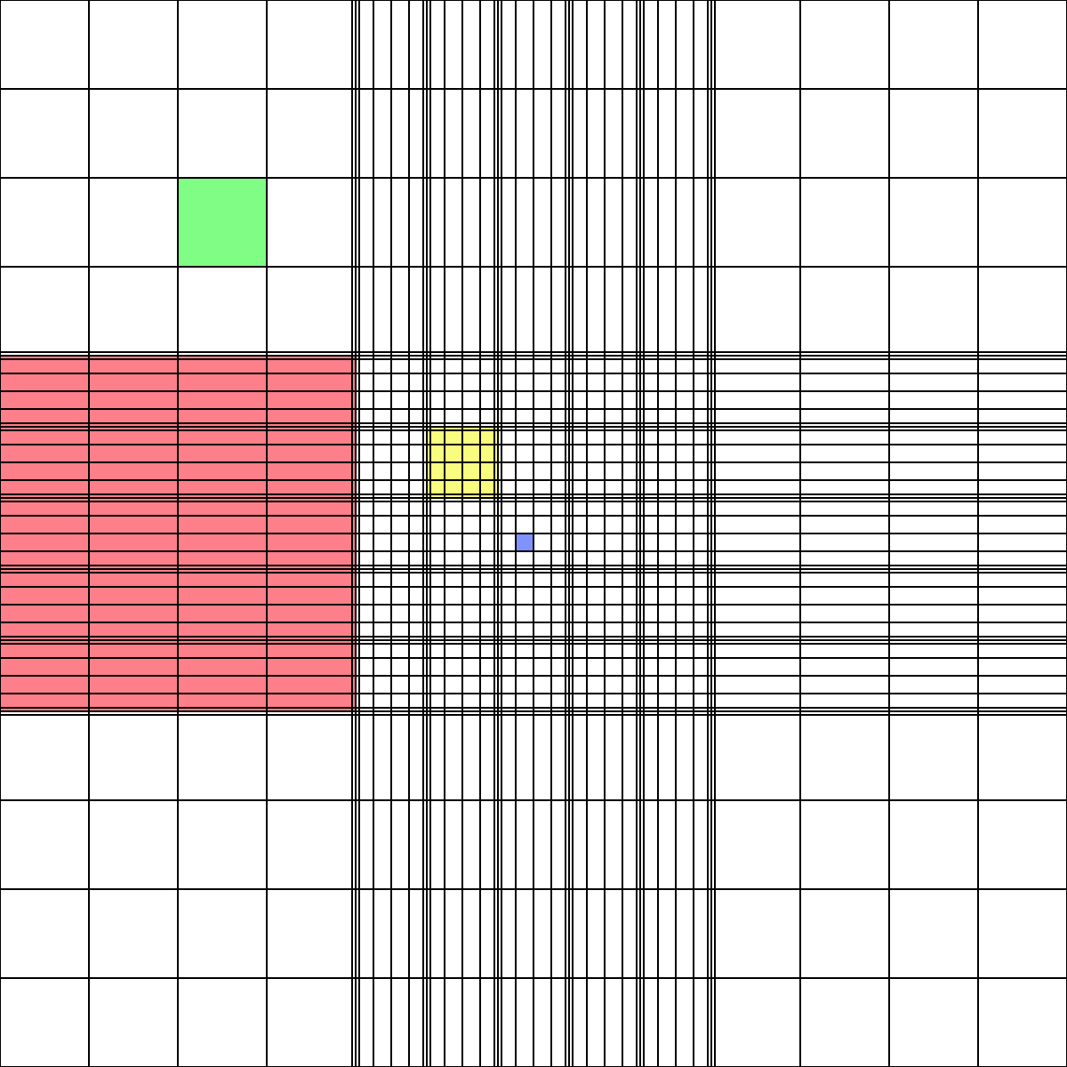

**LIS (SOFT) Resulting**

* Two CSF orders in LIS
  + CSFC - CSF Cell Count
  + CSFCD - CSF Cell Count and Diff
  + If < 5 nucleated cells are counted and CSFCD is ordered, cancel CSFCD and order CSFC in the LIS.
  + If > 5 nucleated cells are counted and CSFC is ordered, cancel CSFC and order CSFCD in the LIS.
* How to enter CSF results in LIS:
  + Select Resulting Worklist from the LIS main menu.
  + Select CSFCD template.
  + Select Pend + Nonver. Select OK (or press Enter).
  + From the worklist on the left side, select the CSF order number. CSF worksheet will appear on the right screen. Required fields are in bold.
    - CTUBE field: enter tube number on which count was performed, or sterile cup
    - CQUAN field: enter total volume of CSF received
    - CCOLfield: enter color of supernatant (choose from dropdown box)
      * CSF is normally colorless. If the fluid is turbid or bloody, centrifuge an aliquot, or look at the tube spun for chemistry, and assess the color of the supernatant for any degree of xanthochromia from 1+ to 3+ (pale yellow or orange color).
    - CTURB field: enter turbidity (choose from dropdown box)
      * The presence of a pellicle, coagulum, or sediment should always be reported.
      * Clear – clear
      * Hazy – slight (barely visible turbidity)
      * Sl. Cloudy- print visible but not easily read through sample in tube
      * Cloudy – print not visible through sample in tube
      * Bloody – fluid cloudy with blood contamination
      * Turbid – marked cloudiness with particulate matter seen
    - CSFCC: activate the diffpad by clicking on it and perform diff. Verify diff by selecting the diffpad Verify icon. Click VERIFY ALL after all required fields are resulted.

**Quality Control**

* Two levels of XN-CHECK QC are run every 24 hours and documented on the XN 2000 Maintenance sheet.
* For hemocytometer body fluid cell counts, at least one cell count control specimen is analyzed in duplicate for each eight hours of patient testing.
* Cell-Chex body fluid controls Level 1 and 2 are tested every 8 hours of patient testing.
  + Hold vials of the control horizontally between the palms of the hands and roll the vial back and forth for 30 seconds. Then hold vial on cap end and mix by rapid inversion, using 20 quick flicks of the wrist, to ensure the cells are completely resuspended. Invert the vials 8 to 10 times immediately before sampling.
  + Remove sample using a clean capillary tube or pipette tip.
  + Immediately close vial after sampling is complete. Wipe the threads of both the vial and cap before replacing cap and returning to refrigeration for maximum open-vial stability.
  + Perform count in the five large squares and on both sides of the hemocytometer.
  + If the cell count is <20/uL, the counts must match + 2 cells, or 50%.
  + If the count is >20/uL, the counts must correlate within 20%.
  + Record results on the QC log sheet. Results must agree with stated ranges on the QC log sheet of each level or must be repeated.
* Background checks on diluting fluids must be performed to check for contamination that could affect counts.
* Perform a hemocytometer count on diluent each 8 hours of use.
* Record results on the QC log sheet.
* Acceptable range is 0 – 2 nonspecimen particulates/µL.
* Change diluents or prepare new ones if counts exceed this limit and repeat.
* A procedural control is used for quality control of cell counts, in which cytospin cellular recovery is correlated to the automated or manual nucleated cell count according to the chart below.
  + This control is performed per specimen.
  + Follow the procedure Cytospin Procedure (BRMCG.LAB.HEM.023.R).
  + Record results on the Manual Cell Count Worksheet or on the printed XN 2000 results.

**Cytospin Recovery**

|  |  |
| --- | --- |
| **Nucleated Cell Count** | **Cytospin Expected**  **Total Cell Recovery** |
| 0 | 0 - 40 |
| 1 - 5 | 20 - 100 |
| 6 - 10 | 60 - 150 |
| 11 - 20 | 150 - 250 |
| >20 | >250 |

* Corrective action: If too few or too many nucleated cells are seen on the cytospin:
  + Repeat the hemocytometer count and/or
  + Prepare a new cytospin.
  + Document actions taken.
* Background checks on diluting fluids must be performed to check for contamination that could affect counts.
  + If a manual dilution is prepared, perform a hemocytometer count on diluent each 8 hours of use.
  + Record results on the CellPack Background Check Log or Manual Cell Count Worksheet.
  + Acceptable range is 0 – 2 nonspecimen particulates/µL.
  + Change diluents or prepare new ones if counts exceed this limit and repeat.

**CSF Differential**

* Prepare a cytospin slide and stain with Wright stain.
* Scan the entire cytospin using 10X objective for proper cell distribution, cellularity, and clumps or sheets of cells.
* Perform 100-cell differential if possible, using 40X objective.
  + If nucleated cell count is > 5 cells /µL, perform differential and count 100 cells.
    - If less than 100 cells can be diffed, change the diff pad limit to the total number of nucleated cells counted.
  + If < 5 nucleated cells are counted and CSFCD is ordered, cancel CSFCD and order CSFC in the LIS.
* If unidentified cells are seen, enter comment with the number and description of cells in the Unidentified Cells field.
  + If unidentified cells are seen and cytology is not ordered, a pathologist will review the slide and decide if further testing needs to be done.
  + CSF Specimens will not be sent to Pathology unless any suspicious cells are noted.
* RBCs in CSF may be introduced by a traumatic tap or be present because of hemorrhage.
  + The presence of xanthochromia indicates a previous hemorrhage has occurred and the RBCs are being broken down in the fluid producing color due to bilirubin or other breakdown pigments.
  + A previous traumatic tap may also cause xanthochromia.
* Increased WBC count may indicate an inflammatory response, leukemia, malignancy, or parasitic infection.
* Increased lymphocytes are seen in aseptic or viral meningitis while neutrophilia is seen in bacterial meningitis as well as in several other conditions.

**Limitations**

* Differentiating red blood cells from nucleated blood cells may be difficult, especially if the RBC’s are crenated.
* Bloody fluids are difficult to count accurately because they may be partially or completely clotted.
  + If the CSF if partially clotted, perform counts on the remaining fluid.
    - In CWCT and CRCT fields, enter counts and comment “Count may be inaccurate due to clot in CSF specimen.”
  + If the CSF is completely clotted, try to agitate the CSF sample to get enough fluid to make a cytospin.
    - Perform a differential on the cytospin.
    - In the CWCT and CRCT fields, type in “See Note” and enter comment “Count could not be performed due to clotted specimen.”

# ATTACHMENTS

None.

# RELATED DOCUMENTS

Manual Cell Count Worksheet (BRMCG.LAB.HEM.017.A_V2)

Body Fluid Analysis (BRMCG.LAB.HEM.016.R)

Cytospin Procedure (BRMCG.LAB.HEM.023.R)

CJD Decontamination (NTX.LAB.SAFE.0628.R)

# REFERENCES

1. Kjeldsberg, C.R. and Knight, J.A. (1993). Body Fluids - Laboratory Examination of Cerebrospinal, Seminal, Serous, and Synovial Fluid: A Text Book Atlas (3rd Ed). Chicago: A.S.C.P. Press.
2. Strasinger, SK., Urinalysis and Body Fluids, Chapter 7, F.A. Davis, Philadelphia, 1985.

|  |  |
| --- | --- |
| Revision History |  |

|  |  |  |  |  |
| --- | --- | --- | --- | --- |
| **Version #** | **Effective Date** | **Description of Change** | **Revised By** | **Removed Date** |
| 1 | 10/1/2012 | New System Format | Amanda Schafer |  |
| 2 | 9/2015 | Update to Reflect New XN | Nevine Michael |  |
| 3 | 6/1/2017 | Clarified instructions, combined CSF procedures, added QC acceptability limits | Charlotte Ratliff |  |
| 4 | 8/21/18 | Diff performed when 5 cells seen to match new critical value range | Eric Holloway |  |
| 5 | 8/2023 | Added instructions for the Cell Chex controls | Shahzad Ali |  |