

|  |  |  |  |
| --- | --- | --- | --- |
| Title: | ACL TOP Coagulation Specimens Requirements | | |
| Department/Service Line: | Laboratory | | |
| Approver(s): | CLIA Director | | |
| Location/Region/Division: | BSWH | | |
| Document Number: | BSWH.LAB.CG.408.R_V3 | | |
| Last Review/Revision Date: | See Signatures | Origination Date: | July 2020 |

# sCOPE

This procedure applies to Baylor Scott & White System laboratories using the ACL TOP instruments.

# DEFINITIONS

*When used in this document with initial capital letter(s), the following word(s)/phrase(s) have the meaning(s) set forth below unless a different meaning is required by context. Additional defined terms may be found in the BSWH P&P Definitions document.*

None.

|  |
| --- |
|  |
| method/Utility |
| This procedure outlines specimen requirements, handling conditions, and rejection criteria for Coagulation testing. |

# PROCEDURE

**Specimen Collection and Handling**

**Suitable Specimen**

Use blood collected by standard venipuncture technique into plastic tubes. Acceptable anticoagulant is 0.109 Molar (3.2%) buffered sodium citrate anticoagulant**.**

1. Using standard venipuncture techniques**,** mix nine parts of freshly collected blood with one part of 0.109 Molar (3.2%) buffered sodium citrate anticoagulant.

* Blood specimens should be drawn by venipuncture from the extremity opposite from the infusion is being given to avoid artifacts due to possible contamination of the sample by heparin infusion.
* If the patient is receiving intravenous therapy or has in indwelling line or catheter note the following:
  1. Drawing through an indwelling catheter is to be strongly discouraged because of possible contamination of the sample with heparin from the catheter.
  2. When samples are collected through an indwelling catheter, the line should be flushed with 5 mL of saline, and the first 5 mL of blood or 6-times the line volume (dead space volume of the catheter) be drawn off and discarded before the coagulation tube is filled.
  3. When samples are collected from a normal saline lock (capped off venous port), twice the dead space volume of the catheter and extension set should be discarded.
* The citrate concentration must be adjusted in patients who have hematocrit values above 55%.
* If a winged blood collection set is used, the first tube drawn in the series might be underfilled. If a coagulation specimen is being drawn first, it is recommended that a no additive or coagulation tube be drawn prior to the tube that will be sent for testing to ensure the proper anticoagulant-to blood ratio.

1. Invert the tube gently 4 times immediately after venipuncture to ensure proper mixing of blood and anticoagulant.

***Note:*** Manufacturer guideline must be followed regarding specimen handling and processing on other type of tubes received in the laboratory if acceptable and validated for coagulation testing.

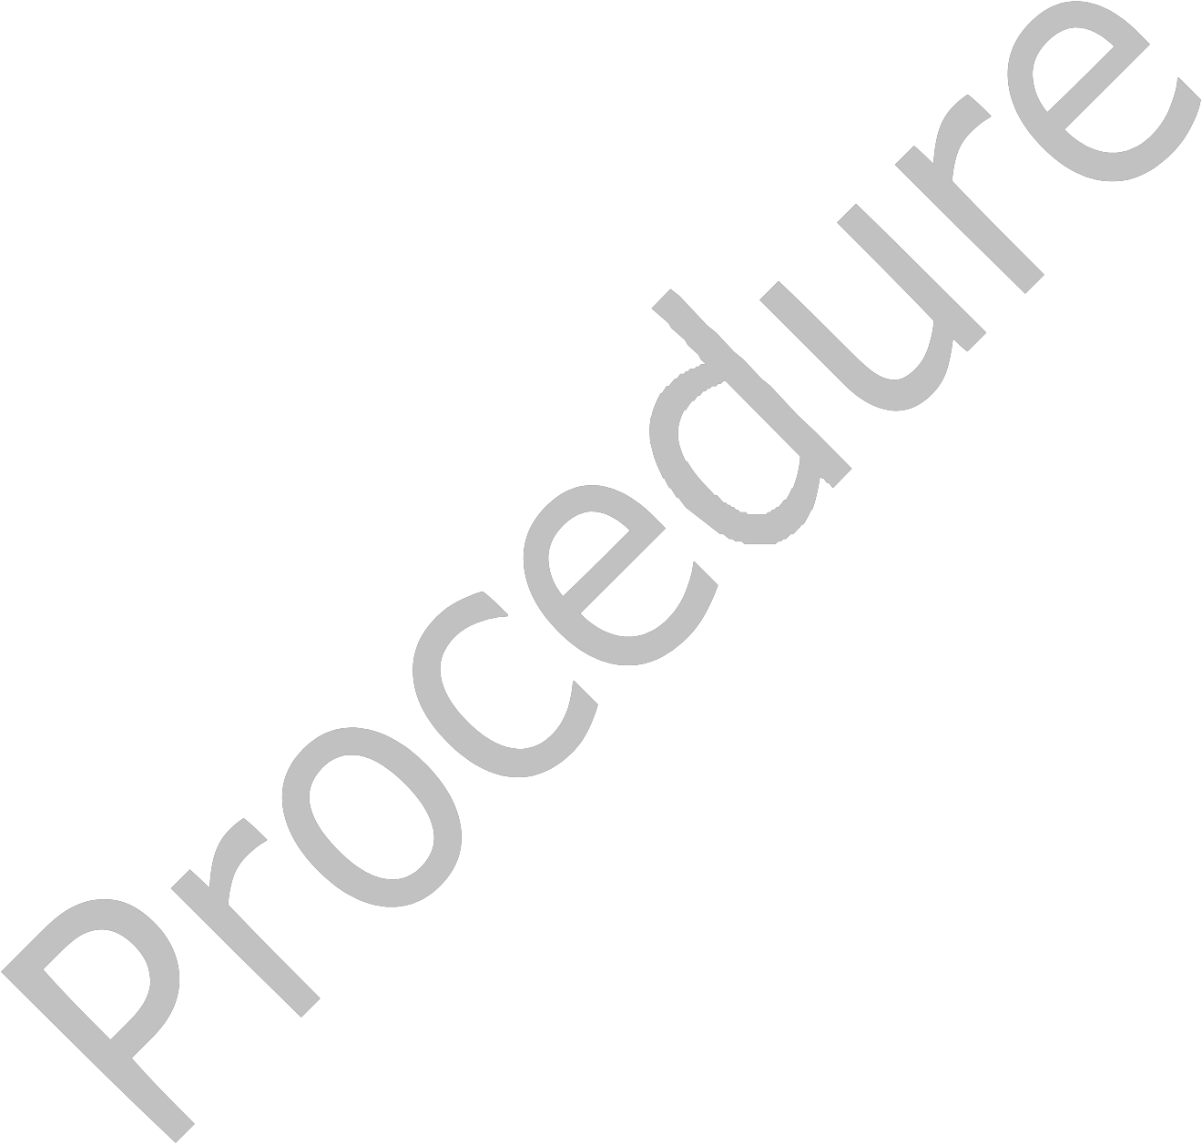**Handling Conditions**

The specimen should be transported at room temperature.

1. Order of draw: Sodium citrate tube should be first tube drawn or second tube drawn if blood cultures are ordered.
2. The whole blood specimen is checked for clot formation by gentle inversion before centrifugation and by visual inspection of the plasma for clots after centrifugation. Applicator sticks may also be used to inspect specimen for clots (see Rejection Criteria section for rejection of specimen).
3. Centrifuge the blood specimen according to each facility’s protocol as soon as possible after collection. Citrate tubes should be centrifuged at a speed and time to consistently produce platelet poor plasma (platelet count <10,000/uL).

* If testing cannot be performed within allowable times, platelet poor plasma should be removed from cells, transferred to a plastic freezer proof tube and frozen (Refer facility appendices).
* Frozen plasma samples must be rapidly thawed at 37°C and tested immediately.

**Hematocrit values above 55%**

Proper ratio of plasma to anticoagulant is necessary for coagulation testing and accurate results. To maintain the proper ratio of plasma to anticoagulant it may be necessary to adjust the amount of anticoagulant in the citrated blue top tube. Patient’s with a high hematocrit value >55%, the plasma volume will be too low for the amount of sodium citrate solution in the tube. Thus, the coagulation test results (PT, aPTT) may be falsely prolonged because of the excess anticoagulant in the plasma. To correct for the increased anticoagulant volume, the amount of sodium citrate must be reduced in the tube *before*drawing the blood sample.

The following calculation may be used to determine the appropriate sodium citrate volume to determine the appropriate volume of sodium citrate:

**X = (1.85 x 10-3) (100-HCT) (VBlood)**

**X** = volume of sodium citrate required for that volume of blood

**HCT** = patient’s hematocrit

**V** = volume of blood required in the blood collection tube

**1.85 x 10-3** = constant

It is acceptable to remove 0.1 mL of the citrate for the majority of adult samples, since the majority of high hematocrit values are between 55% and 65%. Sample is mixed and processed in the same fashion as the other coagulation samples. A note should be added in LIS stating that the hematocrit was elevated and the citrate concentration was adjusted.

***Note:*** If a hematocrit is above 55% on a pediatric patient, the calculation must be used to determine the appropriate amount of citrate to be removed.

**Procedure for Handling Hematocrits Above 55%**

1. Define one of the following:
2. If the hematocrit seems to be higher than normal on a visual inspection of a centrifuged sodium citrate tube, verify the hematocrit.
3. If the hematocrit of a patient is known to be 55% or higher, verify hematocrit.
4. If coagulation testing is requested for neonates, verify the last known hematocrit before preparing tube.
5. Obtain the appropriate tube size for the patient.
6. Based on the hematocrit, perform one of the following:
   1. If the hematocrit is between 55% and 65%, remove 0.1 mL of the citrate from the tube.
   2. If the hematocrit is above 65%, use the calculation to determine the appropriate sodium citrate volume using the patient’s hematocrit and the tube size selected (see calculation above).
7. Taking care not to splash or spill any anticoagulant, open the sodium citrate tube and remove the volume calculated using a calibrated pipette(s).
8. Carefully recap the sodium citrate tube.
9. Notify the phlebotomist of the special collection. They need to know that the tube no longer holds a vacuum and they will need to collect the specimen in a sterile syringe, adding EXACTLY the amount required according to the tube size by removing the tube cap.
10. For neonates, notify the nurse collecting the blood of the procedure and *exact*blood volume needed.
11. When tube is received in the lab, verify blood volume before analysis.
12. Before reporting out final results, include comment in LIS indicating that the hematocrit was elevated and the citrate concentration was adjusted.

**Rejection Criteria**

The following specimens should be rejected and a recollect requested:

* Inadequate labeling of the tube.
* Insufficient quantity of blood collected.
* Maximum time after collection exceeded.
* Wrong anticoagulant for test requested.
* Sample containing anticoagulant is clotted.
* Specimens with less than 90% expected fill of the collection (See image below for acceptable fill volumes).
* Tube is overfilled (See image below for acceptable fill volumes).
* On visual inspection of a centrifuged blue top, the hematocrit appears to be higher than normal. Determine the hematocrit value. If the hematocrit is >55%, then recollect with properly adjusted tube. Refer to the Handling Conditions – Hematocrit Values Above 55% within this document.
* When a sample is inappropriately collected or unsuitable for analysis.
* Hemolyzed samples

3.5 mL 3.0 mL 2.0 mL

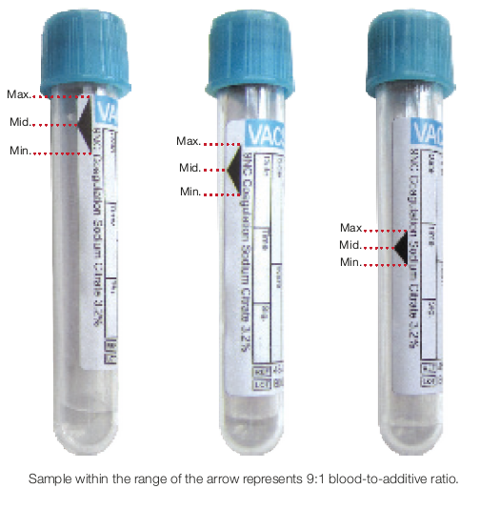

**Interfering Substances**

Refer to Table 3 below regarding known interfering substances. Additional information can also be found in the manufacturer’s package insert.

**Table 1**



**Lipemic Specimens:**

If lipemia interferes with the analysis of a sample and a Coag error occurs, the following steps may be considered for troubleshooting:

* Centrifuge the specimen for 12,000 x g for 5 minutes. Rerun the specimen after centrifugation.
* If the Coag Error is still present after centrifugation the following may be conducted:
  + Consult with CLIA director before reporting. A comment of disclaimer may be included in result indicating lipemia is present.
  + If an alternative method is used to resolve lipemia, it is the responsibility of the laboratory to validate that method for use.
  + Laboratories may send to other facilities that may use an alternative method to resolve lipemia.
  + Send specimen out to a facility that has a mechanical system (not optical) to perform coagulation test.

# ATTACHMENTS

None.

# RELATED DOCUMENTS

ACL TOP Analytes (BSWH.LAB.CG.403.R)

# REFERENCES

1. CLSI H21-A5:2008 Collection, Transport, and Processing of Blood Specimens for Testing Plasma-Based Coagulation Assays and Molecular Hemostasis Assays, 5th Edition
2. Coagulation Draw Volume Guide, Greiner.
3. 3.IFU [VACUETTE® Blood Collection Tubes US only (gbo.com)](https://www.gbo.com/fileadmin/media/GBO-International/02_Downloads_Preanalytics/TECHNICAL_Instructions_for_Use/English/980200B_09_EN.pdf)

|  |  |
| --- | --- |
| Revision History |  |

|  |  |  |  |  |
| --- | --- | --- | --- | --- |
| **Version #** | **Effective Date** | **Description of Change** | **Revised By** | **Removed Date** |
| V2 | 1/2022 | Included addition to remove 0.1 mL of citrate from hematocrits 55% to 65%.  Removed TCT.  Removed storage Table. Updated inversions required for blue tops. Clarified order of draw | BSWH Hematology Sub-Council | NA |
| V3 | 7/2023 | Removed section to ultracentrifuge specimen if lipemia is present and added manufacturer guidelines for centrifugation of coagulation specimen. | BSWH Hematology Council | NA |
|  |  |  |  |  |
|  |  |  |  |  |