
Title: | Manual POC Test Result Entry via Enter/Edit in Epic
Department/Service Line: | Laboratory
Approver(s): | CLIA Director
Location/Region/Division: | Baylor Scott & White Health
Document Number: | BSWH.LAB.POC.002.R_V3
Last Review/Revision Date: | See Signatures | Origination Date: | 5/2019

sCOPE

This document applies to personnel manually resulting POC test results via Enter/Enter in Epic within Baylor Scott & White Health.

DEFINITIONS

When used in this document with initial capital letter(s), the following word(s)/phrase(s) have the meaning(s) set forth below unless a different meaning is required by context. Additional defined terms may be found in the BSWH P&P Definitions document.

POC – Point of Care

method/Utility
The purpose of this procedure is to describe the proper process for manually resulting POC tests within Epic.

PROCEDURE
Enter or Edit Results for Inpatient Documentation

- Order the appropriate POC test in Epic.
- Look at the Brain or Work List to find the Task for the specific lab. Click on the hyperlink for Enter/Edit Results.
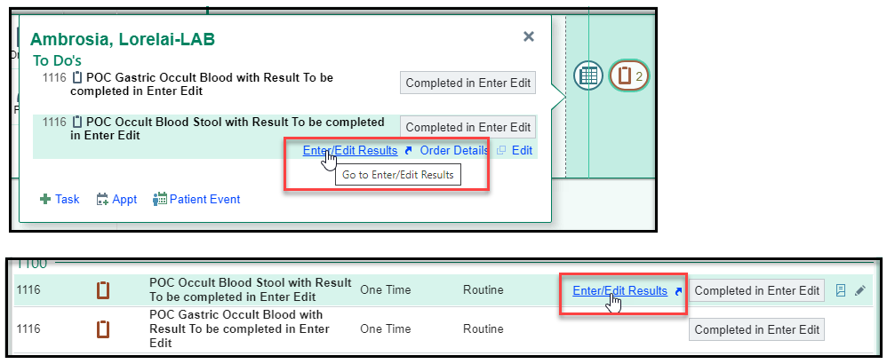

- You can also use the Enter/Edit Results Activity to find the lab. Highlight the lab and double Click to open that Resulting tool. The process is the same from here as it is for utilizing the hyperlink.
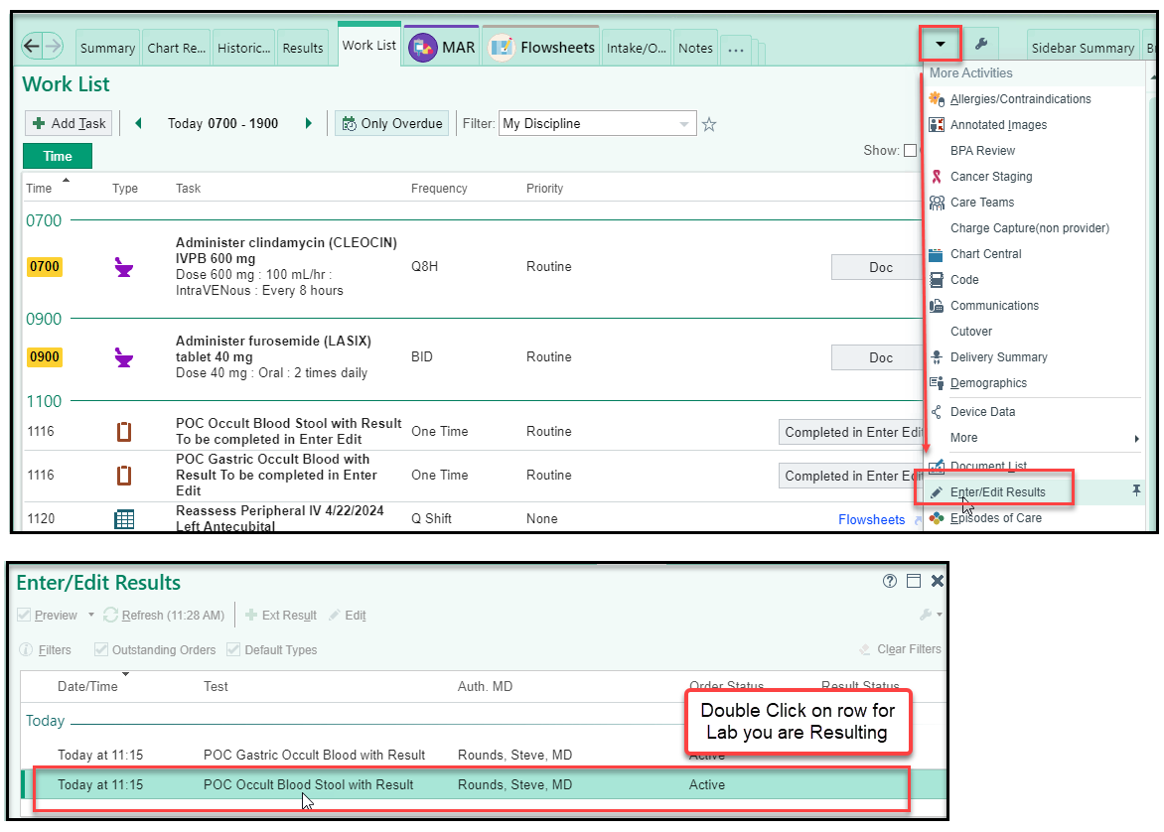
- If there is only one lab to be resulted, Epic will default to that lab. If there is more than one, you will need to choose the lab by highlighting the row of the lab you are documenting.
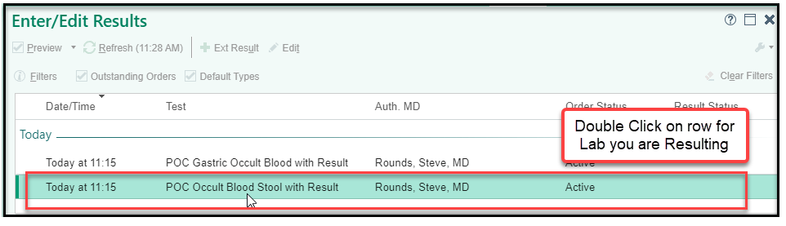
- Collected by and Collection date and time will default to the current Epic user and current date and time. Update to actual collector and actual collection date and time.

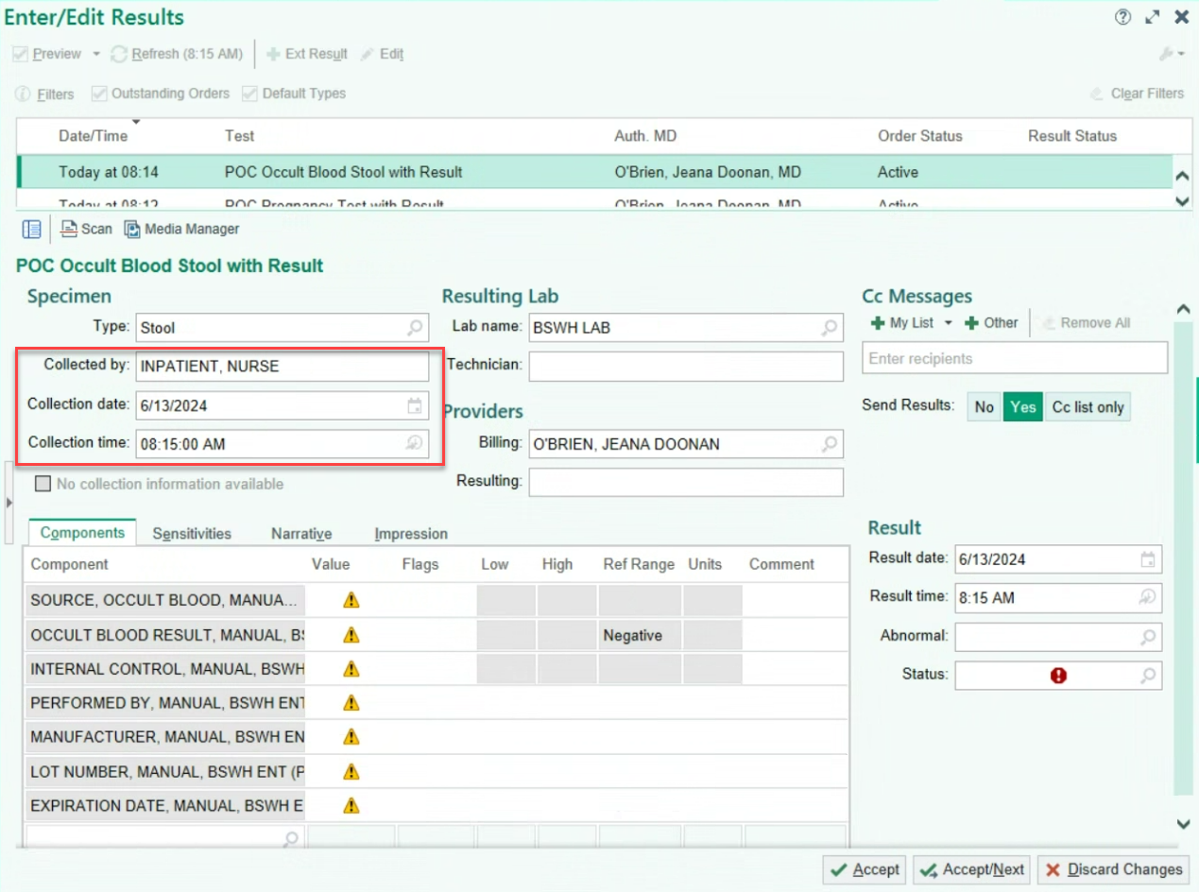
- Enter values for all result components. The Status will normally be Final result. If resulting on behalf of a provider, ensure that information is recorded correctly in the performed by component.
Click Accept once completed.
Note: If comments are needed to document further action (such as critical value communication documentation) record in the comment box seen below.
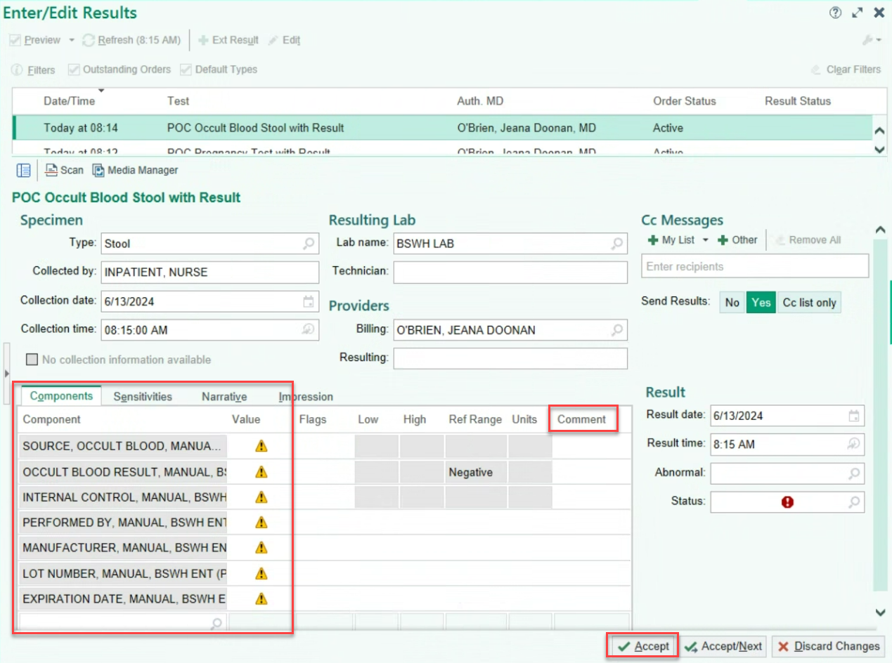

- Go back to the Brain or Work List and click Completed in Enter Edit. This documents the Task as Completed.
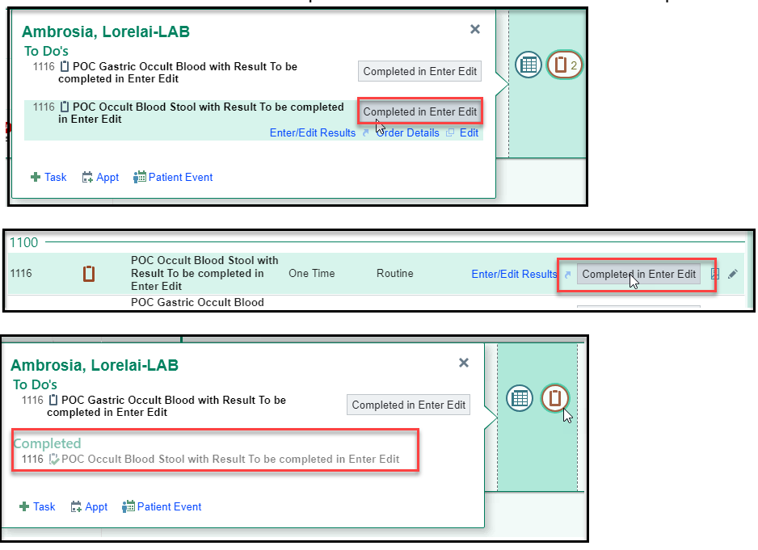

- Documentation can be viewed on the Results activity.
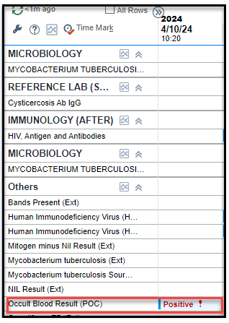

Enter or Edit Results for Ambulatory Documentation

- Order the appropriate POC test in Epic.
- Navigate to the Visit Orders Report from the Schedule.
- Complete Specimen Collection task under the Point of Care Needing Specimen Collection header.
Note: Some tests can be resulted via interfaced instrument or via Enter/Edit. For those tests, the task to complete will require collection date/collection time and “Will this be an Interfaced Result?”. If the wrong selection is made in this step the user will need to cancel the test and reorder.
- Click on the hyperlink for Enter Results.

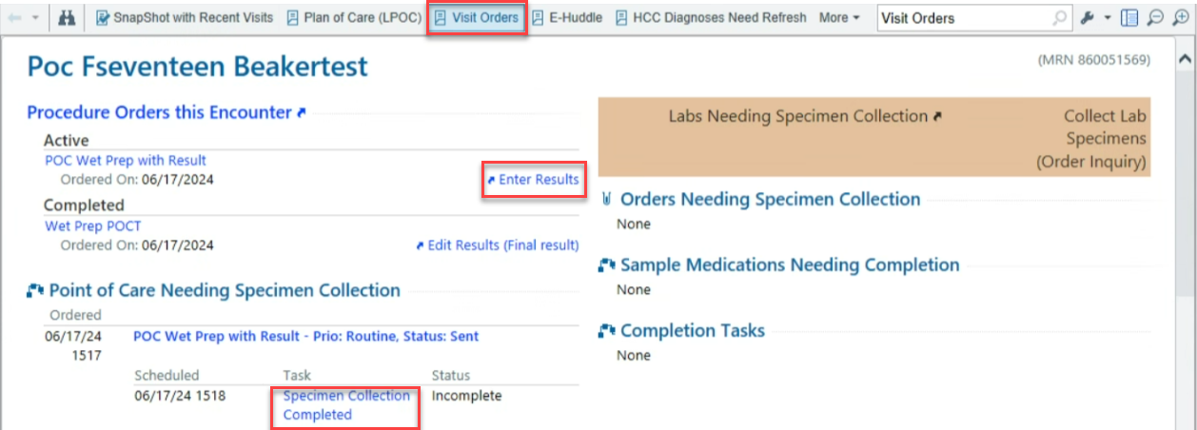
- Collected by and Collection date and time will default to the current Epic user and current date and time. Update to actual collector and actual collection date and time.

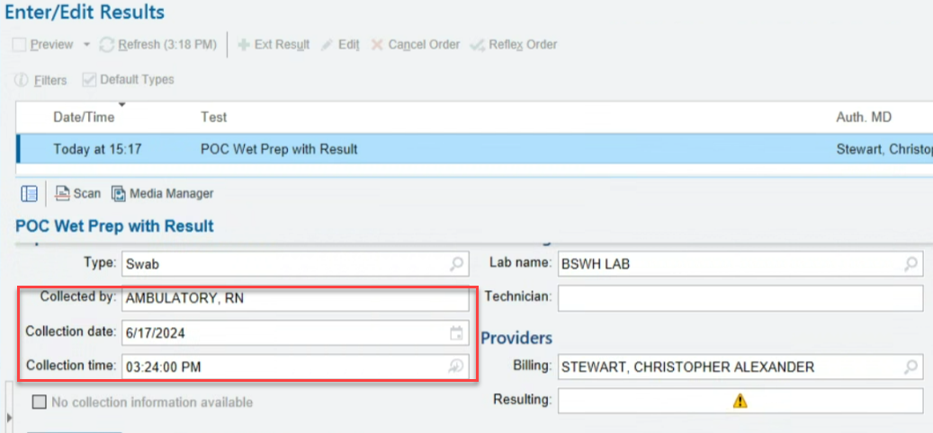

- Enter values for all result components. The Status will normally be Final result. If resulting on behalf of a provider, ensure that information is recorded correctly in the performed by component.
Click Accept once completed.
Note: If comments are needed to document further action (such as critical value communication documentation) record in the comment box seen below.
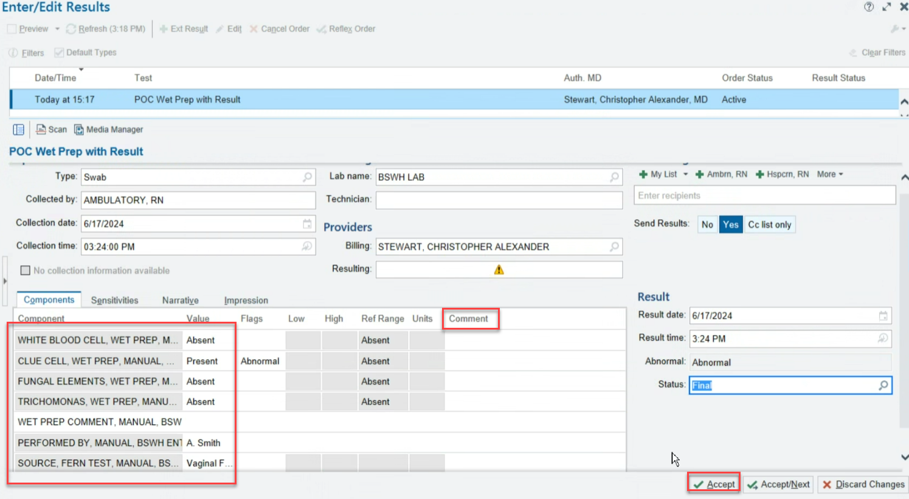

ATTACHMENTS

None.

RELATED DOCUMENTS

POC Quality Management Policy (BSWH.LAB.POC.001.P)
Provider Performed Testing Program (BSWH.LAB.PPT.001.P)

REFERENCES

None.

Revision History
Version # | Effective Date | Description of Change | Revised By | Removed Date
2 | See Signatures | Updated for reporting of Source. | R. Steward | NA
3 | See Signatures | Updated for Beaker | R. Steward | NA

