
Co-oximetry Gem-OPL Point of Care Procedure  (Oxygenation Portable Laboratory – HSC Lung & Sleep Health Only) | Attachments  Yes No
Key words Co-oximeter, blood gases, Co-oximetry, CO, Carbon Monoxide | Number  GHP-PC-CLINIC LAB-PROCEDURES-Co-Oximetry GEMOPL v. 05-2010
Category Provision of Care | Effective Date  October 2005
Manual Clinic Laboratory Procedure Manual | Last Review Date  January 2014
Issued By Laboratory Administration | Next Review Date  January 2015
Applicable Health Specialty Center Staff | Origination Date  October 2005
Level of Complexity Moderate | Retired Date
Review Responsibility Laboratory Technical Consultants | Contact Laboratory Technical Consultants
APPROVAL(S) Laboratory Medical Director | Approved Date  October 2005

GEM OPL CoOximeter Procedure
Clinic Lab Procedure (Pages 1-4)
Troubleshooting Guide (Page 5)
Computer Test (Page 7)
- Purpose/PRINCIPLE
To provide direction for performing O₂, CO, and met-hemoglobin tests using the GEM OPL instrument

Whole blood samples are measured for total hemoglobin concentration and the relative concentrations of oxy-, carboxy-, and methemoglobin. The GEM OPL illuminates the sample with multiple wavelengths, records the optical absorbance of the sample at each wavelength, and computes the results.

II. POLICY
Laboratory Staff will follow the approved techniques outlined in this procedure.

III. Specimen:
Whole blood samples are drawn in a heparinized syringe and sodium or lithium heparinized vacutainer tubes are acceptable.

Citrate, fluoride, oxalate and EDTA tubes are NOT acceptable.

IV Reagents/ Materials:
- Disposable cuvettes- cuvettes are obtained from Instrument Laboratories. Store cuvettes in the sealed bag with a desiccant pouch at room temperature. The desiccant pouch has a color indicator that should be blue. If the color indicator has changed to pink, do not use the cuvettes until a new desiccant pouch can be added to the bag. Prior to use, verify indicator is blue.
- There is no expiration for cuvettes properly stored.
- The temperature probe located on the rear panel of the instrument should be kept by the cuvette bag, which is currently in use.

V. Quality Control:

- OPTICAL FILTERS: Optical filters are used to determine whether the optics have been contaminated and to verify that the calibration has not changed. There are two optical filters-yellow and orange. Each filter has a specific serial number that matches the serial number of the GEM OPL with which it is used. Both filters are to be run weekly and once each day of patient testing.

To Perform:
- Confirm that the filters have the same serial number as the GEM OPL
- Wait until the ready message appears on the display.
- Remove any debris from the surface of the optical filters by wiping them with dry gauze.
- Insert the filter into the cuvette slot and enter the sample information at the prompt.
- Verify that each of the results is within the established range for the filter.
- Document results on the QC logsheet, making sure that the results are in range.

- LIQUID QC. Liquid QC serves as another means to verify that the GEM OPL system is functioning properly. Controls are the IL Multi-4 CO-Oximeter controls levels 1,2, and 3. They are obtained from Instrument Laboratories. Store at 2-8C. Expiration date is stamped on each vial. Three levels of Liquid Control should be performed weekly. Document QC on the Quality Control Log and send to the lab at the end of the month.

- The tech performing Quality Control must compare each level of QC results with the corresponding QC ranges to verify they are in range.
- The QC ranges are found on the QC package insert.
- The correct control lot number information, Cuvette lot number information, ranges, dates, and tech initials must be recorded on the logsheet.
- If the results are out of range, repeat the control one time to see if it comes in range. If not, discontinue testing and notify the lab for further direction.

To Perform:
- Hold the ampoule by the top above the break line. Shake the sample according to the manufacturer’s recommendations, approximately 10 seconds.
- Restore liquid to the bottom of the ampoule with gentle tapping. If foam or small bubbles are present, allow ampoule to stand until these have come to the surface.
- With fingers protected, snap open the ampoule.
- Contents should be sampled as soon as the ampoule is opened. Use a syringe to transfer liquid from the ampoule into a syringe.
- Insert the syringe tip into the cuvette syringe port on the cuvette and inject the QC sample holding cuvette down at a 45º angle. Inject QC material into the cuvette until the sample reaches the vent patch. Leave syringe attached to cuvette.
Note: Over injection of QC material will, cause the vent patch to budge outward. If this happens, pull back slightly on the syringe plunger just until the patch flattens.
- Check that no air bubbles are present in the sample light path.
Note: Air bubbles will yield erroneous results. If air bubbles are present in the light pathway, discard cuvette.
- Hold the cuvette by the black cap and rotate it so the textured blue side of the vent patch will be on the left side when inserted. Insert the cuvette into the slot of the instrument’s front panel within 30 seconds of filling it.
Note: A delay of analysis greater than 30 seconds may yield erroneous results.
- Verify that results are with in the established ranges.

VI. Calibration:
The initial calibration is set at the factory. Recalibration is required only if the optical filters do not meet the established specifications.

VII. Calibration Verification:
Calibration Verification is performed every 6 months using a purchased assayed 5 level set of Calibration Verification Controls. Calibration Verification is also performed after instrument service.

There are 5 levels of samples (3 samples for each level) with known values and are tested in the same manner as patients. The results obtained are plotted on a graph, compared to the known values, and must be within established acceptable limits. If the calibration is stable, the recovered value should match the expected value. If not, troubleshooting and correcting action are needed.

VIII. PROCEDURE
Verify that the GEM OPL is ready. The display will read: READY insert cuvette. Verify that the GEM Code is correct for the cuvette bag in use. If not it must be changed.

To change the GEM Code
- press MAIN MENU on the keypad.
- Select the CALIBRATION option from the main menu.
- Select 1. GEM Code. This will display the current code.
- Change the code to match the cuvette bag.

Patient Test Procedure:
- Patient testing can only be done if all quality control results are within acceptable limits.
- The instrument indicated that it is ready to analyze samples by displaying the following message:

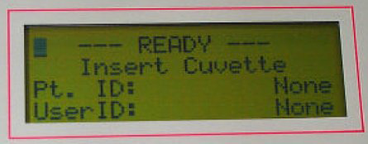

- Roll the syringe containing the blood sample between your hands periodically inverting the syring to mix the sample thoroughly. The sample must be mixed for a full 10 second interval just prior to injection into the cuvette.
Note: Poorly mixed samples or those containing clots may cause inaccurate results.
- Expel one drop of sample from the syringe and connect the syringe to a disposable cuvette.
- Hold the cuvette at a 45 angle and inject sample into cuvette until sample reaches the vent patch at the opposite end. Never force blood into the cuvette.
Note: Over injection of QC material will, cause the vent patch to budge outward. If this happens, pull back slightly on the syringe plunger just until the patch flattens.
- Confirm that the light path at the widest portion of the sample chamber is free of debris or air bubbles. Ignore bubbles outside of the light path.
Note: Air bubbles will yield erroneous results. If air bubbles are present in the light pathway, discard cuvette.

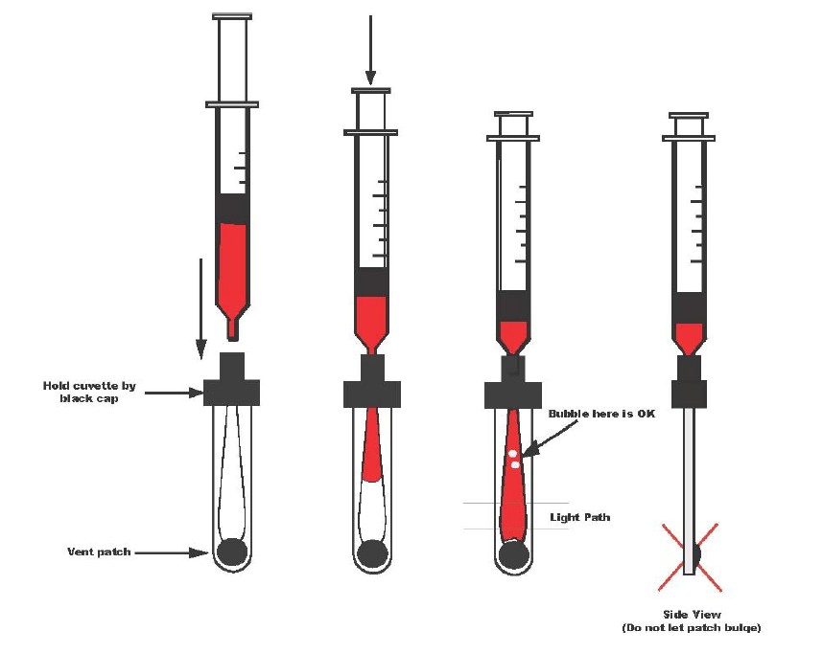

- Remove any sample on the cuvettes exterior surface before inserting into the GEM OPL.
- Holding the cuvette by the black cap, rotate it so the textured blue side of the vent patch will be on the left side when inserted. Insert the cuvette within 10 seconds of filling it.
- Follow the screen prompt to enter sample information.
- Observe the LCD display. Do not disturb the GEM OPL while it is busy. The results display within 10 seconds.
- Withdraw the cuvette as soon as the sample has been analyzed. Data will stay on the display until the cuvette is removed.

IX. Linearity:
tHB 5-21 g/dL
O2Hb 0-100%

X. Reference Range
tHB 12.0-18.0 g/dl

XI. Reporting Results:
- Record Results on Manual Worksheet (Check the column with the matching results)
- For Computer entry use Function: MEM
- Worksheet: BG2HS
- Refer to page 5 for complete result entry instructions.

Pulmonary:
Either hand write or use a computer generated label to supply the following information to the lab with each test request:
- Patient Name
- Birthdate
- Medical Record
- Encounter Number
- Date & Time of Testing
- Diagnosis Code
- Ordering Provider
- Tech Number
- Test Name and Test Result

At the end of the day, fax the results to the lab at 651-254-8191. The lab will enter the patient information and their results into Misys.

XII. Troubleshooting:
If liquid controls or optical controls are out of range, see pages 37-39 of GEM OPL Instrument Manual.
Technical Service Phone Number: 1-800-678-0710.

Troubleshooting Guide:
- If controls are out of range, rerun controls. Never report any patient results when Q.C. values fall outside of the stated control ranges.
- Liquid Control: Verify that the correct lot number is being used.
Optical Filters: Verify that the serial number of the filter matches the serial number of the GEM OPL.
- Liquid Control: Verify that controls are not expired and that the controls have been stored correctly.
- Verify that the procedure was run correctly.
- Verify that proper cuvette handling and sampling technique was used.
- Verify that the GEM code on the box of cuvettes matches the GEM code that was entered into the instrument.
- Rerun controls.
- Liquid Controls: If the control values are still unacceptable, open and run new controls, if possible.
- If Liquid Controls or optical filters remain out of control, or if you are experiencing other problems with the instrument, see pages 37-39 of the GEM OPL Instrument Manual.
- Notify a lab technical consultant. The manufacturer may be called, if necessary. Technical Service Phone Number: 1-800-678-0710.
Reminder: According to the Internal Quality Control Policy, If expected QC values are not attained, patient results will not be reported until troubleshooting is complete.

XIII.References:
GEM OPL Manual, 2004
Regions Hospital Laboratory I-STAT Procedure, 4/1999
Massachuesetts General Hospital POCT program 2010

XIV. Author/Reviewers:
Original Author: DABergo
Most Recent Reviewer: DABergo

XV. Definitions

XVI.Compliance

Failure to comply with this policy or the procedures may result in disciplinary action, up to and including termination.

XVII.Attachments

XVIII.Other Resources

XVIXENDORSEMENT
Laboratory Administration

Computer Order and Result Entry

GEM OPL Oxygenation Portable Laboratory

Order Codes: COOXB

RESULTING:

Function MEM, worksheet BG2HS

RESPONSE

Test Code Test Name Other Comments
THGB Total Hgb, COOX Enter results to 1 decimal place

FO2HB O2 Sat, Measured Enter results to 1 decimal place, Extra information will automatically append-normal range info.

COWB Carbon Monoxide Enter results to 1 decimal place.
Extra information will automatically append-normal range into.

METHB Methemoglobin Enter results to 1 decimal place

O2CN O2 Content Enter results to 1 decimal place.
Extra information will automatically append-normal range into.

Authors/Reviewers
LEJohnson
GEFelland
DBergo

