

Subject  ECG MUSE Procedure | Attachments  Yes No
Key words MUSE, ECG computer, MAC Computer, Retrieve, Merge, Edit, EKG | Number  GHP-PC-CLINIC LAB-PROCEDURES-EKG Muse v. 07-2008
Category | Effective Date  May 2004
Manual Clinic Laboratory Procedure Manual | Last Review Date  November 2013
Issued By Clinic Laboratory – Laboratory Technical Consultants | Next Review Date  November 2014
Applicable Clinic Laboratory Staff | Origination Date  July 2007
Applicable Clinic Laboratory Staff | Retired Date
Level of Complexity Not Applicable | Contact Laboratory Technical Consultants
Review Responsibility Laboratory Administration | Approval Date
APPROVAL(S) Laboratory Medical Director

Purpose/principle This procedure provides instruction for transmitting ECG results to the MUSE system.

Once the ECG is performed on the ECG instrument, it is transmitted to the MUSE where it is stored. From MUSE, we can retrieve and print ECG’s, enter provider changes to the instrument interpretation, merge manually entered patient data with an interfaced order, and reconcile any discrepancies in chart numbers, account numbers and patient names.

Definitions
MUSE Computer system where confirmed and unconfirmed ECG’s are stored
Edit Process of making changes to the ECG instrument interpretation
Unconfirmed ECG An ECG that has been transmitted from the ECG cart to MUSE but has not had the
ECG machine interpretation overread by the provider. Printout says it is
unconfirmed.
Confirmed ECG ECG that has been overread by the provider. The provider has made changes
to the interpretation, if necessary, and the changes have been entered into
MUSE. This is the finalized ECG. Printout says it is confirmed.
Retrieve Process of pulling up a copy of an ECG that is stored in MUSE.
Merge Process of merging manually entered patient information with an interfaced order.

Procedure:
This procedure will be divided into 3 main screens:
A. ECG MUSE Sign-on Page 2
B. Home Screen Page 3
C. Edit Retrieve: Patient Record Screen Page 7
1. Viewing Options Page 7
2. Updating Patient Demographics Page 10
3. Edit/Retrieval Screen: Problems Requiring Resolution: Page 11
4. Over-reading the ECG Page 15
5. Editing the ECG Page 16
6. Print a Record to a Defined Device Page 16
7. Deleting an ECG Order in MUSE Page 19
8. Outside Provider Order Page 19

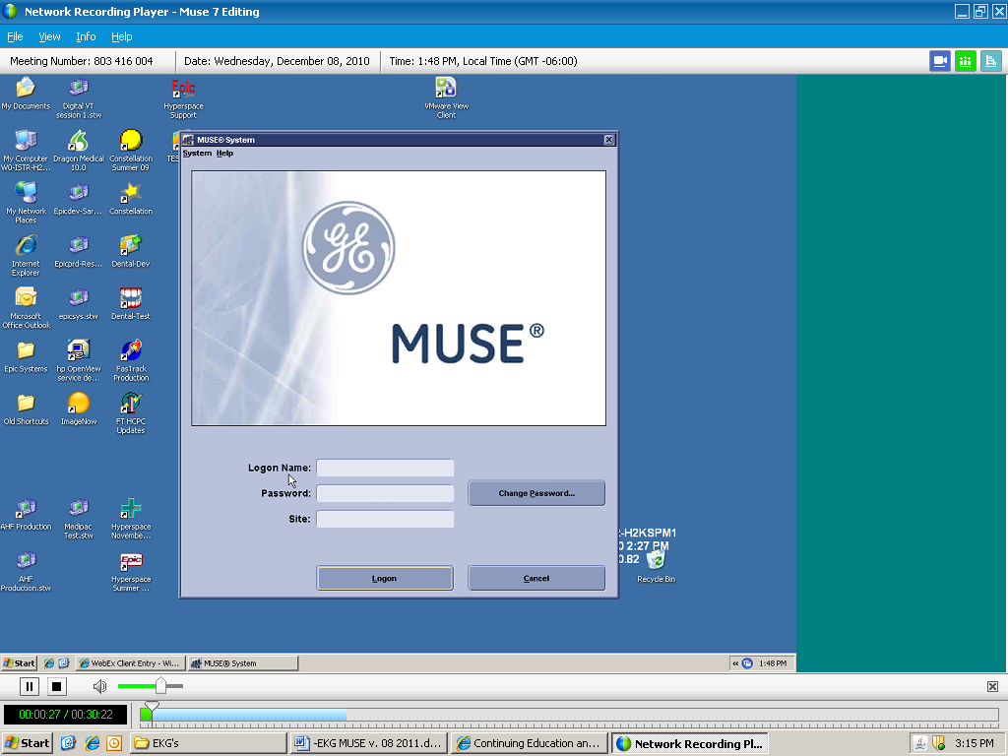

A. ECG MUSE Sign On:
1. On the computer desktop, double click on the MUSE Icon
- The MUSE Authorization window appears.
- Enter the following information:
User ID: Each person with Muse access has a unique User ID.
Password: Your password is a complex password consisting of 8 characters. There should be one capital letter, lower case letters and a number. It expires in 90 days.
Site Number: 1

User ID and Password: User ID and Password are obtained from Lab Computer Support. To obtain a User ID and Password, an authorized requester should contact Lab Computer Support. Lab Technical Consultants are authorized requesters.

HP Clinics and, as of July 8th, 2007, Regions Hospital ECG’s are stored on site 1. If a Regions Hospital ECG is needed that was performed before July 8th, 2007, contact the Helpdesk at 952-967-6600.

Privileges are assigned as follows:
- Lab Assistants: Retrieve only
- Lab Tech: Edit, Retrieve
- Clerical: Retrieve only
- Nursing: Most can retrieve only. Nurses who perform ECG’s have access to Edit and Retrieve.
- Provider: Over reader, Edit and Retrieve
- Advanced Practice Providers (APP’s): Over read, Edit and Retrieve:
The APP’s supervising physician must ensure that this is within the provider’s scope of practice and should be confirmed by the clinic’s Chief of Professional Services. Once established, the APP may be set up with the necessary MUSE privileges to over read and bill for ECG’s. For proper documentation of privileges, contact Laboratory Administration.

Once Log on is accepted, the Authorization window closes and the Home Screen opens.

Summary of Steps to Editing an ECG:
- ECG is transmitted into MUSE
- Copy is given to Provider to over-read and the copy is returned to lab..
- Sign onto MUSE and MUSE opens to the HOME page.
- Select the patient from the Edit List or the Edit/Retrieval List
- This opens the patient record to the Edit/Retrieve Screen.
- Make sure that the message says “No Mismatch Detected
- Make sure the Order and Visit numbers are filled in.
- If not, these must be resolved before confirming.
- Record any of the provider changes, if present, to the instrument interpretation.
- Confirm and Print

B. Home Screen

1. Title Bar: Displays the current application, user, and site
2, Menu Bar Selection: Provides access to all tasks available within the Editor application. Clicking
on the menu item brings up a drop-down menu of related commands. Most items on the drop-down menu can also be accessed by using corresponding shortcut keys or icons.

3. Icon Toolbar: The toolbar across the top is a list of ICONS that are available in MUSE.. When
the cursor hovers over the ICON and it is active, a display message appears identifying the ICON. If the ICON is inactive, it will be grayed out. ICON’s are either active or inactive depending on where you are working in MUSE. When an EKG is highlighted or opened, more ICON’s become active.

Example: HOME Screen:
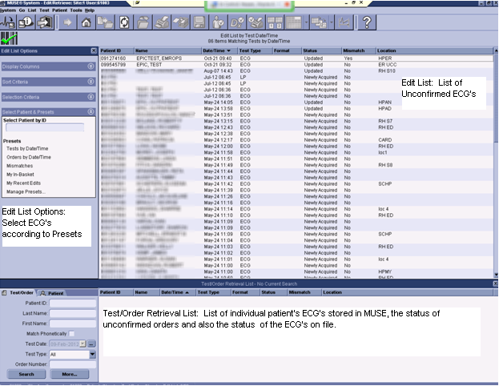

4. Edit List: The Edit list is displayed in the large right Window Pane. The edit list contains the Unconfirmed ECG’s. At the Edit List, patient tests may be selected for editing, printing or confirming. The ECG’s on this list can be sorted by clicking on the column header. The options are
- Patient ID: Patient Medical Record Number:
- Name: Patient Name
- Date and Time: Date and Time that ECG was performed
- Test Type: Test type for our purposes will be ECG
- Status: The ECG test status is in upper and lower case letters. The options are
  - Newly Acquired: The ECG was sent to MUSE
  - Updated: The ECG has been updated to the edit list after a correction or an order was recently attached.
- Mismatch: States whether there is a mismatch, Yes or No
- Location: Clinic Location where performed.

5. Edit List Options: The Upper Left Window Pane contains Edit List Options. Edit List Options contains a number of PRESETS or filters. This allows only ECG’s that meet the criteria of the PRESET to be displayed. The list of PRESETS options include:
- Select Patient by ID:
- Select Orders by Date & Time: This list is for orders for all clinics. The order status displays in UPPERCASE letters and can be OPEN, PENDING AND DISCARDED.
- Select by Clinic Location: View ECG’s performed only at specified clinic location.
- Mismatches: See all the clinic PID/name mismatches
- Clinics by Location: This is the default

6. Test/Order Retrieval List: Located in the lower half of the Home screen. This screen contains a list of the patient’s stored ECG’s in MUSE, the ECG order and ECG status, whether confirmed, ` unconfirmed newly acquired or updated..

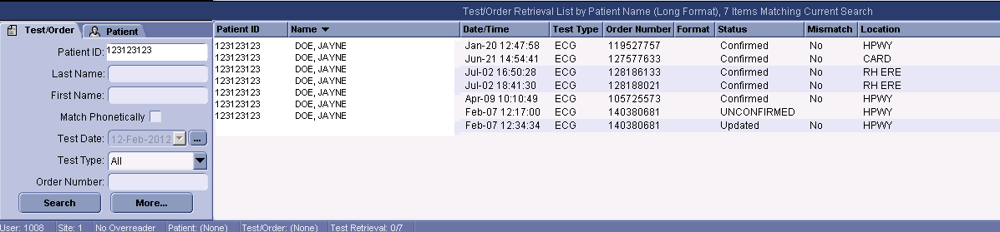

There are two tabs on the lower left hand side of the screen:
Test/Order: If you search by Test Order, all tests and orders are listed. Open any test/order by clicking on it.
Patient: Enter the chart number of patient name. Their name appears in the retrieval screen. Double click on the patient name and it takes you in to their file. It opens to a list of tests and orders.

7. Edit/Retrieval Toolbar: This toolbar is located at the bottom of the Home Screen. It lists the User ID, Site, Overreader and Patient Information.

Patient Medical Record Number in MUSE:
Muse requires a 9 digit number. HealthPartners patients have an 8 digit medical record number. To meet MUSE requirements, add a zero in front of the HealthPartners Medical Record Number.

Opening a Patient Record:
A patient record can be opened by entering the record through the Edit List or the Test/Order Retrieval List:

a. Opening from the Edit List:
  - To open a single record: Select the patient and double click on the record.
  - To open multiple records: Hold the Ctrl key down and click on each record you want to view. Or hold the Shift key down and click on the last record you want to view. All records between the first and last record selected are now highlighted. Press the Enter key to view the first record, then each selected record consecutively.

b. Opening from the Order/Retrieval List:
            - Type in the patient ID in the Patient ID text box, or type the Last Name, First Name, Test Date, Test Type or Order Number.
            - You can choose to check or clear the Match Phonetically box to search patient names phonetically or exactly as typed.
            - Click Search. A list appears with all the patients in the system matching the name and/or test date entered.
            - Highlight and double-click on the name of the report wanted. The report opens in the Report Editor window.

Icon Descriptions and Functions:

 Go to Home

 Go to Selected Item: Select an item by clicking on it and then click on this icon. Another option is to double click on the item.

 Open Next Selected Item: If you selected on more than one ECG on the EDIT list, once you open the first ECG, click on the arrow to move to the next selected ECG. When completed, it returns to the Home Screen.
 Print Test: Option to print to any System Printer listed in the printer directory

 Update: Save changes without confirming and billing. The record status will be noted as Updated in the Edit List. We generally use Update instead of Save Test as Demographics Complete. Both update demographic changes.
 Save Test as Demographics Complete: Very similar to Update. The record status will be noted as Demographics Complete in the Edit List.
 Send Test to In-basket: Do NOT use

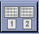 Send to Serial Comparison: When multiple ECG’s are run within a few minutes of each other and sent to MUSE, this allows the deletion of the unwanted ECG’s and reruns the serial comparison so that the current ECG will compare with the desired previous ECG
 Send Open or Selected Test to Discarded Data List: To Delete the unwanted ECG’s, highlight them and send to the discarded data list. If the wrong ECG is accidently deleted, call the Helpdesk. Discarded ECG’s are retrievable.

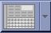 Select Test Editor Layout: There are several waveform options for viewing the patient record. Waveform Layout, Serial Presentation Layout, Clinical Layout, Enhanced Clinical Layout, Clerical Layout and the option to select a Primary Layout and an Alternate Layout.

 Physician Tools for Over-reading: Do NOT Use

 Physician Tools for Over-reading: Do NOT Use

 On-line Help: This is the MUSE manual. It opens to the area that is being worked on.

 Log Out: Logs out to Log In Screen

 Exit Application: Exits Application and shuts down MUSE

 Confirm, Print and Route

C. Edit/Retrieve: Patient Record Screen:

1. Viewing Options:
There are several patient record viewing options.
- Waveform Layout
- Serial Presentation Layout
- Clinical Layout
- Enhanced Clinical Layout: Do NOT Use
- Clerical Layout
- Select as Primary Layout : Do NOT Use
- Select as Alternate Layout: Do NOT Use
Select this Icon and press the drop down arrow or Tools>Test Editor Layout.
Select the layout of your choice.

Clerical Layout: Displays patient demographic information without a waveform, and may be edited.
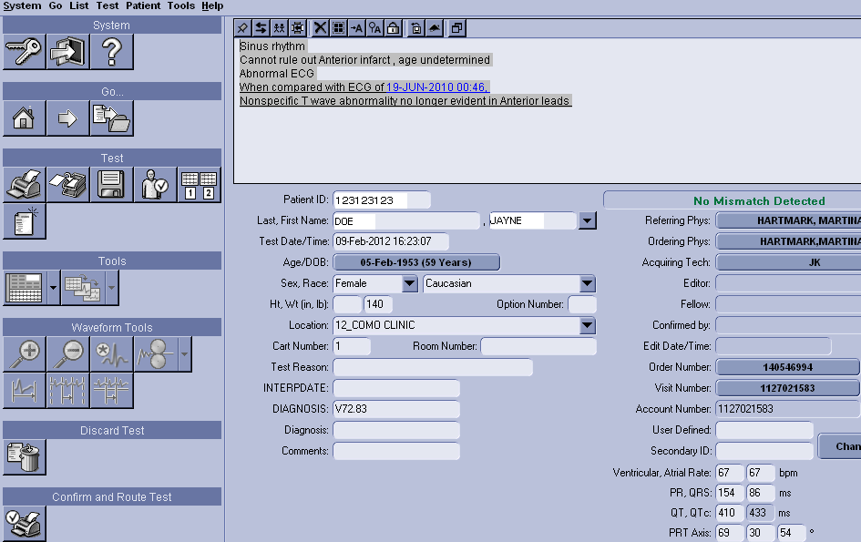

Clinical Layout: Displays patient demographic information with waveform and may be edited.
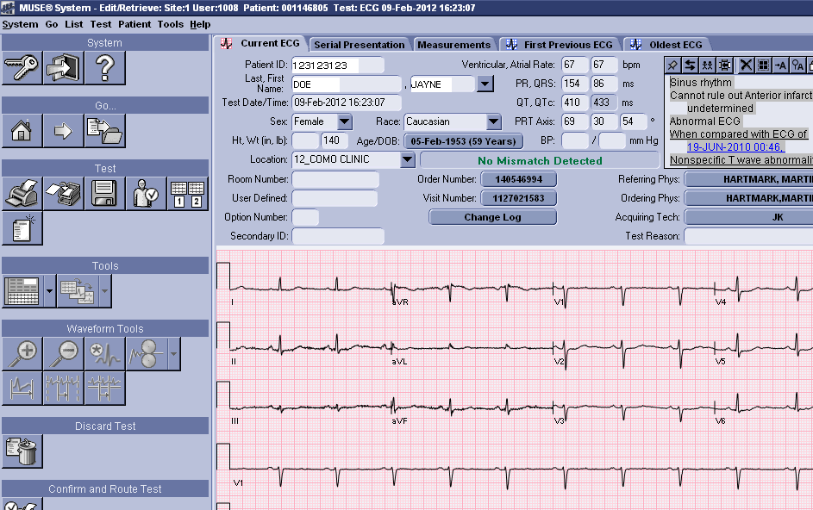

Waveform Layout
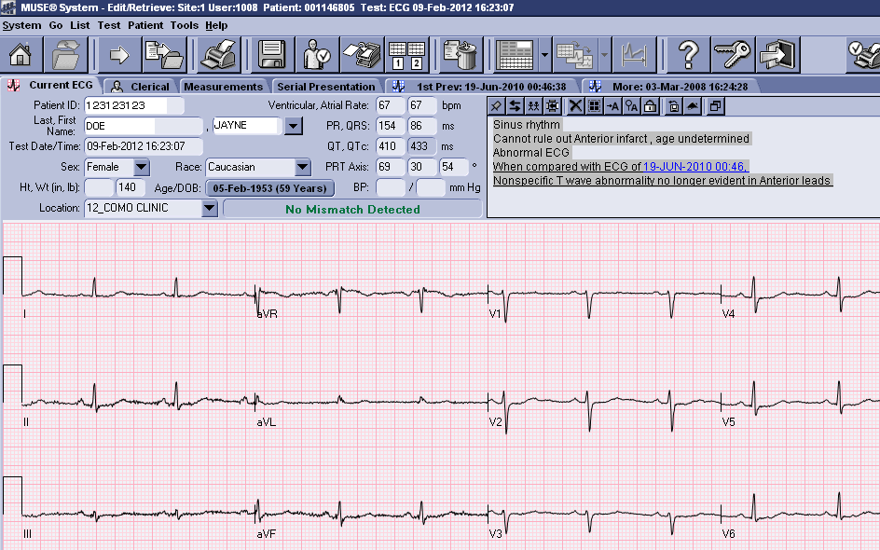

Serial Presentation Layout: Displays current ECG and most previous
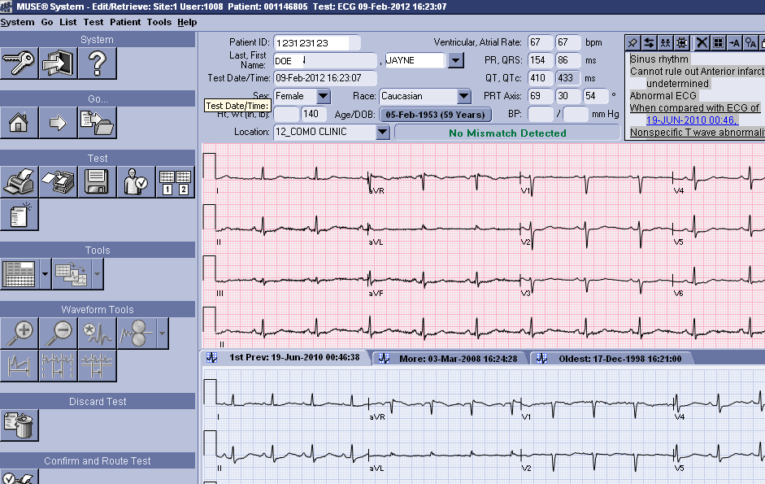

Discard Test ICON: Selecting the Discard Test ICON discards the ECG that is open on the screen. The pink grid is the only ECG edited or discarded. Selecting the first previous and then the Discard Test ICON, still discards the current ECG (pink grid).

2. Updating Patient Demographics:

Example: Edit/Retrieval Screen: Complete with requirements met.
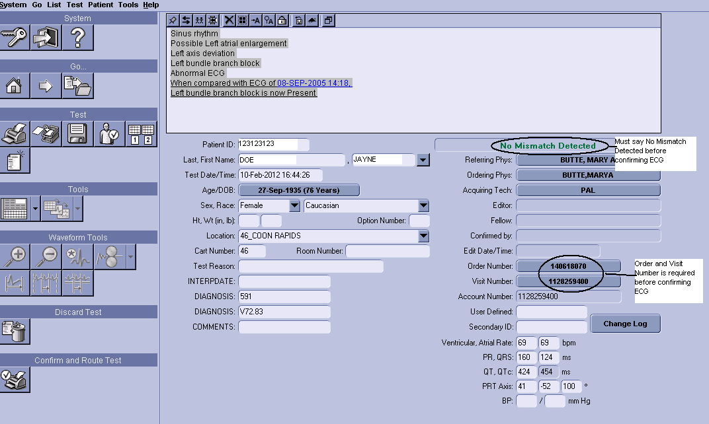

a. Downloaded Patient Orders: Whenever possible, download patient orders into the ECG machine instead of manually entering information. Downloading patient information into the ECG machine, ensures that patient demographics are correct.

b. Manually Entered Patient Orders: When orders are manually entered into the ECG cart and transmitted to MUSE, there is the possibility of name mismatches and incorrectly released orders.

c. Messages: When a patient record is opened and information is correct, a message says “No Mismatch Detected”. If there is message such as “PID Mismatch” or “No ADT Record for Patient”, it must be resolved before confirming the ECG.

d. Order and/or Visit button:
An order number is required for the ECG to be visible in the patient medical record in EPIC and to bill correctly.
To get this order number, an order needs to be entered into the patient medical record and the test released through an appointment.

Order Number and a Visit Number are obtained by:
- Downloading the patient information from EPIC into the ECG Cart. This is the method we should ALWAYS use unless EPIC or MUSE is down or there is an Emergency. When we download:
  - All patient information is correct
  - There is an order number and a visit number making sure that all workflow is correct.
  - The preliminary report is visible in EPIC and is overwritten upon confirmation so there is always just one report in EPIC per order.
- Manual Entry with a valid order released through an appointment:
  - The order Number, if entered on the cart from the white sheet, will be visible as the order number in MUSE. You will be able to click on it to merge the order and visit number. Beware of clerical errors which prevent the ECG from filing to EPIC and billing correctly.
- Manual Entry with no order/appointment:
a. Since a valid order number isn’t available, MUSE generates a pseudo order number so that the preliminary ECG can be viewed in EPIC. This number looks the same but it is not an actual order number. It cannot be merged to the visit and it cannot be used for billing. This preliminary ECG will never be overwritten in EPIC upon confirmation. There will always be multiple ECG reports for the same tracing in EPIC.

- Merging a Manually Entered Order with an Interfaced Order:
Every ECG in MUSE must be associated with an EPIC order. It is required to have the order released through the appointment associated with the order. If patient information was manually entered into the ECG cart without a valid order number, once the ECG was sent to MUSE the order number will be auto-generated and the Visit number will be blank. To get a valid visit number, an order needs to be placed in EPIC for the date of service and released through an appointment from that day. Once that is completed, merge it by going into MUSE and click on the Visit button. Select the Visit number. Select the order number and make sure you are selecting the correct order. Once the provider has over-read the ECG, confirm it in MUSE. The preliminary report will always stay in EPIC and there will be a separate report for the confirmed report.

f. Update: Use at any time to save changes without confirming and billing. The record status will be noted as Updated in the Edit List.

3. Edit/Retrieval Screen: Problems Requiring Resolution:

Example: Edit/Retrieval Screen: Order Number and Visit Number are blank.
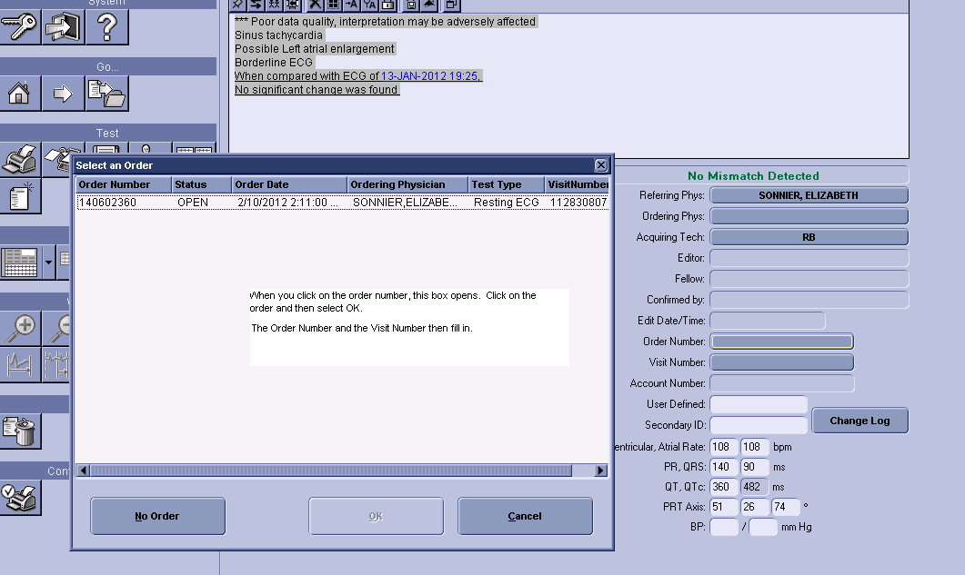

a. Order and/or Visit button are blank:
Every ECG in MUSE must be associated with an EPIC order and ordered through the appointment associated with the order. If the Order number is auto-generated and the visit button in MUSE is blank, it may be for one of the following reasons:

- The patient information was manually entered into the ECG machine and no patient appointment was made in EPIC. No appointment is available to merge the ECG with. Have the nurse/provider order the ECG through that day’s appointment. Release the order. Click on the Order number to fill in the Order and Visit numbers. This merges the ECG.
- The Order/Visit numbers are blank because 2 ECG’s were performed for the same order and another order needs to be created if both ECG’s are wanted on the medical record. Verify that 2 ECG’s were performed; make sure that the provider wants both and that one was not transmitted in error. If the provider wants both, ask the nurse to place a second order for an ECG. Then merge the second ECG to the new order. If only one ECG is wanted, delete the unwanted one.
- There may be a message that the order is pending. This means that the order was downloaded into the ECG machine but not used. The order needs to be returned to Open Orders.
- The patient information was manually entered into the ECG machine and sent to MUSE. All information was entered correctly and the order was released through an appointment but needs to be merged with the interfaced order. Click on the Order Number and the Order and Visit number will fill in.

Example: Edit/Retrieval Screen: Error Message: No ADT Record for Patient and Visit Number is blank.
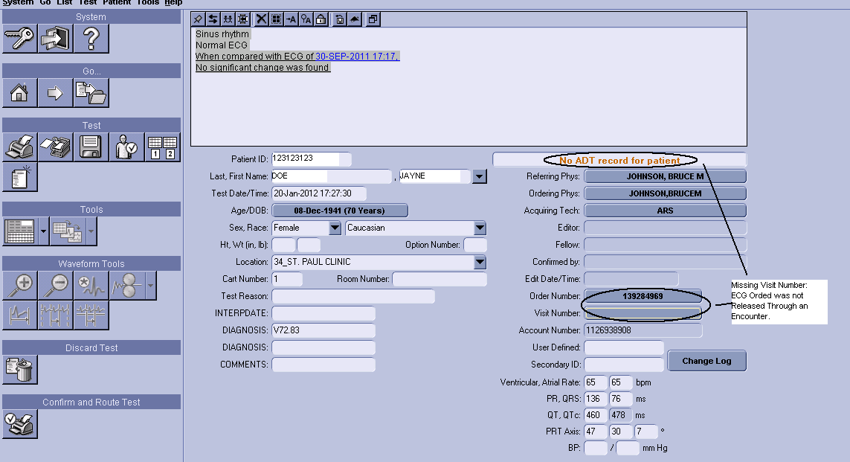

b. PID/Name Mismatch
A mismatch message will appear if there is a mismatch. To resolve the mismatch:
Click on the down arrow next to the Last Name field.
Select the appropriate name from the list. The report name will be replaced by the name selected.
Report Name: Current report name
System Name: Name attached to the record that was acquired into the MUSE before the current report, and has the same PID as the current report.
Admitting Name: Name sent to the MUSE from the HIS interface. Always select the Admitting Name when the Admitting Name and the Report Name are the same. If they are different, investigate the reason for the mis-identification.

When there is a mismatch, make sure to verify the correct number in EPIC. Sometimes the wrong number has been entered or a zero is missing at the beginning of the patient chart number. If this is the case, do the following:
- Correct the number.
- Select the admitting name. The Order and Visit fields will be visible.
- If the error message is still there, click on the Order Number and select “No Order”.
- Select the Visit Number and choose the correct visit.
- The Order Number is now blank.
- Select the Order Number again and select the correct order and say ok.
- The message should now say “No Mismatch Detected”.

Example: Edit/Retrieval Screen: Error Message: PID Mismatch
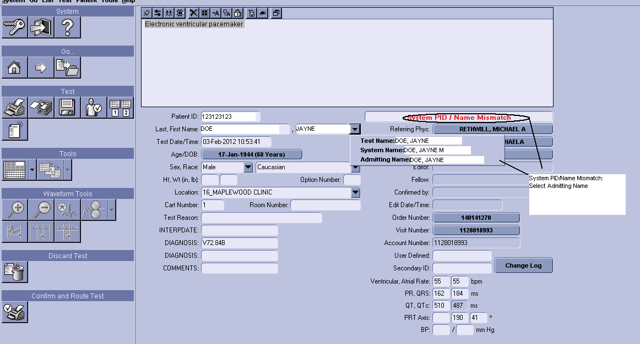

c. Pending Orders
To change Pending status to Open, go to Test>Orders & Accounts>Change Order Status to Open or Shortcut Key F2

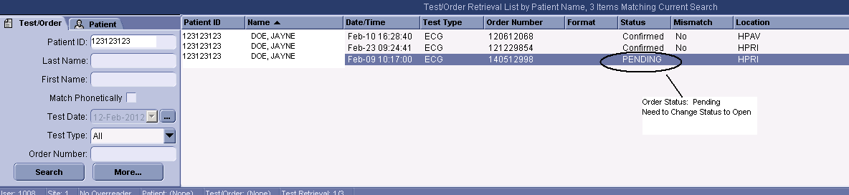

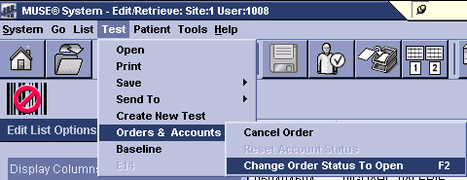

d. Serial Comparison:

Multiple ECG’s are sometimes run within a few minutes of each other and transmitted to MUSE. Multiple ECG’s are often rerun because of interference due to movement, lead problems, electrical, etc and a better tracing is desired. Since the instrument compares a patient’s ECG with the most previous ECG, the comparison will be made with the ECG’s run a few minutes earlier. In order to get an accurate serial comparison comparing the ECG from this appointment with the previous appointment, a new serial comparison should be run.

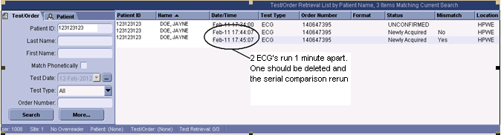

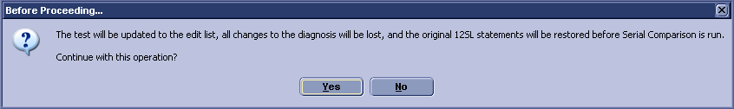

Send to Serial Comparison

Delete unwanted ECG tracings from the Edit List or the Test/Order Retrieval List.

Option 1:
- Highlight the record from the Edit List
- Click on the Send Test to Serial Comparison Icon.
- The system will remind you that all changes to the diagnosis will be lost and the original 12SL statements will be restored. Click Yes.

Option 2:
- Highlight the record on the Edit List.
- Click Test on the menu Bar. Select Send To and then Serial Comparison
- The system will remind you that all changes to the diagnosis will be lost and the original 12SL statements will be restored. Click Yes.

- Order Status Mismatch
If the Order Status Mismatch error message is present and there is an order and visit number, it is likely due to the fact that the order number is a pseudo-order number, created because there wasn’t an order. This was created so the preliminary ECG is visible in EPIC but it cannot be used for merging or billing. A new order will have to be placed for the correct date of service and the order will have to be released through the correct appointment. Then, the order can be merged by clicking on the order number in EPIC and selecting the correct order.

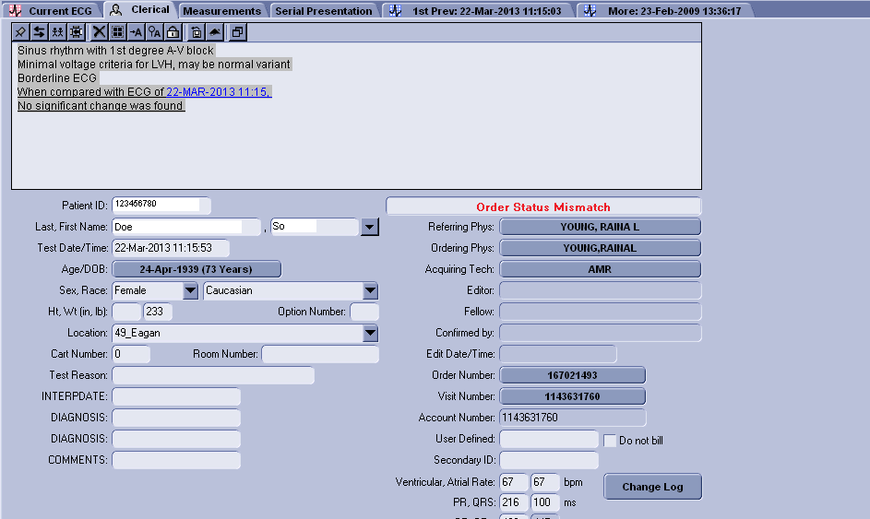

- Over-reading the ECG:

Example: Edit/Retrieval Screen: Selecting an Over-reading Physician
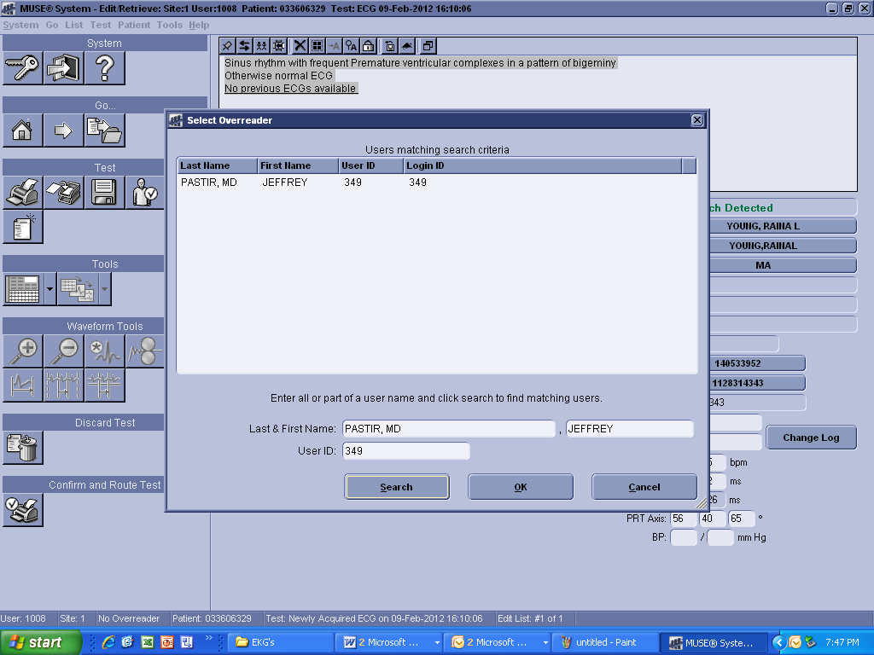

Selecting an Over-reading Physician:
- At the Edit List, select Tools>Select Over-reader. The Select Over-reader window appears
- You can search by name or user ID.
- To search by User ID, type the User ID in the User ID field.
- To search by Physician Name, type in all or part of a over-readers name in the First and Last Name fields. Click Search to search for matching users.
- Highlight the correct user and click OK. The user’s name will now appear as the over-reader for any reports being confirmed.

5. Editing the ECG:

Example: Edit/Retrieval Screen: Editing an ECG
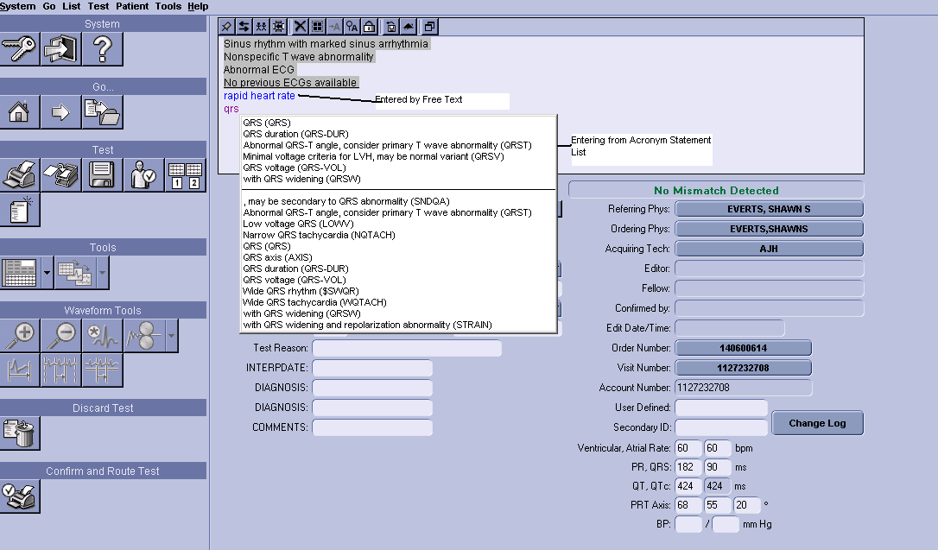

To Edit the ECG:
See the Interpretation Screen that displays the instrument interpretation.

The original 12SL diagnosis appears shaded in gray.
Free Text entered appears with a different background color.
The cursor is over each character.
Blinking Cursor: Indicates where the library statements or free text will be inserted.

a. Adding Acronym Statement from the Acronym Statement List:
- Type the first letter or second letter of the acronym you want to add to the diagnosis.
- The Matching Mode list appears, with a list of the acronyms that contain the letters typed.
- Highlight and double click on the correct acronym statement in the list. It appears in the diagnosis.
- To delete the acronym statement, highlight the statement and press the Delete key, or place the cursor at the end of the statement and press the Backspace key.

b, To add Free Text to the current Diagnosis Statement:
- At the diagnosis statement window, insert the cursor at the point where you want to insert a free text statement.
- Begin typing. Note: If you begin typing and the acronym drop-down box appears, continue typing until it disappears.
- Press the Enter key to move to the next line.
- To delete free text, highlight the text and press the delete key or insert the cursor and press the Backspace key. This deletes one character at a time.
- To insert an acronym while typing free text, select the Insert key. The acronym drop down menu appears. Select the appropriate acronym and continue.

c. To Restore the Original 12SL Diagnosis:
- Right click at the diagnosis statement. A menu appears.
- Select Original 12SL Diagnosis. The Original 12SL Diagnosis window appears. Click Restore. The diagnosis statement will be restored to the original 12SL diagnosis, including any statements deleted during editing.
- All new statements and free text will be deleted if Restore Original Diagnosis is selected.

Edit Toolbar: Located in the Interpretation Screen

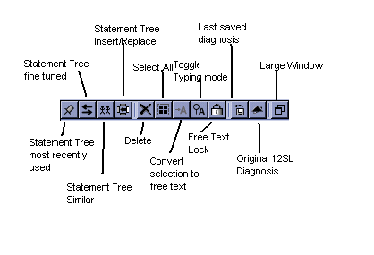
- Confirming the ECG:
The ECG can be confirmed when:
- The Error Message has been resolved and it says “No Mismatch Detected”
- Order and Visit Numbers are filled in
- The Provider either agrees with the instrument interpretation and makes no changes to the ECG, or the Provider changes have been entered.
- When finished, press the Confirm and Route Icon or (F6) to confirm the ECG.

e. Shortcut Keys:
F5: Refresh
F6: Confirm and Route
F7: Skip to the next test
F8: Update to the edit list
F2: Opens a Pending or Discarded order: Highlight and press F2. This changes
the order to OPEN.

6. Print a ECG to a Defined Device

Example: Print an ECG
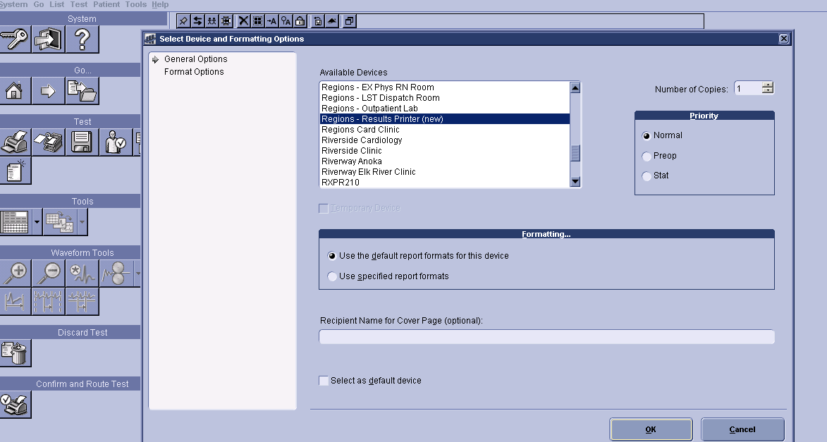

a. To Print an individual ECG:
- Select the Print ICON or Highlight a record and select Report from the Menu Bar at the top of the screen.
- Select Print.
- Select the desired printer from the list.
- Select the number of copies. The default is 1.
- Click OK

b. To Print a List:
- Select and click on the print ICON.
- To print a list, do a right click on the list and a box pops up to “print list”.
- Select the printer you wish to print to.

c. Printing to Regions Result Printer
When printing ECG’s to Regions Cardiology to be over-read by a cardiologist, always print to Regions Result Printer.

7. Deleting an ECG order in MUSE:
- Cancel an ECG order without results, in EPIC. Credit the order in Sunquest. If it is cancelled only in Sunquest, the cancel will not file back to EPIC.
- Once an ECG is transmitted to MUSE and you want to delete it, contact IS Computer Help Desk. IS will make sure the record is correct in EPIC and that the billing information is also correct. This includes unwanted occurrences of transmission of multiple ECG’s. Call or e-mail IS & T computer support. Make sure you say it is in MUSE.

8. Outside Provider Order:
- Place the order in EPIC. You will need to get an Epic number for the outside provider by contacting LIS, permission from a clinic provider to use them as the ordering provider or use the clinic’s Doc of the Day.
- Release the order through a lab appointment.
- Enter the name of the outside provider in the “comments”
- ECG should be edited and confirmed according to the regular process:
  - Clinic provider can read and edit ECG
  - ECG can be sent to Regions to read and edit
  - If patient is a pediatric patient (<17 years of age), the ECG is sent to Childrens Heart.
- Follow faxing instructions as indicated on the paper requisition.

Always log out or exit application when finished with session.
Log Out: Logs out to Log In Screen

Exit Application: Exits Application and shuts down MUSE

Interpretations/Results
N/A
ECG results are blocked from the provider in-basket. The tracing is available in Epic in the patients chart under the ECG tab. Once the ECG is transmitted to MUSE, a preliminary, unconfirmed, copy is visible in EPIC in the patient’s chart. When the ECG is confirmed, the preliminary is overwritten with the final, confirmed report.

Reference Ranges (Expected Values)
N/A

Computer Entry
See Procedure

Notes
Edit List should be monitored weekly by each clinic’s laboratory staff and “Super Users”. If ECGs are still waiting in the “Edit List” after 1 week, reprint and distribute to physician reader.

Author/Reviewers (s)
Denise Bergo2
Nancy Butala
JAGayken
DBergo

Endorsement
Laboratory Administration

