**New specimen collection option for Chlamydia/GC orders- August 3rd**

Effective August 3, 2015 patient self-collected vaginal specimens will become an acceptable source type for the testing of Chlamydia trachomatis and/or Neisseria gonorrhoeae by nucleic acid amplification at HealthPartners Central Laboratory.

Providers should use the same EPIC order codes as before (Chlamydia - 0095, GC (N. Gonorrhoeae - 3042 or Chlamydia & GC - 3801).

**Once ‘vagina’ is selected as a source type, a drop-down box appears prompting the provider to differentiate between provider-collected and patient-collected.**

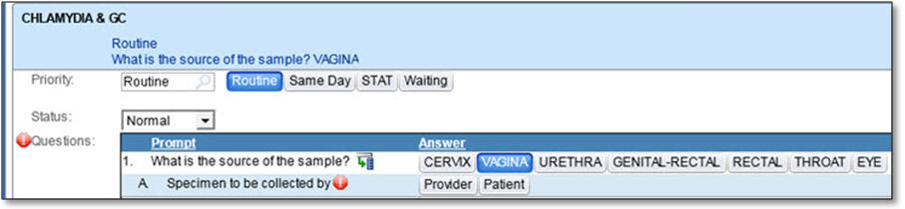

Vaginal sources (whether patient-collected or provider-collected) MUST use a different collection media from the other swab sources - The Aptima Vaginal Swab Collection kit. An example of the **orange-colored vial** is shown below. (Please note - Any *Non*-Vaginal sources collected with the orange-colored Aptima Vaginal media will be rejected.)  Aptima Vaginal Swab Collection Kit supplies can be ordered using Lawson order # 133717.

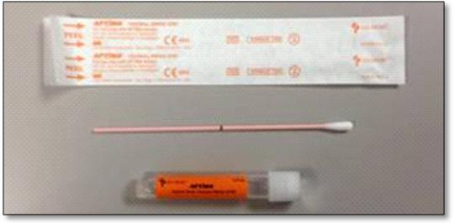

* According to numerous studies, self-collected vaginal swabs represent as high as or more sensitive an approach for detecting both CT and NG compared to provider-collected endocervical swabs (typically 97.2% and higher)
* A recent pilot study performed at the Woodbury location showed that collection was convenient in either an exam room or bathroom, and easier than leaving a urine sample. There were no patient complaints, and especially younger patients were most open to the technique and its privacy.
* Chlamydia is one of the most common bacterial STIs in the United States, and the majority of cases are asymptomatic. If left untreated, chlamydia can lead to serious complications. Screening for chlamydia is an ICSI, Level 1 Recommendation with a goal to meet 80%.

Questions may be directed to Dr. Douglas Olson, Central Lab Medical Director at 651-254-9618, Amy Walton, Woodbury CDS at 651-702-5300, or Paige O’Keefe, Central Lab Technical Specialist at 952-833-1800.