
HealthPartners/GHI
Subject  Glucose  Accu-Chek® Inform II Point-of-Care Procedure | Attachments  Yes No
Key words Glucose Meter, AccuChek, blood sugar, glucose, BG, POC glucose | Number  GHI-PC-CLINIC LAB-Procedures-Glucometer Inform II v. 12-2013
Category Provision of Care | Effective Date  December 2013
Manual Clinic Laboratory Procedure Manual  Point-of-Care (PPM) Procedure Manual | Last Review Date  November 2014
Issued By Clinic Laboratory Administration | Next Review Date  November 2015
Applicable Clinic Laboratory Staff | Origination Date  December 2013
Level of Complexity Waived | Retired Date
Review Responsibility Laboratory Technical Consultants | Contact Laboratory Technical Consultants

Glucose Accu-Chek Inform II
Clinic Lab Procedure (Pages 1-11)
Troubleshooting (Pages 12-13)
Computer Test (Pages 14)

PURPOSE/PRINCIPLE
This procedure provides direction for performing a whole blood glucose test using the Inform II meter.

This AccuChek Inform II glucometer is a waived test intended to quantitatively measure glucose in venous arterial, neonatal heelstick, or fresh capillary whole blood samples. Specimens measured at the Point of Care aid in monitoring the effectiveness of glucose control.

The enzyme on the test strip, a mutant variant of quinoprotein glucose dehydrogenase (Mut. Q-GDH), from Acinetobacter calcoaceticus, recombinant in E. coli, converts the glucose in the blood sample to gluconolactone. This reaction creates a harmless DC (direct current) electrical current that the meter interprets for the blood glucose result. The sample and environmental conditions are also evaluated using a small AC (alternating current) signal. The system reports a plasma-like glucose result.

POLICY
Staff performing fingerstick glucose will follow the approved techniques outlined in this procedure.

HealthPartners family of care uses single-use needle and lancing devices for all phlebotomy and blood collection procedures. Should it be necessary to re-stick a patient, a new, single-use needle or lancing device will be used.

HealthPartners family of care will clean the outside of the POCT meter with an approved disinfectant wipe (i.e., Sanicloth AF) after each patient test for meters that come into direct contact with patients in accordance with HPMG policy and CDC requirements. All meters will be cleaned between patients regardless of whether the meter is visible dirty or not.

SPECIMEN

A. Confirm patient identification prior to testing using 2 patient identifiers.
B. Acceptable specimens:
- Venous whole blood, arterial whole blood, neonatal heelstick, or fresh capillary whole blood samples drawn from fingertips may be tested.
- Lithium heparin, sodium heparin, or EDTA anticoagulants may be used.
- Do not use fluoride or iodoacetate.
- Do not use serum or plasma samples.
- If a specimen has been refrigerated it must be brought to room temperature before testing.

NOTE: Venous and capillary blood may differ in glucose concentration by as much as 70
mg/dL, depending on the time of blood collection after food intake (within 2 hours).

- Venipuncture, arterial puncture, or line draw: Lines must be adequately flushed before obtaining samples for testing.

- Capillary blood must be tested immediately. Venous and arterial blood samples must be tested within 30 minutes to minimize glycolysis. If using fresh whole blood in the absence of an anticoagulant, test immediately to prevent clotting. When whole blood in a test tube or syringe is used, mix well before testing. This can be accomplished by gently inverting the capped tube, or by inverting and rolling the syringe.

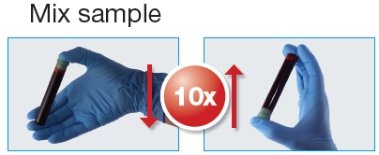

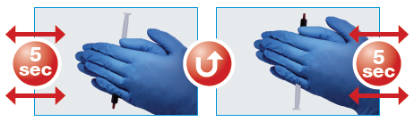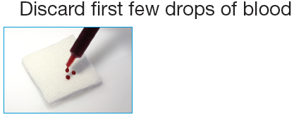

SPECIAL SAFETY PRECAUTIONS

Use Universal Blood and Body Fluid Precautions.

REAGENTS AND EQUIPMENT
All reagents are commercially prepared and labeled. Both test strips and quality control materials are available from Material Management. Clinic laboratories supply orders will request test strips and controls for the entire clinic. (Attachment #1-AccuChek Inform II Reagent Ordering and Distribution) Clinic Laboratories and Nursing Care Units will order their own fingerstick lancing devices.

A. Equipment
1. Accu-Chek Inform II blood glucose meter, base unit, and storage case, Roche Diagnostics, Indianapolis, IN 46256
2. Sterile-approved lancing device

B. Materials
1. Accu-Chek Inform II test strips, Roche Diagnostics, Indianapolis, IN 46256
2. Accu-Chek Inform II controls, Level 1 (Lo/gray cap) and Level 2 (Hi/white cap), Roche Diagnostics, Indianapolis, IN 46256
3. Accu-Chek Inform II linearity test kit, Roche Diagnostics, Indianapolis, IN 46256 (used only by Laboratory Supervisors or Laboratory Technical consultants)

C. Supplies
    - Skin preparation (wash/dry hands and alcohol pad prep)
    - Gloves
    - Single Use Lancets

D. Storage and Stability:
- Store test strips in the original capped container at room temperature. (The acceptable temperature range is 2 – 30 °C or 36 – 86 °F.) Do not freeze. Use the test strips at a temperature range between 16 – 35 °C or 61 – 95 °F. Store unused test strips in the original container with the cap closed. DO NOT remove test strips from the test strip container and put them into another container such as a plastic bag or pocket. Close the container tightly immediately after removing a test strip to protect the test strips from humidity. Use the test strip immediately after removing it from the container. Strips (opened or unopened) expire upon manufacturer’s expiration date. Discard expired strips.
2. Store control and linearity solutions at room temperature. (The acceptable temperature range is 4 – 30 °C or 36 – 86 °F) Do not refrigerate or freeze. Identify expiration date as 3 months after opening solutions or manufacturer’s expiration date, whichever comes first. Write open and expiration date on label. Do not stick the label over any part of the barcode. Discard expired controls.

CALIBRATION
The AccuChek II Inform meter does not use individualized code keys in each meter. The code key (for the entire lot) is read into a code key reader and the information uploaded into the meters through the wireless/wired network. ONLY the Clinic Laboratory Technical Consultants can use the code key reader to enter the required strip lot data into the system.

LINEARITY – 20 - 600 mg/dl
- Each monitor is checked for linearity before being put into use or if problems arise.
- Use Roche Accu-chek comfort curve Linearity test kit, (6 levels).
- The Laboratory Technical Consultants performs linearity.

QUALITY CONTROL
Control specimens must be tested in the same manner and by the same personnel as patient samples, i.e., control specimens must be analyzed by personnel who routinely perform patient testing. This does not imply that every operator must perform QC daily, so long as QC is performed at the required frequencies. However, a variety of analysts must participate in QC on a regular basis. The individuals performing the QC must also perform patient testing in that clinical area. QC duties may NOT be assigned to any individual who does not regularly perform patient testing in that same clinical area.

A. HealthPartners/GHI Clinic Control frequency (both levels):
- Once every 24 hours or every day of patient testing
- Immediately after use of both STAT patient tests
- If the AccuChek Inform II meter has been dropped
- If a vial of test strips has been found left open
- When test results contradict a patient’s clinical symptoms
B. Control procedure: Both Level 1 (Lo) and Level 2 (Hi) controls are required.
  - Turn meter on and press ►. Scan or enter operator ID and press.
  - The Main Menu screen is displayed.
  - Select Control Test.

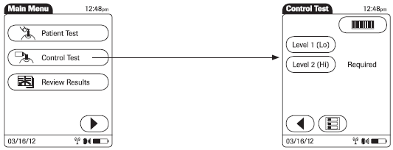

  - Scan the control barcode. (you do not need to select the control level)

  - Scan the strip barcode.
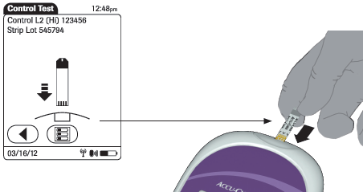

  - Remove one test strip from the vial. Close the strip vial immediately and completely. Test Strip must be used within 5 minutes. Hold the test strip so that the lettering ACCU-CHEK is facing upward and the end with the metal contacts fits inside the strip port. Slide the test strip into the test strip port as far as it goes. The meter beeps.

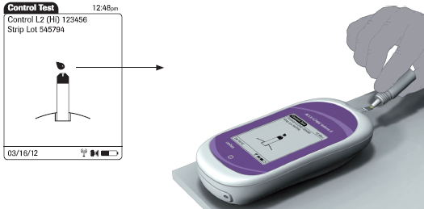
  - Wait until the flashing drop appears in the display before applying the control solution. Apply a drop of control solution to the front edge of the test strip. Do not apply control solution to the top of the strip. The solution will be pulled into the strip. Wipe vial tip and replace cap on control vial. Once sufficient control solution has been detected, the meter beeps and measurement begins.
  - The hourglass icon indicates the test is running. When the test is completed and the result is read, the meter beeps again.
  - PASS or FAIL displays.
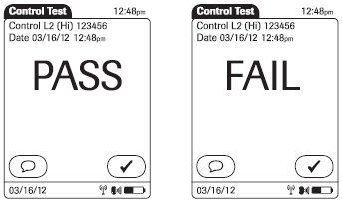
  - If the control fails, entry of a comment is required. See QC corrective action below.
  - Remove the strip and discard. AccuChek Test Strips may be discarded in regular trash containers.
  - Repeat this process for the remaining control.

C. Control evaluation
- The operator performing the quality controls is responsible for performing any necessary corrective actions. See QC corrective action below.
- Failed control results may indicate:
a. Old or contaminated glucose control solution. NOTE: Allowing control material to pool and/or dry around the tip of the vial can falsely increase the control result.
b. Test strip deterioration.
c. Meter malfunction.
D. QC corrective action
1. If the result is FAIL, enter the appropriate comment into the meter.
2. Evaluate unacceptable control results as follows:
  - Verify that controls are not expired. Discard controls that are expired.
  - Repeat any out of range control, verifying that the control procedure above has been followed carefully. NOTE: If top of vial has dried control residue, wipe and discard 1 -2 drops before retesting.
  - Replace controls and repeat. (Contact the clinic laboratory for new Quality Control materials)
  - Replace strips and repeat.
  - If still unresolved, contact your clinic laboratory for assistance.

NOTE: The Clinic Laboratory will inspect your meter and replace your control solutions every three months. Bring your tote, meter and testing supplies to the laboratory. Laboratory staff will label the new set of controls with the open and expiration dates. If you need to replace your controls before three months please contact the clinic laboratory.

SPECIMEN
A. Confirm patient identification prior to testing using 2 patient identifiers.
B. Acceptable specimens:
- Venous whole blood, arterial whole blood, neonatal heelstick, or fresh capillary whole blood samples drawn from fingertips may be tested.
- Lithium heparin, sodium heparin, or EDTA anticoagulants may be used.
- Do not use fluoride or iodoacetate.
- Do not use serum or plasma samples.
- If a specimen has been refrigerated it must be brought to room temperature before testing.

NOTE: Venous and capillary blood may differ in glucose concentration by as much as 70 mg/dL, depending on the time of blood collection after food intake (within 2 hours).

- Venipuncture, arterial puncture, or line draw: Lines must be adequately flushed before obtaining samples for testing.

- Capillary blood must be tested immediately. Venous and arterial blood samples must be tested within 30 minutes to minimize glycolysis. If using fresh whole blood in the absence of an anticoagulant, test immediately to prevent clotting. When whole blood in a test tube or syringe is used, mix well before testing. This can be accomplished by gently inverting the capped tube, or by inverting and rolling the syringe.

PROCEDURE - FOR PATIENT TESTING

NURSING NOTE: Prior to testing patients in the Care Units, EPIC order, AccuChek (Nursing Procedure) 82962, MUST be placed. Add appropriate diagnosis code for patient being tested.

Steps for capillary puncture procedure:
Assemble the materials necessary to perform the test.
    - Vial of test strips
    - Skin preparation pad
    - Gloves
    - Lancet
    - Gauze pads (2 X 2) Gauze is preferable over cotton because cotton may leave small fibers on the skin, jeopardizing good blood flow).

- Turn meter on and press ►. Scan or enter operator ID and press. The Main Menu screen is displayed.

- If controls are due, perform controls tests according to the control procedure (above).
- From the Main Menu, press Patient Test.

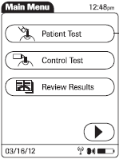

- Enter the patient's 8 digit MRN. Verify the information on the screen that the information entered is correct.

NURSING NOTE: To test a patient before their MRN is assigned or known, use the Clinic Emergency Barcode. The Emergency Barcode is found on the inside cover of the AccuChek tote. It is REQUIRED to send the Clinic Laboratory the correct patient name and MRN when it becomes available. The person performing the test is responsible for providing this information to the Laboratory. Patient information will be forwarded to the Clinic’s Laboratory Technical Consultant for entry into the patient’s medical record.

- Scan the strip barcode when asked the strip lot number.

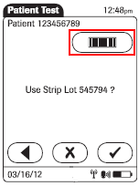

The following screen appears

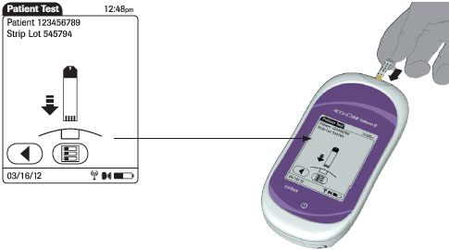

5. Hold the test strip with the lettering ACCU-CHEK facing upward and the metal contacts toward the meter. Slide the test strip into the test strip port as far as it goes. The meter beeps. Reclose the strip vial immediately and completely. You are prompted to apply a blood sample. Wait until the red flashing drop appears on the display. Obtain specimen.

- Heelstick: Blood flow may be increased by using a warm washcloth or a heel warmer. Cleanse the heel with the skin preparation pad. Dry with gauze.

To perform a heelstick, place your thumb on the inside bottom of the foot and push the skin across the heel toward the outside of the heel. Choose the most medial or most lateral portions of the plantar or bottom surface of the heel.

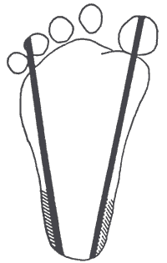

Stick in shaded area only.

Capillary Collection: Blood flow may be increased by warming the site for 3 – 5 minutes by using a warm washcloth or appropriate warming device. Have patient wash hands with soap and water prior to fingerstick to remove any food or drink product residue.

- Fingerstick: The middle or ring finger is preferred for fingerstick collections. Avoid cold, cyanotic, bruised, cut or swollen fingers. Use the non-dominant hand if possible. Each test should be performed from a new skin puncture.

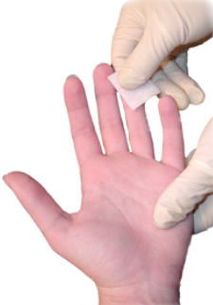

- Gently massage the finger five or six times from the palm to the base of the finger and up to the tip of the finger.
- Cleanse the finger with the alcohol pad. Allow the finger to air dry.

NOTE: It is imperative that the skin be dry prior to puncture.

- Position the hand at a level below the heart.
- Hold the finger firmly with one hand and place the disposable lancet device against the finger, selecting either side of the fleshy pad.
- Trigger the lancet device. Wipe away the first drop of blood – This is important as you need to remove interstitial fluid that may be in the first drop of blood which could lead to erroneous results. Hold the puncture site downward and gently apply intermittent pressure to the surrounding tissue. Do not apply strong repetitive pressure (“milking”). This may cause erroneous test results.
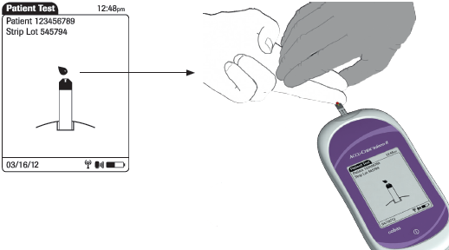

- Apply the drop of blood to the front edge (yellow dosing area) of the test strip. Do not apply the blood to the top of the strip. Blood will be pulled into the test strip. Once sufficient blood has been pulled into the test strip, the meter beeps and measurement begins.

NOTE: Place the meter on a hard, flat service while the test is in progress. Blood can be wicked out of the strip when the meter is placed on bedding after applying blood to the strip.

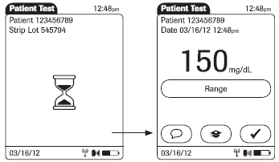

- The hourglass icon indicates the test is running. Once the test is completed, the result displays. If you do not wish to enter a comment, press to return to the Main Menu
- If appropriate or prompted, press  to enter a comment. Press to return to the results screen, and press again to return to the Main Menu.

NURSING NOTE: If the AccuChek Inform II glucose test is performed POC by nursing or rooming staff and the patient’s glucose result is <70 mg/dL or >400 mg/dL a comment is required. In addition,
Follow Standing Orders Protocol for Hyperglycemia or Hypoglycemia.
(See Attachment #2 for hypoglycemia and hyperglycemia standing order protocols.)

- If the result is below the lower limit or above the upper limit of the reportable range, the following flags may appear:

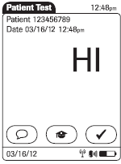

- LO – below the System Measurement Range, i.e. less than 20 mg/dL
- HI – above the System Measurement Range, i.e. greater than 600 mg/dL

NOTE: For confirmation of critical glucose values, (<50 mg/dL or >450 mg/dL), or results outside of the analyzer’s System Measurement Range, (<20 mg/dL or >600 mg/dL), the Medical Provider may order a confirmatory glucose at no charge to the patient. The patient should be sent to the laboratory for venipuncture collection and the specimen sent STAT to Central Lab or Regions Hospital for confirmation.

- Remove the strip and discard.
- Clean the AccuChek Inform II meter with a Sanicloth. The AccuChek Inform II meter MUST be disinfected between patient uses. Allow to air dry.
- When dry return the meter to the base unit to charge.

If a patient is experiencing symptoms that are not consistent with the blood glucose result obtained, proceed with the following steps:
- Ensure that patient hands are free from food residue prior to testing. Have them wash their hands with soap and water, disinfect and repeat test.
- Repeat controls to verify correct meter function.
- Review LIMITATIONS AND INTERFERENCES. Some patient samples must be tested by another method to obtain reliable results.
- Patient may be sent to the Clinic Laboratory for venipuncture and glucose sent to Central Laboratory for analysis.

EXPECTED VALUES/REFERENCE RANGE
- Fasting Whole Blood (Fasting at least 8 hours): 70-100 mg/dL
- Random Whole Blood (Fasting less than 8 hours) 70-180 mg/dL
- Critical values of <50 mg/dl or >450 mg/dL should be reported to the physician immediately and documented with a PHON1.

INTERPRETATION/RESULTS
- Results are transmitted automatically to the patient’s electronic medical record via wireless transmission. This is contingent upon entry of a valid patient MRN into the patient ID field.

NOTE: Use of the comment OPERATOR ERROR prevents electronic reporting of the test result.

- Laboratory critical values: ≤50 mg/dL or ≥450 mg/dL.

- Critical Values must be reported to persons in a position to intervene on the patient’s behalf.
(Follow your specific nursing protocol for reporting of results.)

- Follow the nursing policy for treatment.

REPORTING RESULTS
Clinic Labs: see the Computer Entry section of this procedure

Maintenance:
- The AccuChek Inform II meter needs little or no maintenance with normal use. It automatically tests its own systems every time it is turned on and lets you know if something is wrong.
- After each patient, clean outside of monitor with an approved disinfectant wipe (i.e. Sanicloth AF).
- Turn meter off to clean. Do NOT let moisture enter the Test Strip guide.
- Keep monitor free from dust. Protect from extremes in temperature and humidity.
- Operate monitor between 6˚-44˚C (43˚-111˚F) and 10-90% humidity.

LIMITATIONS OF THE PROCEDURE

Sample source
There are significant differences between venous, capillary (finger or heel stick), and arterial blood glucose levels, with the venous glucose level tending to be the lowest of these three sources. These differences may be even greater depending on time elapsed since the individual has consumed food, etc. Such differences may be as much as 70 mg/dL. Unusual sample sites for capillary puncture, such as forearm, ear lobe, etc. may NOT be used for glucose testing, as even bigger differences may occur.

Shock or peripheral perfusion problems
When a patient is in shock and/or has peripheral perfusion problems, differences in glucose concentrations between sites are even greater. (Blood loss from trauma could be one cause). The normal processes by which glucose and other substances are distributed throughout the system are impaired. Capillary samples should not be used for these patients.

Diabetic ketoacidosis (DKA)
When a patient has very high blood glucose (hyperglycemic-hyperosmolar state, ketotic or non-ketotic), the usual ways glucose moves between red cells and plasma, and between venous and capillary spaces, are changed. Capillary samples should not be used for these patients. Even a venous sample tested on a glucose meter may be unreliable. A venous or arterial sample may be tested by an iSTAT analyzer or sent to Central Laboratory or Regions Hospital for testing by standard laboratory instrumentation.

Time delay between fingerstick glucose test result and draw of Clinical Laboratory specimen
A person’s glucose level is continuously changing. In addition, treatment (insulin, orange juice, food, exercise, etc.) may have been administered between obtaining of samples.

Hematocrit
Hematocrit should be between 10 and 65% for testing on this meter.

Specific interferences
Triglycerides >1800 mg/dL, galactose >15 mg/dL, and ascorbic acid >3 mg/dL may cause false overestimation of glucose results. If a neonate demonstrates symptoms of galactosemia, do not use the meter; send the patient to the laboratory for heelstick collection. Specimen will be sent to Central Laboratory or Regions Hospital STAT for testing.
Glucose strip storage/reagent deterioration
Improperly stored test strips may result in unreliable results. See REAGENTS/SUPPLIES/EQUIPMENT (above).

Proper sample
Patients and samples must be identified properly and immediately. Always use correct sampling technique (see SPECIMEN and PATIENT TEST PROCEDURE above). Capillary samples must not be contaminated by substances on the patient’s fingers (cleansing agents, sugars from food, etc.) The skin prep fluid must be completely dry. Wipe away the first blood drop before testing; do not squeeze excessively. Samples drawn from or near IV lines may be contaminated with IV fluids.

Maltose
Maltose does NOT interfere with this test method.

Expected reproducibility
On the same sample tested at the same time, duplicate testing is expected to produce results ± 15 mg/dL if the glucose level is <75 mg/dL, and ± 15% if the glucose level is >75 mg/dL.

PROCEDURE NOTES
Please contact the clinic laboratory about Glucometer failures.

ERROR MESSAGES

Error Message | Possible Solutions
Meter display does not turn on. | Wait 10 seconds and try again. If meter still does not turn on, place the meter in the base unit and confirm that it is charging, i.e., charge the battery by placing the meter in the base unit.
Type bad dose | Insufficient blood on the test strip. Repeat the test using a new test strip, ensuring proper sample application.
Battery Low or Battery Critically Low | Charge the battery by placing the meter in the base unit.

ReferenceS

- Accu-Chek Inform II System, Roche Diagnostics, Indianapolis, IN 46256, 2013
- Accu-Chek Inform II test strips package insert, Roche Diagnostics, Indianapolis, IN 46256, 20123
- Accu-Chek Inform II controls package insert, Roche Diagnostics, Indianapolis, IN 46256, 2013
- Accu-Chek Inform II linearity test kit package insert, Roche Diagnostics, Indianapolis, IN 46256, 2013

RELATED DOCUMENTS
  - computer order and result entry
  - Nursing Hyperglycemia standing orders protocol
  - nursing hypoglycemia standing orders protocol
  - glucose worksheet
  - pOINT OF CARE TESTING POLICY

APPENDIXES

na

AUTHOR/REVIWER(S)

Kkaestner

akhOWARD

COMPLIANCE
Failure to comply with this policy or the procedures may result in disciplinary action, up to and including
termination.

ATTACHMENTS

OTHER RESOURCES

ENDORSEMENT Laboratory Administration

Computer Order and Result Entry
GLUCOSE, bG, ACCUCHEK INFORM II METER
Order Codes: GLBGR (Random, <8 Hours Fast)
GLBGF (Fasting >8 Hours)
ORDERING:
NOTE: Lab should automatically add a GLBGF order to any GTT. Order on the same access number as
the GTT.

After the computer has assigned an accession number in RE, you will be prompted for the following:

CODE NAME RESPONSE
HOURS Hours Fasting Enter number of hours fasting in increments of 0.5. If < 0.5 hours, enter 0.

RESULTING:
WORKSHEET:
Function MEM, Worksheet CP_ _ (Chem Preg)

RESPONSE:
CODE NAME RESPONSE
GBGR Glucose, bG Strip, R Enter the number directly.
GBGF Glucose, bG Strip F If Inform II meter read LO, enter <10.
If Inform II meter read HI, enter >600**.

NOTE: For Pre-GTT orders, proceed as follows:
- If GBGF is >200 and patient is >/= 16 years old append -CDM (Criteria for Diabetes Mellitus in Adults) to the result (example: 350-CDM).

- If provider cancels the GTT, or the provider cannot be contacted, send GTT to be credited using code EGL (Test Contraindicated Due to Elevated Fasting Glucose).

- If provider continues the GTT, append -DOGTT (Dr. OK’d GTT) to the GBGF result (example: 350-
DOGTT). In this case, do NOT append -CDM.

ADDITIONAL INFORMATION:
The computer will append the code -QBC2 (Semi-quantitative result may be 5-10% lower than quantitative
result) to all results.

* If results are >600, check with provider to see if specific numerical results are needed. If so, add GLR or
GLF order to accession number and send to Central Lab.

Revised/Reviewed By:
Karen Kaestner

