PAP AND/OR HPV SPECIMEN RECEIVING TIP SHEET

**PAP and/or HPV specimen receiving process in the lab:**

1. Sort the inbasket by patient name. Review for duplicate orders for the same patient and resolve before you “Done” the order- see guidelines below.
2. “Done” the PAP and/or HPV order from the inbasket - Sunquest labels will print.
3. Inspect the specimen vial(s) for proper labeling and collection
   1. Verify the patient first name, last name and date of birth(DOB)/medical record number(MRN) match the order in the inbasket
   2. Verify correct date of collection (DOC)
   3. Verify there is a collection device in the vial
4. Resolve any order, collection and/or labeling issues prior to receiving in Sunquest – see guidelines below
5. Receive the tests in Sunquest using “ORM”

PAP TEST, ROUTINE (Epic 3682) 🡪 Misys test code: **PARL**

PAP TEST, DIAGNOSTIC (Epic 3683) 🡪 Misys test code: **PADL**

PAP TEST, ANAL (Epic 3619) 🡪 Misys test code: **PAPAN**

HPV, HIGH RISK (Epic 4233) 🡪 Misys test code: **HPVH**

1. Place the Sunquest CID and MRN foot labels on the Pap vial directly under the Epic label so that you can visually see the patient identifiers on all labels for verification of patient identification (see visual guide).
2. Discard any remaining labels in shred bin.
3. Track and bag all Pap specimens together on their own batch list to Regions. Each specimen should be placed in an individual biohazard bag, before placing in the larger bag, to minimize risk of cross contamination if a vial should leak.
4. Send the specimens to Regions via reroute.

**Resolving order, collection and/or labeling issues:**

a. Multiple orders for same patient in the Inbasket: create and send a telephone encounter message to the provider’s care team pool to review and cancel the duplicate order(s).

b. Unlabeled pap container: If there is no Epic label on the vial, the vial must be discarded. Regions Hospital Cytology will not accept an unlabeled sample and they cannot be reconciled using a Good Catch form. Review the inbasket at the end of the shift for an order that did not have a labeled specimen delivered to the lab. Cancel the order using cancel code TCAN-UNLAB-RECOL (Test Cancelled-Specimen Received Unlabeled-Please Recollect) and discard specimen. Create and send a telephone encounter to the provider’s care team using the dotphrase LABNOLABEL (This lab test has been cancelled due to the specimen being received unlabeled. If this test is still needed, please reorder and notify the patient to return for a new collection.

c. Correct patient first name, DOB and/or MRN;different last name: refer to care unit to resolve name discrepancy/change, re-label with the correct patient label and complete a Good Catch form. After the correction has been made and the specimen re-labeled, prepare for send out per protocol.

1. Incorrect DOC; refer to care team to resolve discrepancy, re-label with the correct patient label and complete a

good catch form. After the correction has been made and the specimen re-labeled, prepare for send out per protocol.

e. If there is no order placed in Epic: create and send a telephone encounter message to the provider’s care team pool and request orders using the dot phrase LOVNO. Prepare for send out, per protocol, after order has been placed.

f. If there is no collection device in the vial: create and send a telephone encounter message to the provider’s care team pool requesting confirmation that a pap was collected. If collection is confirmed, prepare for send out per protocol. If no specimen collected, cancel and credit the order using cancel code NRS (no specimen received).

**Placement of Sunquest labels to allow for positive patient identification**

Adhere the Sunquest foot label directly below the Epic label to allow for easy verification of patient information.

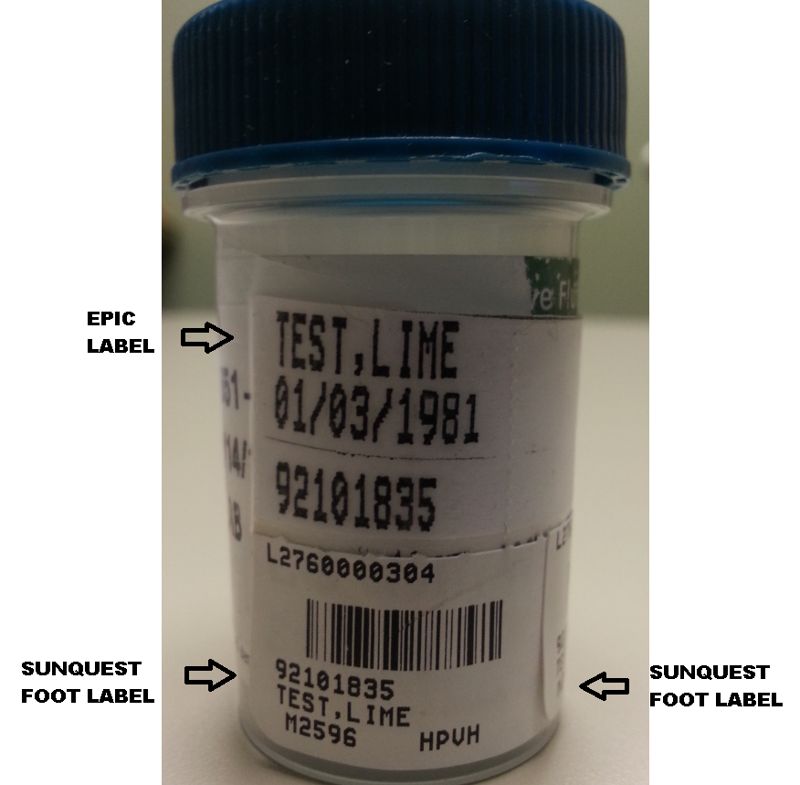

If more than one Sunquest foot label is required on the specimen (multiple tests ordered), adhere directly adjacent to first foot label across the bottom of the vial

