**A guide to 360 – lab procedures**

Select myPartner – Tools & Services – Policies, manuals & guides- Polcy manual resource directory

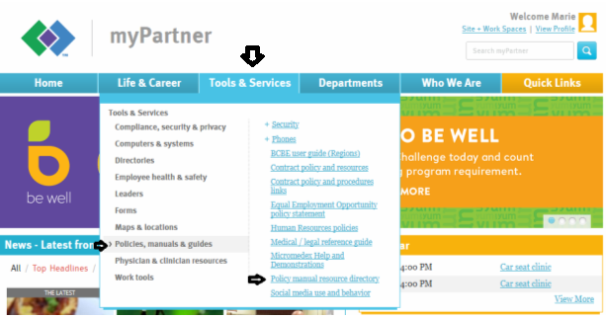

For Riverway lab testing procedures: Scroll down to Riverway Clinic – Clinic wide policy manual (s)

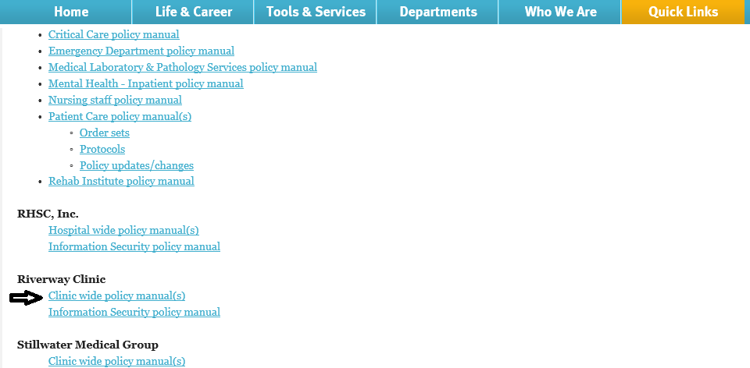

Enter the and select

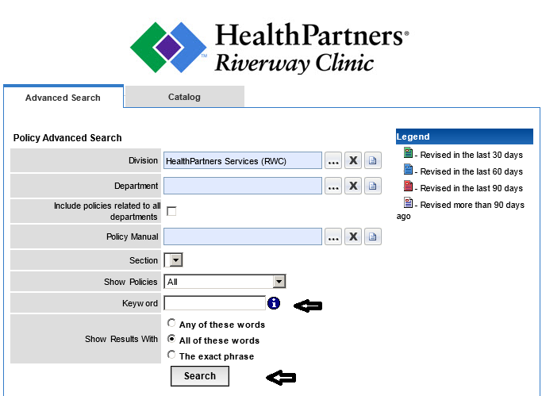

For general procedures related to Sunquest, data entry, result correction, etc.

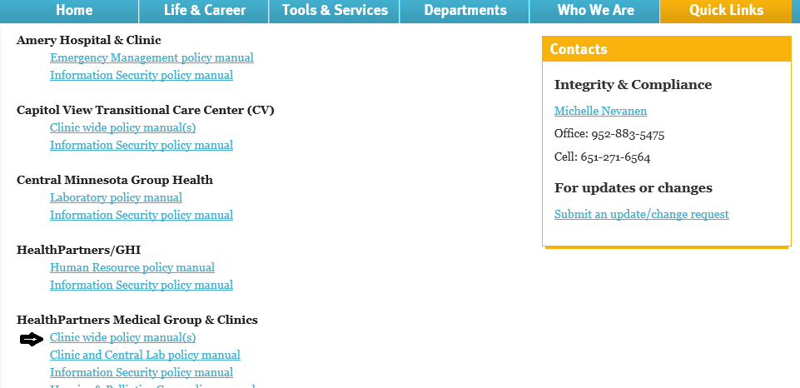

Enter the and select

