It is up to each of us to provide only high quality, adequate volume specimens for testing
Lab Staff,
Specimen quality and volume have become of critical importance on the automation lines at Central Lab and Regions. It is more important than ever that you are aware that the way blood is collected, mixed and processed in the Clinics determines the success of testing and insures accurate test results for the patients.
The automated processing lines, (pipettes, aliquot needles, probes) and analyzers are very sensitive to even the smallest clot of fibrin in serum or plasma specimens or separator gel, accidently aspirated when the volume of specimen in a tube is to low. Incidences like these have the potential to take the system down for hours. That is why it is up to the Clinic Medical Laboratory Technicians, Lab Assistants and Medical Assistants to provide only high quality, adequate volume specimens for testing.
Central Lab and Regions have asked for our assistance to remind staff of the proper techniques and procedures for specimen collection and processing in the clinics. Please review the information below ASAP to help patients avoid canceled tests and recollections, and to avoid the potential of shutting down our automation lines/chemistry analyzers.
Each specimen must be carefully examined by the send-out person for quality and acceptability. Unsatisfactory specimens must be rejected, test/s canceled, care teams notified and re-collected if required.
See below for correct sample preparation and information on, examples of, and tips for avoiding the most common unsatisfactory qualities reported by Central Lab.

Correct Sample Preparation Fibrin Clot
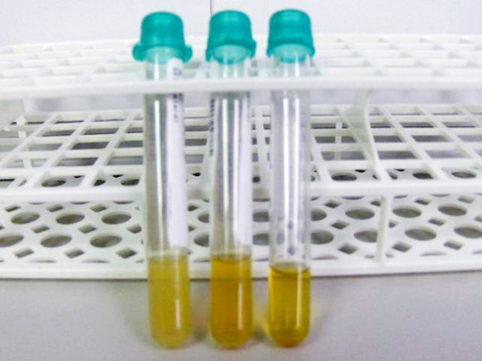 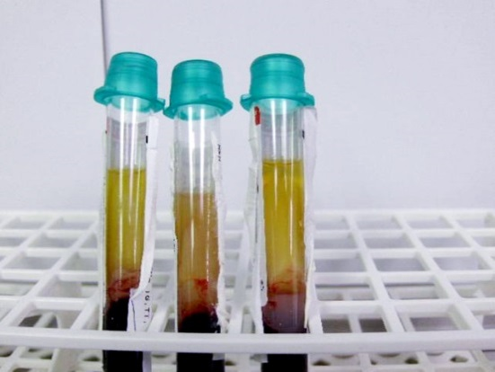 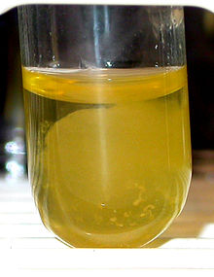
- Spun down before proper clotting process- 15-30 minutes.
- Centrifuge either not set to correct RPM’s or not spun down long enough- 15-25 minutes.
- Arrive at CL - will need to be poured off and re-spun.

Serum Samples
Spun down and poured off correctly

Improperly Spun Down in Centrifuge

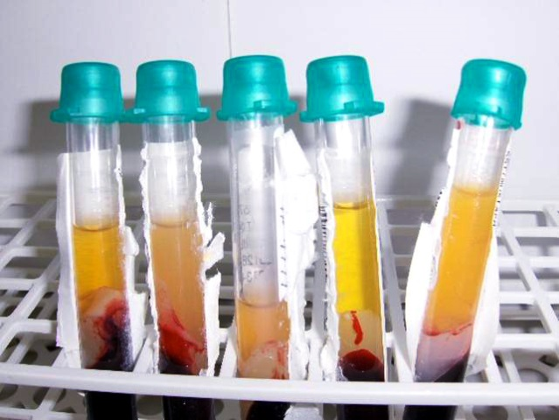
Results - Blood Cell Contamination Correction (Centrifuge RPM’s adequate):
- Be sure clotting process is complete; spin 15-30 minutes.

Complete Barrier Separation

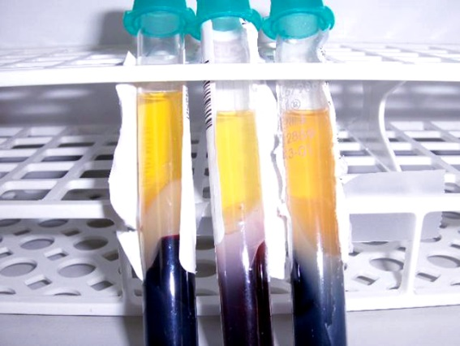
Blood Cells Suspended in Sample - with samples re-centrifuged

Good separation with barrier showing complete seal of blood cells from serum. (Anglehead centrifuge)

Blood Cells Suspended in Sample
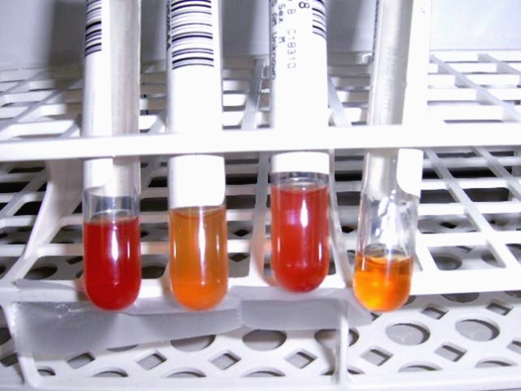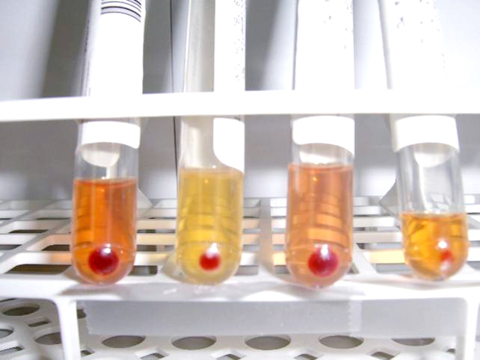
Re-centrifuged samples with “Gross Blood”- serum now clear and able to be processed through the line.
- #1 and #3 show slight hemolysis-May affect results of some analytes.
- If appear cloudy, check for Lipemia (Fat in blood) or suspended cells.
- Suspended cells will appear as swirling on shaking sample-Respin for 10 minutes- if still cloudy and no button in tube - probably Lipemia.

Blood cells suspended in serum — either separated into transport tube or in original barrier tube.
- Cloudy but no Triglyceride content (swirls in sample denotes blood cells).
- Central Lab will need to re-centrifuge sample.
- Some analytes may be affected. (Especially Glucose and Potassium.)

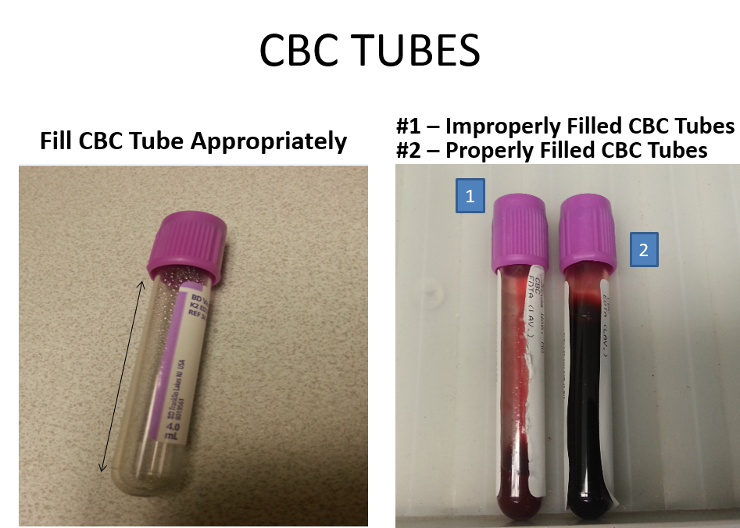
Fill CBC purple top appropriately
Fill CBC to appropriate fill line located on side of purple top for proper EDTA dilution. Overfilled or under-filled tubes will be rejected.

