Subject  Stago STart 4 Coagulation Analyzer | Attachments  Yes No
Key words –  Coagulation, Protime, PT, INR | Number  GHI-PC-CL
Category Provision of Care | Effective Date  8-1-2017
Manual | Last Review Date
Issued By Central Laboratory- | Next Review Date  8-1-2018
Applicable  HealthPartners Clinic Laboratories; Apple Valley, Eagan, Inver Grove Heights, Riverside, Midway, West, Health Center for Women, Health Specialty 435 | Origination Date
 | Retired Date
Review Responsibility – Regional Clinic Laboratories Supervisors | Contact –  Denise Bergo

Purpose
This procedure provides instruction for performing the prothrombin time (PT) test on the Stago STart 4 analyzer.

Principle
The principle of the test consists of the use of calcium thromboplastin to measure the clotting time of the patient’s plasma. The test measures, as a whole, the activity of extrinsic coagulations factors:
- factor II (Prothrombin)
- factor V (proaccelerin)
- factor VII (proconvertin)
- factor X (Stuart-Prower factor)

Specimen
Collect 2.7 mL (in 3 mL tube) 3.2% Sodium Citrate Plasma (light blue-top) tube filled to fill line on the tube.
If using a butterfly for collection, use a blue top tube to clear the line of air before collecting the sodium citrate tube. At minimum, tube must be 90% full to be used for testing. (Within 10% of the etched line)

Stability
- Specimens are stable unspun and capped for 24 hours at room temperature.
- DO NOT refrigerate.
- If testing is delayed due to an instrument failure, batch and send specimens to Regions hospital for testing. Append –SRH.
- If testing will not be completed within 24 hours, freeze an aliquot of plasma at -20° C.

Rejection Criteria
- Samples that do not meet the minimum draw requirement
- Samples exceeding maximum draw requirement
- Clotted
- Hemolyzed

Processing
- Centrifuge the blood specimen to obtain platelet poor plasma, as previously assessed per centrifuge, as soon as possible after collection.
- Visually check the specimen for a HCT >55% or < 20% by estimating if the proportion of red blood cells to total blood drawn is greater than 55 % or less than 20%.
- If HCT visually appears < 55% and > 20% proceed with testing.
- If HCT suspected to be >55% or < 20% thoroughly remix sample, perform testing on ABX, Multiply ABX HCT result by 1.1.
- If HCT result is <20%, append by free text “Low Hematocrit may affect result”

- If HCT result is >55%, collection in a special tube adjusted for volume is required
    - If patient has a standing order for high hematocrit and a special tube was collected, perform testing on the special tube.
    - If no previous history and no standing order for special tube:
      - Cancel test
      - Notify care team
      - Contact patient to return for recollection
      - Contact St. Paul lab for further instruction

Reagents

STA-Neoplastine CI Plus
Preparation:
- Document open date, revised expiration date and tech code on the vial
- Pour liquid from Reagent Vial 2 into Reagent Vial 1 and tap gently
- Allow to stand 30 minutes at room temperature
- Gently invert to mix prior to use
- Add stir bar to vial
Stability:
- Unopened: Until manufacturer expiration date when stored at 2-8°C
- Reconstituted: 8 days if returned to the refrigerator after each run. 8 hours at room temperature

STA- Coag Control Normal and Abnormal
Preparation:
- Document open date and time, revised expiration date and tech code on the vial
- Reconstitute each vial of control with 1 ml of Reagent Grade water
- Allow to stand at room temperature for 30 minutes
- Gently swirl vial before use
Stability:
- Unopened: Until manufacturer expiration date when stored at 2-8°C
- Reconstituted: 1 hour at room temperature, 8 hours at 2-8°C.
- Warm for 30 minutes prior to use.

Reagent Grade Water:
Preparation:
Pour a small amount to sterile container for daily use – discard after use
DO NOT PIPETTE DIRECTLY FROM REAGENT BOTTLE
Stability:
- Unopened at room temperature until manufacturer expiration date
- Post open: 30 days at room temperature

Equipment
Centrifuge
50 microliter MLA pipette
1 ml MLA pipette
STA® STart 4 Analyzers

1. Display screen
2. Incubation areas
3. Timer buttons
4. Pipette key
5. Testing area
6. Keypad
7. Neoplastine storage well (37 ºC)
8. Metal ball storage well
9. Paper

Supplies
NERL Water
Pipette Tips
Metal balls
Metal ball dispenser
Cuvettes
Magnetic Stir Bars
Printer paper

Quality Control
- Normal and abnormal quality control testing is performed every 8 hours each day of patient testing hours per procedure.
- Controls are run in duplicate
- Use number 1 as the patient ID for the normal control and number 2 as the patient ID for the abnormal control
- Attach control result printout to worksheet, document tech code
- Record results on quality control log
- Verify results are within acceptable range
- Enter QC results in OEM.
NOTE: If controls are out of acceptable range refer to section on corrective action when controls fail to perform as expected. Controls must be acceptable prior to reporting patient test results.

Procedure
- Turn on the analyzer, it will perform a self test – allow to warm for 30 minutes
- Load Neoplastine in the stirring reagent well. Add/confirm presence of stir bar.
- Allow Neoplastine to warm for 15 minutes.
- Place test cuvettes in channel 1 incubation wells – may be divided into section of two cuvettes
- Add a metal ball to each test cuvette – allow to warm for 3 minutes
- Prepare additional cuvettes as needed
- Attach pipette tip to the Finnpipette
- Verify the dial is set to 100uL – setting #4
- Fill pipette tip with Neoplastine, dispense once to prime and place in the 37°C holding well
- Press any key to display the menu screen
- Press 1 to select test menu press Enter []
- Press 1 to select PT press Enter [].
- Pat ID 1: Enter patient sample accession number press Enter [].
NOTE: all patients are run in duplicate – Instrument will identify first two wells as PST ID 1, next two wells as PAT ID 2, etc
- Continue to enter patient IDs and press Enter [] for all patients to be tested.
- After last patient ID, press Enter [] twice.
- Instrument temperature will display in lower right corner, confirm within acceptable range and document on daily logsheet.
- Add 50 uL of patient sample to the appropriate cuvettes. Dispense to back left corner. Note: Change pipette tip after every use – do not use same tip for replicates
- Gently lift cuvettes and tap on the bench, quickly replace in incubation wells
- Press incubation well timer  key for the appropriate row of wells
- At 110 seconds the instrument will beep.
- Move the cuvettes to the testing area
- Prime the Finnpipette once by dispensing neoplastine back into the reagent vial just before pressing the pipette control key
- Press the pipette control key 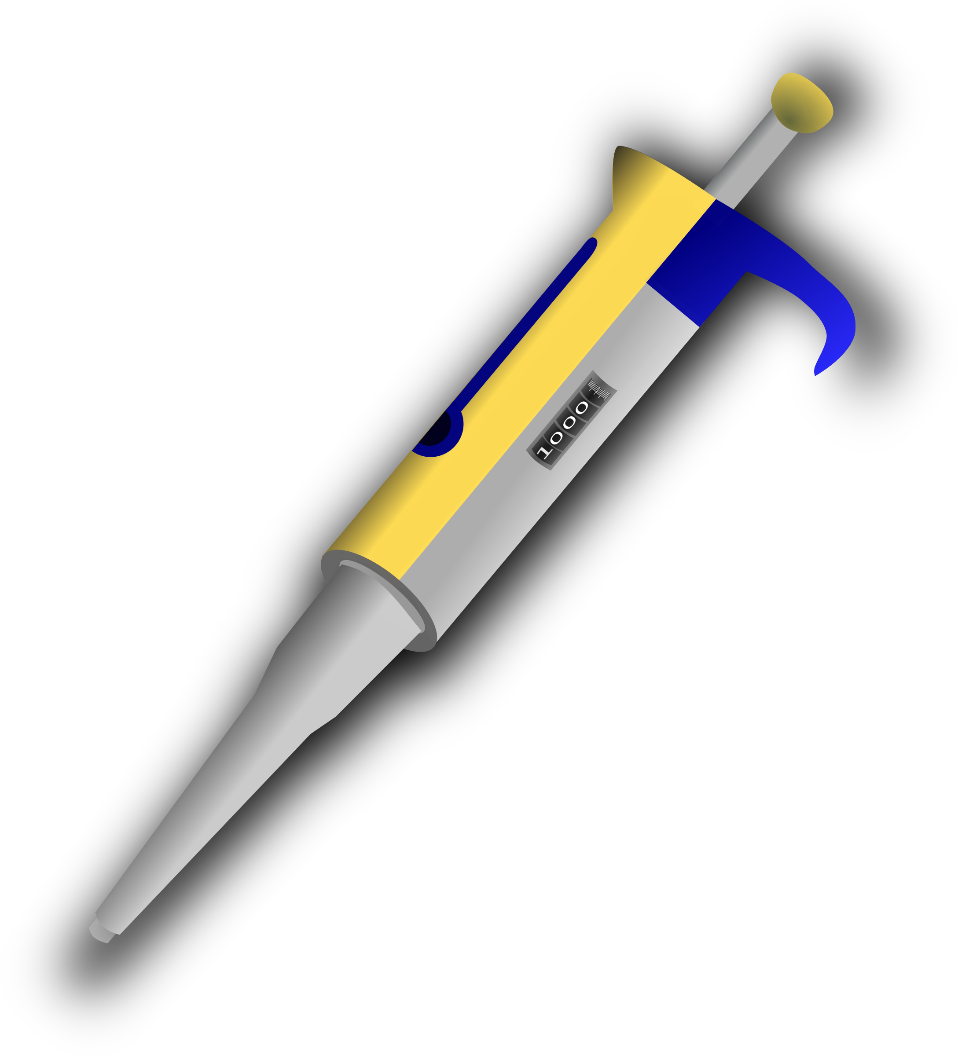
- Gently but firmly dispense 100 uL of Neoplastine to each cuvette in rapid succession. Dispensing to the front left corner. ( You will hear a beep with each dispense)
- Results will automatically print. Press escape  button to go back to the main menu and print last result
- Attach printout to the worksheet, affix patient label(s), record test result(s) and document tech code.
- Enter results in computer
- Remove and discard cuvettes
- Return Neoplastine and controls to the refrigerator immediately after the end of each run.

Corrective action when a control fails to perform as expected
- Verify use of correct control, lot number, reference ranges and expiration date/time
- Remix and repeat
- If acceptable – document corrective action, record results and proceed with patient testing
- If repeat failure – document corrective action and proceed to step 3.
- Open a new control, mix and test
- If acceptable – document corrective action, record results and proceed with patient testing
- If repeat failure – document corrective action and proceed to step 4.
- Contact your laboratory supervisor

Interpretation/Results
The PT results can be expressed in a number of different ways:
- As seconds (patient’s time is compared with that of a normal plasma)
- As a ratio of the patient’s PT to that of the normal PT
- As a percentage of the normal activity
- As INR (International Normalized Ratio)

REFERENCE RANGE

Reference Range | 12.0-14.5 seconds | No reference range available for children < 6 months.
Critical Range | INR ≥ 5.0 | Check for clots using wooden sticks
Repeat Range | INR ≥ 5.0 | Check for clots using wooden sticks
Reportable Range

Procedure Notes
<mMin | PT is low | Report PT as <10 and INR as <0.7
>mMax | PT is high | Report PT as >100 seconds and INR as >11.5
Check for clots with wooden sticks before reporting either <10 or >100 seconds. Also, check for the presence of hemolysis when reviewing an INR >5.0. If appropriate make an internal comment in the LIS to document hemolysis and clot check.

Computer result entry for Protime/INR

- Order Code: APRO
- WORKSHEET: CO_ _ (COAG Clinic)

RESULTING (Patient Results):
FUNCTION: MEM
TECH: << Return>>
SHIFT: << Return>>
WORKSHEET: CO - -
DEVICE LAB LOCATION: (Clinic Lab Location) << Return>>
TEST-1: << Return>>
CAP METHODS TO BE USED DURING THIS RESULT ENTRY SESSION
ACCEPT (A) OR MODIFY (M) A
NUMBER OF SPECIMENS FOR OTHER WORKLOAD, METHOD _ _ COA << Return>>
WORKLOAD DATA FOR << Return>>
ACC. NO.; Enter Accession Number
PROX: Enter Protime in Seconds
RINR: Enter INR
ACCEPT (A), MODIFY (M), REJECT (R)
Result Notes:
- Critical INR is > 5.0.
- Repeat the INR for confirmation
- Notify Centralized INR Hotline (651-451-4195)
- Document with a PHON1 per protocol.
- If the Hematocrit result is < 20, append “Low Hematocrit may affect result”
- Reference range is 12.0-14.5 seconds. There is no reference range available for children < 6 months
- Reportable Range for PT is 10-100 seconds. Report PT as <10 or >100 seconds
- Reportable Range for INR is 0.7-11.5. Report INR as <0.7 or >11.5

RESULTING (Quality Control):

Function: MEM
Tech: << Return>>
Shift: << Return>>
Worksheet: CO - -
Device Lab Location: (Clinic Lab Location) << Return>>
Test-1: << Return>>
CAP METHODS TO BE USED DURING THIS RESULT ENTRY SESSION
ACCEPT (A) OR MODIFY (M) A
NUMBER OF SPECIMENS FOR OTHER WORKLOAD, METHOD _ _ COA << Return>>
WORKLOAD DATA FOR << Return>>
MANUAL RESULT ENTRY
ACC. NO.; C-QPTN (Normal)
C-QPTA (Abnormal)
PROX: Enter Protime in Seconds

ACCEPT (A), MODIFY (M), REJECT (R)

Quality Control Notes:
- Controls must be acceptable prior to reporting patient test results.
- All QC Results should be accepted on the instrument and in Sunquest and Documented on the Quality Control Worksheet.
- Attach applicable codes to the results in Sunquest
- Document steps taken to resolve QC issues on the logsheet.

QC Modifier Codes
AC | After Calibration
CAL | Calibration Necessary
NB | New Bottle of Control
NBC | New Bottle of Calibrators
NLR | New Lot of Reagents
OKAG | OK according to QC Guidelines
OKAG | (Use only if R12S is only QC failure)
RNC | Repeated-Same Bottle of Control, New Aliquot
RNV | Repeated/New Vial of Control
SAC | See Assayed Control
TRBL | Troubleshooting - See Log

Limitations

1. Sample: The slightest coagulation (micro-clots) will induce considerable shortening of the times measured (autocatalytic activation of all the factors) whereas extensive coagulation will prolong the clotting times because of consumption of factors and fibrinogen.

Do not keep plasmas at 2-8 °C because in this temperature range the factor VII may be activated by the kallikrein system (2).

2. Anticoagulant: Maintain the correct anticoagulant/blood sample volume ratio of 1:9. If there is any considerable variation in hematocrit, modify the quantity of anticoagulant accordingly.

3. Heparins: The STA® - Néoplastine® CI Plus test is insensitive to unfractionated heparin levels up to 1 IU/ml and to low molecular weight heparin levels up to 1.5 anti-Xa IU/ml.

4. Thrombin Inhibitors: Thrombin inhibitors (e.g., hirudin, argatroban...) present in the sample to be tested may lead to a prolonged prothrombin time for this sample.

Vitamin K antagonists
- Vitamin K antagonists will depress plasma levels of factors II (prothrombin), VII (proconvertin), X (Stuart factor) and IX (antihemophilic factor B).
- For the assessment of the vitamin K antagonist therapy, refer to the current recommendations.

References
1. STA- Neoplastine Cl Plus, Determination of Prothrombin Time (PT) package insert. March 2009
2. STA- Coag Control N+ABN: citrated control plasmas normal and abnormal levels: Control Plasmas for Assays of Coagulation Parameters on STA analyzers. Package Insert 26378-02- Revised November 2004
3. Stago STart 4 Instrument Manual 2002
4. Diagnostica Stago Sample Procedure, STA-Neoplastine CI Plus Assay, DSI-ASG-AAD, December 2008

Author (s)
Karen Kaestner
Denise Bergo
Marie LaFromboise

Approved by
Laboratory Medical Director or Designee

