HealthPartners
Subject  Sysmex® XN-550  Automated Hematology Analyzer  Procedure | Attachments  Yes No
Key words – Complete Blood Count with Platelets and Automated Differential, Hemogram with Platelets and Automated Differential, CBC, Blood count, indices, Hemoglobin, White count, Red count, Platelets | Number  GHI-PC-Clinic Lab-Procedures-Sysmex XN-550
Category Provision of Care (PC) | Effective Date  3/30/2019
Manual Clinic Laboratory Procedure Manual | Last Review Date  See Electronic Record
Issued By Clinic Laboratory Administration | Next Review Date  See Electronic Record
Applicable Clinic Laboratory Staff | Origination Date  3/30/19
Applicable Clinic Laboratory Staff | Retired Date
Review Responsibility Regional Clinical Lab Supervisors/ Laboratory Medical Director | Contact RCLS
- Purpose
The Sysmex XN-550 is a quantitative automated hematology analyzer for in vitro diagnostic use in determining 23 whole blood diagnostic parameters (WBC, RBC, HGB, HCT, MCV, MCH, MCHC, PLT, RDW-SD, RDW-CV, MPV, NEUT#, LYMPH#, MONO#, EO#, BASO#, IG#, NEUT%, LYMPH%, MONO%, EO%, BASO%, IG%. Examination of the numerical and/or morphological findings of the complete blood count by the physician are useful in the diagnosis of disease states such as anemias, leukemias, allergic reactions, viral, bacterial, and parasitic infections.

This device performs hematology analyses based on the hydrodynamically focused impedance measurement, the flow cytometry method (using a semiconductor laser) and the SLS-hemoglobin method.

The device counts and sizes red blood cells (RBC) and platelets (PLT) using hydrodynamic impedance counting. At the same time the hematocrit (HCT) is calculated via the RBC pulse height detection method. Cytometry is used to analyze physiological and chemical characteristics of cells and other biological particles. Flow cytometry is a method used to analyze those cells and particles as they pass through extremely small flow cells.

- Definitions
CBC – Complete Blood Count
WBC – White Blood Cell
RBC – Red Blood Cell
HGB - Hemoglobin
PLT - Platelet
MCV – Mean Cell Volume
EDTA – Ethylenediamine Tetraacetate
WAM -- Work Area Manager

- Specimen Information
A. Required specimen and volumes:
1. Whole blood should be collected in EDTA-2K or EDTA-3K anticoagulant.
2. Optimal draw is a 13 x 75 tube filled to capacity.
3. A minimum of 1 mL of whole blood is required for sampler analysis.
- Manual analysis whole blood mode
      - Closed tube – 1 mL
      - Open microtube – 100 μL

  - Acceptable specimen: Sodium Citrate may be used for platelet results when platelet clumping
is noted on the EDTA specimen. See Procedure Notes for further instructions.

- Storage and stability: EDTA blood samples should be analyzed within 4 hours. Specimens
stored at 2-8°C are stable for up to 24 hours. Allow refrigerated samples to come to room temperature and mix well before analysis.

D. Causes for rejection:
1. Unlabeled/mislabeled specimens.
2. Clotted specimens.
3. Specimens > 24 hours old.
4. Gross hemolysis.
5. Samples drawn above an IV line
E. Characteristics that may affect test results: lipemia, icterus, and cold agglutinins.

Note: Do not place CBC and Diff samples on a mechanical rocker. Constant rocking may cause PLT clumping and alter white cell membranes, resulting in false interpretive messages.

- Sysmex Reagents:
    - Sysmex reagents and CELLCLEAN AUTO are used on all Sysmex XN-L Series modules.
    - All reagents are used at room temperature and are to be used within the manufacturer’s
expiration date on each container.
    - Record date received and date opened on container.
    - All reagents are azide free and are intended for in vitro diagnostic use only. Do not ingest.

XN-L REAGENTS OPEN EXPIRATION
CELLPACK DCL 60 Days
SULFOLYSER 60 Days (1.5L)
Lysercell WDF 90 Days
Fluorocell WDF 90 Days

  - Diluents
CELLPACK DCL: Whole blood diluent for use in hematology analyzers. CELLPACK DCL Storage
- Store at 2º-35ºC away from direct sunlight.
- If frozen, thaw and mix thoroughly before using.
- CELLPACK DCL is clear and colorless. If it is showing signs of contamination or instability such as cloudiness or discoloration, replace container.
CELLPACK DCL Stability
- Unopened, it is stable until expiration date printed on the container.
- Opened, stable for 60 Days.
CELLPACK DCL Hazard Risk
The OSHA Hazard Communication Standard of 29CFR part 1910.1200 requires SDS documentation of ingredients which have been determined to be health hazards, comprise 1% or greater of the composition, are physical hazards, are capable of release to exceed permissible exposure limit/threshold limit values or have been identified as carcinogens. CELLPACK does not have ingredients with those characteristics.

  - Lysing Reagents
SULFOLYSER (SLS): Reagent for the automated determination of hemoglobin concentration of blood. Sulfolyser is lysing reagent that releases the hemoglobin to be measured by the SLS hemoglobin method.
SULFOLYSER Storage
- Store at 1º-30ºC away from direct sunlight.
- Allow the container to equilibrate to environmental temperature (15-35º) prior to use.
- Replace the reagent if it is showing signs of contamination or instability such as cloudiness or discoloration.
SULFOLYSER Stability
- Unopened, it is stable until expiration date printed on the container.
- Opened, stable for 60 Days (1.5L) or 90 Days (5L).
SULFOLYSER Hazard Risk
The OSHA Hazard Communication Standard of 29CFR part 1910.1200 requires SDS documentation of ingredients which have been determined to be health hazards, comprise 1% or greater of the composition, are physical hazards, are capable of release to exceed permissible exposure limit/threshold limit values or have been identified as carcinogens. SULFOLYSER does not have ingredients with those characteristics.

Lysercell WDF: Reagent product to be combined and used with Fluorocell WDF. By hemolyzing red blood cells with Lysercell WDF and dying the white blood cell component with Fluorocell WDF, the counts and percentages of neutrophils, lymphocytes, monocytes, eosinophils and basophils are analyzed.
Lysercell WDF Storage
- Store at 2º-35ºC away from direct sunlight.
- Use at an environmental temperature (15-35º).
- Do not use the reagent if it is suspected to have frozen.
- Replace the reagent if it is showing signs of contamination or instability such as cloudiness or discoloration.
Lysercell WDF Stability
- Unopened, it is stable until expiration date printed on the container.
- Opened, stable for 90 Days.
Lysercell WDF Hazard Risk
The OSHA Hazard Communication Standard of 29CFR part 1910.1200 requires SDS documentation of ingredients which have been determined to be health hazards, comprise 1% or greater of the composition, are physical hazards, are capable of release to exceed permissible exposure limit/threshold limit values or have been identified as carcinogens. Lysercell WDF does not have ingredients with those characteristics.

  - Staining Reagents
Fluorocell WDF: Used to stain the leukocytes in diluted and lysed blood samples for determination of differential count in blood.
Fluorocell WDF Storage
- Store at 2º-35ºC in a dark place.
- Do not use the reagent if it is suspected to have frozen.
Fluorocell WDF Stability
- Unopened, it is stable until expiration date printed on the container.
- Opened, stable for 90 Days.
Fluorocell WDF Hazard Risk
The OSHA Hazard Communication Standard of 29CFR part 1910.1200 requires SDS documentation of ingredients which have been determined to be health hazards, comprise 1% or greater of the composition, are physical hazards, are capable of release to exceed permissible exposure limit/threshold limit values or have been identified as carcinogens. Refer to the SDS.

  - Cleaning Agent
CELLCLEAN AUTO: Detergent for fully automated hematology analyzer. To be used as a strong alkaline detergent to remove lysing reagents, cellular residuals, and blood proteins remaining in the hydraulics of the analyzer on XN series/XN-L series automated hematology analyzers.
CELLCLEAN AUTO Storage
- Store at 1-30º C, away from direct sunlight.
- Do not use the reagent if it is suspected to have frozen.
CELLCLEAN AUTO Stability
- Unopened, it is stable until expiration date printed on the container.
CELLCLEAN AUTO Hazard Risk
The OSHA Hazard Communication Standard of 29CFR part 1910.1200 requires SDS documentation of ingredients which have been determined to be health hazards, comprise 1% or greater of the composition, are physical hazards, are capable of release to exceed permissible exposure limit/threshold limit values or have been identified as carcinogens. Refer to the SDS, CELLCLEAN AUTO is corrosive and may cause burns to skin.

  - Control Material for XN-550
XN- L CHECK-Manufactured by Streck, available as a tri-level package. Whole blood commercial control used to monitor performance of all XN-550 analyzer platforms. XN-L CHECK consists of human and/or animal red and white blood cells with a platelet component suspended in fluid medium. Each vial contains 3 mL of control material.
- Storage
  - Store vials at 2-8ºC.
  - Do not freeze or expose to excessive heat.
- Stability
  - Unopened and properly stored, XN-L CHECK is stable until the expiration date
printed on the unopened vial.
  - Open vial stability is 15 days for XN-L CHECK when promptly refrigerated after each use.
  - Record the date on each vial upon opening or cap piercing.
  - Heat or freezing can damage XN-L CHECK without gross visible changes.
  - Moderate hemolysis can be normal. Deterioration is suspected when the mean of the control
results is not within the assay expected ranges after appropriate troubleshooting.
  - If deterioration is suspected, call the Sysmex Technical Assistance Center. 1-888-879-7639
(1-888-8SYSMEX)

  - XN CALTM: for use in calibrating the analyzer for WBC, RBC, HGB, HCT, PLT.
XN CAL Storage.
Store the calibrator in a dark refrigerator at 2-8ºC
XN CAL Stability
Unopened and properly stored, XN CAL is stable until the expiration date printed on the
unopened vial.
Open vial stability is 4 hours.
Always wear PPE when using control blood products. Also, wash your hands after completing the process.
The basic blood used in the control blood has tested negative for HBs antigen, HCV/HIV- 1/HIV-2 antibodies, and serologic tests for syphilis. However, there are no tests that can completely rule out any infections. In addition, it has not been tested for other viruses. Therefore, handle it with the same level of care you would use when handling pother blood samples.

  - XN-550 Reagent Replacement
When the replacement of reagent is required, an error message appears. Promptly acknowledge the error message by clicking execute to enter the reagent replace dialog box and proceed to replace the indicated reagent. Verify that “CAPS LOCK is off.

Replacing a new diluent / hemolytic agent
      - Touch the name of the reagent to be replaced.
      - Place a check-mark next to ‘Replace the reagent,’ then place the cursor in the reagent code text box.
c. Using the hand-held reader, scan the reagent code on the new reagent container.
NOTE: Scan Reagent Code 2 when available on the reagent container.
d. Remove the cap from the expired/empty container and carefully remove the spout.
e. Pull out the dispensing set straight up.
f. Insert the dispensing set straight into the new reagent container and close the cap.
g. Select [Execute]
a. Reagent replacement starts. When complete, the dialog box closes
automatically.

Replacing Fluorocell WDF
a. Display the [Reagent Replacement] dialog box.
b. Prepare the new reagent cartridge. Confirm the reagent has not expired.
      - Pull out the dye holder drawer.
      - Slowly remove the dye cover, taking care that dye does not drip.
      - Remove the entire dye holder. Once removed, a Help dialog box appears.
      - Remove the old reagent cartridge from its holder.
      - Install the new reagent cartridge into the holder.
        - Make sure the color of the label on the new reagent cartridge matches the color of the dye cover and install. Analyzer will beep as confirmation of new reagent installation.
        - If the wrong reagent is installed, the analyzer beeps repeatedly and the Help dialog box appears in the IPU screen.
      - Place the dye cover.
        - Place into dye holder drawer.
        - The ID of the new reagent is read automatically and the information is registered.
      - Close the dye holder drawer.
        - Reagent replacement starts. Reagent replacement window closes when complete.

Note: Run all three levels of QC after any reagent change.

- Calibration
Calibration and Precision
Initial calibration is performed during installation by the Sysmex Service Engineer. Perform calibration as needed, e.g., when QC data is fluctuating. However, if the abnormality in the QC analysis data was caused by an error in the analyzer, degradation of the reagent, or degeneration of the control blood, do not perform calibration. Calibrators traceable to reference methods are used in the calibration of the analyzer.

The laboratory must verify calibration every six months or on an "as-needed" basis to ensure accuracy of system. Calibration verification is also required if one or more of the following occur:
- Critical parts are replaced.
- Controls show an unusual trend or are outside of acceptable limits and cannot be corrected by maintenance or troubleshooting.
- When advised by Sysmex Sevice Engineer.

Calibration verification may be performed by review and documentation of commercial control and X-barM QC data, proficiency testing results and patient control testing results. The operator may calibrate the following parameters using XN CAL calibrator: WBC, RBC, HGB, HCT, PLT.

Before calibration, ensure that routine cleaning has been performed and precision check is
within acceptable limits.

- Precision Check
- Perform routine maintenance on the analyzer and perform a background count to ensure counts are within acceptable limits.
- Verify that there is sufficient volume of all reagents. Precision and Calibration procedures will be aborted if the XN-550 runs out of reagent.
- Obtain a sample of fresh normal whole blood. Do not use commercial controls or calibrators for precision. The blood donor specimen should:
- Be a healthy person who is not taking any medication.
- Have morphologically and numerically normal CBC.
- Be drawn in potassium EDTA anticoagulant tube using proper collection technique.
- Have a minimum of 2.5 mL of sample.
- On the main unit, check the Status indicator LED. Confirm the LED is green indicating the analyzer is Ready.
- Select the Analyzer menu button on the control menu.
- Select [Calibration] – [Precision Check]
- Mix the vial containing the sample – 10 end-over-end inversions confirming cell button is
dispersed.
- Place the vial in the sample tube holder.
- Press the start switch on the analyzer.
- Repeat mixing and analysis (total of 11 times).
- The results are displayed in the [Precision Check] analysis dialog box.
- If the analysis results do not satisfy conditions for normal results or if results are outside acceptable limits, the test numbers of the tests that must be repeated are displayed. Select and redo the manual analysis.
- When all analysis results satisfy the conditions, select [OK] in the dialog box.
- Select [Yes] to record passing precision results in the precision check history.

NOTE: If an error occurs during analysis and the analysis can no longer continue, stop precision check. Once the error has been corrected, redo the manual analysis.

- Calibration – XN CAL
- On the main unit, check the Status indicator LED. Confirm the LED is green indicating the analyzer is Ready.
- Select the Analyzer menu button on the control menu.
- Select [Calibration] – [Calibrator Calibration]
- Mix the vial containing the calibrator according to package insert.
- If the sample tube holder is not ejected, press the sample tube holder open/close switch.
- Place the vial in the sample tube holder.
- Press the start switch on the analyzer.
- Repeat mixing and analysis (total of 11 times).
9. The results are displayed in the [Calibrator Calibration] analysis dialog box.
- If the analysis results do not satisfy conditions for normal results, or if results are outside acceptable limits, the test numbers of the tests that must be repeated are displayed. Select and redo the manual analysis.
- When all analysis results satisfy the conditions, select [Calibration] in the dialog box.
- Select [OK] to display results in the [Calibrator Calibration] execution dialog box.
- Select the check box to include the calibration parameter in the calibration exercise, clear the check box to exclude the parameter in the calibration exercise. If a parameter meets all of the following criteria, the check box will automatically be selected:
- 80% < New Rate < 120%
- New Rate – Current Rate < +5
- Range Value < Max Range
- Acceptable Limit < Delta Percent < Service Limit
If a parameter meets all of the conditions and the Delta Percent is less than the Acceptable Limit, it is excluded from calibration as there is no need for calibration.
If a parameter does not meet all of the conditions and the Delta Percent is greater than the Acceptable Limit, the calibration cannot be performed. Calibration is performed with the parameter excluded. Selecting the check box enables you to manually enter a value in [New Rate (%)]. A range of 80% to 120% may be entered.
- Select [OK] to update the compensation rates. The calibration process is logged in the calibrator calibration history.

- Quality Control Utilizing BeyondCare Quality Monitor
Quality control is performed in order to monitor an analyzer’s performance over time. XN-L CHECK is the material used to monitor the performance of the XN-550 analyzer. Quality control should be run in accordance with regulatory agency requirements. For the BeyondCare Quality Monitor program, 3 levels of controls are run at least once every 24 hours. The BeyondCare Quality Monitor program is a tool that will help you determine when troubleshooting is necessary and dynamic screen prompts will guide the end user for the next action. All troubleshooting actions are logged in the Activity Log. (Reference the BeyondCare Quality Monitor User Manual)

A. XN-L CHECK Commercial Controls Instructions for Use
1. Remove vials from refrigerator and allow them to come to room temperature (18-25°C), for
approximately 15 minutes.
2. Mix vials by rolling each vial between the palms of the hands for 15-20 seconds.
3. Invert each vial by holding the vial at the ends between the thumb and finger.
4. Invert end-over-end using a very quick turning motion of the wrist at least 20 times.
5. Perform a close visual inspection of each vial confirming the cell button is completely removed.
6. Continue inversions as needed to re-suspend the vial contents.
7. Return QC to the refrigerator when done. Don’t leave QC out more than 30 minutes.

B. Frequency of QC
All three levels of QC are performed at the following times:
- Daily before sample analysis
- After replacement/replenishment of reagents
- After instrument maintenance
- When there is a concern about the accuracy of analysis values
C. Registering and modifying a QC file – lot information input
  - Make sure the button on the right edge of the control menu is [Sampler] and that the analyzer is in the ‘Ready’ state.
  - Open the sampler adapter holder.
  - Load all three levels of QC material into the sampler adapter.
  - Touch [Sampler] on the right edge of the control menu.
  - Touch the screen to indicate your [Starting Tube Position].
  - Touch [OK].
  - Close the sampler adapter holder.
  - Press the start switch.
  - QC will populate then next available open QC files.
  - Perform parallel studies between production lot and new lot prior to production lot expiration.
New QC lot crossover study: As soon as the new QC lot is received, the new lot is analyzed in conjunction with the current QC. The BeyondCare Quality Monitor program establishes the target and limit values for the new QC lot as soon as the first vial of each level gets analyzed.

D. XN-L CHECK QC Analysis
  - Make sure the button on the right edge of the control menu is [Sampler] and that the analyzer is in the ‘Ready’ state.
  - Open the sampler adapter holder.
  - Load all three levels of QC material into the sampler adapter.
  - Touch [Sampler] on the right edge of the control menu.
  - Touch the screen to indicate your [Starting Tube Position].
  - Touch [OK].
  - Close the sampler adapter holder.
  - Press the start switch.

E. Reviewing QC Results in BeyondCare Quality Monitor
- If analyzer displays GREEN, this indicates QC passed and analyzer is ready to process samples.
- If analyzer displays YELLOW, more information is needed or QC is overdue. The resolve button becomes active if there is a QC value outside of limits.
- Resolve is activated: If a QC error has been detected, resolve button becomes active and dynamic troubleshooting prompt guides the end user to the next course of action. The instructions button gives details on how to perform the troubleshooting action.
- QC is overdue: End user needs to analyze QC since it exceeds the timeframe from the preferences screen.
- If analyzer displays RED, QC failed analysis and analyzer is determined out of service with a reference to a service call.

For a calendar view of whether the QC passed or failed, access the Summary report which will also display background status,
    - P= Last 2 different levels of QC passed
    - F= QC failed
    - B= Background counts pass
    - X= Background counts failed
    - ?= Run QC
    - S= service event
    - Calibration (EBC)

Follow the BeyondCare Quality Monitor for troubleshooting Quality Control results exceeding the upper or lower limit of acceptability. For QC that is out of acceptable range do the following:
- Check expiration date on the QC bottle.
- Repeat QC level that was out.
- Open a new vial of QC if repeat values still out of range.
- Document all out of range QC and action taken to correct by following troubleshooting instructions in BeyondCare.
- To review QC on the analyzer, click on QC files, select a QC file, and touch the display switch button to view the radar charts.
- Touch the QC Chart button on the tool bar to view the LJ chart. Red X indicates QC out on LJ.
BeyondCare Quality Monitor will automatically not manage (exclude) a QC run if a corrective action has taken place and the same QC level is repeated and falls within the BeyondCare Quality Monitor specification limits. A “SM” (system managed) symbol will appear next to the raw data in the Insight™ report. No QC runs are ever deleted.
If the QC reviewer decides to manage (include data in calculations) or not manage (exclude data from calculations the BeyondCare Quality Monitor application), log into Insight (www.sysmex.com/Insight) and select Review QC data which will allow QC data management by the Insight user. HP laboratories maintain a SNCS connection so the QC results will transmit automatically to Insight after each run.
F. Recording and Storage of QC Data
The BeyondCare Quality Monitor application stores the last 2.5 years of QC data on demand. All QC data older than 2.5 years is archived.
G. Review of QC Data
    - The following reports should be reviewed at regular intervals according to the laboratory’s policy: Insight Report, Detailed Daily Verification Report, and Continuous Calibration Verification Certificate.
    - Once these reports have been reviewed through the BeyondCare Quality Monitor application, they can be accessed by going to Activity _ Reviewed Documents.
    - Reports are archived for 2.5 years in BeyondCare Quality Monitor. Reports that are older than 2.5 years can be attained by contacting Sysmex Technical Assistance Center.
H. Printing LJ Charts off the Analyzer
1. Select [QC Files] icon and highlight file to output.
2. Select [QC Chart] icon.
3. Set Range of points to output by clicking [Range] and capturing the points with the cursors.
4. Select [output] to print the selected chart to either GP or LP.
NOTE: Comments that were added to the data do not print on the GP and LP report.
- Operating Procedure
A. Start-Up Procedure
1. Checks prior to turning on:
a. Visual inspections of analyzer / system / reagents
  - Verify network / host connections are properly working.
  - Verify sufficient reagent supply.
2. Turning ON the entire system
- Verify that all power switches for each device are in the ON position.
- Press the Green power button on the front of XN-550 to power ON the entire system.
3. Log on to the XN-550
a. When the logon dialog box appears, it will ask for user name and password.
b. Select “admin” for the User name.
b. Type “m145m” for the Password.
4. Analyzers self-checks
a. XN-550: Initialization of the mechanical parts; Rinse; Temperature
stabilization; Background Check (up to 3 times).

XN-L Acceptable Background Counts
Parameters | Acceptable Limit
WBC | 0.10 x 10³/ μL
RBC | 0.02 x 10⁶/μL
HGB | 0.1 g/dL
PLT-I | 10 x 10³/ μL
WBC-BF | 0.001 x 10³/ μL
RBC-BF | 0.003 x 10⁶/ μL

5. Analyze Quality Control Material. Refer to QC section of Procedure.

B. Patient Sample Processing
1. System Analysis (sampler analysis)
      - Make sure the sampler cover (front) and sampler cover (manual unit) are closed.
      - Make sure the button on the right edge of the control menu is set as sampler. When the mode is set to manual, press the mode switch.
      - Make sure that either the left or right sampler adapter holder is in a state to be
pulled out.
1. A sampler adapter holder can be pulled out when the sampler adapter status
indicator LED is solid green or OFF.
      - Pull out the sampler adapter holder that you want to use.
      - Remove the sampler adapter.
      - Mix the sample.
      - Place the sample tube in the sampler adapter.
      - Touch Sampler on the right edge of the control menu.
      - Touch an item to set the condition.
      - Touch [OK].
      - Place the sampler adapter in the sampler adapter holder selected in the sampler
settings box.
      - Push in the sampler adapter holder.
      - Press the sampler analysis start/stop switch.
      - Review results in WAM to determine whether repeat or reflex testing is required
      - Rerun sample if required. Make smear if required.
    - Manual Analysis
      - Check the status of the analyzer. Confirm the analyzer is ready.
      - Make sure the button on right side of control menu is Manual. When it’s set to
Sampler, touch [Mode] in the control menu.
      - Select the Change Analysis Mode button on the control menu
      - Select analysis mode
        - [Whole blood] is selected when whole blood is being analyzed
        - [Low WBC] Select this to perform low WBC analysis on whole
        - blood
      - Select [OK]
      - Select Manual Analysis button on the control menu
      - Use handheld barcode reader to scan sample ID.
- Query to Host- Patient Demographic will auto populate.
- Aspiration Sensor- Specify whether or not the aspiration sensor is used.
- Cap Open- Select this checkbox to perform micro sample analysis (analysis
with the sample tube cap open.)
      - Select [OK]
      - Open the Sampler cover (manual unit).
      - Properly mix the specimen and place in the tube holder.
- If running microtainer, remove the cap using caution to avoid splattering.
- Check all microtainer samples for clots with wooden sticks before running.
      - Press the start switch on the analyzer
        - The tube holder will slide in and the sample will be aspirated
        - When the analysis is complete, the tube holder slides out
      - Remove the sample, repeat steps for additional samples
      - Review results in WAM to determine whether repeat or reflex testing is required. Rerun sample if required. Make smear if required.

- Maintenance
A. Shutdown – performed daily
1. Confirm analyzer and sample unit are at ready.
2. If sample tube holder is not ejected, press the sample tube holder open/close
switch.
3. If any tubes remain in holder, remove.
4. Touch [Menu] on Toolbar.
5. Touch [Shutdown]. Touch [OK].
-XN-550 on-board maintenance history will auto-populate Shutdown.
-IPU will automatically shut off at the conclusion.

- Routine Cleaning – performed weekly.
CELLCLEAN AUTO is used to shut down the entire system. Refer to the XN-L Series
Troubleshooting Manual for detailed, illustrated procedures.
1. Confirm analyzers, sampler unit are at ready.
2. Touch the [Maintenance] Icon in the Menu screen.
3. Touch [Rinse Instrument].
4. Touch [Routine Cleaning].
a. Open Sampler Cover (manual unit) and place CELLCLEAN AUTO in tube holder.
b. Press start switch.
-XN-L on-board maintenance history will auto-populate Routine Cleaning.
Maintenance performed on the XN-550 will be automatically tracked in the maintenance history.
Refer to the XN-L Series Troubleshooting Manual for ‘as needed’ maintenance.

- PROCEDURAL NOTES
  - Do not place samples on a mechanical rocker. Excessive mixing may alter white cell membranes resulting in false interpretive messages.
  - If a sodium citrate tube is used for EDTA induced platelet clumping, multiply the citrate platelet count by 1.1 to correct for anticoagulant dilution.
  - For troubleshooting specifics refer to the XN-L Series Troubleshooting Manual.

- Limitations of Procedure
- Parameters that exceed Sysmex Reportable Range limits are flagged with @ beside the result. These samples will be sent to Regions to be diluted, rerun and multiplied by the dilution factor.
- Each clinic has established ranges that differ from Sysmex original reportable range limits. Refer to the clinics Technical book to see the Established Ranges

XN-L Series Manufacturer Stated Reportable Range
Parameter | Range | Units
WBC | 0.04 - 440.0 | x10³/μL
RBC | 0.02 - 8.60 | x10⁶/μL
HGB | 0.0-26.0 | g/dL
HCT | 0.2-75.0 | %
PLT | 1 - 5000 | x10³/μL

Possible Sample Interferences
- Specimens must be free of clots and fibrin strands.
- Marked changes in plasma constituents (e.g., low sodium, extremely elevated glucose) may cause cells to swell or shrink. The blood to anticoagulant ratio is important.
- Red cell fragments, microcytic RBC's or white cell cytoplasmic fragments may interfere with automated platelet counts. An optical platelet may be performed to avoid this interference.
- Cold agglutinins produce spurious macrocytosis, elevated MCH's MCHC's, falsely decreased RBC counts and HCT's. Rare warm agglutinins produce the same spurious results as a cold agglutinin.
- Extremely elevated WBC's may cause turbidity and increase the hemoglobin, in addition to RBC and HCT values.
- Severely hemolyzed samples (in vitro) falsely decrease RBC and hematocrit. Recollect hemolyzed specimens.

- Giant platelets and clumped platelets may falsely elevate the WBC count and falsely decrease the platelet count.
- Platelet clumping and/or "platelet satellitism" can occur in specimens collected in EDTA. This may falsely elevate the WBC and falsely decrease the platelet count. Recollect the specimen in Sodium Citrate anticoagulant analyze and multiply by 1.11 dilution factor.
- Abnormal paraproteins found in Multiple Myeloma patients can falsely increase the HGB. To correct HGB perform plasma replacement.
- Abnormal proteins as seen in Multiple Myeloma and Waldenstrom's macroglobulinemia may falsely increase the WBC count.
- Lipemia falsely elevates the HGB & MCHC.
- Severely icteric samples may falsely elevate the HGB value and related indices. Abnormal proteins, such as found in multiple myeloma, may cause interference and falsely elevate HGB and MCHC results.
- Rocking specimen excessively, may affect the WBC differential.
- Megakaryocytes may falsely increase WBC counts on automated hematology analyzers.

- Interpretations/Results
Parameter Marks may accompany a numeric result or may replace a numeric result in some
Instances.

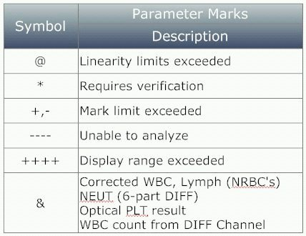

  - Pathology Review – See pathology review criteria in Attachments.

- Computer entry
- See the Work Area Management (WAM) Procedure for detailed instructions on how to mange patient results.
- See the Sysmex Downtime Procedure for instructions on how to manage patient results during a downtime period.

- Expected Values/Reference Ranges
CBC with Differential Reference Range
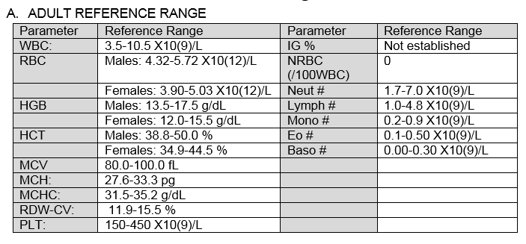
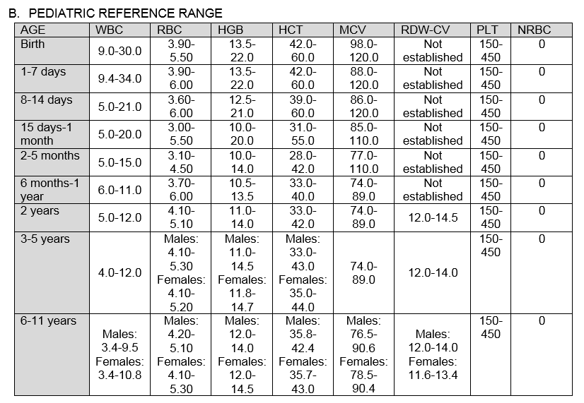
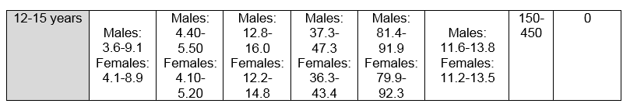
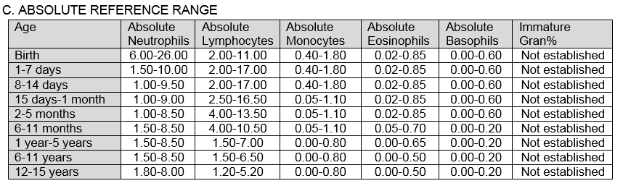
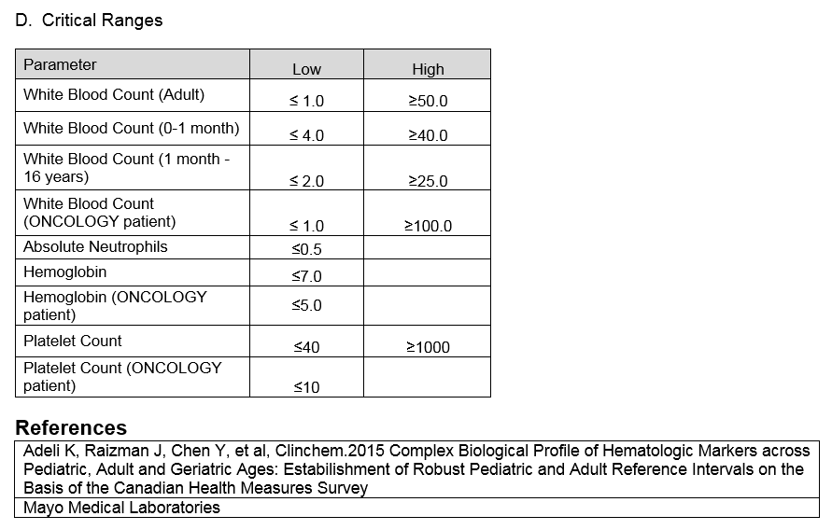
- RELATED DOCUMENTS
- Sysmex WAM Procedure
- Manual Differential and Morphology Procedure

- References
- Sysmex XN-L Series Basic Operation (North American Edition), Sysmex Corporation, Kobe, Japan.
- Sysmex XN-L Series General Information (North American Edition), Sysmex Corporation, Kobe, Japan.
- Sysmex XN-L Series Troubleshooting (North American Edition), Sysmex Corporation, Kobe, Japan.
- Clinical and Laboratory Standards Institute (CLSI). Laboratory Documents: Development and Control; Approved Guideline; Fifth Edition. (GP2-A5, 2006).
- Sysmex Reagents of America Inc., Mundelein, IL. XN CAL, Hematology Calibrators: Calibrators for Sysmex Hematology XN-Series Analyzers, package insert.
- Sysmex America Inc., Lincolnshire, IL. XN-L CHECK Hematology Control for Sysmex XN-L Series Analyzers package insert.
- Sysmex America Inc., Lincolnshire, IL. Sysmex Insight Participant Overview Guide.
- Koepke, John. Practical Laboratory Hematology. Churchill Livingstone Inc. 1991.
p. 24-25, 36-39.
- Cornbleet J., Spurious results from automated hematology cell counters. Lab Medicine. 1983;8:509-514.
- Sysmex Reagents of America, Inc. SDS sheets and reagent product inserts.
- College of American Pathologists (CAP) Hematology-Coagulation Checklist, July 2012.
- Stewart, Charles and Koepke, John. Basic Quality Assurance Practices for Clinical Laboratories, Van Nostrand Reinhold, 1989, p 189.
- Gulati GL, Asselta A, Chen C. Using vortex to disaggregate platelet clumps, Laboratory Medicine, 28:665, 1997.
- Zhou X, Xiaoli W. Amikacin Can Be Added to Blood to Reduce the Fall in Platelet Count, American Journal of Clinical Pathology, 136:646-652, 2011.
- Sysmex America Inc., Lincolnshire, IL. XN Applications Manual.
- Sysmex America Inc., Lincolnshire, IL. BeyondCareSM Quality Monitor User Manual

- ATTACHMENTS
  - Pathology Review Criteria
  - Sysmex XN-L Flagging Interpretation Guide
  - Sysmex XN-L Daily Maintenance Log

- Compliance
Failure to comply with this policy or the related processes and procedures may result in disciplinary
action, up to and including termination.

- Approvals
See Electronic Record

