 HP Clinics-Regions
Adding a Pathology Review QuickGuide

This tip sheet is to assist staff with the steps needed to add on and document a Pathology Review
Ordering the Pathology Review Lab Order (Lab1490)-Clinic Process
- Lab staff should order the Path Review test in Beaker any time the criteria for path review of a slide is met. The Path Review guidelines can be found in the Clinic WAM Rules Summary document listed at the end of the QuickGuide.
- In WAM: Lab staff will add the PATH order by going to Action box and choosing PATH. Result by double clicking in the result column next to PATH and select refer to path.
- Fill out Path Review Form.
- Send instrument printout, Path Review Form, EDTA tube and 2 properly prepared and labeled smears (smears should start at end opposite frosted side and end near frosted side; slide should be 2/3-3/4 in length and fully dried before inserting in slide holder). Put this all together in one bio-hazard bag.
- In Beaker: Lab staff will add the Path Review (Lab1490) to the sample meeting Path Review guidelines by using Specimen Update.
- NOTE: Before ordering the Path Review and putting on a packing list, make sure the results have crossed over to the patient’s chart otherwise, a duplicate order may appear in WAM. If that happens, that duplicate order can be canceled in WAM.

Adding Path Review Order
- Using Specimen Inquiry find the sample that needs the Path Review. Click on the specimen to open it.
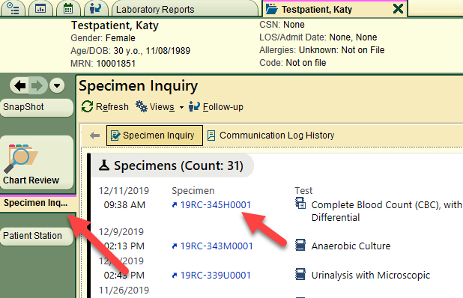

- Select Specimen Update
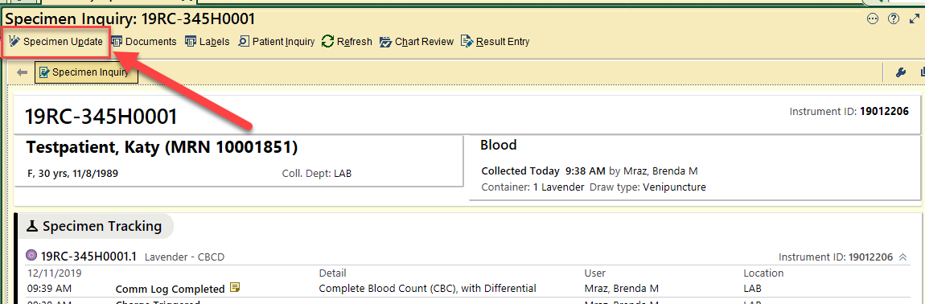

- Select Add-ons.

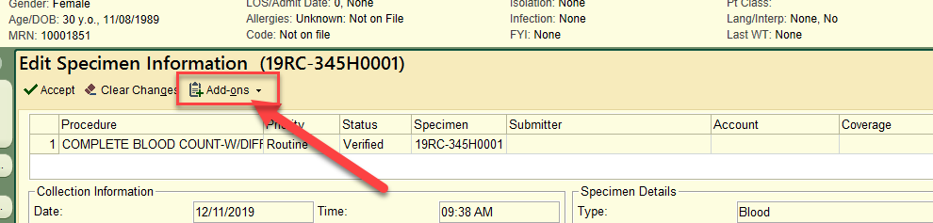

- From drop down menu under the Add-ons, select New Orders

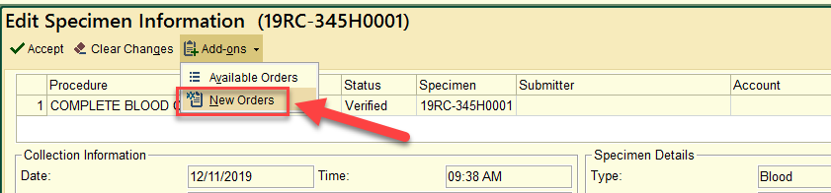

- Type in Path Review and then press Enter key

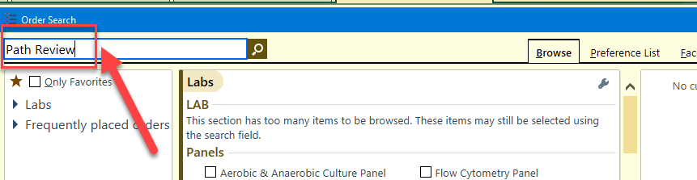

- Select Path Review test (LAB1490) and Accept

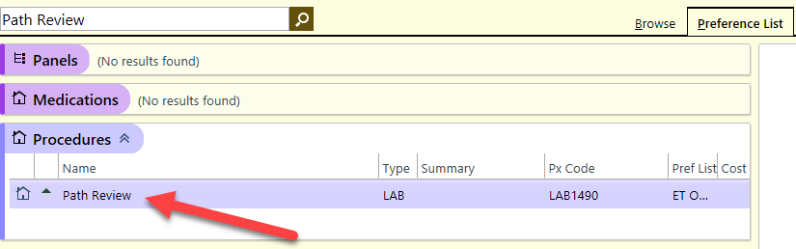

- Add the Path Review Reason using the drop down options and then Accept
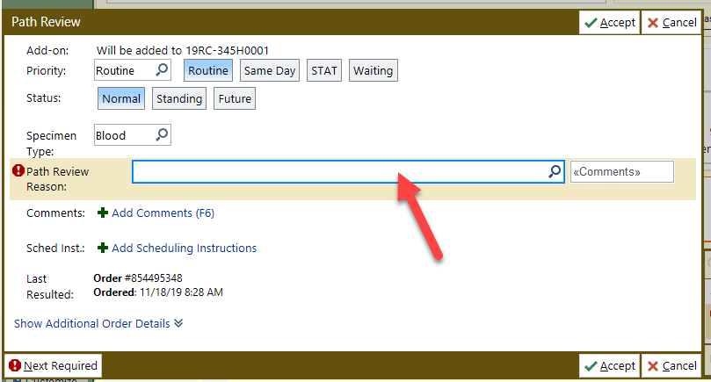
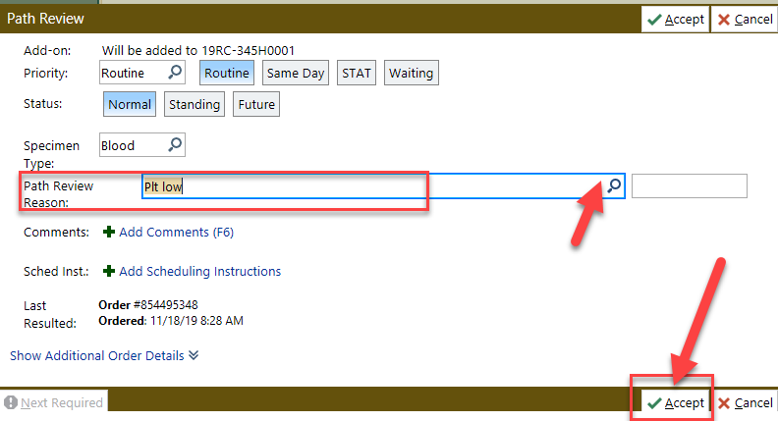
- Sign order using appropriate Diagnosis code and Provider. If Provider information doesn’t automatically populate, use the provider that ordered the CBC test.

If added correctly it will show up as an On Test order right below the CBC/CBCD order. Accept the changes
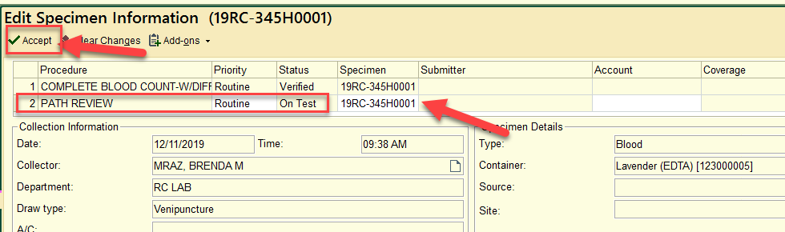

- Add the sample to a packing list.
Adding the Pathology Review Lab Order to a Packing List
- Using Search box, enter Packing List Editor
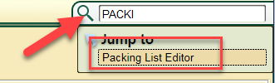
- Create New Packing List
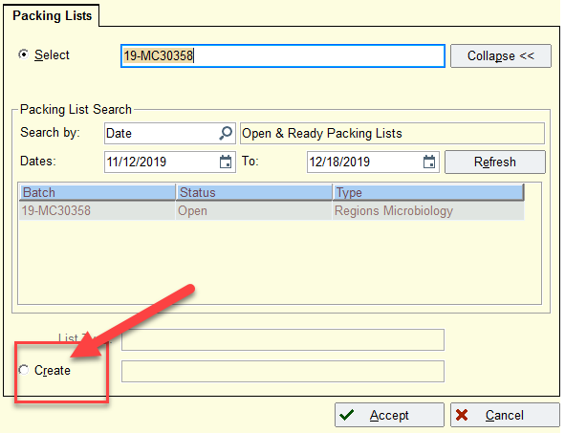
- Click on watchglass to bring up a list of available Batch Types. Select Regions Lab Refrigerated. Click on Accept and a new Packing List will be created and a Batch List number will be assigned
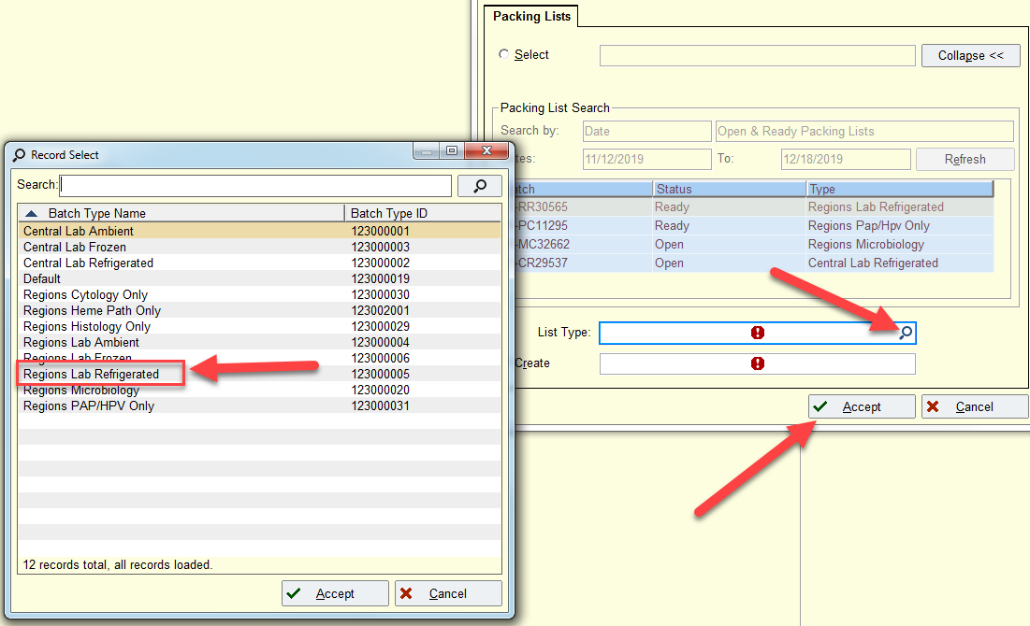
- Click on Accept to open the packing list. Add Sample to Packing List by entering the sample number under the Container section. Add as many samples as needed to the packing list.
- When all samples have been added. Select the √ Ready.
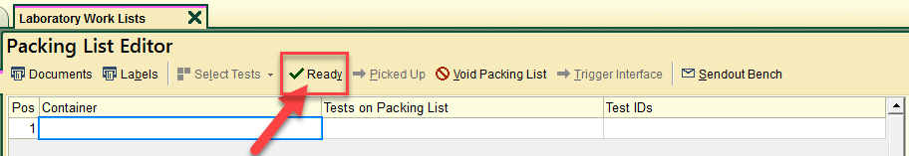
- When ready to send to Regions select →Picked Up
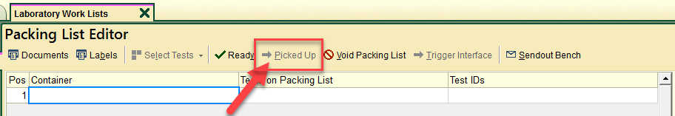

Resulting/Final Verify the Pathology Review Lab Order (Region’s Process)
- Receive the packing list using Receiving (Regions will need to do this for samples received from the clinics)
- Find the sample(s) with Path Review order on Outstanding list
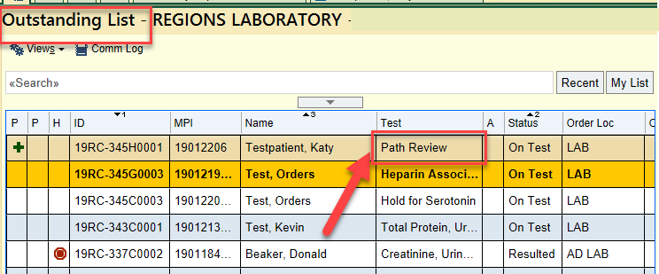
- After reviewing the slides, using Result Entry and Verification answer the Path Review order
  - The Path Review Reason should auto-fill from the order, if it doesn’t you can find it under the Questions tab for the sample order
  - Click on the watchglass for the Path Review Prompt, “Performed” will autofill
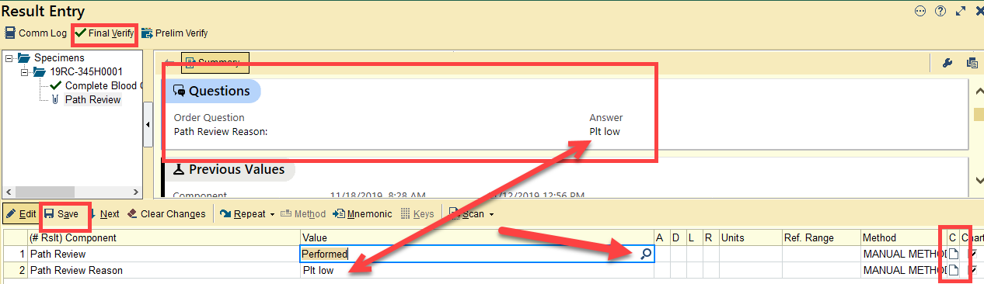
- You can add a comment in the notes section if you want to document Pathology Comments
- Save and Final Verify when smear review has been completed.
- Upon final verification, any comments added will display under the chart component
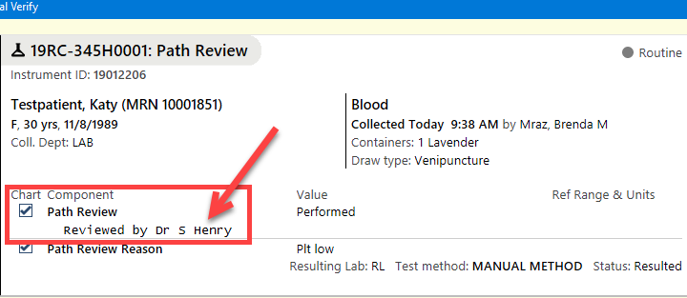
- You can review previous dates a Path Rev was sent in result entry.
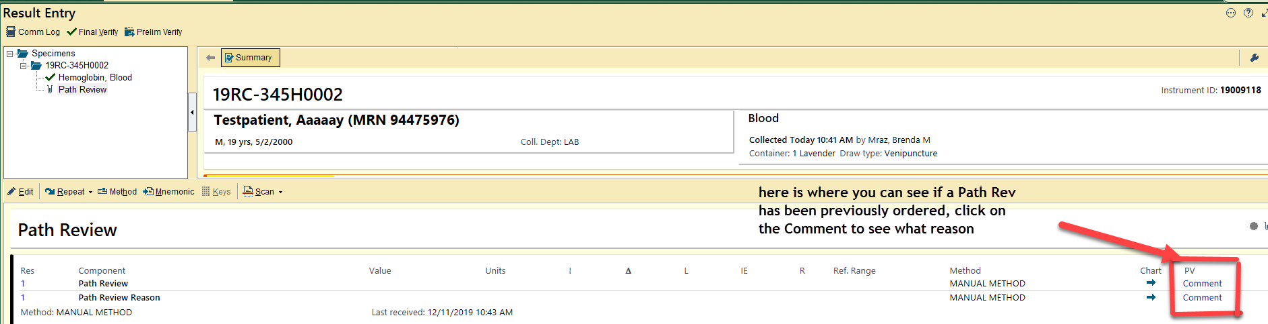

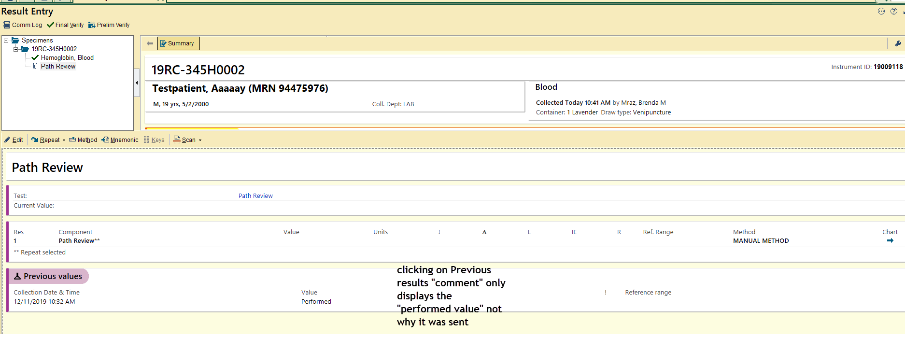

Clinic WAM Rules Summary for HP Clinics
Changes are in Blue-Updated 2021
WBC Suspect flags (based on scattergrams)
- Blasts/Abn Lymphs
  - Scan slide, perform manual differential if needed
- Left Shift
  - Scan slide, perform manual differential if needed
- Atypical Lymph
  - Scan slide, perform manual differential if needed
- NRBC?
  - Scan slide, perform manual differential if needed

WBC Flags (based on instrument values)
- Order Path Rev on First Occurrence and then every 6 months if needed for WBC counts <=2.0 or >=25.0 all ages
- Critical WBC High
  - >/=50.0 and >/=17 years
  - >/=25.0 and 1 month-16 years
  - >/=40.0 and 0-1 month
  - >/=100.0 and Oncology patient
  - Follow SOP for documenting critical results
- Critical WBC Low
  - Check for clots
  - </= 1.0 and >/=17 years
  - </=2.0 and 1 month-16 years
  - </=4.0 and 0-1 month
  - </=1.0 and Oncology patient
  - Follow SOP for documenting critical results
- WBC Delta
  - +/- 10# within 3 days
  - Review history to verify sample integrity
  - If history and sample integrity okay, accept results
- WBC Linearity
  - >440.0
  - Perform dilution and rerun
  - Perform scan
- Neutropenia
  - </=1.0#
  - Scan, perform manual differential if abnormalities
  - If no previous, perform manual differential and order Path REV on first occurrence and then every 6 months if still exists
- Lymphocytosis
  - >/=5.0 # and >/=16 years
  - >5.2# and >/=12 years -<16yrs
  - >6.5 # and >/=6 years -<12yrs
  - >7.0 # and >/=1 years -<6yrs
  - >10.5# and >/=6 mo -<12 mo
  - >13.5# and >/=2mo -<6 mo
  - >16.5# and >/=15days -<2 mo
  - >17.0# and >/=1 days -<15 days
  - >11.0# and >/=0 days -<1 days
  - Scan, perform manual differential if abnormalities
  - If no previous, perform manual differential and order Path REV on first occurrence and then every 6 months if still exists
- Monocytosis
  - >/=2.0#
  - Scan, perform manual differential if abnormalities
  - If no previous, perform manual differential and order Path REV on first occurrence and then every 6 months if still exists
- Eosinophilia
  - >/=1.5#
  - Scan, perform manual differential if abnormalities
  - If no previous, perform manual differential and order Path REV on first occurrence and then every 6 months if still exists
- Basophilia
  - >/=0.3#
  - Scan, perform manual differential if abnormalities
  - If no previous, perform manual differential and order Path REV on first occurrence and then every 6 months if still exists
- IG Present
  - >5.0 %
  - Perform manual differential
  - Moderate complexity clinics always send to regions
  - High Complexity Clinic/Hospital or Path Rev on first occurrence of IG>5% and immature cells seen are younger than a band form (metas, myelocytes promyelocytes/blasts/prolymphocytes) then every 6 months if still exists

RBC Suspect flags (based on histogram)
- RBC Abnormal Distribution
  - Perform scan
- RBC Agglutination
  - Perform scan
  - Follow protocol
- Fragments
  - Scan slide
  - Perform PLT estimate
  - If fragments present, order Path REV every time if 6/hpf or more seen on smear.

RBC Flags (based on instrument values)
- RBC Turbidity/HGB interference
  - > 37.5 MCHC
  - Follow SOP
- RBC Linearity
  - >8.60
  - Perform dilution and rerun
- HGB Critical
  - </=7.0 all ages
  - Follow critical call policy
  - Order Path REV on first occurrence and then every 6 months if still exists
- High HGB
  - >16.0 and female and >16 yrs
  - >16.5 and male and >16yrs
  - Scan and order Path REV if hgb is >20 and age is >16yrs male/female on first occurrence and then every 6 months if still exists
- HGB Linearity
  - >26.0
  - Perform dilution and rerun
- HGB Delta
  - > 3.0# increase/decrease within 5 days
- HCT Linearity
  - >75.0%
  - Perform dilution
- MCV High
  - >/=108.1
  - Scan slide and order Path REV on first occurrence and then every 6 months if still exists
- MCV Low
  - <70
  - Scan slide and order Path REV on first occurrence and then every 6 months if still exists
- MCV Delta
  - >5.0# increase/decrease within 5 days
  - Verify sample integrity
- RDW-CV
  - >/=22.0
  - Perform slide review
  - Order Path Rev on first occurrence and every 6 months if still exists
- NRBC
  - > 5 / 100 and >/ = 16 yrs
  - Perform slide review
  - Order Path Rev on first occurrence and every 6 months if still exists
PLT Suspect Rules (based on histogram)
- PLT Clumps
  - Check for clot
  - Scan smear
  - PLT estimate
  - Follow protocol
- PLT Abnormal Distribution
  - Check for clot
  - Scan smear
  - PLT estimate
PLT Flags (based on instrument values)
- Order Path review on first time and every 6 months if still exists for PLT <100 (and no fibrin/plt clumps found on smear) or PLT >1000
- PLT Critical
  - </=40 all ages all locations except oncology patients
  - </=10 for oncology patient
  - >/=1000 all ages all locations
  - Check for clot
  - Perform PLT estimate
- Thrombocytopenia
  - 41-100
  - Check for clot
  - Perform PLT estimate
- PLT Delta
  - >25% increase/decrease and PLT value <100
  - Check for clots
  - Scan smear
  - Perform PLT estimate
- PLT Linearity
  - >5000
  - Perform dilution and rerun
Additional Rules
- If differential ordered on patient </=7 days, order manual differential
Function Rules (based on instrument errors and flags not already covered)
- Function Error
  - Check sample volume and integrity
  - Rerun if needed and evaluate rerun results
  - Take rerun value if no further flags
- Result Error
  - Check sample volume and integrity
  - Rerun if needed and evaluate rerun results
  - Take rerun value if no further flags
- PLT Asterisk Flag/ WBC Asterisk Flag/ IG Asterisk Flag
  - Scan slide to confirm

