**SYSMEX XN-L FLAGGING GUIDE INTERPRETATION**

|  |
| --- |
| Flag: |
| Abnormal, PLT Abn Distribution |
| Abnormal, RBC Abn Distribution |
| Abnormal, WBC Abn Scattergram |
| Delta Check- Hgb Delta |
| Delta Check- MCV Delta |
| Delta Check- PLT Delta |
| Delta Check- WBC Delta |
| IG Present/Immature Gran? |
| Insufficient blood volume/Function Errors |
| Linearity Check-HCT |
| Linearity Check-HGB |
| Linearity Check-PLT |
| Linearity Check-RBC |
| Suspect, Asterisk Error-IG |
| Suspect, Asterisk Error-PLT |
| Suspect, Asterisk Error-WBC |
| Suspect, Atypical Lympho? |
| Suspect, Blasts/Abn Lympho |
| Suspect, Fragments? |
| Suspect Left Shift |
| Suspect, PLT Clumps? |
| Suspect, RBC Agglutination? |
| Suspect, Turbidity/HGB Interference? (aka MCHC >37.5) |

**Abnormal, RBC ABN. Distribution (Dimorphic Population)**

The RBC Abn Distribution IP Message is generated when the histogram pattern from the RBC channel is abnormal or when RBC < 0.50 x 106 /μL. Judgement for other RBC IP Messages is not performed when RBC is < 0.50 x 106 /μL. Dashes appear in place of affected results. For example, if there are multiple peaks present on the RBC histogram, there would be dashes in place of results for the RDW-SD and RDW-CV. Sometimes this IP Message may cause the RBC, HCT, MCV, MCH, MCHC, RDW-SD and RDW-CV to be marked with an asterisk (*). The asterisk (*) indicates these results may be unreliable and should be confirmed according to your laboratory protocol prior to reporting.

 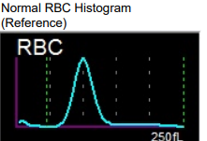

The RBC count and MCV for the two populations shown on the RBC histogram can be found in the Service/RBC/PLT tab of the Browser Screen if needed.

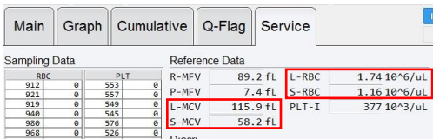

**OpAlert:** RBC Abnormal Distribution: Perform Scan.

Compare RDW to previous results. Scan smear for the presence of abnormal RBC morphology such as: multiple RBC populations, fragmented RBCs, rouleaux or RBC agglutination.

Report any abnormal RBC morphology. If no abnormalities are found, the results with the asterisk (*) may be reported. RDW #nm can be reported on dimorphic RBC populations. Make sure to add the #nm to the comment column so it reports in the patient chart as “not measured.”

**NOTE:** If the RBC morphology is normal and the MCHC is abnormal (<30 or >37.5 g/dL) an interfering substance or condition may be present

**Abnormal, PLT Abn Distribution**

The PLT Abn Distribution IP Message is generated by calculation and size comparison of certain PLT items (PDW*, % of PLT lower discriminator [PL%] *, % of upper discriminator [PU%] *, platelet mean-frequent volume [PMFV]*, platelet large cell ratio*, MPV, platelet upper discriminator [PU]*). *\*These are all non-reportable parameters that are used as part of the flagging algorithm.*

Dashes may appear in place of data for the MPV or the MPV may be marked with an asterisk (*). The asterisk (*) indicates these results may be unreliable and should be confirmed prior to reporting.

 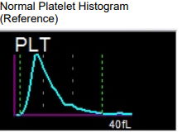

**OpAlert:** PLT Abn Dist: Check for clots, scan smear, perform PLT estimate.

Check the tube for clots by using a wooden stick. If clots found, cancel the test in WAM and Beaker. A new order will need to be placed and patient called back for recollection. If no clots detected, make a slide and **scan the peripheral smear feathered edge and sides looking for platelet clumps and fibrin strands**. Estimate the platelet count and review for the presence of abnormal RBC or PLT morphology.

If platelet estimate does not confirm accuracy of analyzer count replace PLT value with appropriate Clumped comment. **Note:** if the value of platelet is not reported and a comment is reported only, this comment should be entered in the Result and Commentfields.

Report any clinically significant RBC and/or PLT morphology according to our SOP

If no abnormalities are found when reviewing the smear and the analyzer platelet result is consistent with smear review findings, the results with asterisks (*) may be reported.

**Abnormal, WBC Abn Scattergram**

The WBC Abn Scattergram flag is generated whenever clustering in the WDF scattergram is abnormal. Dashes may appear in place of data that was not calculated. This is a non-specific flag which can be generated for a variety of reasons including increased numbers of abnormal cells, poor separation of differential subpopulations, unlysed RBCs, high numbers of platelet clumps or other interfering substances or conditions

Abnormal Scatter Normal Scatter

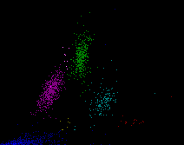 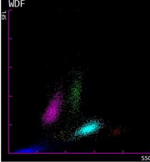

**OpAlert for CBCD:** WBC Abn Scattergram: Verify WBC and perform MDIF

**OpAlert for CBC:** WBC Abn Scattergram: Scan, follow procedure for abnormalities

Check sample integrity for clots and sufficient volume. Compare results to previous values. Scan the slide for abnormal cells or platelet clumping. Perform WBC and PLT estimates. Perform manual differential if applicable. Document if abnormal cells are observed.

If no abnormalities are found when reviewing the smear, the WBC estimate is consistent with the analyzer reported WBC and the PLT estimate is consistent with the analyzer reported PLT, the results with asterisks (*) may be reported.

**Deltas:** Do not need to be repeated.

**Delta Check: HGB Delta**

This message is generated when there is a ± 3.0 difference between the current and last HGB values reported within a 5 day period.

**OpAlert:** HGB Delta failure: Follow Procedure

Evaluate results. Check patient chart for transfusions, surgeries, or other explanation. If the explanation is identified, verify results and document in comment box in WAM: Delta reviewed and OK. If not identified, call the patient care team for explanation. If they can explain delta, then document in comment box: Delta reviewed with Provider (Note who you contacted) and OK. If provider can’t explain the delta, then follow their direction on how to handle.

1) Provider may have you just accept the value: then add comment Delta reviewed with provider and accepted.

2) Provider may accept results but ask that patient come back in for repeat testing. Then comment: Delta reviewed with provider and patient to be retested.

3) Cancel testing if provider doesn’t want to accept the results and wants patient retested.

**Delta Check: MCV Delta**

This message is generated when there is a ± 5.0 difference between the current and last MCV value reported within a 5 day period.

**OpAlert:** MCV Delta failure: Verify Sample Integrity

Evaluate results. Check sample integrity. Check for:

• Clots

• Hemolysis

• Lipemia

• Sample volume at least 1 ml for closed tube and 100 ul capillary.

Check patient chart for transfusions, surgeries, or other explanation. If the explanation is identified, verify results and document in comment box in WAM: Delta reviewed and OK. If not identified, call the patient care team for explanation. If they can explain delta, then document in comment box: Delta reviewed with Provider (Note who you contacted) and OK. If provider can’t explain the delta, then follow their direction on how to handle.

1) Provider may have you just accept the value: then add comment Delta reviewed with provider and accepted.

2) Provider may accept the results but ask that patient come back in for repeat testing. Then comment: Delta reviewed with provider and patient to be retested.

3) Cancel testing if provider doesn’t want to accept the results and wants patient retested.

**Delta Check: PLT Delta**

This message is generated when there is a >25% difference between the current and last PLT value reported within a 5 day period and the PLT value is <100

**OpAlert:** PLT Delta failure: Check for clot, scan smear, perform PLT estimate

Evaluate results. Check patient chart for transfusions, surgeries, or other explanation. Check for clots by using wooden sticks. Scan the smear to estimate the platelet count and review for the presence of abnormal RBC or PLT morphology, PLT clumps and fibrin.

If platelet estimate confirms accuracy of platelet count and delta can be explained, verify results and document in comment box in WAM: Delta reviewed and OK. If not identified, call the patient care team for explanation. If they can explain delta, then document in comment box: Delta reviewed with Provider (Note who you contacted) and OK. If provider can’t explain the delta, then follow their direction on how to handle.

1) Provider may have you just accept the value: then add comment Delta reviewed with provider and accepted.

2) Provider may accept the results but ask that patient come back in for repeat testing. Then comment: Delta reviewed with provider and patient to be retested.

3) Cancel testing if provider doesn’t want to accept the results and wants patient retested.

**NOTE:** If PLT estimate does not confirm platelet count, and clumps or fibrin is present, remove PLT value and replace with appropriate comment. Make sure to enter the comment in the Result and Comment fields.

**Delta Check: WBC Delta**

This message is generated when there is a ± 10.0 difference between the current and last WBC value reported within a 3 day period.

**OpAlert:** WBC Delta failure: Review history to verify sample integrity

Evaluate results. Check patient chart for transfusions, surgeries, or other explanation. If the explanation is identified, verify results and document in comment box in WAM: Delta reviewed and OK. If not identified, call the patient care team for explanation. If they can explain delta, then document in comment box: Delta reviewed with Provider (Note who you contacted) and OK. If provider can’t explain the delta, then follow their direction on how to handle.

1) Provider may have you just accept the value: then add comment Delta reviewed with provider and accepted.

2) Provider may accept the results but ask that patient come back in for repeat testing. Then comment: Delta reviewed with provider and patient to be retested.

3) Cancel testing if provider doesn’t want to accept the results and wants patient retested.

**IG Present/Immature Gran?**

XN-Series analyzers report a 6-part differential that is comprised of Neutrophils, Lymphocytes, Monocytes, Eosinophils, Basophils and Immature Granulocytes. The Immature Granulocyte % / # results include metamyelocytes, myelocytes and promyelocytes.

It only appears when the IG% or IG# exceeds the programmed limit of 5%

The IG Present message alerts the operator to the presence of cells accurately quantitated by the analyzer. When this message is present, it is suggested to review a smear to detect other clinically relevant findings and report the analyzer differential results. If indicated based on smear review, perform a manual differential or comment on clinically relevant findings as described in your laboratory protocol.

Abnormal Scatter in the IG area of Scatergram

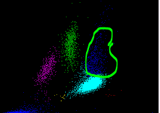

OpAlert: IG% >/=5: Perform Manual Differential, order REV if needed.

Perform WBC and PLT estimate and manual differential. Report any morphology abnormalities. Order REV on first occurrence of IG>5% and immature cells seen are younger than a band form (metas, myelocytes, promyelocytes) then every 6 months if still exists. If unsure of immature cells or if seeing any blasts, cancel and order the CBC review test to go to Regions.

**Insufficient blood volume (short sample)/Function Errors**

This error message is generated by the sample aspiration sensor based on the absorbance of the diluted sample. Results are suppressed when this error message is generated.

**OpAlert:** Result Error: Rerun and evaluate rerun results

Check the sample for clots and that the minimum volume requirements have been met; remix and rerun the sample if acceptable volumes are present. If sample is QNS or not filled properly, cancel test, notify care team and request redraw.

If a sample is suspected of having low hemoglobin, turn off the aspiration sensor in the Manual Analysis dialog box, remix and rerun the sample in the manual mode.

To order a rerun in WAM: Go to actions tab, check the box next to RERUN, and accept. You can now put the sample on the sysmex and run. Go to rerun tab and accept Run 2.

***NOTE:*** Enable the aspiration sensor prior to testing subsequent samples. If this error message is occurring on multiple samples, refer to the analyzer Instructions for Use for troubleshooting information.

To inactivate the aspiration sensor: Go to Main Menu-Settings-Instrument Setting-Aspiration Sensor-pop-up box, unclick Use, OK.

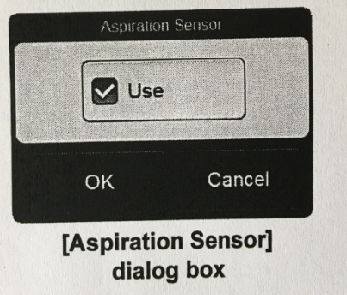



**Linearity Check: HCT**

This message is generated when the HCT value is greater or less than the instrument linear range (0.1-75.0)

**OpAlert:** HCT Linearity: Send to Regions.

Cancel test in WAM and Beaker and reorder appropriate Review test to be run at Region. See tip sheet: Sysmex Preliminary Reports and Send for Reviews.

**Linearity Check: HGB**

This message is generated when the HGB value is greater or less than the instrument linear range (0.1-26.0)

**OpAlert:** HGB Linearity: Send to Regions

Cancel test in WAM and Beaker and reorder appropriate Review test to be run at Region. See tip sheet: Sysmex Preliminary Reports and Send for Reviews.

**Linearity Check: PLT**

This message is generated when the PLT value is greater or less than the instrument linear range (0-5000)

**OpAlert:** PLT Linearity: Send to Regions

Cancel test in WAM and Beaker and reorder appropriate Review test to be run at Region. See tip sheet: Sysmex Preliminary Reports and Send for Reviews.

**Linearity Check: RBC**

This message is generated when the RBC value is greater or less than the instrument linear range (0-8.60)

**OpAlert:** RBC Linearity: Send to Regions

Cancel test in WAM and Beaker and reorder appropriate Review test to be run at Region. See tip sheet: Sysmex Preliminary Reports and Send for Reviews.

**Suspect, Asterisk Error-IG**

**OpAlert:** IG Asterisk Flag: Scan slide to confirm

Evaluate smear for PLT and WBC estimates and PLT, WBC and RBC morphologies. Perform Manual differential. Report abnormal findings. Verify manual results.

**Suspect, Asterisk Error-PLT**

**OpAlert:** PLT Asterisk Flag: Scan slide to confirm

Evaluate smear for PLT and WBC estimates and PLT, WBC and RBC morphologies. Report abnormalities. Verify PLT parameters with appropriate comments as applicable.

**Suspect, Asterisk Error-WBC**

**OpAlert:** WBC Asterisk Flag: Scan slide to confirm

Evaluate smear for PLT and WBC estimates and PLT, WBC and RBC morphologies. Perform Manual differential. Report abnormal findings. Verify manual results.

**Suspect, Atypical Lympho?**

The Atypical Lympho? IP message indicates that the analyzer has detected significant clustering in the region for atypical lymphocytes that is in the upper left lymphocyte region on the WDF scattergram.

An asterisk (*) appears next to the Neutrophil, Lymphocyte, Monocyte, Eosinophil and Immature Granulocyte % and #. The asterisk (*) indicates these results may be unreliable and should be confirmed according to your laboratory protocol prior to reporting.

**OpAlert:** Atypical Lympho: Scan slide, perform MDIF if abn RBC/PLT/WBC.

Scan the peripheral smear for the presence of: atypical or variant lymphocytes; abnormal or atypical monocytes; immature lymphocytes, such as seen in ALL or CLL; immature monocytes; smudge cells; other abnormal cells.

If no abnormalities are found when reviewing the smear and analyzer results are consistent with smear review findings, the results with asterisks (*) may be reported.

If dashes (— —) are in place of numeric data, a manual differential must be performed

HP Clinics can report out reactive lymphocytes (seen in viral infections such as Mono).

Do not report if seeing true atypical lymphocytes (plasma cells) or abnormal cells that you can’t identify. Cancel test and reorder appropriate review CBC and send to Regions.

**Suspect, Blasts / Abn Lympho?**

The Blasts / Abn Lympho? IP message indicates that the analyzer has detected abnormal clustering in the region for blasts and abnormal lymphocytes in the WDF scattergram. An asterisk (*) appears next to the Neutrophil, Lymphocyte, Immature Granulocyte and Monocyte % and #. The asterisk (*) indicates these results may be unreliable and should be confirmed according to your laboratory protocol prior to reporting.

**OpAlert:** Blasts/Abn Lympho?: Scan Slide. Send to Regions if abnormalities.

Scan the peripheral smear for the presence of: blasts, immature granulocytes – promyelocytes, myelocytes, metamyelocytes, atypical or immature lymphocytes other abnormal cells. Report any abnormal cells according to policy. If blasts are seen, cancel test and reorder appropriate CBC Review test to send to Regions.

***NOTE:*** Reviewing the feathered edge and sides of the peripheral smear is suggested as blasts and other large cells may migrate to this area during smear preparation.

If no abnormalities are found when reviewing the smear and analyzer results are consistent with smear review findings, the results with asterisks (*) may be reported.

If dashes (— —) are in place of numeric data, a manual differential must be performed.

**HP clinics cannot report out Blasts. These must be confirmed by Regions.**

**Suspect, Fragments?**

The Fragments? IP Message is determined from calculation and size comparison of certain RBC and PLT items (MCV, RDW-SD, MCHC, RBC Lower Discriminator [RL]*, PLT Upper Discriminator [PU]*, PLT Upper Discriminator % [PU%]*)

**OpAlert:** Scan, perform PLT estimate. If fragments present, refer out (REV)

Scan the peripheral smear for the presence of fragmented RBCs, platelet clumps and fibrin. Perform manual differential. Add comments to PLT if clumps or fibrin present. Report the presence of any clinically significant RBC morphologies. Refer to pathology if moderate schistocytes (Treat as a heme emergency and send the specimen **STAT**) or teardrops seen.

***Note:*** if removing PLT value and replacing with the comment CLUMP, enter CLUMP in both the numeric and comment column. If reporting PLT value with a comment, use comment from comment list in WAM

**Suspect, Left Shift?**

This flag will only generate in samples that have a WBC is >0.50 x 103/µL in the Whole Blood (WB) mode. The Left Shift? IP message indicates that the analyzer has detected abnormal clustering in the region for left shift (bands) in the WDF scattergram. When bands are present, they are included in the neutrophil population. An asterisk (*) appears next to the Neutrophil and Eosinophil % and #. The IG% and IG# may also have an asterisk. The asterisk (*) indicates these results may be unreliable and should be confirmed according to your laboratory protocol prior to reporting.

**OpAlert:** Left Shift: Scan slide, perform MDIF if abn RBC/PLT/WBC.

Scan the smear for the presence of band cells in increased numbers, toxic granulation or vacuolation of neutrophils or other abnormal cells. Report any abnormal cells according to policy.

If no abnormalities are found when reviewing the smear and analyzer results are consistent with smear review findings, the results with asterisks (*) may be reported.

If dashes (— —) are in place of numeric data, a manual differential must be performed

**Suspect, PLT Clumps?**

The PLT Clumps? IP Message is determined by abnormal clustering in the WDF scattergram. Asterisks (*) will appear next to the PLT result. Dashes may appear in place of data for the MPV or the MPV may be marked with an asterisk.

**OpAlert:** PLT Clumps? Check for clot, scan smear, plt estimate, add comments. Remove plt value and replace with comment if clumps/fibrin found on feather edge.

**Platelet Clumps flag: Whenever WAM flags for plt clumps or OP ALERT states to check for clots, take the top off the tube and use the wooden applicator sticks to check for visible clots. If clots detected, cancel test in WAM and Beaker, reorder test, and call patient back for a redraw. In WAM record that you checked for clots and what the outcome was by clicking on comment box. A pop-up box appears. Defaults to internal comment-these comments stay in WAM and do not go to the patients chart. Document: Ex. No clots detected or clots detected. Save. Quit.**

Scan the smear, especially the feathered edge, for the presence fibrin strands and/or platelet clumps. If neither are present, verify the WBC and PLT by a manual slide estimate. If the WBC and PLT estimates are consistent with the analyzer counts, report the results.

If the estimates are not consistent with the analyzer counts, refer to the next step to obtain an accurate count.

***NOTE:*** If platelet clumps or fibrin strands have interfered, replace the PLT value with appropriate CLUMP flag.

**For EDTA Clumpers:**

Draw EDTA and Citrate tube (citrate must be full)

Follow the tip sheet: **Running Citrate Tube for Clumped EDTA PLTS.**

Moderate complexity lab must send a copy of the analyzer printout and the slides, made immediately from EDTA and Citrate tubes, to Regions.

**Suspect, RBC Agglutination?**

The RBC Agglutination? IP Message is determined by calculation and size comparison of certain RBC items (MCHC, MCH, RBC, Upper RBC histogram discriminator [RU %]*). *The RU% is not a reportable parameter, but it is used in the RBC Agglutination algorithm.

Asterisks (*) appear next to the RBC, HGB, HCT, MCV, MCH, MCHC and RET # parameters. The asterisk (*) indicates these results may be unreliable and should be confirmed according to your laboratory protocol prior to reporting.

**OpAlert**: RBC Agglutination: Scan slide, follow protocol

**Cold Agglutination**

If the RBC appears too low in relation to the HGB and HCT, and the MCV, MCH and MCHC are moderately elevated, the specimen may contain cold agglutinins. At temperatures less than body temperature, cold agglutinin antibodies bind the RBCs together so that the particles counted by the instrument are clumps rather than individual cells. This results in falsely low RBC values. WBC and Hgb are not affected by cold agglutinins, so these values should remain the same after warming the specimen.

1. **Scan** the peripheral smear for the presence of agglutinated RBCs. Visually check the sample tube for agglutination.

2. **If agglutinated RBCs are present**: Warm the sample at 37°C for 15-30 minutes in the

incubator.

3. Reanalyze the warmed sample in the manual mode after mixing by manual inversion 10

times**.**

4. If after prewarming, the patient results change in a manner consistent with the presence of

cold agglutinins, report out the results from the warmed specimen after adding free text

comment, “Prewarmed”, to RBC, MCV, MCH, MCHC. To add free text- Double click

comcolumn next to test parameter. A new box of comments opens, in the

bottom of the box is a yellow section. Type in Prewarmed. Do not add any characters (no

semicolon, no dash etc) then SAVE. These will attach right below the value when crossing

to Beaker. NOTE: Results will hold in outstanding list in Beaker so you just need to

review in Beaker outstanding, see that all the results crossed and then use the Final at top of

screen in outstanding list to send it to patient chart.

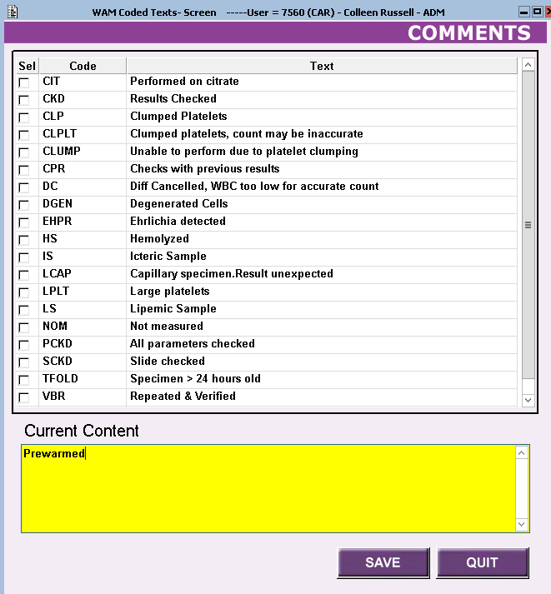

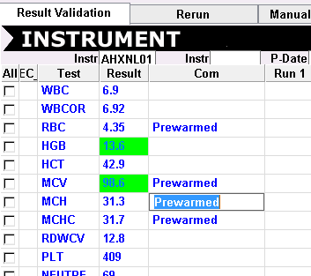

5. Sometimes agglutination can be so severe that warming the sample does not enable

accurate analysis. In this case send specimen to Regions along with the Sysmex instrument

copy stating cold agglutinin suspected.

6. Moderately Complex labs should send their samples to Regions.

**Suspect, Turbidity/HGB Interference? (aka MCH >37.5)**

The Turbidity/HGB Interference? IP Message occurs when the MCHC is >37.5 g/dL and indicates that turbidity may be present in the diluted and lysed sample. This turbidity could interfere with the HGB detection light path and falsely increase the HGB value. Other interfering substances or conditions may impact the hematocrit and cause an MCHC >37.5 g/dL.

Asterisks (*) appear next to the HGB, MCH and MCHC parameters. The asterisk (*) indicates these results may be unreliable and should be confirmed according to your laboratory protocol prior to reporting.

**OpAlert:** MCHC >37.5: Send to Regions

It is acceptable to verify an MCHC up to 37.5 g/dL.

**Clinic WAM Additional Terms/Workflows**

**Send to Regions**-Do not validate any results. Cancel test in WAM and Beaker and reorder appropriate Review test to be run at Region.

**Order REV in OpAlert**: In WAM, go to actions box and order a PATH-double click under the result column and add comment sent for Path review. Validate results. Fill out the green slip to Region and follow the directions on the form on what to send.

**Canceling test**: If a hematology order needs to be canceled, it must be canceled in WAM and in Beaker.

**Preliminary Hematology Beaker Test Code: NOTE: only WBC or HGB or Plt will be available for prelim.**





Use the Prelim test code to generate a new order and label when providers request a prelim result for WBC, HGB, PLT since specimen will be sent to Regions to run and final verify. Manually enter the WBC, HGB, Plt values that we got off the sysmex run.