

Subject  Stago Satellite Maintenance | Attachments  Yes No
Key words  Coagulation, Daily, Weekly, Monthly Maintenance | Number  GHI-PC-CLINIC LAB-PROCEDURES- Stago Satellite Maintenance v. 04-2019
Category Provision of Care | Effective Date  See Electronic File
Manual Coagulation Procedure Manual | Last Review Date  See Electronic File
Issued By Regional Clinic Laboratories Supervisors | Next Review Date  See Electronic File
Applicable Clinic Laboratory Staff | Origination Date  October, 2017
Applicable Clinic Laboratory Staff | Retired Date
Level of Complexity Moderate | Contact Regional Clinic Laboratories Supervisors
Review Responsibility Regional Clinic Laboratories Supervisors | Approval Date  See Electronic File
APPROVAL(S) Laboratory Medical Director

Purpose/ Principle
This procedure provides instruction for the routine maintenance of the Stago Satellite Coagulation Analyzer.

Reagents/Equipment/Supplies
Reagent Grade Water | 20% Ethanol | Paper Towels | NP Swab
STA Cleaner Solution & Desorb | Scissors | Cotton Tipped Swabs | Vial of hot water
Dilute bleach solution: see “Dilute Bleach” section below

- Refer to the Stago Satellite Prothrombin Time Assay procedure for a list of reagents used to perform testing on this analyzer, their preparation and stability.
- Note the current reagents loaded in the product carousel (volumes and expiration dates/ times). You will need to adjust product stability hours in global verification.
- Reagents used to perform maintenance:
  - Ethanol 95%
    - Store product in its original container at 18-25°C until use.
    - Do not use if the color has changed from a clear liquid, the expiration date has passed or there are other signs of deterioration.
    - Ethanol 95% reagent is toxic, use smallest volume needed for procedure.
    - Dilute ethanol 20% is used to clean the measurement cells and the incubation cells.
      - Prepare 20% ethanol from 95% ethanol:
        - Mix 1 part of ethanol at 95% with 4 parts of reagent grade water (1 ml ethanol + 4 mls reagent grade water).
        - Solution is stable for 2 hours and should be disposed of immediately after use.
  - Dilute Bleach:
    - Calculations to prepare 0.37% active chlorine decontamination solution:
      - N=(B/0.37)-1
        - N= parts of water to add to 1 part of bleach
        - B= % active chlorine in the bleach you are using.
      - Comes in 2 strengths: 8.25% and 6.0%
    - Regular Bleach (6.0% sodium hypochlorite solution):
      - Decontamination solution is made by mixing 1 part of 6.0% bleach with 15 parts of reagent grade water (2 ml bleach + 30 ml reagent grade water).
        - Stable for 24 hours when stored at room temperature.
    - Regular Bleach (8.25% sodium hypochlorite solution):
      - Decontamination solution is made by mixing 1 part 8.25% bleach with 21 parts of reagent grade water (1 ml bleach + 21 ml reagent grade water).
        - Stable for 24 hours when stored at room temperature.
  - STA Cleaner Solution
  - STA Desorb
Special Safety Precautions
- Ethanol:
  - Special precautions should be taken when using ethanol during weekly maintenance procedures.
  - Comes in 250 ml plastic bottle.
    - Ethanol may be fatal or cause blindness if swallowed.
    - Ethanol is known to be a skin irritant. Gloves should be worn when handling ethanol.
    - Ethanol is flammable. Store away from heat or flame. The smallest amount needed to perform a task should be used.
- Bleach:
  - Special precautions should be taken when using this product to make the decontamination solution used for weekly maintenance.
    - If bleach is splashed in eyes, hold eye open and rinse slowly and gently with water for 15-20 minutes. Remove contact lens if present, after the first 5 minutes, then continue rinsing the eye.
    - If bleach is splashed on skin or clothing, take off contaminated clothing. Rinse skin immediately with plenty of water.
    - Gloves should be worn when handling bleach.
PREVENTIVE MAINTENANCE
Weekly:
Cleaning the needle and the washing well
Cleaning the shield
Cleaning the carousels
Cleaning the sample and product compartments
Cleaning the rail
Cleaning the rail glass
Cleaning the rail, sample and product covers and the needle passage.
Cleaning the optical sensor
Cleaning the covering (if necessary)
Cleaning the monitor (if necessary)
Save test config.
Monthly:
Clean the dust filters
Quarterly:
Replace the dust filters
Yearly:
Replace the needle
Preventive maintenance visit by local authorized Service Representative
PROCEDURE
Weekly Maintenance:

Cleaning Needle and Washing Well
- Access Test Status Screen and record number of cuvettes.
  - Access Status, product screen:
    - Record product volumes and remaining hours of stability to be updated during global verification.
- Access User Maintenance Menu.
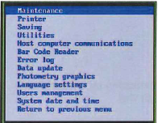
  - If completeing monthly maintenance, perform the “System Backup” process now. See “System Backup” procedure under “Monthly Maintenance” below.
- With Maintenance highlighted, hit [enter] again.
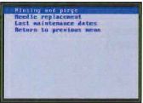
- [Enter] to access Rinsing and Purge menu.
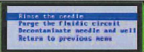
- ↓ arrow until to Decontaminate Needle and Well. [Enter] to confirm.
- Follow instructions on the screen:
  - Open cover and unload product from position 1.
  - Press any key to continue.
  - Load Desorb into position 1 of product carousel. Close cover and press any key to continue.
  - Decontamination time is 15 minutes.

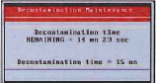

  - When complete, a message appears to open the cover and remove the Desorb. Press any key to continue.
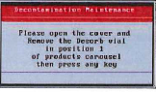
  - Close the product cover.
- From the Rinsing and Purge Menu:
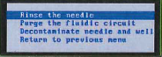
  - Access Rinse the Needle menu.
  - [Enter] to confirm- the needle is rinsed.
  - Access Purge the Fluidic Circuit menu.
  - [Enter] to confirm. The fluidic circuit is purged.
  - Quit the Rinsing and Purge Screen.
  - Press ↓ to return to Return to Initial Menu
  - [Enter] to confirm.

The Decontaminate Needle and Well menu is used if the system has become contaminated (i.e. waste container accidentally loaded in place of cleaner solution). If Decontamination is required, follow the procedure outlined in the Operator’s Manual, Section 4.6.6. This procedure takes approximately 4 hours to complete.

Clean the Shield
- From the User Maintenance Menu, turn the analyzer off. The toggle switch is on the right side of the instrument.
- Remove the rail cover.
- Slightly unscrew the flange (transparent washer) so that it swivels and release the shield.

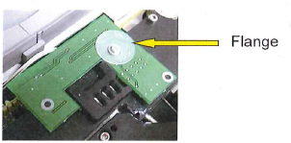

- Place the shield in the dilute bleach solution.
- Set a timer and soak for 15 minutes.
- Perform the rest of the maintenance while the shield soaks.
- Clean the product and sample carousels.

Clean carousels
- Remove sample and product carousels from their compartments.
- Wipe carousels with a damp cloth moistened with hot water.
- If the carousels become contaminated (broken tube or spilled plasma), clean with dilute bleach solution.

Clean sample and product compartments
- Clean sample and products compartments with a damp cloth moistened with hot water
Clean the rail
- Remove cuvette roll by manually driving the belt.
- Remove the cuvette roll and its support
- Use a scissors to cut off any used cuvettes. Discard the cuvettes. (This is very important).
- Carefully clean the rail with a cotton tipped applicator moistened with hot water. Do not allow water to contact the electronic card.

Clean the rail glass
- Carefully clean the rail glass with a cotton tipped applicator moistened with Sta Cleaner. Slide the applicator through the rail window and gently clean the glass.
- Dry the rail glass with a dry cotton tipped applicator.
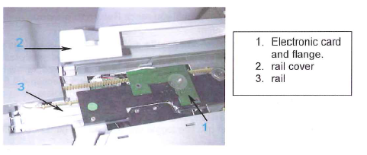

Clean the rail, sample and product covers
- Remove the sample cover needle protection, product cover needle protection and the wash well needle protection.

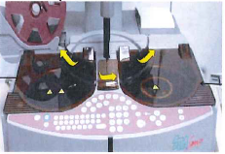

- Clean the covers with a damp cloth moistened with dilute bleach. (See supplies)
- Clean the needle passage with a cotton tipped applicator moistened with dilute bleach.
- Place the needle protection covers back into their notches.

Clean the optical sensor
- Clean the optical sensor with a nasopharyngeal swab slightly moistened with Sta Cleaner.
- Dry the sensor with a gauze pad.

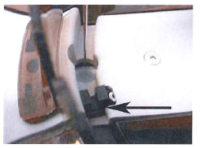

Remove shield from dilute bleach
- Remove shield from dilute bleach solution.
- Rinse shield with distilled water and dry well.
- Put the shield in place by placing the notch on the right side.

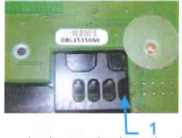
- Swivel the flange back around to keep shield in place.
- Put the rail cover back on.

If performing monthly maintenance, skip the remainder of this section and proceed to Monthly Preventative Maintenance Section.

- Turn the Satellite back on.
Clean Monitor & Global Verification
- While the analyzer performs Global Verification, clean the monitor, cover and keyboard with a cloth moistened in 20% ethanol.
- When the cuvette management message displays, press the Esc key to quit the error message.

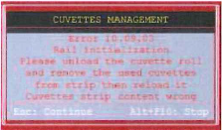

- When Global Verification Done window appears, select [continue]. Load any needed products.
  - Edit volumes and stability as needed
  - 1.3 ml of Desorb is used during the weekly maintenance. Subtract 1.3 ml from the beginning Desorb volume and update volume during Global Verification.
Example: new bottle = 15 ml and 1.3 ml is used during decontamination, 15-1.3 = 13.7 ml volume to enter during Global verification
- When the [cuvette roll change] window appears, reload the cuvettes.

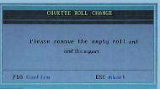

- Replace the cuvette support and roll to complete the process. Enter the number of cuvettes on the wheel (this number was recorded at the beginning of the procedure).
- Simulate changing the cuvette bin to complete the procedure.

Save test configuration to disk/usb
- Access the User Menu.
- Press the ↓ key to reach Saving. [Enter] to confirm.
- Save/ reread parameters displays. With the cursor on Selection of items, press [enter] to select.
- Select “test settings” and “system parameters” using the space bar. Press [F10] to save.
- Select Saving and [enter].
- When prompted, “Do you want to save selected parameters?” press [enter] to confirm.
- Follow instructions on the screen. Insert the formatted floppy disk/USB when requested. [Enter] to confirm.
- When “Saving OK” displays, remove the floppy disk/USB, label as “test config, system parameters” and the date made.
- Return to the previous menu, press [enter] to confirm.

Monthly Maintenance

Clean dust filters
- Power off the Stago Satellite.
- Use the filter tool from the tool box to remove all 3 filters.

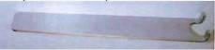

- The filters are located beneath the Satellite. One is in the front; the other two are on each side.
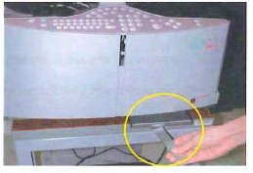
  - Open the filter support.
  - Clean the filter with either a vacuum or compressed air.
  - Replace the filter into the support.
  - Replace the filter in the Satellite. The larger side of the support (inferior part) must be facing down when placed on the instrument.

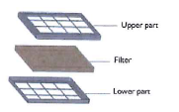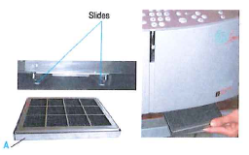
- Turn instrument back on when procedure is complete, or if performed as part of weekly maintenance, finish weekly maintenance.

System Backup
- Access User Menu.
- Press the ↓ key to reach Saving. [Enter] to confirm.
- Save/Reread Parameters displays. With the cursor on Selection of items, press [enter] to select.
- Arrow down to “Device Status”. Press [Enter].
- Press “S” to save data files
- Follow instructions on the screen. Insert the formatted floppy disk/USB when requested. [Enter] to confirm.
- When “Saving OK” displays, Press [enter].
- Remove the floppy disk/USB, label as “Device Status” and the date made.
- Return to the previous menu, press [enter] to confirm.

Quarterly Maintenance

- The only recommended quarterly maintenance is to change the air filters
- STA Satellite replacement air filters may be ordered from Diagnostica Stago. Replacement part is #80132;
- 1 pack contains 3 air filters.

As Needed Maintenance

Changing the Time on the STA Satellite
- Access the User Maintenance Menu from the Menu Bar. Once the window is displayed for User Maintenance, move the cursor to the “System Date and Time” line. [Enter] to access the program. The following window is displayed.

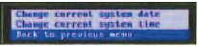

- Press the ↑ key until you reach [change current system time]. The time format is defined in Global Options. When typing in the new time you must use the same format as displayed.
- Confirm the new time with [Enter]. The updated time will be displayed.
- When complete, [Back to previous menu] and [Esc] out of the User Maintenance to return to the main menu.
- When exiting out of User Maintenance, the STA Satellite will go through Global Verification.

References
STA Satellite® Operator’s Manual July 2016.
STA Satellite ® User Guide November 2011.

Author (s)
Dylan Eaton
Karen Kaestner
Amanda Wherry
Marie LaFromboise

Approved by
Laboratory Medical Director or Designee

