|  |  |
| --- | --- |
| Logo Alone 8-11-15 |  |
| **Subject**  **Stago Satellite Prothrombin** | **Attachments**  Yes  No |
| **Key words**  Coagulation, INR, PT, Satellite | **Number**  **GHI-PC-CLINIC LAB-PROCEDURES-Stago Satellite Prothrombin v. 04-2019** |
| **Category** | **Effective Date**  **See Electronic File** |
| **Manual** Coagulation | **Last Review Date**  **See Electronic File** |
| **Issued By** Clinic Laboratory Administration | **Next Review Date**  **See Electronic File** |
| **Applicable**  Clinic Laboratory Staff using the STA Satellite Analyzer | **Origination Date**  **October, 2017** |
| **Retired Date** |
| **Level of Complexity** Moderate | **Contact** Regional Clinic Laboratories Supervisors |
| **Review Responsibility** Regional Clinic Laboratories Supervisors | **Approval Date**  **See Electronic File** |
| **APPROVAL(S)** Laboratory Medical Director |  |

**Purpose**

To provide instruction for the performance of the prothrombin time (PT) test on the Stago Satellite.

**Principle**

STA®- Neoplastine CI Plus is used for prothrombin times on the STA® Satellite. A mixture of thromboplastin is added to citrated plasma and the time of clot formation is determined. The STA® Satellite is a fully automated coagulation instrument, which uses an electromagnetic mechanical clot detection system. The oscillation of a steel ball within the cuvette with the thromboplastin and plasma is monitored by the STA® Satellite. When the oscillation of the steel ball is stopped by clot formation, this registers the time in seconds.

The ISI value of a given thromboplastin is determined by performing PTs on normal plasmas and Coumadin treated patient plasmas with the given thromboplastin and the WHO reference thromboplastin. The slope of this regression curve of the matched pairs is the ISI for the thromboplastin. (The ISI of the WHO reference thromboplastin is 1.0, however this may not be the ISI of your lot of Neoplastine, that information is found in the package insert for that given reagent.)

The prothrombin time is a basic coagulation screening test for the assessment of congenital and acquired deficiencies of the extrinsic pathway (factors II, V, VII, X). The prothrombin time can be prolonged in certain clinical states, i.e. warfarin therapy, intestinal reabsorption disorders, liver failure, fibrinolysis and Disseminated Intravascular Coagulation (DIC).

The prothrombin time is also used to monitor warfarin therapy because of its sensitivity to variations in the concentration of the Vitamin-K dependent factors II, VII, IX and X. Because of the variations in the prothrombin time results with different thromboplastins and instruments, it is recommended that the prothrombin time results be converted to an INR. The INR corresponds to the value of the ratio of the patient’s PT and the geometric mean PT of the normal reference population raised to the ISI (International Sensitivity Index) power.

**Specimen**

* Collect 2.7 mL of whole blood in a 3 mL tube of 3.2% Sodium Citrate Plasma (light blue-top tube) filled to fill line on the tube.
* If using a butterfly for collection, use a blue top tube to clear the line of air before collecting the sodium citrate tube.
* At minimum, tube must be 90% full to be used for testing. (Within 10% of the etched line)

**Specimen stability**

* Specimens are stable unspun and capped for 24 hours at room temperature.
* DO NOT refrigerate.
* If testing is delayed due to an instrument failure, batch and send specimens to Regions hospital for testing.
* If testing will not be completed within 24 hours, freeze an aliquot of plasma at -20°C.

**Unacceptable Specimens**

* Samples that do not meet the minimum draw requirement
* Samples exceeding maximum draw requirement
* Clotted samples
* Hemolyzed samples

**Specimen processing**

1. Centrifuge the blood specimen to obtain platelet poor plasma, as previously assessed per centrifuge, as soon as possible after collection.
2. Visually check the specimen for a HCT >55% or < 20% by estimating if the proportion of red blood cells to total blood drawn is greater than 55 % or less than 20%.
   1. If HCT visually appears < 55% and > 20% proceed with testing.
   2. If HCT suspected to be >55% or < 20% thoroughly remix sample, perform testing on Sysmex. Multiply Sysmex HCT result by 1.1.
      1. If HCT result is <20%, append by free text “Low Hematocrit may affect result”.
      2. If HCT result is >55%, collection in a special tube adjusted for volume is required.
         1. If patient has a standing order for high hematocrit and a special tube was collected, perform testing on the special tube.
         2. If no previous history and no standing order for special tube:
            1. Cancel test
            2. Notify care team
            3. Contact patient to return for recollection
            4. Contact St. Paul lab for further instruction.

**Reagents**

**Desorb:**

Preparation:

1. Remove cap and discard rubber stopper
2. Install Maxi Reducer
3. Replace cap
4. Document open date, revised expiration date and tech code on vial

Stability:

* Unopened: Until manufacturer expiration date when stored at 2-8°C
* Opened: 14 days stored on the instrument

**STA-Neoplastine CI Plus:**

Preparation:

1. Pour liquid from Reagent Vial 2 into Reagent Vial 1 and tap gently
2. Allow to stand 30 minutes at room temperature – DO NOT mix before 30 minute incubation
3. Gently invert to mix
4. Document open date, revised expiration date and tech code on the vial
5. Add clean stir bar to the vial - stir bars must be decontaminated when changing reagent (see instructions below).
6. Tilt vial and add maxi reducer being careful not to set on top of stir bar.

Stability:

* Unopened: Until manufacturer expiration date when stored at 2-8°C
* Reconstituted: 4 days when stored on the instrument

Decontaminate the Neoplastine Stir Bar:

1. Place the stir bar in a plastic screw top aliquot tube.
2. Add 2mL of Desorb.
3. Cover, shake for 10-15 seconds then soak for 5 minutes (place tube on rocker to soak).
4. Replace the Desorb solution in the tube with water and repeat x2.
5. After the second rinse, dry the stir bar and store in a dry aliquot tube until the next time the Neoplastine needs to be replaced.

**STA- Coag Control Normal and Abnormal:**

Preparation:

1. Reconstitute each vial of control with 2ml of Reagent Grade water
2. Allow to stand at room temperature for 30 minutes - DO NOT swirl before 30 minute incubation
3. Gently swirl vial before use
4. Document open date and time, revised expiration date and tech code on the vial

Stability:

* Unopened: Until manufacturer expiration date when stored at 2-8°C
* Reconstituted: 36 hours stored on instrument at high complexity lab locations and 24 hours at moderate complexity lab locations. (Deviates from package insert - See stability study documentation in labadmin drive).

**Quality Control**

* Normal and abnormal quality control testing is performed every 8 hours each day of patient testing per procedure.
* After replacement/replenishment of reagents
* After instrument maintenance
* When there is a concern about the accuracy of analysis values
* Results interface into LIS.
* Verify results are within acceptable range.

If controls are out of acceptable range, refer to section VI. Corrective action is required when a control fails to perform as expected.

NOTE: Controls must be acceptable prior to reporting patient test results.

**Procedure**

NOTES:

* Instrument to remain on, only shutdown for weekly maintenance.
* Press any key to “wake” instrument from save mode (dark screen)
* DO NOT open cover without instrument permission
* Press ESC to toggle between Main menu and TEST PANEL screen
* Blinking red light in front of probe indicates instrument is running – keep clear of probe

1. **Reagent & Supply Loading/ Unloading**Prepare reagents as instructed.  
   Reagents in large vials are loaded in carousel position 1, 5, 9 and/or 13.   
   Reagents placed in positions 1-11 on carousel allows viewing of all reagents on one screen.
   1. Desorb – Position 1 – it is required in this position for weekly maintenance – add maxi reducer
   2. Neoplastine – incubate at room temperature 30 minutes - Swirl the reagent vial gently to obtain a homogeneous suspension, add clean stir bar, tilt and add maxi reducer
   3. Controls - incubate at room temperature 30 minutes – swirl to mix

NOTE: reagents containing stir bars must not be directly adjacent to one another on the carousel.

**Load Product by Vial**

On TEST PANEL screen

* 1. Select F2 Products: vial
  2. Open cover when prompted
  3. Press any key
  4. Use ↑↓ to select position – when highlighted - <ENTER>
  5. Selected position will be at bottom of screen
  6. Carousel will rotate the selected position to be in front of the barcode reader
  7. Place product in carousel with the barcode facing the reader <ENTER>  
     Use insert for controls   
     Product information will display across bottom of screen
  8. Confirm volume <ENTER> (adjust as needed)
  9. Confirm stability <ENTER> (adjust as needed)
     1. QC stability is 36 hours per internal stability study for high complexity lab locations. 24 hours at moderate complexity lab locations
     2. High complexity lab locations ONLY: Satellite will expire QC at 24hrs, to work around this the QC vials should be removed and then placed back on the carousel, update the stability to 12 hours (This will allow us to use the same QC vials for the full 36 hours). The volume should also be manually updated to reflect the remaining volume in the vial (ex: 1.8).
  10. Repeat for all reagents loaded
  11. Close cover
  12. ESC - Quit

Carousel will initialize and display TEST STATUS screen

ESC to return to TEST PANEL screen

**Unload Product by Vial**

On TEST PANEL Screen

* 1. Select F2 Products:vial – product loading pop up window
  2. Open cover – press any key
  3. Arrow ↑ to highlight product to be removed <ENTER>
  4. Carousel will move product to barcode loading position
  5. Remove product
  6. Repeat steps 4-5 until all desired products removed
  7. Close cover
  8. ESC
  9. ESC-Quit

Carousel will initialize – please wait

**Load by carousel**On TEST PANEL screen

* 1. Select F2 Products: vial
  2. Open cover when prompted
  3. Press any key
  4. Load reagents with barcode facing reader
  5. Close cover - Instrument will initialize carousel
  6. A reagent will be highlighted
     1. Verify reagent name <ENTER>
     2. Verify reagent volume <ENTER>
     3. Verify reagent stability <ENTER>
        1. QC stability is 36 hours per internal stability study at high complexity locations. 24 hours at moderate complexity lab locations.
        2. High complexity lab locations ONLY: Satellite will expire QC at 24hrs, to work around this the QC vials should be removed and then placed back on the carousel, update the stability to 12 hours (This will allow us to use the same QC vials for the full 36 hours). The volume should also be manually updated to reflect the remaining volume in the vial (ex: 1.8).
  7. press ESC

**II. Cuvette Roll Loading:**

* 1. Access the CUVETTE ROLL CHANGE window
  2. Remove the empty roll
  3. Install the new cuvette roll
  4. After changing the cuvette roll, the cuvette bin must be emptied

**Accessing CUVETTE ROLL CHANGE window:**

* 1. Access from the Error Window:   
     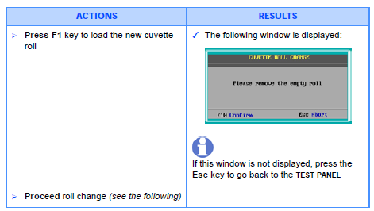
  2. Access from the Main Menu, TEST PANEL screen:   
     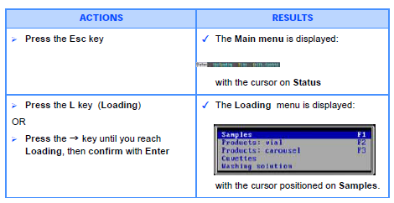

**Changing Cuvette Roll:**

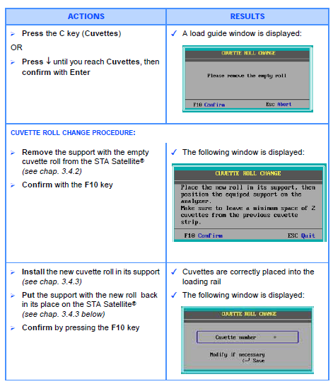

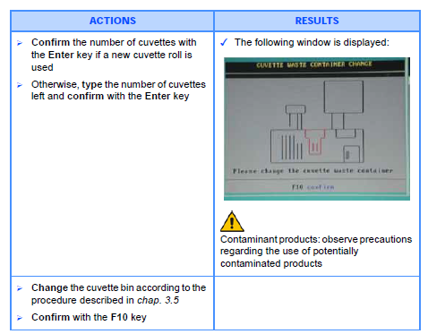

**NOTE: there are 220 cuvettes/roll**

**Removing the empty roll:**

* 1. During this procedure, do NOT lift the cover of the measurement rail. If the cover is lifted, the STA Satellite stops immediately.
  2. Take out the roll support from its location by lifting it up.
  3. Take out the empty roll from its support (*see below*), and throw it away.   
     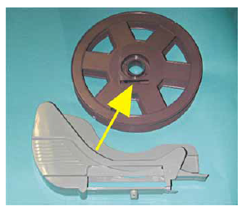
  4. Place the new roll by passing the cuvette strip behind the axis support (see below).
  5. Unroll the cuvette roll until the limit shown below.
  6. Replace the support with the new cuvette roll back in its place.
  7. Make sure to leave a minimum space of two cuvettes from the previous cuvette strip.
  8. Confirm with the F10 key.

**Axis location in the roll support**

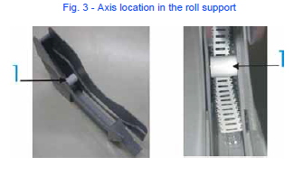

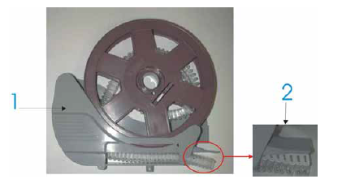

1. **Cuvette roll support**
2. **Cuvette roll limit**

**Change of the Cuvette Bin - Risk of BIOLOGICAL CONTAMINATION**

* 1. Each time the cuvette roll is changed, the cuvette bin must be emptied. The cuvette bin contains potentially biologically hazardous material. It must be discarded according to local regulations.
  2. Take out the cuvette bin from the STA Satellite by pulling it to the right.
  3. Put the cuvette bin on a flat stable surface.
  4. Take a disposable bin cover.
  5. Clip the cover on the disposable bin (see below)  
     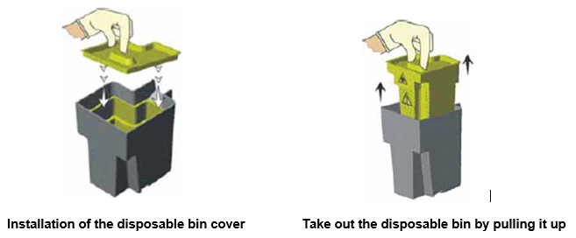
  6. Discard the disposable bin and its content in the biohazardous waste container.
  7. Take a new disposable bin and insert it into the bin.
  8. Replace the cuvette bin with the new disposable bin in place, make sure the bin is pushed in as far as it will go.
  9. Press F10 to confirm the cuvette bin replacement.

**III. Quality Control Testing**

Controls must be run prior to performing any patient testing and every 8 hours of operation.  
  
**Running Controls**On main menu screen

* 1. Select C (calibration/control)
  2. Use ↑↓ to select Quality control <Enter>
  3. PT+ highlighted
  4. Press F1 to Select – a letter “S” will appear to the left
  5. Press F10 to confirm – run selected controls
  6. A pop up window will appear: “Password” will be highlighted in blue, password is QC <ENTER>.
     1. The “S” will change to a yellow rectangle
  7. Press ESC to return to Test Status screen
  8. Instrument will run controls
  9. ESC
  10. ESC – return to TEST PANEL screen

**IF A CONTROL FAILS** – an alarm will sound and a pop up window will appear-refer to procedure section. Corrective action is required when a control fails to perform as expected. The failure must be addressed prior to continuing with testing. To silence alarm – press the space bar.

**Reviewing Controls**

* 1. ESC to return to main menu screen
  2. Select C (calibration/controls).
  3. Use ↑↓ to select Daily control <Enter>
  4. F6 to print results
     1. Save printouts for 2 years
  5. Press ESC two times

**To Review Levy Jennings Graphs**

* 1. Select C (calibration/controls).
  2. Use ↑↓ to select Quality control <Enter>
  3. PT+ highlighted <ENTER>
  4. Use F2/F3 to toggle between levels
  5. ESC
  6. Pop up window – “Return to result list” highlighted <ENTER>
  7. ESC – return to TEST PANEL screen
  8. Results interface into LIS.

**IV. Patient testing- Loading samples**

NOTE: Microtainer tubes must be loaded in MANUAL MODE

**Sample loading by VIAL - MANUAL MODE - cover must remain CLOSE**  
On TEST PANEL screen

* 1. Select F1 Samples – sample loading pop up window
  2. Verify MANUAL MODE – if in AUTO MODE, see below to select MANUAL MODE
  3. ESC
  4. Remove cap from sample tube
  5. Place tube with barcode facing reader - gently press tube down to ensure it is seated at bottom of carousel
  6. PT+ highlighted <ENTER>
  7. F10 to validate – sample ID will move to upper box on the screen with carousel position and PT+ indicated
  8. Repeat steps 4--7 for all samples to be tested
  9. ESC – options
  10. “Quit” highlighted <ENTER>
  11. Run will start
  12. End of run – results will print
  13. Save printouts for 2 years
  14. Results interface into LIS

**Loading a microtainer tube**

* 1. Place a microtainer adapter on the carousel
  2. Using a disposable pipette, aliquot ~ 1ml of sample into a microtainer tube and place in adapter on carousel
  3. Select F8 to select microtainer tube
  4. Manually enter MPI number <ENTER>
  5. PT+ highlighted <ENTER>
  6. Select F10 validate– sample ID will populate box on the upper screen with position and PT+
  7. Verify presence of a “µ” to the right of the sample carousel position

**Sample Loading by VIAL - AUTO MODE**

On TEST PANEL screen

* 1. Select F1 Samples – sample loading pop up window will appear
  2. Verify in AUTO MODE
  3. ESC
  4. Remove cap from sample
  5. Place tube with barcode facing reader – gently press tube down to seat at bottom of carousel
  6. Press any key – sample ID and position will populate lower box
  7. Repeat for all samples
  8. ESC
  9. “Quit” highlighted <ENTER>
  10. Run will begin
  11. End of run – results will print
  12. Save printouts for 2 years
  13. Results interface into LIS.

**Sample Loading by Carousel – use for large batches that do not include microtainer tubes**

* 1. Must be in AUTO MODE – If in MANUAL MODE, see below to select AUTO MODE
  2. On TEST PANEL screen
  3. Select F1 Samples – sample loading pop up window will appear
  4. Verify in AUTO MODE
  5. Open cover
  6. Remove cap from sample
  7. Place tube with barcode facing reader- gently press tube down to seat at bottom of carousel
  8. Close cover
  9. Carousel initialization – Reading carousel identity
  10. Run will start
  11. End of run – results will print
  12. Save printouts for 2 years
  13. Results interface into LIS.

**Repeat Testing**

On TEST PANEL screen

* 1. Highlight sample to be repeated <ENTER>
  2. Select F4 Delete
  3. Select F10 Save – this will erase previous result
  4. Select F5 Insert
  5. PT+ will be highlighted <ENTER>
  6. Select F10 Save
  7. Select F10 Run
  8. Run will start
  9. End of run – results will print –save printout for 2 years
  10. Compare repeat result to first result - Verify within acceptable repeatability range
      1. The results must check within 5% on the seconds (not the INR)
         1. Example: Patient seconds are 42.5 and 44.3
         2. Using the first result of 42.5 + 5% = 42.5 x 0.95= 40.4  
             42.5 x 1.05= 44.6
         3. The repeat 44.3 is within the 5% range of 40.4-44.6 and the repeat is acceptable.
         4. Report the repeat value
      2. If the repeat result is >5%
         1. Check for clot
         2. Run controls to verify performance of the test
            1. If controls are acceptable – repeat testing on patient sample for a third result
            2. If controls are unacceptable – replace reagents and repeat control and patient testing
  11. Results interface into LIS. Select the appropriate repeat result and final verify.

NOTE: DO NOT use F3 Rerun. This function will report a mean of the two runs and will not report actual repeat result.

**Select MANUAL/AUTO MODE**

On TEST PANEL screen

* 1. Select F1 Samples – sample loading pop up window will appear
  2. ESC
  3. ESC – options
  4. ↑ to highlight MANUAL/AUTO MODE
  5. <ENTER>
  6. ESC
  7. “Quit” highlighted <ENTER>
  8. ESC to return to TEST PANEL screen

**Performing a STAT test**

Before loading sample on carousel – MANUAL MODE

* 1. Select F12
  2. Load sample with barcode facing reader
  3. The sample ID and position will populate lower box on the screen (normal tube) will change to yellow
  4. PT+ highlighted <ENTER>

After sample loaded on carousel – Run not started

* 1. ↑ to select sample ID <ENTER>
  2. Sample ID and position will populate lower box
  3. Select F12 STAT/ROUTINE (normal tube) will change to yellow <ENTER>

After sample loaded on carousel – Run started

* 1. ↑ to highlight sample ID <ENTER>
  2. Select F12 STAT/ROUTINE
  3. F10 to validate
  4. ESC

**V. Testing Completed- Unloading Samples**

**Unload samples:**

On TEST PANEL screen

* 1. Select F1 Sample – sample loading pop up window
  2. Open Cover
  3. Remove samples
  4. Recap and place in storage rack
  5. Close cover

**VI. Corrective Action When a Control Fails to Perform as Expected**

1. An error pop-up window will display and instrument will beep.   
   *Quality Control: Control out of limits for the test PT+*ESC to continue- pop-up will disappear and alarm will stop.   
   NOTE: On daily control screen, control will be RED and flagged “Out of Range”.
   1. Verify use of correct control and expiration dates
   2. Verify volume and expiration dates of Desorb and Neoplastine
   3. Repeat testing using same vial

Press ESC as needed to return to main menu screen

* + 1. Select C (calibration/controls)
    2. Use ↑↓ to select Quality control <Enter>

Window displays: Control out of range

* + 1. Arrow ↑ to ACCEPT <ENTER> ( DO NOT SELECT RERUN AS FAILED DATA WILL NOT BE SAVED)
    2. Password: CQ (super user password) <ENTER>
    3. ESC to return to main menu
    4. Repeat control testing per procedure
       1. If results acceptable – document corrective action in LIS, reject failed result, accept repeat result and proceed with patient testing.
       2. If repeat failure – document corrective action in LIS, reject failed results and proceed to step 4.
  1. Prepare an new vial of control

Press ESC as needed to return to main menu screen

* + 1. Select C (calibration/controls)
    2. Use ↑↓ to select Quality control <Enter>

Window displays: Control out of range

* + 1. Arrow ↑ to ACCEPT <ENTER>
    2. Password: CQ (super user password) <ENTER>
    3. ESC to return to main menu
    4. Perform control testing per procedure
       1. If results acceptable – document corrective action in LIS, accept result and proceed with patient testing
       2. If repeat failure – document corrective action in LIS, reject failed result and proceed to step 5.
  1. Prepare a new Desorb and/or Neoplastine
     1. Press ESC as needed to return to main menu screen
     2. Select C (calibration/controls)
     3. Use ↑↓ to select Quality control <Enter>

Window displays: Control out of range

* + 1. Arrow ↑ to ACCEPT <ENTER>
    2. Password: CQ (super user password) <ENTER>
    3. ESC to return to main menu
    4. Perform control testing per procedure
       1. If results acceptable – document corrective action in LIS, accept result and proceed with patient testing
       2. If repeat failure – document corrective action in LIS, reject failed and proceed to step 6.
  1. Contact your laboratory supervisor.

**Quality Control Notes**

* Controls must be acceptable prior to reporting patient test results.
* All QC Results should be accepted on the instrument and in EPIC Beaker.
* Document steps taken to resolve QC issues.

**Calculations**



The INR is automatically calculated by the STA® Satellite. The ISI is furnished by the manufacturer in the package insert and is stored in the CALIBRATION page for PT (or PT+) along with the geometric mean (reference time). The Geometric Mean is determined from the normal patient study that is completed at the start of each new lot of neoplastine. This mean can be found on the new lot documentation for the site.

**Reference Range**

|  |  |  |
| --- | --- | --- |
| Reference Range | 12.0-14.5 seconds | No reference range available for children < 6 months. |
| Critical Range | INR ≥ 5.0 | Check for clots using wooden sticks |
| Repeat Range | INR ≥ 5.0 | Check for clots using wooden sticks |

**Procedure Notes**

|  |  |  |
| --- | --- | --- |
| <mMin | PT is low | Report PT as <10 and INR as <0.7 |
| >mMax | PT is high | Report PT as >100 seconds and INR as >11.5 |
| Check for clots with wooden sticks before reporting either <10 or >100 seconds. Also, check for the presence of hemolysis when reviewing an INR >5.0. Hemolyzed samples and clotted samples should be rejected. | | |

**Reporting Results**

Results interface into LIS.

Refer to EPIC Beaker result entry procedure.

**Changing Passwords**

There are 4 levels of Password defined. We define passwords for level 1 and level 2. Each level defines available functions to the user.

Password for Level 1 is QC. Use this password to order QC rerun controls, re-run patient tests, delete tests.

Password for Level 2 is CQ: Use this password to change QC ranges, change reference time, cancel QC, rerun out-of-range QC, delete QC, and delete patient files.

**How to create or modify logins and passwords:**

* 1. Press ESC for Main Menu
  2. Go to Maintenance Menu
  3. Arrow down to Users Management and press enter
  4. Log in to this area with the Level 2 password (CQ) and press enter
  5. Log in: We do not use a log in
  6. Password; Level 1: Enter QC
  7. Password, Level 2: Enter CQ
  8. Password, Level 3, Level 4: Do not enter a password
  9. Escape to quit

Refer to the EPIC Beaker result entry procedure

**Limitations of the Procedure**

* 1. Sample: The slightest coagulation (micro-clots) will induce considerable shortening of the times measured (autocatalytic activation of all the factors) whereas extensive coagulation will prolong the clotting times because of consumption of factors and fibrinogen.
     1. Do not keep plasma at 2-8 °C because in this temperature range the factor VII may be activated by the kallikrein system (2).
  2. Anticoagulant: Maintain the correct anticoagulant/blood sample volume ratio of 1:9. If there is any considerable variation in hematocrit, modify the quantity of anticoagulant accordingly.
  3. Heparins: The STA® - Néoplastine® CI Plus test is insensitive to unfractionated heparin levels up to 1 IU/ml and to low molecular weight heparin levels up to 1.5 anti-Xa IU/ml.
  4. Thrombin Inhibitors: Thrombin inhibitors (e.g., hirudin, argatroban...) present in the sample to be tested may lead to a prolonged prothrombin time for this sample.
  5. Vitamin K antagonists
     1. Vitamin K antagonists will depress plasma levels of factors II (prothrombin), VII (proconvertin), X (Stuart factor) and IX (antihemophilic factor B).
     2. For the assessment of the vitamin K antagonist therapy, refer to the current recommendations.

**References**

* 1. STA Satellite® Operator’s Manual July 2016.
  2. STA Satellite ® User Guide November 2011.

*For additional information, please refer to the manufacturer’s package inserts.*

**AUTHOR(S)/REVIEWER(S)**

Karen Kaestner

Denise Bergo

Marie LaFromboise

Dylan Eaton

Amanda Wherry

**APPROVED BY**

Laboratory Medical Director or Designee