
InflammaDry® Test Procedure | Attachments  Yes No
Key words InflammaDry® | Number  GHI-PC-CLINIC LAB-PROCEDURES-InflammaDry®  v. 01-2021
Category Provision of Care | Effective Date  See Electronic File
Manual Clinic Laboratory Procedure Manual | Last Review Date  See Electronic File
Issued By Clinic Laboratory – Regional Clinic Lab Supervisors | Next Review Date  See Electronic File
Applicable Clinic Laboratory Staff, Ophthalmology | Origination Date  November 2016
Applicable Clinic Laboratory Staff, Ophthalmology | Retired Date
Level of Complexity: Waived
Review Responsibility Clinic Laboratory – Regional Clinic Lab Supervisors | Contact Regional Clinic Lab Supervisors
APPROVAL(S) Director, Laboratory Services

PURPOSE/PRINCIPLE
InflammaDry® is a rapid immunoassay test for the visual, qualitative in vitro detection of elevated levels of the MMP-9 protein in human tears from patients suspected of having dry eye. InflammaDry® is to be used to aid in the diagnosis of dry eye, in conjunction with other methods of clinical evaluation. The test is intended for prescription use at point-of-care sites.
InflammaDry® utilizes Direct Sampling Micro Filtration technology based on the principle of lateral flow immunoassay. MMP-9, if present in the tear sample, is captured between MMP-9 specific mouse monoclonal and goat polyclonal antibodies at concentrations ≥40 ng/ml. This antigen-antibody complex is captured by NeutrAvidin immobilized as the test line.
POLICY
Laboratory staff will follow the approved techniques outlined in this procedure.
Storage Requirements:
- Store kits in a dry location between 4-25°C (39-77°F).
- Kits may be used until printed expiration date on the outer packaging and containers.
- Test cassette and sample collector must remain in their foil pouches until just before use.

Reagents and Equipment
- Individually packaged Sample Collector
- Individually packaged Test Cassette
- Buffer vial – buffered salt solution containing 0.1% Sodium Azide, as a preservative

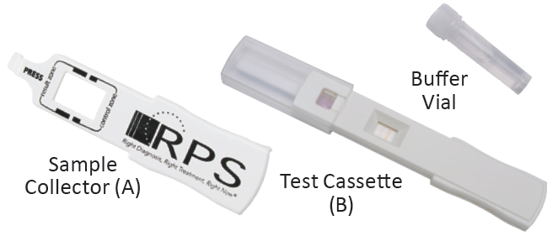
- Timer
- Gloves
- Quality control materials
Specimen:
Tear fluid

QUALITY CONTROL
Positive and negative external controls must be run and documented on the InflammaDry® QC worksheet with each new box opened and monthly. Controls must perform as expected prior to reporting patient results. Internal controls must be verified and documented on the patient worksheet for each test performed.

Internal Controls
- InflammaDry® has built-in procedural controls.
- An unused InflammaDry® device has a purple flow indicator on the test strip in the sample transfer window (G). The unused device also has two (2) faint orange lines in the result window (H).
- If the test is valid, a BLUE line will appear in the control zone. The appearance of the control line indicates the correct application of adequate sample volume. The control line must appear for all tests to be considered as valid tests.
- If the control line does not appear, the test must be interpreted as invalid and has to be repeated by resampling the eye using a new InflammaDry® test kit. DO NOT report invalid test results. Repeat the test after waiting 60 minutes.
A purple fluid wave is observed moving across the result window (H) while the test is running. Once the background within the result window (H)) is white and 10 minutes have elapsed, the test may be accurately read. If there is a streaky fluid wave in the background, or if the test is negative after 10 minutes, allow an additional 5-10 minutes of running time prior to interpretation.
External Controls
External quality controls are intended to verify that the test reagents are working and that the test is correctly performed.
InflammaDry® external controls consist of two (2) vials (positive and a negative control) and a diluent.
- External Positive Control: Buffered solution containing detergent and recombinant MMP-9 protein, as well as additional proteins to simulate biological matrix.
- External Negative Control: Buffered solution containing detergent and proteins to simulate biological matrix.
- Diluent: Deionized water.
- Store controls at room temperature, not to exceed 30°C, until the expiration date noted on the outer packaging.
- The controls are designed for one (1) use. Opened vials should be used once within the day of reconstitution then discarded.
Quality Control Procedure
- Choose either the positive or negative control. Only one (1) control may be run on each InflammaDry® test.
- Remove the cap and rubber stopper from the selected control vial and add five (5) drops of diluent from the diluent bottle, one (1) drop at a time.
- Recap the control vial and gently shake the vial to dissolve the lyophilized powder. Let the vial with the liquid sit for at least two (2) minutes prior to use.
- Open the control vial and pour the entire liquid contents of the vial into the inside of the black cap.
- Open the sample collector pouch from an unused InflammaDry® test.
- Dip the sampling fleece into the control liquid in the black cap.
- Run and read the InflammaDry® results per the procedure. A positive control should show a positive result and a negative control should show a negative result.
- Repeat for the other control.
Procedure
Preparing the test and taking a sample:
NOTE: Check the expiration date on all packaging. Do not use if foil pouches are damaged.
- Identify patient according to patient identification policy.
- Tear open each foil pouch at the indicated perforation and remove the contents. Do not touch the sterile sampling fleece (C) prior to collecting the patient sample.

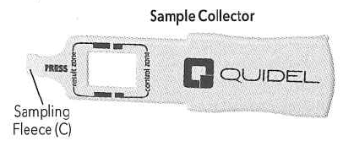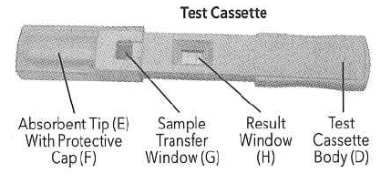

- Locate the sampling fleece (C) on the underside of the sample collector.
- If ocular anesthetic is applied to the eye, wait at least two (2) hours prior to collecting a sample.
- Gently lower the patient’s eyelid to expose the inside of the lower lid (palpebral conjunctiva).
- Gently dab the sampling fleece (C) in multiple locations along the palpebral conjunctiva, releasing the lid after every two to three (2-3) dabs to allow the patient to blink, until the sampling fleece is saturated. Adequate saturation usually occurs when the sampling fleece is dabbed at least six to eight (6-8) times then allowed to rest against the conjunctiva for an additional five (5) seconds. In more severe dry eye states, additional dabbing may be necessary to moisten the sampling fleece. Do not use a dragging motion when collecting the sample.
- Upon saturation with tear fluid the fleece will glisten. Based on tear volume and composition, the fleece may appear white or patchy pink in color.
Assembling the test:
- Locate the test cassette (B) with the test cassette body (D) and the protective cap (F). Remove the protective cap (F) from the test. The opened test cassette should be used within one (1) hour.
- Assemble the test by gently placing the sampling fleece (C) of the sample collector (A) into the sample transfer window (G) of the test cassette body (D).
- Press firmly where indicated until the test feels secure. A double-click means the test is properly assembled.
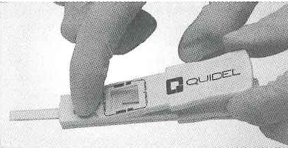
- Replace the protective cap (F) over the absorbent tip (E).
- Label with a patient label by wrapping and flagging the label around the test cassette body (D). Do not cover the test result window (H) with the patient label.
NOTE: The opened test cassette should be used within one (1) hour of collection.
Running the test:
- Open the buffer vial.
- Remove the protective cap (F).
- Immerse the absorbent tip (E) into the buffer vial for a minimum of 20 seconds, ensuring that the absorbent tip is not bent in any manner.

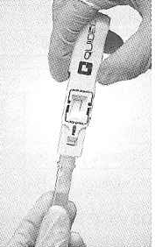

- Remove the absorbent tip (E) from the buffer vial, replace the protective cap (F) and lay the test flat on a horizontal surface for 10 minutes.
NOTE: Do not interpret the test results before completing at least 10 minutes of development time. A purple fluid wave may be observed moving across the result window (H) while the test is running.
Once the background within the test result window (H) is white and 10 minutes have elapsed, the test may be accurately read. If there is a streaky fluid wave in the background, or if the test is negative after 10 minutes, allow an additional 5-10 minutes of running time prior to interpretation. You must wait 15 minutes before reporting a negative.
The test should be read within six (6) hours of test completion. After this period of time, it is possible that the results may change. Accurate visual interpretation requires examination under brightly lit conditions.
The results of the test are indicated through two (2) lines, which appear in the result window (H): the control line and the result line. The control line appears as a BLUE line in the control zone. The control line indicates the correct application and performance of the test and must appear for the test to be valid.
Positive Result
The presence of both a BLUE line in the control zone and a RED line in the result zone indicates a positive result. An uneven or incomplete RED line is due to an uneven distribution of tear fluid on the sampling fleece. Even if the RED line is faint in color, incomplete over the width of the test strip, or uneven in color, it must be interpreted as positive. A positive result indicates the presence of MMP-9 ≥ 40ng/mL.
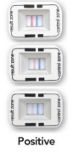
The results should be evaluated with all clinical and laboratory data available. If the results do not agree with the clinical evaluation, additional tests should be performed.
Negative Result
The presence of only a BLUE line in the control zone indicates a negative result. A negative result is indicative of an MMP-9 level <40 ng/mL.

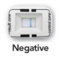

The results should be evaluated with all clinical and laboratory data available. If the results do not agree with the clinical evaluation, additional tests should be performed.
Invalid Results
If a BLUE line does not appear, the test may be invalid. Re-immerse the absorbent tip (E) into the buffer vial for an additional 10 seconds. If a BLUE line still does not appear, the test must be discarded and the subject retested by resampling the eye using a new InflammaDry® test kit. Do NOT report invalid test results.
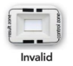
Although the test requires only 10µl of fluid, if a second sample is needed, repeat dabbing may result in reducing the available tear fluid required for collecting an adequate sample. Each additional sample collection may reduce or alter the MMP-9 antigen load transferred to the test. If a second sample is needed, the sampling may be repeated 60 minutes later.
REPORTING THE RESULTS
Staff performing the test will record patient test results on the Inflammadry® worksheet and in the notes in the patient medical record. At the end of the day, the care unit will fax/deliver a copy of the worksheet to the laboratory for result entry into the laboratory information system.
Care team: Place order in Epic, release and perform collect step
Clinic Lab: Receive and result in Beaker
EXPECTED VALUES/REFERENCE RANGE
Negative - Normal levels of MMP-9 (ng/mL) in human tears range from 3 ng/mL to 40 ng/mL.

LIMITATIONS OF THE PROCEDURE
- MMP-9 is a nonspecific indicator for the presence of inflammation. A positive test result should not be used as the sole basis for treatment or other management decisions.
- Patients with severe aqueous deficient dry eye, who produce a sample volume of less than 6 µl, may yield a false negative result.
- InflammaDry® should not be used within 20 minutes of performing a Schirmer tear test. As this may stimulate degranulation if MMP-9 and cause a false positive result.
- A recent history of ocular surgery or infection, allergic conjunctivitis, or other ocular surface diseases may lead to elevated levels of MMP-9 and cause a false positive result.
- Patients with a history of contact lens use or recent ocular surgery were not studied; no data supports any claims for safety and efficacy in these populations.
- Certain medications such as systemic immunomodulators, topical or oral steroids, cyclosporine tetracycline, and topical azithromycin, are known to inhibit mettaloproteinase activity. Use of these medications may lead to false negative results.
- Running the test in an environment with a temperature of 45°C or above and humidity of 60% or above may increase sensitivity and cause a false positive result.
- InflammaDry® should not be performed in conditions which could lead to conjunctival injury, such as Stevens’ Johnson Syndrome or other cicatricial conditions.
- Slit-lamp biomicroscopy is required to eliminate patients with active intraocular inflammation.
- InflammaDry® should be performed prior to instilling ocular anesthetic, topical dyes, or performing Schirmer testing.

WARNINGS AND PRECAUTIONS
- For in vitro diagnostic use only. For prescription use.
- Keep the test cassette and sample collector in their foil pouches until just before use.
- The Dacron® material used in the sampling fleece may cause allergic reactions for some people.
- Do not use InflammaDry® past the expiration date.
- Wear disposable gloves while handling samples and wash hands after the test is complete.
INTERFERING SUBSTANCES
The following medications show false positive or false negative results. Therefore, patients should not be tested with InflammaDry® if the following medications are administered into the eyes within two (2) hours of testing with InflammaDry®.
- Merck, Trusopt
- Vistakon, Iquix
- Vistakon, Quixin
- Wilson, Proparacaine
Caution: Topical opthalmic medications come in different formulations and some formulations (i.e., gels, ointments, etc.) may persist on the tear film longer than others. Therefore, caution should be used when using the InflammaDry®. Test on a subject who may be on such a medication, since certain medications may cause erroneous results if present on the ocular surface. In addition, certain medications may cause erroneous results if used immediately before taking a sample. If ocular anesthetic or any other topical medication has been applied to the eye, wait at least two (2) hours before collecting sample.

ReferenceS
- InflammaDry® package insert, RPS-ID-20-U InflammaDry-20 Test 1337401 December 2017.
- InflammaDry® External Controls Positive and Negative package insert– RPS 2014.

AUTHOR/REVIEWER(S)

MLafromboise/LKappenman
Compliance

Failure to comply with this policy or the procedures may result in disciplinary action, up to and including termination.
ENDORSEMENT
Laboratory Administration

