
Co-oximetry Gem-OPL Point of Care Procedure  (Oxygenation Portable Laboratory – HSC Lung & Sleep Health Only) | Attachments  Yes No
Key words Co-oximeter, blood gases, Co-oximetry, CO, Carbon Monoxide | Number  GHI-PC-CLINIC LAB-PROCEDURES-Co-Oximetry GEM OPL v. 11-2020
Category Provision of Care | Effective Date  See Electronic File
Manual Clinic Laboratory Procedure Manual | Last Review Date  See Electronic File
Issued By Laboratory Administration | Next Review Date  See Electronic File
Applicable Health Specialty Center Lung and Sleep Health Staff | Origination Date  October 2005
Level of Complexity Non-waived | Retired Date
Review Responsibility Regional Clinic Lab Supervisors | Contact Regional Clinic Lab Supervisors
APPROVAL Laboratory Medical Director | Approved Date  See Electronic File
Purpose/PRINCIPLE
The purpose of this procedure is to provide direction for performing oxy-, carboxy-, and methemoglobin tests using the GEM OPL instrument.
Whole blood samples are measured for total hemoglobin concentration and the relative concentrations of oxy-, carboxy-, and methemoglobin (O₂Hb, COHb and MetHb). The GEM OPL illuminates the sample with multiple wavelengths, records the optical absorbance of the sample at each wavelength, and computes the results.
POLICY
Health Specialty Lung and Sleep Health Respiratory staff will follow the approved techniques outlined in this procedure.
SPECIMEN
Whole blood samples are drawn in a sodium or lithium heparinized blood gas syringe.
Citrate, fluoride, oxalate and EDTA tubes are NOT acceptable.
REAGENTS/MATERIALS
- GEM®OPL® Oxygenation Portable Laboratory
- Disposable cuvettes- cuvettes are obtained from Instrumentation Laboratories. Store cuvettes in the sealed bag with a desiccant pouch at room temperature (15-30°C). The desiccant pouch has a color indicator that should be blue. If the color indicator has changed to pink, do not use the cuvettes until a new desiccant pouch can be added to the bag. Prior to use, verify indicator is blue. There is no expiration for cuvettes properly stored.
- Optical QC filters.
- The temperature probe located on the rear panel of the instrument should be kept by the cuvette bag, which is currently in use.
- Multi-4TM CO-Oximeter Control.
QUALITY CONTROL
- OPTICAL FILTERS: Optical filters are used to determine whether the optics have been contaminated and to verify that the calibration has not changed. There are two optical filters-yellow and orange. Each filter has a specific serial number that matches the serial number of the GEM OPL with which it is used. Both filters are to be run each day of patient testing, when an analyzer is brought in from a hot to a cold temperature or vice versa, whenever the performance of the analyzer requires verification.
To Perform:
- Confirm that the filters have the same serial number as the GEM OPL.
- Wait until the ready message appears on the display.
- Remove any debris from the surface of the optical filters by wiping them with dry gauze.
- Insert the filter into the cuvette slot and enter the sample information at the prompt.
- Verify that each of the results is within the established range for the filter.
- Document results on the QC logsheet, making sure that the results are in range. Patient testing should not be performed if any one of the four optical QC values is out of range.
- LIQUID Quality Control (QC): Liquid QC serves as another means to verify that the GEM OPL system is functioning properly. Controls are the IL Multi-4 CO-Oximeter controls levels 1, 2, and 3. They are obtained from Instrument Laboratories. Store at 2-8ºC. Expiration date is stamped on each vial. Three levels of Liquid Control should be performed weekly and with a new lot or shipment of cuvettes. Clarification: If there were no patients during a week, running 3 levels of liquid QC is still required. Document QC on the Quality Control Log and send to the lab at the end of the month.
- Controls should be tested after taking out of the refrigerator. They should sit at room temperature no longer than 15 minutes.
- The tech performing quality control must compare each level of QC results with the corresponding QC ranges to verify they are in range.
- The QC ranges are found on the QC package insert.
- The correct control lot number information, cuvette lot number information, ranges, dates, and tech initials must be recorded on the log sheet.
- If the results are out of range, repeat the control one time to see if it comes in range. If not, discontinue testing and notify the lab for further direction.
- The controls should be reddish in color when received and remain so until the expiration date. Change of color to brown and/or inability to achieve listed values is an indication of deterioration.
To Perform:
- Hold the ampule by the top above the break line. Shake the sample (rock and roll 5 times) according to the manufacturer’s recommendations, approximately 10 seconds.
- Restore liquid to the bottom of the ampule with gentle tapping. If foam or small bubbles are present, allow ampule to stand until these have come to the surface.
- With fingers protected, snap open the ampule.
- Contents should be sampled as soon as the ampule is opened. Use a syringe to transfer liquid from the ampule into a cuvette.
- Insert the syringe tip into the cuvette syringe port on the cuvette and inject the QC sample holding cuvette down at a 45º angle. Inject QC material into the cuvette until the sample reaches the vent patch. Leave syringe attached to cuvette.
Note: Over injection of QC material will cause the vent patch to bulge outward. If this happens, pull back slightly on the syringe plunger just until the patch flattens.
- Check that no air bubbles are present in the sample light path.
Note: Air bubbles will yield erroneous results. If air bubbles are present in the light pathway, discard cuvette.
- Hold the cuvette by the black cap and rotate it so the textured blue side of the vent patch will be on the left side when inserted. Insert the cuvette into the slot of the instrument’s front panel within 30 seconds of filling it.
Note: A delay of analysis greater than 30 seconds may yield erroneous results.
- Verify that results are with in the established ranges.
CALIBRATION
The initial calibration is set at the factory. Recalibration is required only if the optical filters do not meet the established specifications.
PROCEDURE
Verify that the GEM OPL is ready. The display will read: “READY insert cuvette”. Verify that the GEM Code is correct for the cuvette bag in use. If not it must be changed.
To change the GEM Code
- Press MAIN MENU on the keypad.
- Select the CALIBRATION option from the main menu.
- Select 1. GEM Code. This will display the current code.
- Change the code to match the cuvette bag.
- Quality Control must be run with each lot number change.
Patient Test Procedure:
- Patient testing can only be done if all quality control results are within acceptable limits.
- The instrument indicated that it is ready to analyze samples by displaying the following message:
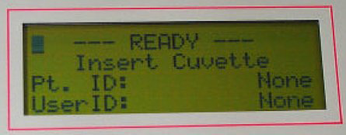
- Gloves must be worn anytime there is a possibility of exposure to blood or body fluids.
- Release the order from Epic.
- Perform the collect step to generate a patient label.
- Label the syringe.
- Collect sample per protocol.
- Roll the syringe containing the blood sample between your hands periodically inverting the syringe to mix the sample thoroughly. The sample must be mixed for a full 10 second interval just prior to injection into the cuvette.
Note: Poorly mixed samples or those containing clots may cause inaccurate results.
- Expel one drop of sample from the syringe and connect the syringe to a disposable cuvette.
- Hold the cuvette at a 45º angle and inject sample into cuvette until sample reaches the vent patch at the opposite end. Never force blood into the cuvette. Leave the syringe attached to the cuvette.
Note: Over injection of sample will cause the vent patch to bulge outward. If this happens, pull back slightly on the syringe plunger just until the patch flattens. Never force sample into cuvette. If cuvette does not fill easily, discard it and use another one.
- Confirm that the light path at the widest portion of the sample chamber is free of debris or air bubbles. Ignore bubbles outside of the light path.
Note: Air bubbles will yield erroneous results. If air bubbles are present in the light pathway, discard cuvette.
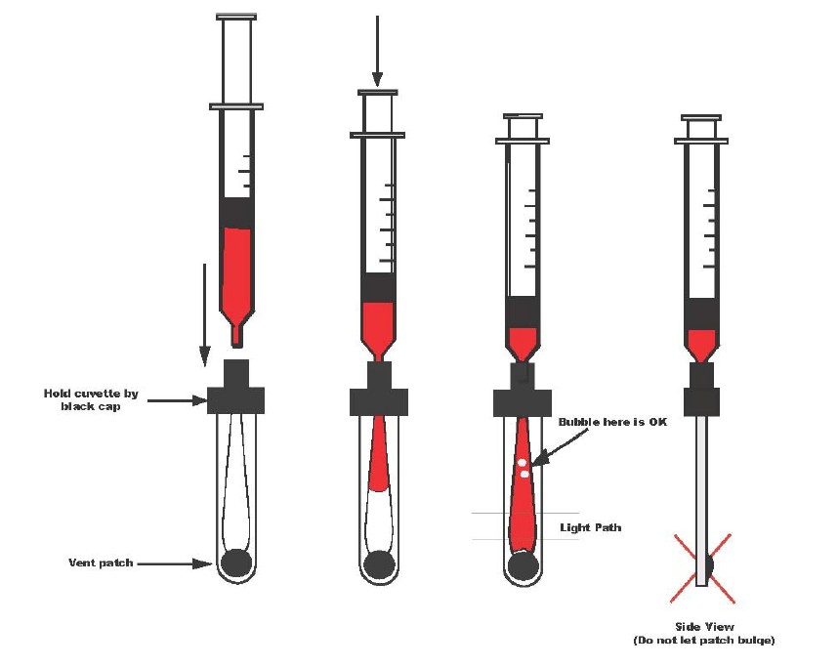
- Remove any sample on the cuvettes exterior surface before inserting into the GEM OPL.
- Holding the cuvette by the black cap, rotate it so the textured blue side of the vent patch will be on the left side when inserted. Insert the cuvette within 10 seconds of filling it.
- Follow the screen prompt to enter sample information.
- Observe the LCD display. Do not disturb the GEM OPL while it is busy. The results display within 10 seconds.
- Withdraw the cuvette as soon as the sample has been analyzed. Data will stay on the display until the cuvette is removed.
- Discard used cuvette and syringe in the biohazard container.
LINEARITY
Total Hemoglobin (tHb) 5-21 g/dL
Oxyhemoglobin (O₂Hb) 0-100%
REFERENCE RANGE
Total Hemoglobin (tHb) 12.0-18.0 g/dL
Oxyhemoglobin (O₂Hb)
Carboxyhemoglobin (COHb)
Methemoglobin (MetHb)
REPORTING RESULTS
Pulmonary:
On the patient worksheet:
- Affix the Beaker generated label – if a label is not available include:
  - Patient first and last name
  - Patient date of birth
  - Patient medical record number (MRN)
- Document the date and time of testing
- Tech who performed the testing
- Record Results
At the end of the day, fax the results to the lab at 651-254-8191. The lab will enter the patient information and results into EPIC Beaker.
Results Entered into EPIC Beaker by Laboratory Staff:
- Total Hgb, COOX Enter results to 1 decimal place
- O2 Sat, Measured Enter results to 1 decimal place
- Carbon Monoxide Enter results to 1 decimal place
- Methemoglobin Enter results to 1 decimal place
- O₂ Content Enter results to 1 decimal place

Refer to EPIC Beaker result entry procedure
TROUBLESHOOTING
If liquid controls or optical controls are out of range, see pages 37-39 of GEM OPL Instrument Manual.
Troubleshooting Guide:
- If controls are out of range, rerun controls. Never report any patient results when QC values fall outside of the stated control ranges.
- Liquid Control: Verify that the correct lot number is being used.
Optical Filters: Verify that the serial number of the filter matches the serial number of the GEM OPL.
- Liquid Control: Verify that controls are not expired and that the controls have been stored correctly.
- Verify that the procedure was performed correctly.
- Verify that proper cuvette handling and sampling technique was used.
- Verify that the GEM code on the box of cuvettes matches the GEM code that was entered into the instrument.
- Rerun controls.
- Liquid Controls: If the control values are still unacceptable, open and run new controls.
- If Liquid Controls or optical filters remain out of control, or if you are experiencing other problems with the instrument, see pages 37-39 of the GEM OPL Instrument Manual.
- Notify a Regional Clinic Lab Supervisor (RCLS). The manufacturer may be called, if necessary. Technical Service Phone Number: 1-800-678-0710.
Reminder: According to the Internal Quality Control Policy, if expected QC values are not attained, patient results will not be reported until troubleshooting is complete.
REFERENCES
- GEM OPL-Oxygenation Portable Laboratory Operator’s Manual, PN 6320480230 Rev. 03, February 2006.
- Regions Hospital Laboratory I-STAT Procedure, 4/1999
- Massachuesetts General Hospital POCT program 2010
- Multi-4TM CO-Oximeter Control package insert, February 2018.
AUTHORS/REVIEWERS
Original Author: DABergo
DABergo
Deaton
MLLaFromboise

Compliance

Failure to comply with this policy or the procedures may result in disciplinary action, up to and including termination.
ENDORSEMENT
Laboratory Administration

