Subject  ECG Acquisition Procedure |  | Attachments  Yes No
Key words ECG, EKG, MUSE |  | Number  GHI-PC-CLINIC LAB-PROCEDURES-ECG Acquisition Procedure v. 04-2019
Category Provision of Care (PC) |  | Effective Date  See Electronic File
Manual HPMG Clinic Laboratory Procedure Manual |  | Last Review Date  See Electronic File
Issued By Laboratory Administration |  | Next Review Date  See Electronic File
Applicable All HealthPartners Personnel who Acquire ECG Tracings |  | Origination Date  December 1997
 |  | Retired Date
Review Responsibility Regional Clinic Laboratories Supervisors |  | Contact Regional Clinic Laboratories Supervisors
APPROVAL(S) Laboratory Medical Director

I. Purpose/Principle

This procedure provides direction and ensures standardization for the acquisition of quality ECG tracings. This will facilitate rapid identification of acute myocardial infarction and life-threatening arrhythmias and prompt medical treatment for HealthPartners patients.

The Electrocardiogram (ECG) is a recording of the electrical impulses associated with cardiac contraction and relaxation. It records the amount of voltage generated by the heart, and the time required for that voltage to travel through the heart. When the magnitude of voltage, represented on the vertical scale, is compared with time, represented on the horizontal scale, the result is the familiar peak and valley pattern of the ECG.

II. Policy
HealthPartners medical staff provides ECG acquisition services for all clinics during clinic hours of operation.

An ECG is a critical component of patient care. The following are indications/considerations for an ECG:

- For patients without known heart disease, the ECG is used as a screening test for coronary artery disease (CAD), cardiomyopathies, or left ventricular hypertrophy (LVH) and is then used as a baseline for future reference and comparison.

- Preoperatively, an ECG is used as a diagnostic tool to rule out silent coronary artery disease or potential life-threatening arrhythmias. This is very important as the presence of any of the above indications can cause further complications during surgery, or post operatively for our patients.

- The ECG may also provide diagnostic information in the presence of electrolyte imbalances, such as hypercalcemia (elevated blood calcium), hyperkalemia (elevated blood potassium) and hypokalemia (low blood potassium).

- In patients with known coronary artery disease, the ECG serves as a baseline exam for providers to track progression in the patient’s cardiac status. The ECG is invaluable in the evaluation and treatment of patients with a variety of cardiac conditions such as acute myocardial infarction, valvular and congenital heart disease or pericardial tamponade.

- Rhythm disorders can effectively be evaluated through an ECG rhythm strip. Using the ECG, the Cardiologist can view the heart’s electrical conductivity from multiple angles.

- Evaluation of pacemaker function.

III. PROCEDURE
A. Equipment: MAC 5500
B. Patient Considerations
C. ECG Acquisition process
D. Reporting Process
E. Basic Troubleshooting
F. Maintenance
Appendix: ECG Orders – Beaker Process

- Equipment: MAC 5500
Each clinic has a MAC 5500 Resting ECG Analysis System. The MAC 5500 is able to quickly obtain an ECG and provides an approximate interpretation of the acquired ECG (unconfirmed ECG). The machine interpretation is useful for deciding when to emergently contact the patient’s physician and can serve as a guideline for healthcare workers untrained in ECG interpretation. A definitive interpretation of the ECG is required by a physician or licensed provider (confirmed ECG).

- Components
a. Each MAC 5500, in addition to the CPU (screen), has an acquisition module, lead wires, Silver Mactrode electrodes and heat sensitive paper. (Acquisition modules are not generic but specific to the MAC model). The software on the cart is referred to as Marquette Software System.
  - Additional items required to perform an ECG
- Disposable ECG silver electrodes – Lawson # 104709
  - Check that the expiration date on the pouch has not been exceeded.
  - Once opened, use within 7 days. - Initial and date the pouch when opening.
  - Always keep unused cards of electrodes in their pouch with the open edge folded down or in a poly bag. These can dry out if left exposed.
  - Store in a cool, dry location.
- Thermal grid recording paper – Lawson #7254467. Store in a cool, dry, and dark place. Temperature should be <80ºF (27ºC). Humidity is between 40-65%. Do not expose to sunlight or fluorescent lighting.
- Plug-In lead-wires (set of 10 without resistors).
- Alligator Clips (set of 10) – Call Biomed to order.
- Skin Prep Tape - Lawson #026562
- Gowns (front opening) – Paper/Disposable - Lawson #102081 or Cloth
- Alcohol preps – Lawson #000010 and/or Chloropreps – Lawson #035043

NOTE: DO NOT TRANSPORT BLOOD DRAWING SUPPLIES ON THE ECG CARTS.

- Navigating the Marquette Software Menu Systems:

- The primary functions/keys that will be used are listed below. For full details on the software, refer to the user manual.

- Keyboard Descriptions:
  - Power switch: Powers the system on or off.
  - Function Keys (F1 – F6): Selects screen menu functions. (May also use arrow pad to select menu functions).
  - Arrow Pad: Moves cursor. Center button selects highlighted item.
  - Delete: Erases typed characters
  - Copy: Prints another ECG report
  - ECG (Green Key): Records ECG.
  - Rhythm (Green Key): Prints continuous ECG data.
  - Stop (Red Key): Stops the writer from printing.
  - Return: Enters information.
  - Esc: Return to previous menu.
  - Information: Additional user information.

- Main Menu: (Select “More” from startup screen to open “Main Menu”)

- Main Menu Functions:
  - File Manager: All ECGs that have been acquired on the machine until deleted.
  - More: Additional functions or return to the previous menu.
  - System Setup: Defines settings.
    - With the exception of Daylight Savings Time changes, System Setup should not be used unless directed by Regions Biomed, an RCLS or the IS&T Helpdesk. – Password: SYSTEM
  - Order Manager Interface (ORD MGR INT): Acquiring, downloading, printing and storing ECG orders received from MUSE.
  - Resting ECG: Acquisition.
  - Return: Return to previous screen
  - Speed, Gain, and Filter: settings should not be changed unless requested by the physician.

- Patient Considerations
- Patient Identification:
- Misidentification of patient can result in serious injury or death to a patient or several patients and creation of new and duplicate files in MUSE.
  - Prior to acquiring the ECG, Ask the patient to state his or her full name and birthdate for verbal verification. A family member may also provide this information.
  - Verify patient label with patient information downloaded or manually entered in the ECG machine. Place Beaker label on hard copy of ECG.
- Patient and Site Preparation:
    - When possible, all patients should be offered the option of having a same gender technician perform his/her ECG.
    - The patient should remove all clothing from the waist up. Female patients must remove their bra and be offered a gown which opens to the front. Also remove any nylon stockings if possible.
    - Have patient remove any electronics.
    - Ensure that the patient is lying comfortably with limbs extended and resting on the ECG bed. Legs cannot be crossed. Cover the patient with a blanket if the room temperature is uncomfortable.

    - Gloves should be worn when performing an ECG.
    - Per-manufacturer, Careful skin preparation is the key to an interference-free ECG. Recommended procedures are:
      - Gently rub/abrade the area thoroughly to remove dead skin cells and assure good contact.
      - Thoroughly cleanse site with alcohol or mild soap and water to remove all oily residue, dead skin cells, or excess prep material.
      - Dry the skin completely.
- Pediatric Considerations: (Pediatric patients are defined as those under the age of 17.)
- Children:
    - Try to keep the child relaxed by calmly explaining what you will be doing. They must remain still for as long as possible in order to obtain a good reading.
    - If the child refuses to remain still and you are not able to obtain a good reading inform the nurse/provider.
- Infant, Neonate, and Premature Infant:
    - If the child will not remain still on the ECG bed, the parent or guardian may try holding them in order to obtain a good reading.
- Variations in Process with Pediatric Patients:
    - Cut the ECG electrodes with the scissors on the cart. Cut them in half, lengthwise, so that when they are applied they will not touch each other.
    - All pediatric ECGs need to be manually faxed to Children’s Heart Center (612-813-8825). Fax cover sheets are prepared for this purpose in Lab.
- Additional Patient Considerations:
  - Any comments/notes that may provide important information to the provider (such as the patient not being in an ideal position during acquisition) should be entered into MUSE and reprinted to be signed off by provider. –Refer to MUSE procedure for details.

a) Maintaining the Patient’s Dignity and Privacy
In order to perform an ECG with a minimum invasion into the patient’s privacy the following guidelines must be followed:
- Make sure curtains are closed so that the patient is not concerned about non-medical personnel invading his/her privacy. Close blinds on windows to the outside and turn off lights if possible. Brightness can also cause AC “noise” and indirect muscle artifact.
- Keeping as much of the patient covered as possible. A cloth or paper gown which opens to the front is available for the female patient. A towel or sheet can also be used to augment any other means used to cover an exposed patient.
- Sensitivity is required for precordial (chest) leads for female patients. Many women are particularly sensitive about having their nipple/areolar region exposed. At a minimum make sure this area is covered after the electrode is placed.
- When lifting a woman’s breast, use the back of your hand instead of cupping the bottom of the breast in the palm of your hand. Standard practice is to not place leads on top of the woman’s breast.
b) Unable to lie flat:
If you encounter a patient who is unable to maintain the optimal supine (fully reclined) position, note, “Best Possible, Patient Upright.” This will indicate to the over-reading provider that this ECG was not obtained under ideal circumstances, and this may need to be considered in his/her analysis.
c) Wheelchair Patient:
If you encounter a patient who is in a wheelchair and the ECG is performed on the patient while in the wheelchair, note “Wheelchair Patient”. This will indicate to the over-reading provider that this ECG was not obtained under ideal circumstances, and this may need to be considered in his/her analysis.
e) Obese Patients:
When unable to feel intercostal spaces, measure from the collarbone to sternum and put sensors approximately halfway. Note “Obese Patient”.
f) Patients wearing a Halo:
Patients wearing a metal and plaster cast in conjunction with a broken neck will make placement difficult. There may be room for your fingers to feel lightly underneath the cast. Perform placement as best you can and note that sensors will be lower than usual compared to other patients. Note “Patient wearing halo”.
g) Bandaged Patients:
Do not take bandages off patients. Only a direct patient caregiver is to do this. Note “Bandages”.
h) Medication Patches:
Do best possible with lead placement and Note “Medication Patches”.
- ECG Acquisition Process
- Patient information can be entered into the ECG cart by downloading the ECG order from EPIC or manually entering the patient information into the ECG cart. Always download if possible.
- See end of procedure for details on ECG Orders in Beaker.
- Equipment Preparation:
- Press “Power” to turn on the system.
  - If the system starts up without displaying error messages, the system is operational.
  - If the system displays error messages, turn the power off, then on again. If error messages persist, see troubleshooting tips below.
- Check for proper lead wire connection on the machine “acquisition module.” Improper connection will cause inaccuracies in the ECG. Trace each individual lead wire from its acquisition module label to the colored connector.
- Downloading Order from MUSE CV System:
- Access Main Menu.
- Select “Ord Mgr Int”: (You may need to use the “More” function to find “Ord Mgr Int”).
- Select “Load Orders”.
    - If there are any orders currently stored in the cart, the following message will appear: “There are orders in storage. Before loading new orders, select whether you want to delete all the old orders or append the new ones.”
    - In the downloading process, when selecting Load Orders and the list of open orders appears, if any of the orders are old, load them onto the cart and delete them. Old, unused orders on the open orders list can slow down and cause problems in the downloading process.
- Choose one of the following:
    - If the orders on the cart have a “*” by them, the ECG order has been used. Select “Delete All” or “Delete”.
    - If the ECG orders on the cart have not been used, select “Append New.”
- Location: Type in the department location code(s) you want orders for, separating locations with commas if there are multiple locations. (Example: 46, 47) Press “Enter.”
- Highlight the patient you need.
- Highlight the order and “Select”. Verify that this is the correct patient.
- The following message will appear: “Order # xxxxxxxxx for patient Last name, First name, Patient #xxxxxxxxx has been selected. Press “CONTINUE” to run a test or “CANCEL” to select a different order.
    - Continue takes you back to the Resting ECG Screen and the Patient Data Box is open.
- Patient Data Box: Confirm Name, MRN and Birthdate.
- Enter initials of performing technician. Do NOT enter the diagnosis code.
    - Any comments that may provide important information to the provider should be entered into MUSE and reprinted to be signed off by provider. –Refer to MUSE procedure for details.
- “Return” to open the Patient Data Screen.
- Manually Entering an order into ECG Cart:
  - Access “Main Menu”, select “Resting ECG”.
  - Select “Patient Data.” A window opens to enter the manual order.
  - Enter the patient information.
    - Last name, first name and middle initial.
    - MRN (found directly under the name, with a leading “0” added to make this a 9 digit number.) The HP number “drives” all ECG MUSE functions.
    - Date of Birth (request as day/month/year, 00/00/0000)
    - Gender (Male or Female)
    - Referred By (“Authorizing provider”)
    - Technician (tech initials)
    - Location
  - “Return” (selecting this will bring you back to the Resting ECG menu. Now the patient’s information will be displayed at the top of the screen).
- Outside Patient Orders:
  - Place the order in EPIC. If the provider is not in EPIC, Select Provider, External as ordering provider. Release the order through a lab appointment and proceed using our regular process.
  - Use the regular process to edit and confirm the ECG. ECG’s can be read by a clinic provider/“doc of the day”, Regions Cardiology or Children’s Heart (if pediatric patient). Once ECG is completed, follow faxing instructions as indicated on the paper requisition.
- Electrode (Lead) Placement:
  - Chest leads require precise and proper placement in order to record accurate pictures of the heart. Intercostal means “between the ribs”, so the first intercostal space is between the first and second ribs. It is NOT between the clavicle (collar bone) and the first rib.
  - Notes for lead wire connector position:
- Positioning the lead wire connector in the gel may compromise trace quality or cause lead failure. Be sure to make connection with the non-gelled tab of the silver mactrode.
- Avoid crossing lead wires, which may cause wrong placement.
- Place the Acquisition Module on a clean towel so that there is no contact with the patient or bedding.
- Trace the colored connector from the Acquisition Module to the proper electrode to ensure it is matched to the correct label location.
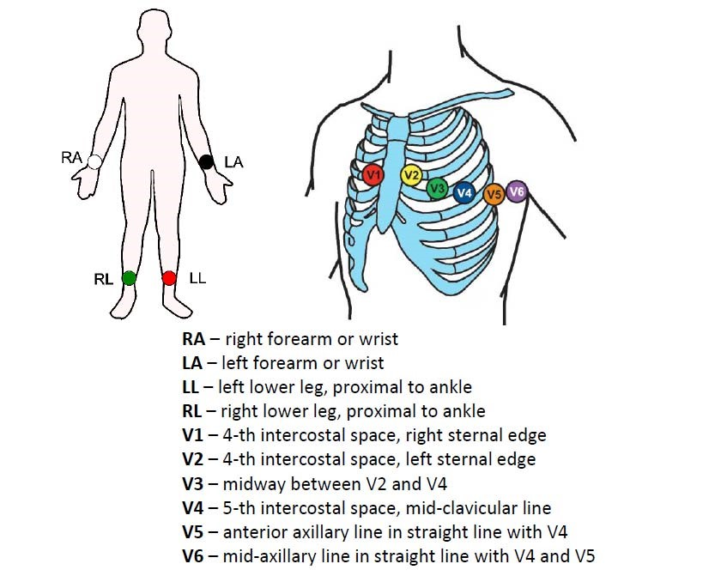
- Press a disposable electrode pad to each of the six chest positions according to the listing below, then connect the chest lead wires (V1-V6) to their corresponding chest electrodes.
  - 12 Lead ECG electrode placement:
    - V1: Fourth intercostal space at the right border of the sternum.
      - Finding this is key. If V1 is incorrect, others will also be wrong.
    - V2: Fourth intercostal space at the left border of the sternum.
    - V3: Midway between locations V2 and V4. It should be placed on the 5th rib.
      - Place V4 first in order to correctly locate V3.
    - V4: At the mid-clavicular line in the fifth intercostal space.
    - V5: At the anterior axillary line on the same horizontal level as V4.
    - V6: At the mid-axillary line on the same horizontal level as V4 and V5.
- Press a disposable electrode pad to the corresponding limb leads described below.
  - (RA=right arm (white), LA=left arm (black), RL=right leg (red), LL=left leg (green)
    - RA and LA: Traditionally placed anywhere on the arm; alternate placement to reduce muscle artifact is midway between the elbow and the shoulder.
    - RL and LL: Traditionally placed a few inches above the ankle; alternate placement to reduce muscle artifact is on the upper leg as close to the torso as possible. If the lower extremity leads must be placed on the lower torso, this must be noted in the comment section of the ECG. Legs must remain uncrossed.
    - Note: Cases such as amputation or thalidomide birth defects will require lead placement on any non-bony prominent part of the extremity, or in a case of hemipelvectomy the LL and RL leads can be placed on the lower abdomen.

- Checking Wave Quality (See Troubleshooting attachment for more details):
  - Leads:
    - Press F2 to open the Leads window.
    - Select “Lead Check” to verify the quality of all 12 leads.
    - Choose “Lead Placement” to see a visual representation of the lead placement.
      - Leads that are bad or poorly connected will flash.
    - Press F2 and select “All Leads” to exit the Lead Check or Lead Placement windows and return to the original screen.
  - Hook-up Advisor:
    - The three-circle indicator on the screen display is a signal quality analysis program that provides continual real-time feedback about waveform quality.
    - The red, yellow, and green indicator lights will help monitor the quality of the ECG signal, and in turn, help eliminate poor technical quality ECG’s, save time, and prevent the need for retakes.
      - Red (circle on the left): Displays red to indicate lead-failure, or extreme baseline shifts.
      - Yellow (center circle): Displays yellow when there is muscle artifact, power line interference, baseline wander, or electrode noise.
      - Green (circle on the right): Displays green when the signal quality is acceptable.
- Acquiring ECG Data:
  - Routine ECG (ECG 12-Lead – O123500073):
*Note: Prior to recording an ECG, the patient’s name should be in the left corner of the screen. The patient should be fully reclined for optimal results.
- Access “Main Menu”.
- Select “Resting ECG” → Patient Data Screen
      - The ECG is run when the Resting ECG option is opened and the Patient Data Screen is on the screen.
- Allow the ECG rhythm to straighten out (waves are not going up and down like hills.)
- When a satisfactory ECG tracing, with a flat baseline and little to no interference, appears on the ECG machine monitor, press and release the “Record ECG” button on the keyboard. The monitor will display a static view of the recorded ECG.
- If this static view still appears satisfactory, press “Continue”. If the static view is unacceptable, “Cancel”.
- The monitor will again display the current dynamic rhythm. Press the “Record ECG” button twice when a satisfactory tracing is displayed.
- Press “Continue” or “Stop” to print and store the ECG tracing.
      - If during the analysis, the ECG machine prompts you to choose an alternate gain setting because the QRS complexes are too large, select NO. The gain can be adjusted via MUSE at the providers request.
  - Rhythm Strip (3062):
    - To obtain a rhythm strip for a patient, connect all leads as you normally would for a resting ECG. Advise the patient that s/he must remain still and quiet for a more extended period of time than a typical 11.2 second ECG strip. A rhythm strip is typically run for 1 minute, however, run as directed by the provider. Check the clock on the screen.
    - When a satisfactory ECG tracing, with a flat baseline and little to no interference appears on the ECG monitor, press and release the “Record Rhythm” key.
    - The machine will continue to record the rhythm until the Stop key is pressed. Each page of ECG paper contains 11.2 seconds of information, at normal speed. Six pages of rhythm will be sufficient to obtain a one-minute rhythm strip. Rhythm strips can only be printed, not stored or transmitted to MUSE.
      - If coughing or moving interrupts the rhythm strip, it will need to be repeated.
    - The provider should write their interpretation on the Rhythm Strip. Date and sign it.
    - Send the pages to “scanning”, or the clinics designated clinic operator, to be scanned into the patients chart.

- Completion of the ECG Process:
- Do not remove the leads from the patient until after the ECG has printed to ensure that the analysis does not include “Poor Data Quality” or “Suspect Limb Lead Reversal.”
  - If either of these statements is included, check all electrodes and leads and avoid crossing lead wires. The ECG must be redone, and the original should not be transmitted into MUSE. If it was transmitted to MUSE, it can be removed from MUSE.
- After confirming correct limb leads placement, if “Suspect Limb Lead Reversal” is still in the analysis, edit the ECG to state, “Limb leads confirmed” in MUSE interpretation and add comment to paper copy.
- Always check the patient name and ID number after each procedure, against the ECG tracing obtained.
- Carefully remove all electrodes, verifying that the correct lead was placed in the correct location.
- Close the screen or change screen so that patient information is no longer visible.

7. “STAT” ECG
Note: When there is a STAT ECG request, always take direction from the provider.
- Patient information for the STAT ECG should be downloaded into the ECG machine or manually entered into the cart prior the acquisition of the ECG whenever possible.
- If the ECG is needed emergently and patient information is unavailable, it is acceptable to run the ECG without patient information

Procedure for STAT ECG with no order

    - Read screen carefully, verify there is no previous patient information on the screen.
    - Go to Patient Data screen by pressing the Power button on or from Main Menu select Resting ECG
    - Press the ECG button on the right side of the keyboard
    - The following box pops up:

Press ECG to record an ECG for Name,ID

Or

Press F1 for Patient Data to enter new patient data

To bypass entry of patient data
- Press ECG button a second time
- Press Continue
- ECG prints
- ECG is transmitted via wireless to MUSE or is stored in File Manager.
- Patient is identified in MUSE by date, time and location

To enter Patient Data:
- Press F1 for Patient Data Box
    - Message to scan patient barcode or a list of orders from MUSE may pop up
    - Press Cancel
    - Enter Patient data
    - Press Continue
    - ECG prints
    - ECG is transmitted via wireless to MUSE or is stored in File Manager

- After the ECG is transmitted to MUSE, the ECG information can be updated once an order is placed through a scheduled appointment and released. It is then available to Merge/Update the ECG with the Epic Order in MUSE.

STAT OVER READ:
- If the provider requests a STAT interpretation from cardiology, find the STAT ECG in MUSE and send to the Regions in-basket to User ID 10000.
- Call Regions cardiology at 651-254-1419 option 0 with this request. Give this person the information concerning the stat over-read such as patient name, clinic location and where to contact the provider. A Cardiology Tech at Regions will follow through, making sure that the ECG is read, confirmed and called to the provider.

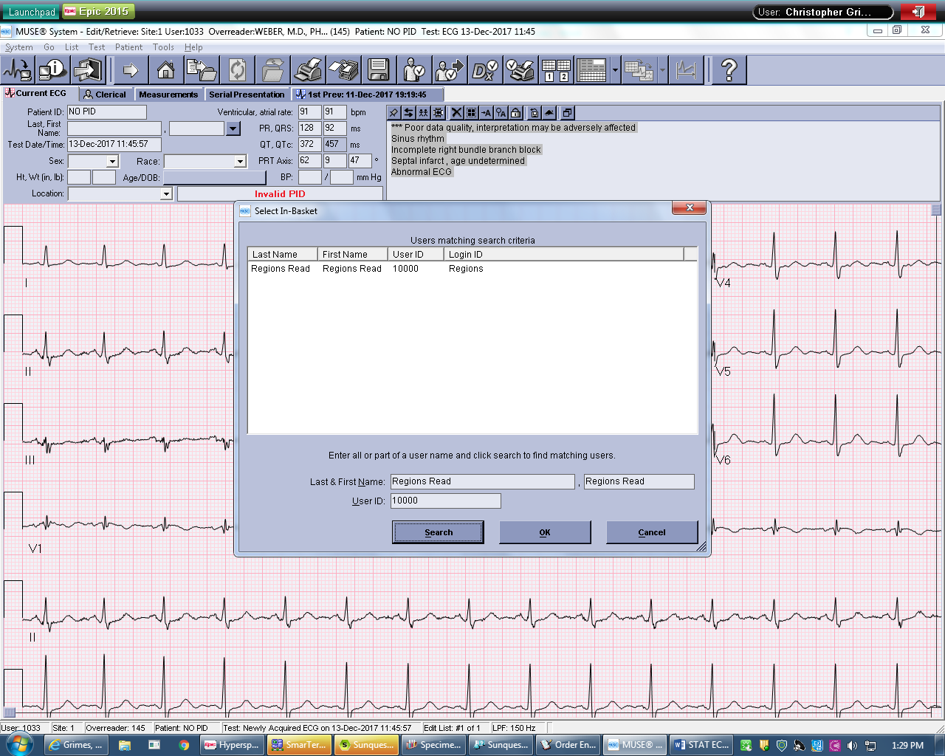

- Reporting Process:
1. Critical Call Interpretations:
- The patient should be asked to remain in the clinic until his/her provider has reviewed the results. Enter a Critical Comm Log in Epic, documenting who and when you gave the critical call results to.

Adult Patients:
The following Adult Interpretive Statements should be called immediately to the provider or nurse. If the ordering provider is not onsite, use the doc of the day or find another onsite provider to review the ECG. Follow the same procedure as the Critical Call Policy:
- Complete Heart Block or 3rd degree A-V block
- Myocardial infarct, acute
- Mobitz type 2 AV block
- Tachycardia >120 beats/minute
- Bradycardia <40 beats/minute
- Injury (synonymous with heart injury)

Pediatric Patients:
The following Pediatric Interpretive Statements should be handled as critical call values for patients under 17 years. Follow the same procedure as the Critical Call Policy:
- Complete Heart Block
- Supraventricular tachycardia
- Ventricular tachycardia
- Tachycardia >200 beats/minute
- Bradycardia <40 beats/minute

2. Paper Tracing:
  - The ECG tracing is performed and prints on the ECG machine.
  - The ECG is transmitted into MUSE.
    - Option 1: MUSE is set up to print the ECG along with the first previous, if available. These are given to the provider to read.
    - Option 2: Provider is given printout from the ECG Cart.
  - Provider reads ECG, making changes in the interpretation, if applicable, and writes them on the printout.
  - ECG is returned to the lab or designated clinic location.
  - Lab, or designated clinic staff at clinics that have CMA’s perform ECG, edits and confirms the ECG in MUSE.

3. Results in EPIC:
- Results will automatically upload to Epic when order is released from Epic and downloaded to the cart. If no order is present when ECG is performed, file in MUSE will need to be updated/merged once order is placed and released from Epic. Refer to MUSE for procedure for details.

4. Over Reading Routine ECG’s:
- Adult ECG’s:
  - Each ECG has a machine generated interpretation and must be over-read by a physician.
  - The completed ECG, along with the first previous when available, is given to the ordering provider for over-reading.
    - ECG’s ordered by an outside provider, APP, Specialty Clinic who does not read their own ECG’s or by a provider not at the performing clinic will be read by Regions Cardiology. -**If ordering provider is not onsite, and the ECG is critical, find an onsite provider to review the ECG immediately.
  - The physician who is over-reading the ECGs will accept or edit the interpretation made by the machine and initial this copy. This copy is returned to the lab for editing. The “Editing Lab” will confirm ECG by inputting over-reading physician name on the ECG in MUSE.
    - If the over-reading physician has not made changes, confirm the ECG. If the physician has recorded changes, make those changes in MUSE and then confirm the ECG in MUSE.
  - ECG’s performed on an Urgent Care patient are over-read by Regions Cardiology. UC ECG’s will automatically route to Regions IF downloaded to an UC location on the cart.
    - If it is not downloaded to an UC location on the cart it must be manually routed to Regions through MUSE.
  - After the ECG is transmitted to MUSE, verify that the patient demographic information is correct, order/visit numbers are correctly populated and the correct serial comparison is performed. There should be a “No Mismatch Detected” message on the screen.
    - If needed, the ECG information can be updated once an order is placed through a scheduled appointment and released. It is then available to merge the ECG with the Epic Order in MUSE. If Regions is doing over-read, the ECG can then be sent to the in-basket with user number 10000. -See MUSE procedure for details.
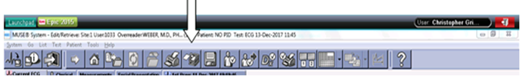

  - For Outside Orders: a copy of the ECG needs to be faxed to the ordering provider using the fax number provided on the outside order form.

b) Pediatric ECG’s:
  - Give a copy of the ECG and first previous, if available, to the ordering provider.
  - Pediatric ECG’s, (patients <17 years of age) both stat and routine will be sent to be read at the Children’s Heart Center by a pediatric cardiologist.
    - Retrieve current ECG and first previous ECG when available, print Epic appointment label and place on ECG copy to be faxed to Children’s Heart Center (612-813-8825).
      - Use the clinic specific Children’s Heart clinic cover sheet when faxing to Children’s Heart Center.
    - Call the Children’s EP Techs at 612-813-8818 to make sure a cardiologist is available to read the ECG, if stat and/or if you have any other questions – leave a voicemail if need be.
    - After the ECG has been over-read, an edited copy of the ECG will be return-faxed to the performing clinic lab. The clinic lab staff will edit and confirm the ECG in MUSE using the Children’s provider as the over-reader.

- Basic Equipment Troubleshooting (See Troubleshooting attachment for Artifact Elimination)
- Lead errors: Always check for proper lead wire connection on the machine “acquisition module.” Improper connection will cause inaccuracies in the ECG. Trace each individual lead wire from its acquisition module label to the colored connector.
- Error messages: If the system displays error messages, turn the power off, then on again. If error messages persist, contact one of the ECG/MUSE superusers, RCLS or BioMed.
- Positioning the lead wire connector in the gel may compromise trace quality or cause lead failure. Be sure to make connection with the non-gelled tab of the silver mactrode.
- Avoid crossing lead wires, which may cause wrong placement.
- In the downloading process, when selecting Load Orders and the list of open orders appears, if any of the orders are old, load them onto the cart and delete them. Old, unused orders on the open orders list can slow down and cause problems in the downloading process.
- Biomed (Biomedical Services): telephone extension 651-254-3971
    - Responsible for “hardware” repairs, (something is broken) such as ECG cart parts or connections.

- MAC 5500 Maintenance
- After Each Patient:
  - Clean instrument wires and wire clips with approved disinfectant.
- As Needed:
  - Clean exterior surfaces monthly or more frequently if needed using approved disinfectant.
  - Visual Inspection of Instrument:
    - Check the case and display screen for cracks and other damage
    - Inspect all cords for fraying or other damage.
    - Verify that all cord and connectors are securely seated. Inspect keys and controls for proper operation.
    - Inspect all plugs and connectors for bent prongs or pins. (Repair or replacement must be performed by qualified service personnel - BioMed).
  - Loading Paper:
    - Red streaks on the printouts indicate the paper is getting low. Follow steps below to reload paper.
      - Depress the square “Internal Access” button to release the lock and open the writer door.
      - Remove any remaining sheets of paper still inside the machine.
      - Remove outer cellophane wrapper from the new stack of paper and discard the cardboard backer.
      - With the vertically elongated circular “cue” hole in the upper left corner, (the corner closest to the Internal Access button), carefully insert the entire stack of paper fully into the machine. The paper is heat and pressure sensitive, and excessive scraping will cause streaking.
      - While holding the top sheet centered outside the paper door, close the door carefully so that the sheet does not rip.
      - When the door is fully closed, press the “Record ECG” button on the keyboard to indicate to the machine that the paper is loaded.
      - If the sheet rips or is excessively off-center and wrinkled, open the paper door and repeat steps 5 and 6. If the paper is not positioned properly, the paper will not stop in the correct position for your report.
  - Changing Time Settings (Daylight Savings):
    - The ECG machine time must be manually updated in the spring and fall during Daylight Savings transitions. Follow the steps below to update the machine time.
      - From “Main Menu” select “More”.
      - Select “System Setup”.
      - Type SYSTEM for password, push Enter (center button on arrow pad).
      - Select “Basic System”
      - Scroll down to Date and Time
      - Scroll down to Current Time
      - Highlight “Hour” and type in correct Hour, Enter.
      - Select Return
      - Select Return. Heading should now read “System Setup.”
      - Scroll down to “Save Setup.”
      - Select “Save to System,” Enter.

Author/Reviewer(s)
Craig Rousar
Pat Diaz
D. Bergo
V. Ross Collins
Nancy Butala
DABergo
Dylan Eaton/JFroehlich/CGrimes/RBoldt

IV. Definitions

V. Compliance
Failure to comply with this policy or the procedures may result in disciplinary action, up to and including termination.

VI. Attachments
- Lead Placement Diagram/Visual Aid
- ECG Troubleshooting Guide
- Children’s Heart Provider Signatures
- ECG Critical Values

VII. Other Resources
- MAC 5500 Resting ECG Analysis System Operator Manuals and Clinical Education and Development Kit materials.

- ECG MUSE Procedure.

- APPROVAL(S)
Dr. Arthur Wineman | Dr. Glenn Nickele
HealthPartners Regional Assistant Medical Director | Cardiology Clinic Medical Director
APPROVAL(S)
Laboratory Medical Director
- ENDORSEMENT(S) Laboratory Administration

Appendix

ECG Orders - Beaker Process

- For HP Clinic Labs who perform ECG’s:
  - There is one order and it contains two tests. (O123500073)
    - First test: MUSE - This test is released separately by selecting the RELEASE button. All other buttons are grayed out.
    - Second test: ECG 12 Lead Routine (Lab Performed). Collect this test with the rest of your lab tests.

Workflow - Ambulatory Order:
- Place the ECG order group.
- It will display the 2 orders, one for MUSE and one for Lab
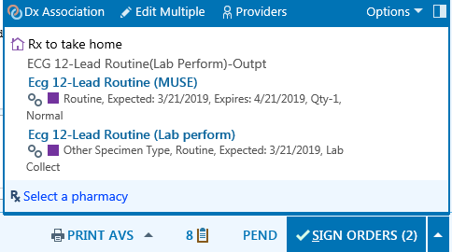
- Sign the orders
- Go to Lab order inquiry and for testing, select the Lab Order inquiry – All report.
You should see both the ECG- MUSE and ECG – Lab perform orders.
- Highlight the ECG- MUSE order and click on RELEASE. This will send the ECG order to MUSE/
For HP clinics, the ECG paper order report should still print.
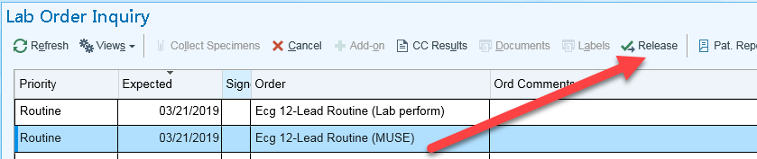
- Highlight the ECG – Lab perform order and select Collect specimens.
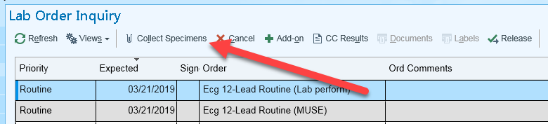
- Complete the Beaker collection steps.
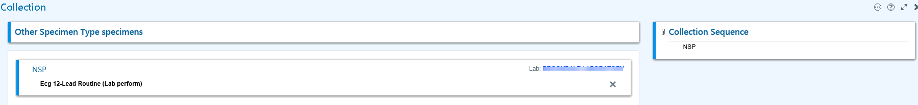
- The Beaker lab ECG order will be auto-resulted by a batch job that runs every hour. Until the batch job runs you will see it on your Outstanding List.

