
Subject  ECG MUSE Procedure | Attachments  Yes No
Key words MUSE, ECG computer, MAC Computer, Retrieve, Merge, Edit, EKG, electrocardiogram | Number  GHI-PC-CLINIC LAB-PROCEDURES-ECG Muse v. 04-2019
Category | Effective Date  See Electronic File
Manual Clinic Laboratory Procedure Manual | Last Review Date  See Electronic File
Issued By Clinic Laboratory – Regional Clinic Laboratory Supervisors | Next Review Date  See Electronic File
Applicable Clinic Laboratory Staff | Origination Date  July 2007
Applicable Clinic Laboratory Staff | Retired Date
Level of Complexity Not Applicable | Contact Regional Clinic Laboratory Supervisors
Review Responsibility Regional Clinic Laboratory Supervisors | Approval Date
APPROVAL(S) Laboratory Medical Director

Purpose/principle

This procedure provides an overview for the instructions for retrieving, printing and entering provider changes to Electrocardiogram (ECG) results in the MUSE system.
Once the ECG is performed on the ECG instrument, it is transmitted to the MUSE where it is stored. From MUSE, ECGs can be retrieved, edited, printed, add provider changes to the instrument interpretation, merged manually entered patient data with an interfaced order, and reconciled any discrepancies in chart numbers, account numbers and patient names.
MUSE Access
- MUSE access is requested via mySupport Center.
- The roles and privileges for staff performing ECGs: Transcribe Provider Interpretation
Definitions
- MUSE: Computer system where confirmed and unconfirmed ECG’s are stored.
- Edit: Process of making changes to the ECG instrument interpretation, order or visit information and demographics.
- Unconfirmed ECG: An ECG that has been transmitted from the ECG cart to MUSE but has not had the ECG machine interpretation over-read by the provider. Printout says it is unconfirmed.
- Confirmed ECG: ECG that has been over-read by the provider. The provider has made changes to the interpretation, if necessary, and the changes have been entered into MUSE. This is the finalized ECG.
- Retrieve: Process of pulling up a copy of an ECG that is stored in MUSE.
- Merge: Process of merging manually entered patient information with an interfaced order.
Summary of Steps for Editing an ECG:
- Once ECG is performed, the ECG is transmitted into MUSE.
- Hard copy (reverse transmittal) is given to provider to over-read and the copy is returned to lab.
- Select the patient from the Edit List or the Edit/Retrieval List.
- This opens the patient record to the Edit/Retrieve Screen.
- Verify there are no error messages and says “No Mismatch Detected”.
- Verify Order and Visit numbers are filled in. If not, these must be resolved before confirming.
- Record any of the provider changes, if present, to the instrument interpretation.
- Confirm and print.
- Home Screen
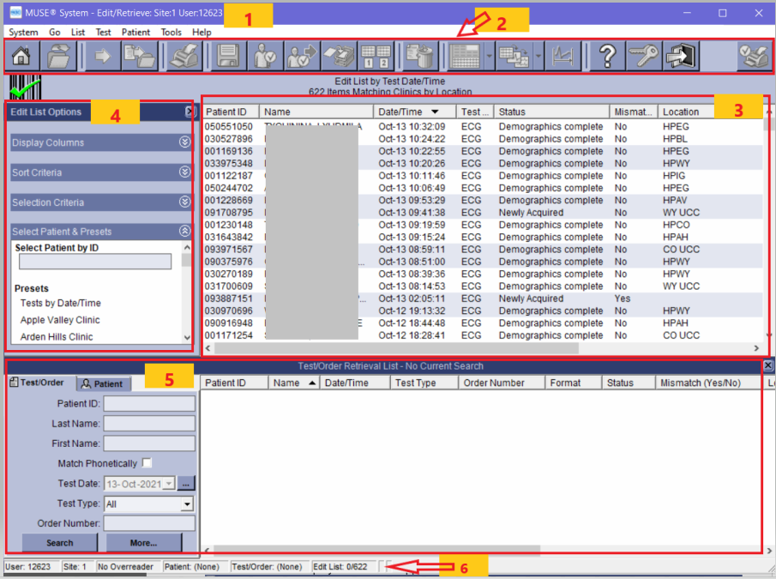
- Title/Menu Bar (1): Displays the current application, user, and site. Provides access to all tasks available within the Editor application.
- Icon Toolbar (2): ICONs are either active or inactive depending on where you are working in MUSE. When an ECG is highlighted or opened, more ICONs become active. See end of procedure for full description list.
- Edit List (3): Contains Unconfirmed ECGs. Patient tests may be selected for editing, printing or confirming.
  - Edit List should be monitored weekly by each clinic’s laboratory staff and “Super Users”. If ECGs are still waiting in the “Edit List” after one week, reprint and distribute to physician reader.
  - The ECGs on this list can be sorted by clicking on the column headers.
    - Patient ID: Patient Medical Record Number (With 0 in front)
      - Muse requires a 9-digit number. HealthPartners’ patients have an 8-digit medical record number (MRN). To meet MUSE requirements, add a zero in front of the HealthPartners’ MRN.
    - Name: Patient name
    - Date and Time: Date and time ECG was performed
    - Test Type: ECG
    - Status:
      - Newly Acquired: ECG received from the cart, but no order from Epic.
      - Updated: File has been updated or corrected in MUSE, but not confirmed.
      - Demographics complete: ECG received from the cart and merged with order from Epic.
    - Mismatch: States whether there is a mismatch: Yes or No.
    - Location: Performing clinic.
- Edit List Options (4): Preset options for filtering ECGs displayed in the Edit List.
  - Staff should not manage or edit the presets without consulting with a MUSE super user or Regional Clinic Laboratory Supervisor (RCLS).
- Test/Order Retrieval List (5): List of the patient’s stored ECGs in MUSE, the ECG order and ECG status (confirmed, unconfirmed newly acquired or updated).
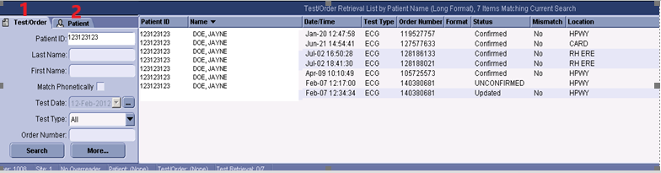
- Search Options
  - Test/Order (1): Search by Test/Order, all tests and orders are listed. Open any test or order by clicking on it. Best used when troubleshooting.
  - Patient (2):
    - Enter the patient chart number. Their name appears in the retrieval screen.
    - Double click on the patient name to open their file and view a list of tests and orders.
- Edit/Retrieval Toolbar (6): Lists the User ID, Site, Over-reader and Patient Information.
- Edit or Retrieve ECG
- Opening a Patient Record
  - Opening from the Order/Retrieval List
    - Type in the patient MRN, last name, first name, test date, test type or order number.
      - You can choose to check or clear the Match Phonetically box to search patient names phonetically or exactly as typed.
    - Click Search. A list appears with all the patients in the system matching the name and/or test date entered.
    - Highlight and double-click on the name of the report wanted. The report opens in the Report Editor window.
  - Opening from the Edit List
    - Select the patient and double click.
- Patient Record Screen

- Current ECG Tab: Waveform Layout

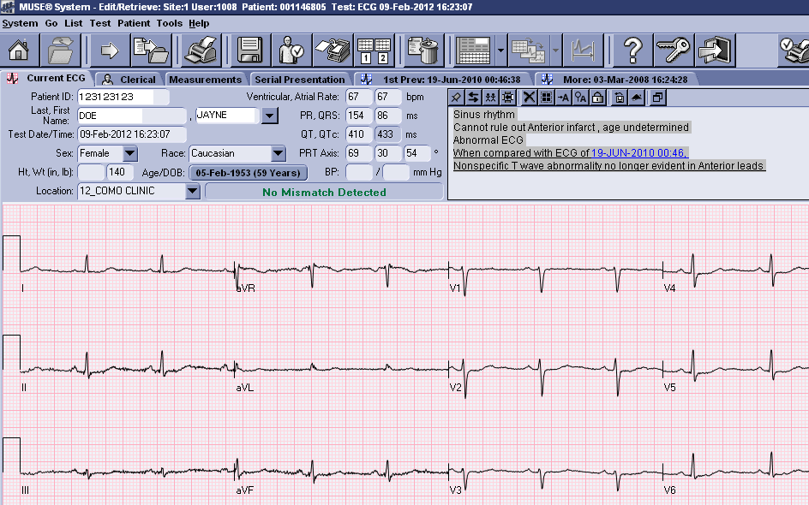

- Clerical Tab (View and update demographics, visit number and/or order number)

Example: Complete with requirements met

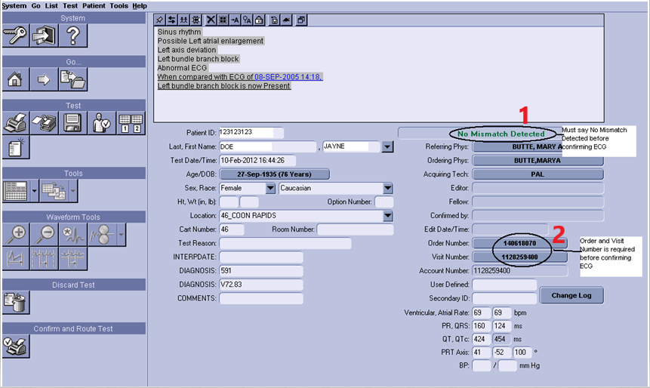

- Messages (1)
  - When a patient record is opened and information is correct, a message says “No Mismatch Detected”.
  - If there is message such as “PID Mismatch” or “No ADT Record for Patient”, it must be resolved before confirming the ECG.
- Order Number & Visit Number (2)
- An order number is required for the ECG to be visible in the patient medical record in Epic and to bill correctly.
- Downloading the patient information from Epic into the ECG Cart
  - ALWAYS use this method unless Epic or MUSE is down or there is an Emergency or STAT ECG.
  - This ensures all information in MUSE will be correct, including the order number and visit number.
- If patient information is manually entered into the ECG cart without a valid order number (Ex: STAT ECG), after the ECG is sent to MUSE a “pseudo-order number” will be auto-generated and the Visit number will be blank. This information must be updated in MUSE.
- See Problems Requiring Resolution section below for instructions on updating or correcting ECGs that have problem messages and/or correcting order or visit numbers.
- Outside Provider Order
- Place the order in Epic. You will need to get an Epic number for the outside provider by contacting LIS and permission from a clinic provider to use them as the ordering provider or use the clinic’s “Doc of the Day”.
- Release the order.
- Enter the name of the outside provider in the “comments”.
- ECG should be edited and confirmed according to the regular process
  - Clinic provider can read and edit ECG.
  - ECG can be sent to Regions to read and edit.
  - If patient is a pediatric patient (<17 years of age), send ECG to Children’s Heart Clinic per procedure.
  - Follow faxing instructions as indicated on the paper requisition.
- Editing the ECG and Adding Comments
- View interpretation from Clerical Tab.
- The original 12SL diagnosis appears shaded in gray.
- Free Text entered appears with a different background color.
- Enter any comments regarding how the ECG was performed (position of patient, patient would not remain still, etc.) that may provide important information to the provider into MUSE via free text and reprint before sending the read to the provider or over-reader.
Example: Edit/Retrieval – Clerical Tab
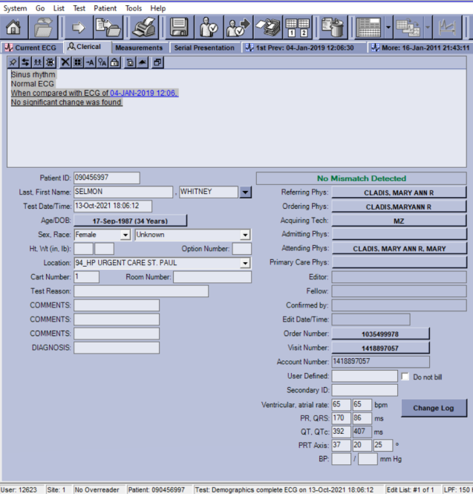

Edit Toolbar: Located in the Interpretation Screen
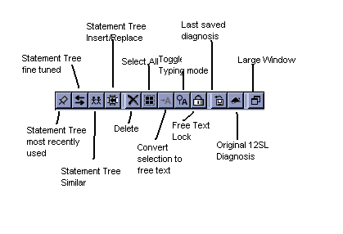
- View interpretation from Clerical Tab.
- The original 12SL diagnosis appears shaded in gray.
- Free Text entered appears with a different background color.
- Any comments regarding how the ECG was performed (position of patient, patient would not remain still, etc.) that may provide important information to the provider should be entered into MUSE via free text and reprinted before sending the read to the provider/over-reader. For printing instructions, see Print ECG section below.
- Adding Acronym Statement from the Acronym Statement List
- Select or insert your cursor into the text box.
- Type the first letter and/or second letter of the acronym you want to add to the diagnosis (1).
- The Matching Mode list (2) appears, with a list of the acronyms that contain the letters typed.
- Highlight and double click on the correct acronym statement in the list. It will appear in the diagnosis.
- To delete the acronym statement, highlight the statement and press the Delete key, or place the cursor at the end of the statement and press the Backspace key.
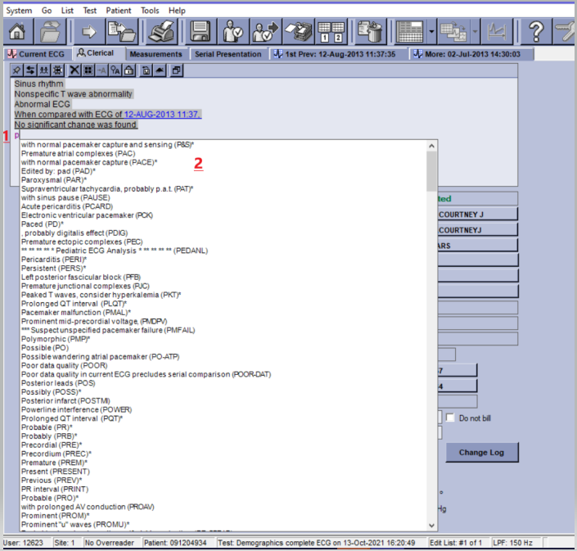
- Adding Free Text to the current Diagnosis Statement
- At the diagnosis statement window, insert the cursor at the point where you want to insert a free text statement.
- Begin typing. Note: If you begin typing and the acronym drop-down box appears, continue typing until it disappears.
- Press the Enter key to move to the next line.
- To delete free text, highlight the text and press the delete key or insert the cursor and press the Backspace key. This deletes one character at a time.
- To insert an acronym while typing free text, select the Insert key. The acronym drop down menu appears. Select the appropriate acronym and continue.
- To Restore the Original 12SL Diagnosis
- Right click at the diagnosis statement. A menu appears.
- Select Original 12SL Diagnosis. The Original 12SL Diagnosis window appears.
- Click Restore. The diagnosis statement will be restored to the original 12SL diagnosis, including any statements deleted during editing.
- All new statements and free text will be deleted if Restore Original Diagnosis is selected.
Deleting ECG Orders in MUSE
- Cancel an ECG order without results in Epic.
- Credit the order in Beaker or contact your RCLS to credit the test.
- To delete and ECG after it was transmitted to MUSE
  - With the file open, select Test > Send To > Discarded Data List
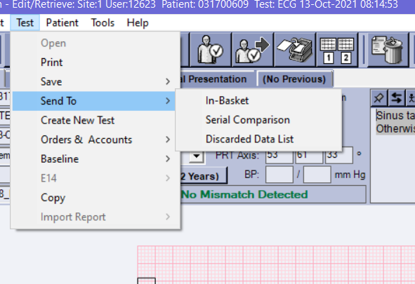

- Problems Requiring Resolution
- The Order number and/or Visit number are blank (Possible reasons)
  - The patient information was manually entered into the ECG machine without a valid order and/or no patient appointment was made in EPIC, so no appointment is available to merge the ECG with.
Error Message: No ADT Record for Patient and Visit Number is blank
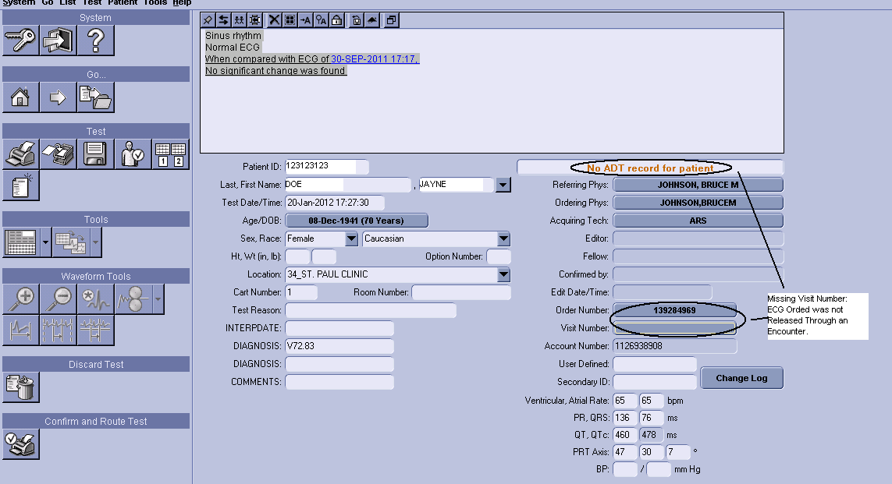
- Ask the care team to order the ECG through the day’s appointment.
- Once ordered and released, merge it by going into MUSE and click on the Visit button.
- Select the correct Visit number then select the order number. Make sure you are selecting the correct order.
- After the provider has over-read the ECG, confirm it in MUSE.
- The preliminary report will always stay in Epic and there will be a separate report for the confirmed report.
- Two ECGs were performed for the same order and another order needs to be created if both ECGs are wanted on the medical record.
- Verify that two ECGs were performed; make sure that the provider wants both and that one was not transmitted in error.
- If the provider wants both, ask the care team to place a second order for an ECG.
- Merge the second ECG to the new order by selecting the correct visit number.
- If only one ECG is wanted, delete the unwanted one.
- A message states the order is pending. This means that the order was downloaded into the ECG machine but not used.
  - The order needs to be returned to Open Orders (See Pending Orders section below).
- Patient ID/Name Mismatch (Error Message)
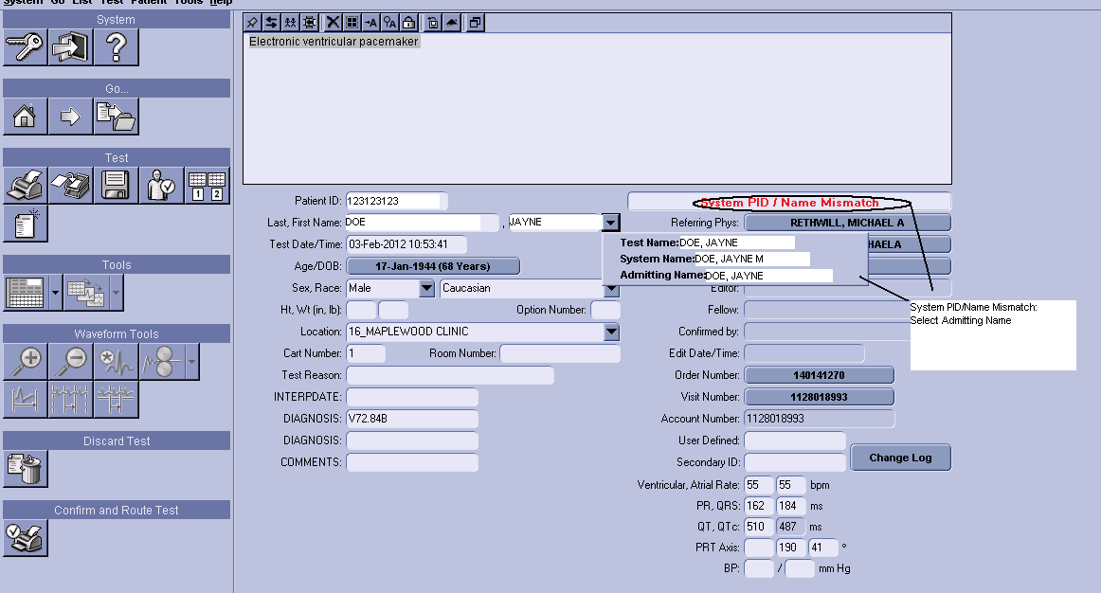
- Click on the down arrow next to the Last Name field.
- Select the appropriate name from the list. The report name will be replaced by the name selected.
      - Report Name: Current report name.
      - System Name: Name attached to record that was acquired into MUSE before the current report and has the same PID as the current report.
      - Admitting Name: Name sent to MUSE from the interface. Always select the Admitting Name when the Admitting Name and the Report Name are the same. If they are different, investigate the reason for the misidentification.
- Verify the numbers are correct. If the wrong number has been entered or a zero is missing at the beginning of the patient MRN, resolve it by:
    - Correcting the number.
    - Select the admitting name. The Order and Visit fields will be visible.
    - If the error message is still there, click on the Order Number and select “No Order”.
    - Select the Visit Number and choose the correct visit.
    - The Order Number is now blank.
    - Select the Order Number again and select the correct order and say ok.
    - The message should now say “No Mismatch Detected”.
- Pending Orders
Orders with a status of “Pending” cannot be confirmed. Follow the steps below to change the status to “Open” and confirm as usual. Ensure that you are working with the correct order by verifying the date, time and location before changing the Status.

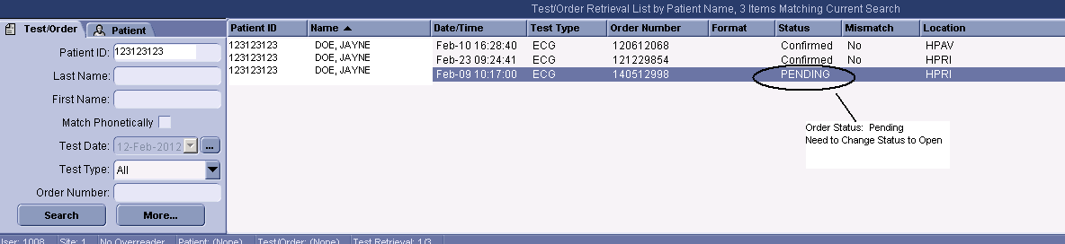
- Go to Test > Orders & Accounts > Change Order Status to Open.

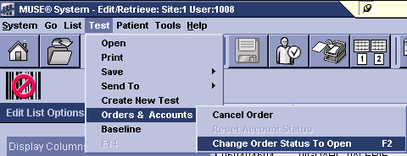

- Serial Comparison Correction
If the same patient has two ECGs run within a few minutes of each other (repeated) the instrument will compare the 2 ECGs to each other instead of using the ECG from the previous visit. To fix this, a new serial comparison must be run.
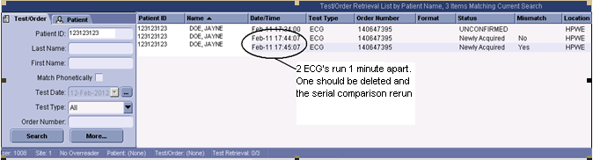
- Send to Serial Comparison (Option 1)
  - Highlight the record from the Edit List
  - Click on the Send Test to Serial Comparison Icon: 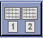
    - The system will remind you that all changes to the diagnosis will be lost and the original 12SL statements will be restored. Click Yes.
- Send to Serial Comparison (Option 2)
  - Highlight the record on the Edit List.
  - From Menu bar: Click Test > Send To > Serial Comparison
- Order Status Mismatch Error Message
If the Order Status Mismatch error message is present and there is an order and visit number shown, the order number is likely a pseudo-order number. This happens when a valid order was not downloaded into the ECG cart.
  - Have a new order placed for the correct date of service.
  - Release order through the correct appointment. Then, the order can be merged.
  - Merge order in MUSE by selecting the correct Visit number and then select the correct order.
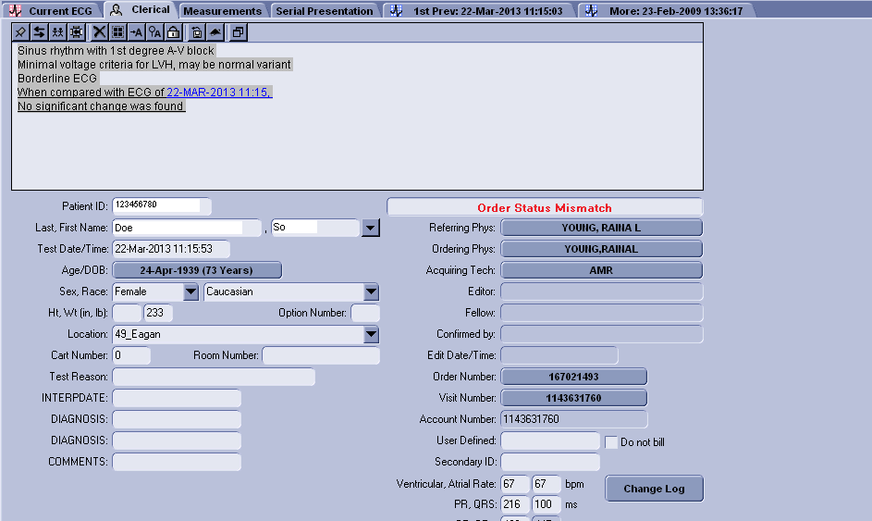

- ECG Over-read & Confirming ECG
  - Selecting an Over-reading Physician
    - At the Edit List, select Tools > Select Over-reader. The Select Over-reader window appears.
    - Search by name or user ID.
    - To search by User ID, type the User ID in the User ID field.
    - To search by Physician Name, type in all or part of the over-reader’s name in the First and Last Name fields and click Search.
    - Highlight the correct user and click OK. The user’s name will now appear as the over-reader for any reports being confirmed.

Example: Edit/Retrieval Screen - Selecting an Over-reading Physician

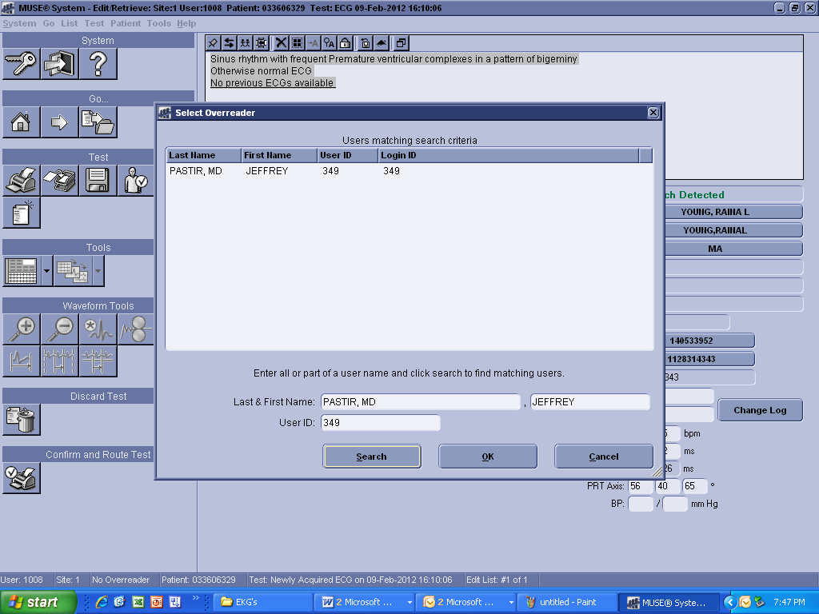

- Confirming the ECG
- The ECG can be confirmed when:
  - The Error Message has been resolved and it says “No Mismatch Detected”.
  - The correct Order and Visit Numbers are filled in.
  - The provider has read the ECG and returned the signed printouts to the lab.
    - Provider will either agree with the instrument interpretation, and makes no changes to the ECG, or will add interpretation comments to the printout.
    - Add provider’s interpretation comments to the ECG in MUSE.
    - When finished, press the Confirm and Route Icon  or (F6) to confirm the ECG.
- Result Transmission to Epic
Once the ECG is transmitted to MUSE, a preliminary, unconfirmed, copy is visible in Epic in the patient’s chart under the Cardio tab. When the ECG is confirmed, the preliminary is overwritten with the final, confirmed report.
- Printing ECGs

Example: Print an ECG
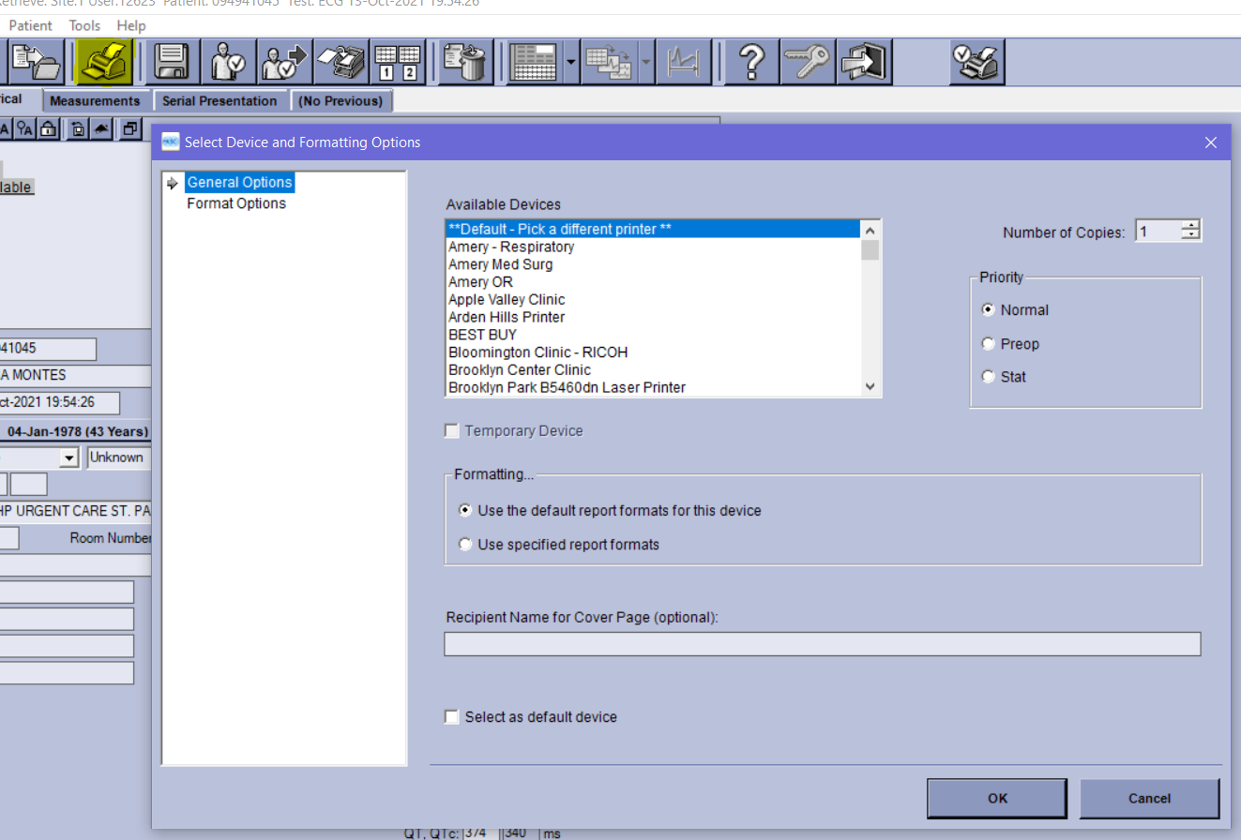

- Print Individual ECG
  - Select the Print ICON or Highlight a record and select Test > Print from the Menu Bar.
  - Select the desired printer from the list, number of copies and click OK.
- Print a List
  - Highlight multiple records by using the shift key.
  - Right click on the highlighted list and a box pops up to “print list”.
  - Select the desired printer from the list, number of copies and click OK.
- Printing to Regions Result Printer
  - When printing ECG’s to Regions Cardiology to be over-read by a cardiologist, always send to Regions in-basket to User ID 10000.
- Icon Descriptions & Functions

 | Go to Home
 | Go to Selected Item: Select an item by clicking on it and then click on this icon. Another option is to double click on the item.
 | Open Next Selected Item: If you selected on more than one ECG on the EDIT list, once you open the first ECG, click on the arrow to move to the next selected ECG. When completed, it returns to the Home Screen.
 | Print Test: Option to print to any System Printer listed in the printer directory.
 | Update: Save changes without confirming and billing. The record status will be noted as Updated in the Edit List.
 | Save Test as Demographics Complete: Very similar to Update. The record status will be noted as Demographics Complete and route in the Edit List. Saves and routes based on test type. If preliminary, it will save as a preliminary. If a completed or correct, ECG hits the Edit list it is identified as demographics complete.
 | Send Test to In-basket: Do NOT USE.
 | Send to Serial Comparison: When multiple ECG’s are run within a few minutes of each other and sent to MUSE, this allows the deletion of the unwanted ECG’s and reruns the serial comparison so that the current ECG will compare with the desired previous ECG
 | Send Open or Selected Test to Discarded Data List: To Delete the unwanted ECG’s, highlight them and send to the discarded data list. If the wrong ECG is accidently deleted, call the Helpdesk. Discarded ECGs are retrievable.
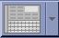 | Select Test Editor Layout: There are several waveform options for viewing the patient record. Waveform Layout, Serial Presentation Layout, Clinical Layout, Enhanced Clinical Layout, Clerical Layout and the option to select a Primary Layout and an Alternate Layout.
 | Physician Tools for Over-reading: DO NOT USE.
 | Physician Tools for Over-reading: DO NOT USE.
 | On-line Help: This is the MUSE manual. It opens to the area that is being worked on.
 | Log Out: Logs out to Log In Screen.
 | Exit Application: Exits application and shuts down MUSE.
 | Confirm, Print and Route.

Author/Reviewers
Denise Bergo
Nancy Butala
JAGayken
DBergo
Dylan Eaton/Chris Grimes
Endorsement
Laboratory Administration

