|  |  |
| --- | --- |
| Logo Alone 8-11-15 |  |
| Blood Collection and Specimen Processing Procedure  (Phlebotomy) | **Attachments**  Yes  No |
| **Key words**  Phlebotomy, Blood Collection, Blood draw, Specimen Collection, Venipuncture, Capillary, Heelstick, Fingerstick, processing | **GHI-PC-NS-CLINIC LAB-PROCEDURES-**  **Blood Collection**  **v. 02-2020** |
| **Category** Provision of Care | **Effective Date**  **See Electronic File** |
| **Manual** ClinicLaboratory Procedure Manual | **Last Review Date**  **See Electronic File** |
| **Issued By** Clinic Laboratory Administration | **Next Review Date**  **See Electronic File** |
| **Applicable**  Clinic Laboratory Staff, W@W staff | **Origination Date**  **September 1985** |
| **Retired Date** |
| **Level of Complexity**  Waived | **Approved Date**  **See Electronic File** |
| **Review Responsibility** Regional Clinic Laboratory Supervisors | **Contact** Regional Clinic Laboratory Supervisors |
| **APPROVAL(S)** Laboratory Medical Director |  |

**Purpose/PRINCIPLE**

The purpose of blood collection is to obtain adequate blood specimens by venipuncture or capillary puncture (microtechnique) for diagnostic laboratory testing.

**POLICY**

Laboratory staff collecting blood specimens will follow the approved techniques for specimen collection outlined in this procedure.

HealthPartners family of care uses single-use needle and devices for all phlebotomy and blood collection procedures. Should it be necessary to re-stick a patient, a new, single-use needle or device will be used.

HealthPartners Medical Group and Clinics **will not accept** blood specimens or cultures (from sources not traditionally collected by patients) for testing that are brought in or collected by patients or family members.

Lab staff is allowed to assist care unit staff in finding needle placement for IV starts, but cannot infuse.

**Specimen:**

The type of blood tubes needed is accessible via the HealthPartners Laboratory Test Directory, in the Epic Beaker lab system when in Lab Order Inquiry and on the patient labels generated by the computer.

It is recommended that venipunctures be performed on patients 5 years of age or older. Venipuncture technique should be used when collecting more than one milliliter of whole blood.

**REAGENTS/MATERIALS**

|  |  |  |
| --- | --- | --- |
| Gloves (latex-free) | Sharps container | Armrest or support |
| Eclipse Safety needles | Alcohol prep pads | Gauze |
| Butterfly needles | Band-aids | Lancets |
| Disposable vacutainer holder | Tape (Coban, Coflex) | Syringes |
| Blood collection tubes | Tourniquet | Microtainer tubes |
|  |  |  |

**Latex Intolerance Notice**

When a patient states that they are latex intolerant (allergic), the phlebotomist must wear vinyl or nitrile gloves. A latex-free tourniquet or blood pressure cuff must be used in place of the latex tourniquet. Apply tourniquet over the patients clothing or use a towel as a barrier to the skin (rubber contains latex too!). When using the blood pressure cuff, inflate pressure to 40 mm).

**Patient Preparation:**

1. When calling the patient to the drawing area, use their first name and first initial of their last name. Greet the patient in a friendly, professional manner using approved scripting:
2. Greet the Patient:

“Good Morning (afternoon, evening), Welcome to the lab, how may I help you?”

1. Introduce yourself and what you are going to do:

“Hello, I’m ______, one of the lab staff. I’m going to draw your blood today.”

1. When you are finished ask:

“Is there anything else I can do for you today?”

**Note:**  Well At Work providers do not need to use the scripting as they are treating the patient as well as the person performing the procedure.

1. **All lab orders will be reviewed with the patient in the draw station before selecting tests to be collected. You may need to change the Beaker settings to “view all” if you do not see orders in the regular lab order inquiry screen. In “view all” screen, make sure to not collect any orders that are not due. The provider/care team may need to be contacted to verify which orders need to be collected.**
2. If the patient has no orders:
   1. Ask the patient if they know the provider who would have placed these orders and what tests are needed. Give the patient the option of waiting while we contact the care team or coming back at a later date once the orders are placed.
   2. If the patient chooses to come back at a later date, respond with “I can send a message to your provider and once those orders are placed you will be notified to come back for the lab testing.”
   3. Send a telephone encounter to the care team indicating to contact the patient to return for testing once the orders are placed.
3. Verify identification of the patient. Ask the patient to state their first and last name and date of birth while your verify they match the information on the label.
4. Evaluate the patient.
   1. Procedure for seating the patient

The patient should be seated comfortably in a chair and should position their arm on an armrest, extending the arm so as to form a relatively straight line from the shoulder to the wrist. The arm is supported firmly by the armrest and should only be slightly bent at the elbow.

* 1. Procedure for having the patient lie down

The patient lies comfortably on their back. If additional support is needed, a pillow may be placed under the arm from which the specimen is to be drawn. The patient extends the arm so as to form a relatively straight line from the shoulder to the wrist.

1. Perform hand hygiene in the presence of the patient, before and working on them. It is not required to wear gloves when finding a vein. Gloves are required to be worn during the actual phlebotomy procedure in its entirety.

**Performing a venipuncture**

1. Assemble supplies for collecting the blood specimen.
2. Apply the tourniquet 3 to 4 inches above the bend in the elbow. Ensure the tourniquet does not roll up, but remains flat against the circumference of the arm. Create a loop in the tourniquet to provide an easy one-handed release.
3. Instruct the patient to make a fist but discourage hand pumping as it can elevate some analytes.
4. Choose the vein that feels fullest. Use the index finger to palpate and trace the path of the vein. Thrombosed veins lack resilience, feel cord-like, and roll easily. Feel firmly, but do not tap or rub finger lightly over skin because you may feel only small surface veins. Always feel for the median cubital vein first; it is usually bigger and closest to the skin’s surface, more stationary, less painful and is associated with the least degree of risk to underlying structures. The cephalic vein (depending on size) is the second choice over the basilica vein, because it does not roll and bruise easily.

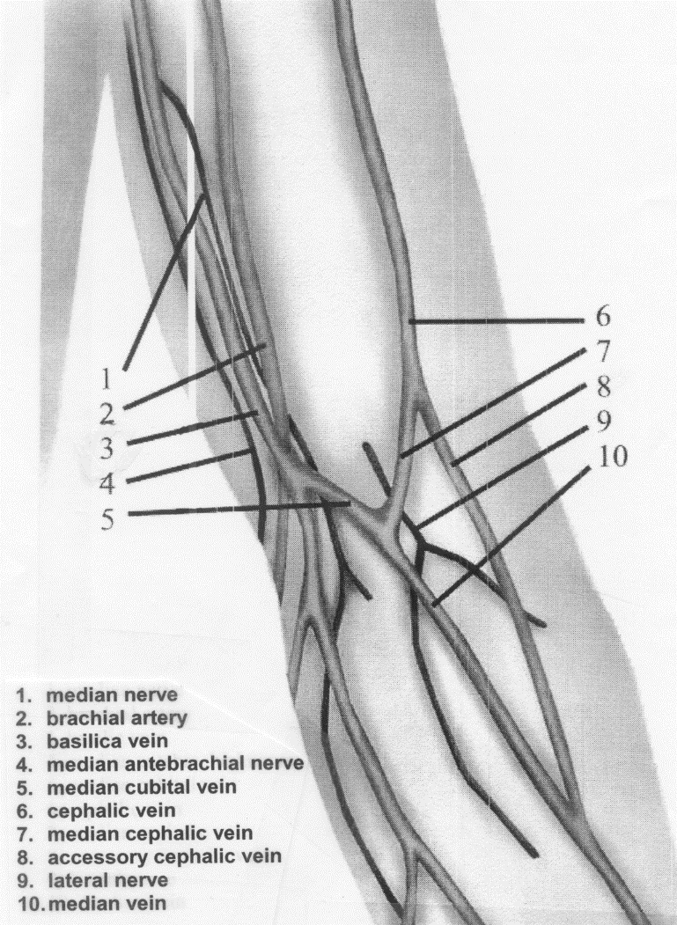

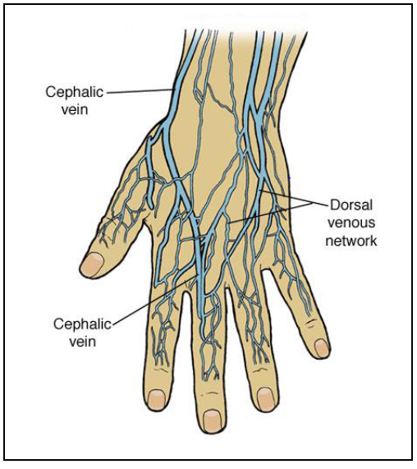

**CLSI Recommendation: GP41-ED7 2017 Collection of Diagnostic Venous Blood Specimens**

*The preferred venipuncture site is the antecubital fossa, which is the area of either arm that is anterior to (in front of) the bend of the elbow where a number of large veins lie relatively near the skin’s surface.*

*When antecubital veins are not acceptable or are unavailable, veins on the back of the hand are also acceptable for venipuncture.*

*Collections outside of the recommended venipuncture sites must not be attempted without a thorough knowledge of the area’s anatomy and the risks involved, and any such attempt must also be made according to facility policy.*

*Arterial punctures shall not be considered an alternative to venipunctures, because results obtained from arterial specimens are not equivalent for many analytes. Arterial blood sampling can also be more painful to the patient and pose greater risk of injury and complications.*

*Veins on the palmer surface of the wrist and the lateral wrist above the thumb to the mid-forearm must not be used.*

1. If a “good” vein cannot be found, try the following:
2. Assess the other arm unless instructed otherwise.

* Ask the patient to make a fist again.
* Apply the tourniquet, remembering that the tourniquet should never be left on the arm for more than one (1) minute.
* Massage the arm from wrist to elbow.
* Palpate lightly.
* Apply heat to the vein site.
* Lower the arm over the bedside or venipuncture chair.

1. Once the vein to be used has been identified, release the tourniquet.
2. If gloves were not worn when finding a vein, don gloves ***in front of the patient.*** From this point, gloves must be worn continually through the entire blood collection process.
3. Using a clean alcohol prep, cleanse the area by moving the pad in a circular motion from the center of the vein site outward. Allow to air dry. NEVER touch the skin after the site is cleansed unless you have prepped your gloved finger. DO NOT remove the finger of the glove to repalpate the vein. Discard the used alcohol prep.

**NOTE:** For collection of blood cultures, refer to the Blood Culture Procedure.

1. Use of a disposable vacutainer holder is required. Thread the needle onto the vacutainer holder. Inspect the needle, syringe or evacuated tube before performing the venipuncture. Rotate the safety shield back. The cover of the safety needle must not be removed until the phlebotomist is ready to draw blood, thus avoiding needle contamination. If the needle touches anything but the sterile site, it must be changed.
2. **Reapply the tourniquet. Do NOT repalpate the site to be used unless the glove is disinfected with an alcohol wipe.**
3. Perform the venipuncture.
   * 1. Evacuated tube method
     2. Grasp the patient's arm firmly, using the thumb to draw the skin taut.
     3. Insert the needle into the vein quickly and smoothly with the bevel of the needle upward at a 30 degree angle or less. Hold the evacuated tube with one hand while the other depresses the tube to the end of the holder. The angle of insertion should be as low as possible to prevent going through the vein entirely. Otherwise, this will cause bleeding inside the arm.

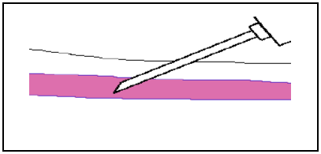

* + 1. The tube should be filled until the vacuum is exhausted and the blood flow ceases, thus ensuring a correct ration of anticoagulant to blood. If more than one tube type is needed, the following order in drawing should be followed:

1. Blood culture (See blood culture procedure for details)
2. Blue top (citrate)
3. Serum separator Gel Red top/ Gold top/ Speckled red top
4. Green top (heparin)/Green top plasma separator
5. Purple top (EDTA)
6. White top (K2EDTA with gel)
7. Grey top (fluoride)
8. TB Gold
9. After drawing each tube, immediately mix by gently inverting the tube at least ten times prior to collecting the next tube. Gentle inversion will avoid hemolysis. Never shake a tube of blood after collecting a blood specimen.

Occasionally a faulty tube will have no vacuum. If a tube is not filling and the needle is inside the vein, another tube should be used. If a tube starts to fill but then stops, the needle should be moved slightly forward or backward, NEVER side to side. This can cause severe pain and injury to nerves. Usually this adjustment will increase the flow.

b. Syringe Method

A syringe and needle may be used to collect blood from patients with more difficult veins

1. When using a syringe, unseat the plunger from the barrel by pulling back on it to break the seal and then, return the plunger fully forward, expelling all air from the barrel.
2. Remove the sheath from the needle. Inspect the tip of the needle visually to determine it is free of hooks at the end of the point and its opening is unobstructed.
3. Grasp the patient’s arm firmly, using your thumb to draw the skin taut. This anchors the vein.
4. Inform the patient of the imminent puncture.
5. Ensure the bevel of the needle faces up. Guide the needle into the skin and vein with a steady, forward motion at an angle of 30º or less.
6. When using a syringe, a flash of blood may appear in the hub of the needle. However, the absence of a flash of blood should not be misinterpreted as an indication that the vein has not been accessed. Once the blood begins to flow, loosen the tourniquet with the free hand.

c. Butterfly Method

A winged infusion set (butterfly assembly) with luer adapters may be used instead of a syringe and needle for very difficult veins. The winged collection set is a "closed" system. Blood flows from the vein through the set directly into the evacuated tube or syringe. When using a winged infusion set and a coagulation tube is the first tube to be drawn, use another blue top tube as a primer. Apply the discard tube just long enough so that the tubing of the butterfly set is primed with blood. By filling the tubing with blood the vacuum of the citrate tube is not partially exhausted with air in the line, which could result in under-filling of the tube.

1. Instruct the patient to unclench their fist.Release the tourniquet after the blood is flowing. Once all tubes are collected, release the tube from the vacutainer holder.
2. Lay a gauze pad lightly on the insertion point without applying pressure.
3. Withdraw the needle. . immediately activating the device’s safety feature according to manufacturer’s instruction. Dispose of needle in a sharp’s container.
4. Apply pressure to the puncture site using the gauze pad.
5. If using a syringe, replace the needle with a Safety Transfer Device to transfer the blood from the syringe to the appropriate tubes or culture bottles. Dispose of the contaminated needle in the sharp’s container.

**Note: The use of a needle to transfer blood into tubes or culture bottles is strictly prohibited.**

1. Gently invert all tubes containing anticoagulant or separating gel10 times.
2. **Label all tubes with the computer generated label in the presence of the patient**.

Note: In the absence of computer labels, label tube with patient first and last name, date of birth, date and time collect of collection and the collector’s initials. See the Patient Identification and Labeling Procedure about reviewing the specimen labels with the patient prior to collecting the specimens.

1. Apply firm pressure to the puncture site using a clean gauze pad until bleeding has stopped. Cooperative patients may be allowed to apply pressure. Bending the patient’s arm up is not an adequate substitute for pressure.
2. Lift the gauze and observe the puncture site for 5-10 seconds for superficial bleeding and any mounding or rising of the surrounding tissue.
3. If bleeding has not ceased, reapply pressure for 1 to 2 minutes and re-examine site. Repeat the process until bleeding has stopped.
4. Cover puncture site with a Band-Aid or gauze and tape. Instruct the patient to leave the bandage in place for at least 15 minutes.
5. To keep our pediatric patients safe, HealthPartners laboratories do not bandage patients under 2 years old due to known risks, including choking, blood flow constriction and/or potential long term irreversible damage. This includes Band-Aids, tape, Coban or Coflex.
   * + - 1. Apply pressure for a short time. If bleeding does not stop, direct the parent/guardian to have a seat in the lab waiting area with their child and ask them to apply pressure until bleeding has stopped.
         2. For pediatric patients older than 2 years, notify the parent/guardian to remove Band-Aids and tape within 30 minutes.Note: Use Coban sparingly **andnever on pediatric patients.** Coban should only be used on patients who are able to remove the wrap themselves or have someone aware of the risks and can assist with removal as soon as possible. If Coban is used for a patient, instruct the patient or care giver to remove immediately if there is any discomfort and do not leave the wrap on longer than 1 hour.
6. Evaluate the patient for signs of dizziness, nausea, hyperventilation, perspiration, pallor, etc. If there is any indication the patient did not tolerate the procedure well, do not release the patient from your care until signs/symptoms subside.
7. Inspect the area, remove and dispose of all used supplies. Remove any unused labels from the draw area.
8. Deliver specimens to appropriate area.
9. Remove gloves and perform hand hygiene.

**Performing a capillary finger puncture**

.

1. Choose a finger that is not cold, cyanotic, or swollen. If possible, use the palmar surface of the third (ring) finger of the non-dominant hand. The index, middle finger or medial aspect of the great toe are also acceptable.

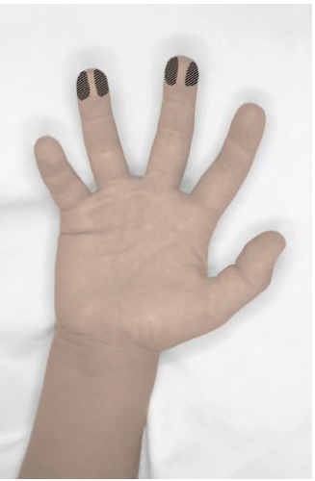 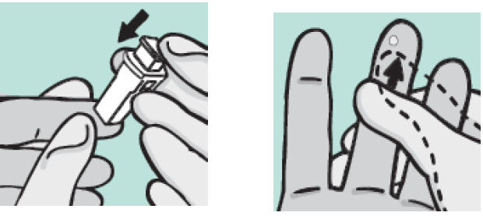

1. Gently massage the finger five or six times from base to tip to aid blood flow.
2. With an alcohol swab, cleanse the ball of the finger. Allow to air dry.

**For lead testing, thoroughly washthe patient’s hands with soap and water to reduce environmental contamination.**

1. Prepare lancet device.
2. Position the lancet on the desired location and activate the lancet device.
3. 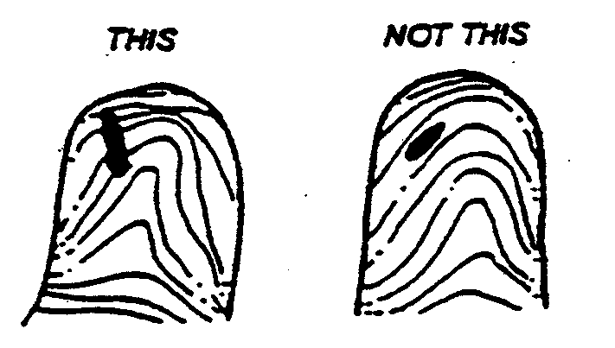The cut should be made across the fingerprints to produce a large, round drop of blood.
4. Wipe the first drop of blood away with a clean gauze (unless testing the first drop for point of care INR testing). since the first drop is likely to contain tissue fluid.
5. Allow well-formed drops of blood to flow into the collection containers by gravity and/or capillary action. Provide gentle squeezing only, as necessary to promote blood flow.
6. Holding the puncture site downward and gently applying intermittent pressure to the surrounding tissue enhances blood flow from the puncture. Strong repetitive pressure (milky) should not be applied as it may cause hemolysis or contamination of the specimen with tissue fluid.
7. Do not use a “scooping” motion to collect blood or allow the blood to pool on the skin surface, as these actions cause hemolysis.
8. If excessive squeezing is necessary due to insufficient blood flow, terminate the procedure. Prewarm another site and repeat the procedure using a new lancet device.
9. Mix additive microtainer tubes by gentle inversion 10 times immediately after collection.
10. With a clean gauze, apply pressure until bleeding stops.
11. Seal and mix tubes by gentle inversion.
12. Label the microtainer tubes in the presence of the patient.
13. **The order of draw is different for microtainer tubes. The EDTA must always be filled first to prevent clotting.**

**NOTES:**

* If the patient’s fingers are cold, warm the fingers in a warm cup of water for 30 seconds or use a heel warmer.
* Microtainers must be labeled, not just the outer transport tube

**Performing a Heel Puncture**

1. Choose a site for the heel puncture on the most medial and lateral portion of the plantar surface (see diagram - shaded area).
2. Prewarm the intended puncture site for 3 to 5 minutes using an infant heel warmer at no higher than 42ºC. If the procedure has not been started within 10 minutes, discard the infant heel warmer and reassess the area. If the area has cooled, rewarm with a new heel warmer.
3. Cleanse the area with an alcohol swab. Allow to air dry.
4. Hold the heel firmly to prevent sudden movement, position the lancet device on the skin with minimal skin compression..
5. Activate the release mechanism on the lancet device. Dispose in sharps container.
6. Wipe the first drop of blood away with clean gauze and discard.
7. Allow well-formed drops of blood to flow into the collection containers by gravity and/or capillary action. Provide gentle squeezing only as necessary to promote blood flow.
8. Holding the puncture site downward and gently applying intermittent pressure to the surrounding tissue enhances blood flow from the puncture. Strong repetitive pressure (milking) should not be applied as it may cause hemolysis or contamination of the specimen with tissue fluid.
9. Do not use a “scooping” motion to collect blood or allow the blood to pool on the skin surface, as these actions cause hemolysis.
10. If excessive squeezing is necessary due to insufficient blood flow, terminate the procedure. Prewarm another site and repeat the procedure using a new lancet device.
11. Mix additive microtainer tubes by gentle inversion 10 times immediately after collection.
12. With a clean gauze, apply pressure until bleeding stops.
13. Seal and mix tubes by gentle inversion.
14. Label the microtainer tubes in the presence of the patient.
15. With clean gauze, apply pressure until bleeding stops.

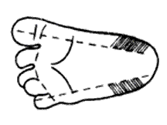 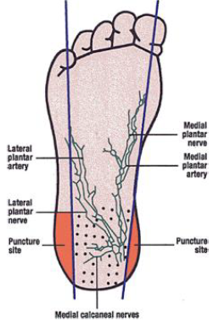

**NOTES:**

* Do not perform punctures on the positive curvature of the heel. or the arch area of the foot.
* Do not perform punctures through previous puncture sites or bruised areas.

# GENERAL PHLEBOTOMY PROCEDURE NOTES

1. Nursing staff performs blood collection from indwelling catheters (e.g. Hickman). Laboratory staff should not attempt to collect the sample from the line, however, lab staff may be asked to assist during the collection to transfer blood into the proper tubes.
2. Requests for arterial punctures should be referred to the hospital.
3. In the event a large hematoma develops, treat the hematoma area by applying ice for 10-15 minutes. This will reduce the swelling in the area. The patient should repeat the ice application at home. If necessary, tell the patient see their provider.
4. New collection supplies must be used with each attempt. A maximum of two attempts should be made before enlisting assistance from a co-worker, if available.
5. Coban is to be used sparingly. (Never on pediatric patients) It must not be utilized to bandage patients after capillary (finger stick) collections, inpatients, Emergency Center patients, or on any other patient with limited risk for bleeding. In addition, Coban should only be used on patients who are able to remove the wrap themselves or have someone aware of the risks that can assist with removal as soon as possible. If you do utilize Coban for a patient, please instruct the patient or care giver to remove immediately if there is any discomfort and do not leave the wrap on longer than 1 hour.

**PEDIATRIC PHLEBOTOMY PROCEDURE NOTES***:*

1. Refer to the “Maximum Blood Draw Amounts from Patients Younger than 14 Years” table above to determine the maximum amount of blood that can be drawn from pediatric patients by age.
2. In newborns to 6 months, the recommended site for microsampling is the heel.
3. In toddlers 6 months to 18 months, the recommended site for microsampling is the great toe.
4. In children over 18 months the recommended site for microsampling is the ring or long finger.

**Maximum Blood Draw Amounts**

Refer to the *Maximum Blood Draw Amounts from Patients Younger than 14 Years* table below to determine the maximum amount of blood that can be drawn from pediatric patients by weight. Contact Pathologist/ Physician to review and approve any amount exceeding the volume listed.

1. **Table - Maximum Blood Draw Amounts From Patients**
2. **Younger than 14 Years**

**Processing of Serum/Plasma Separator Tubes**

1. The tube contains a silicone barrier gel with a specific gravity intermediate to serum and the cell clot. Tubes should be stored at room temperature. Temperatures over 25ºC (77ºF) can cause gel breakdown and subsequent test interference.
2. After drawing, gently invert the tube 5-10 times to activate the clotting mechanism.
3. Allow the sample to clot in a vertical position 15-20 minutes but should be centrifuged within 30 minutes after collection.
4. All plasma separator tubes can be centrifuged immediately after collection.
5. Centrifuge tubes for the recommended speed and time for the model of centrifuge used at that location.

Megafuge: 3200 rpms for 10 minutes

Special coagulation tubes must be spun at 3200 rpms for 15 minutes twice.

1. If blood and gel does not separate well, transfer the serum to a clean tube, centrifuge, and pour off serum. Do not spin a serum separator tube more than once.
2. Store specimen vertically at the required temperature for the test ordered. See Lab Test Directory).
3. Pour off serum specimens that require transfer and freeze appropriate samples (refer to LaboratoryTest Directory).

**ReferenceS**

1. Gaviza and Becan - McBride; Phlebotomy Handbook, Second Edition, 1989.
2. Davis, Thomas F, Ph.D.; Pediatric Blood Collection Handout
3. Smith, James, M.D.; Phlebotomy Inservice, Bloomington Clinic, January 1992.
4. AutoDrop Blood Needle Holder System package insert, 1996
5. Pronto Quick Release Needle Holder pack insert
6. Dennis Ernst; Center for Phlebotomy Education, COLA Symposium; May 2006
7. CLSI H3-a3: Procedure for the Collection of Diagnostic Blood Specimens by Venipuncture; Approved Standard-Fifth Edition
8. CLSI H4-A4: Procedures and Devices for the Collection of Diagnostic Capillary Blood Specimens; Approved Standard-Fifth Edition
9. CLSI H18-A3: Procedures for the Handling and Processing of Blood Specimens; Approved Guideline-Third Edition

**AUTHOR/reviewer(s)**

Barb Johnson

Gail Brors

DABergo

NAKlausen

NJButala

JAGayken

AKHoward

GCardinal

DEaton

LMKappenman

**Compliance**

# Failure to comply with this policy or the procedures may result in disciplinary action, up to and including termination.

**ENDORSEMENT**

Laboratory Administration