
Subject  Outside Provider Orders Procedure |  | Attachments  Yes No
Key words outside orders, OSO, non-HealthPartners provider, QSE 6 |  | Number  GHI-PC-CLINIC LAB-PROCEDURES-Outside Orders Procedure v. 02-2021
Category |  | Effective Date  See Electronic File
Manual Clinic Laboratory Procedure Manual |  | Last Review Date  See Electronic File
Issued By Clinic Laboratory Administration |  | Next Review Date  See Electronic File
Applicable Clinic Laboratory Administration, Clinic Laboratory staff |  | Origination Date  March 2019
 |  | Retired Date
Review Responsibility Clinic Laboratory Administration |  | Contact Laboratory Administration
I.

Purpose To provide guidance on how to serve patients who present to HealthPartners laboratories with orders for laboratory testing from non-HealthPartners providers.

II.

Policy HealthPartners clinic laboratories will provide blood collection and testing services for any patient that presents to the laboratory with an order from a non-HealthPartners provider as long as the order is from an authorized, billable provider and all required information is provided.

HealthPartners will only accept orders from providers licensed to practice in the United States of America.

HealthPartners laboratories will not accept any verbal orders from non-HealthPartners providers for laboratory testing. HealthPartners laboratories will not accept outside orders shown via the patient’s cell phone. A paper copy or faxed/scanned order is required.

III.
Procedure(s)

A. Clinics: MAIN PROCESS WHEN THE OUTSIDE PROVIDER HAS A HEALTHPARTNERS PROVIDER NUMBER AND TESTS ARE AVAILABLE IN EPIC/BEAKER

- Patient presents to laboratory with an order for specimen collection and testing from a non-HealthPartners provider.
- Verify the HealthPartners provider number in Epic.

- Verify that the order includes the following information:
- Test name
- Provider name
-Office name and address
-Office Phone Number
-Office Fax Number
- After-hours Phone Number
- Diagnosis code

- If any required information is missing from the order, contact the outside provider and obtain the information. If the test name, provider name, address and phone number are not complete, the patient must contact their provider to get this information before we will collect the specimen.

- Enter all information into Beaker (order entry).

- Proceed with ordering tests in Epic and follow the Beaker Outpatient collection and receiving procedures.

- Verify patient identity according to the Patient Identification Policy.

- Collect the specimens from the patient and label according to the Specimen Labeling and Specimen Disposal Policy.

- Scan the OSO lab order sheet and attach to the patient’s encounter in Epic. If scanning function is not available: Copy the form and file the copy in the lab OSO folder, send the original to the scanning department requesting it be added to the patient’s encounter in Epic.

B. IF THE OUTSIDE PROVIDER DOES NOT HAVE A HEALTHPARTNERS PROVIDER NUMBER:

In addition to the steps above, you must follow these steps to place the orders, to ensure results go to the outside provider and to request a HealthPartners Provider Number
- Verify in Epic and/or Beaker that the provider does not have a HealthPartners provider number.
- For results to flow correctly:

- “CC Results”, which is located in the “Specimen Inquiry” function, is used to add out-of-network providers to receive results via fax transmission. To add an out-of-network provider, go to enter an asterisk (*) in the CC Recipient field, then press ENTER.

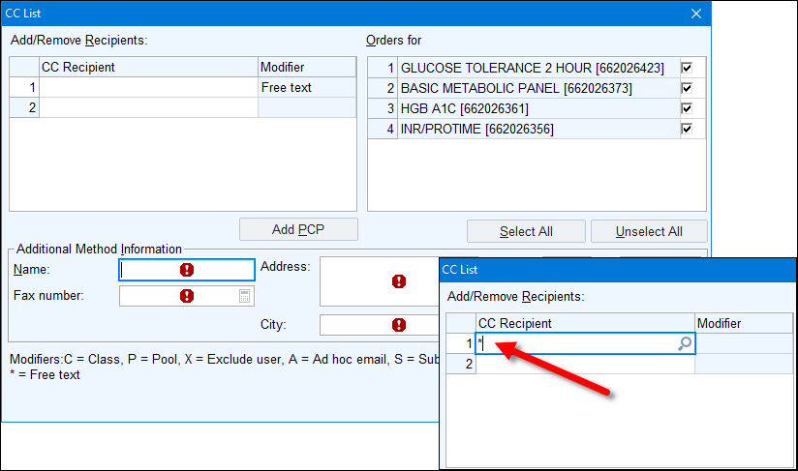

- The minimum information required in the “CC Results” fields are:
- Provider full name
- Clinic phone number
- Clinic fax number

- When placing the orders use “Provider not on File” for the ordering provider.

- To request the HealthPartners Provider Number:
- Go to MySupportCenter and search for Epic Application Access and fill out the form for Referring Clinician Setup (see link for Epic Tipsheet below).

C. OUTSIDE PROVIDER REQUESTS TESTS NOT AVAILABLE IN EPIC/BEAKER

If the patient presents with an outside order (panels or other testing) that are not on our test menu:

- Inform patient that we will only offer testing available in our catalog/test menu.

- Defer patient back to their outside provider for clarification of their orders. Lab staff does not need to call the outside provider to clarify orders.

- Outside orders may contain orders for departments outside of the laboratory. If an order is received containing additional orders destined for another department (i.e. radiology) make a copy of the order received and send the copy to the appropriate department.

D. PROVIDER SERVICES & BILLING
- The IS&T Support Center will assign a HealthPartners Provider number once the new clinician form is received and processed.

- Once the HealthPartners Provider number is assigned, billing will add it to the charge session and continue the billing process.

- In the absence of a HP Provider number, billing may assign an approved billing Laboratory Medical Director as the billing provider.

- The OSO provider HP Provider number will be available in Epic for requests for testing in the future.

E. Genetic Test Requests
HP does not accept genetic testing from providers outside the HP care group. Insurance coverage and costs for genetic testing can vary widely. In many cases genetic testing requires insurance prior authorization as well as a formal genetic counselling appointment to obtain documented patient informed consent prior to testing. Genetic counseling services are not provided by HP for patients outside of the HP care system.

F. Reference Laboratory Testing
- Testing must be sent to HP designated and approved referral laboratories.
- Test requests to laboratories outside of HP approved referral laboratories are not accepted.
- HP will not facilitate third party billing (direct billing between patient/patient insurer and the lab performing the testing) for any laboratory phlebotomy or referral testing services.

IV.

Definitions
Outside Provider/Non-HealthPartners Provider – any provider that is not employed by the HealthPartners organizations within the family of care network.

V.
Compliance

Failure to comply with this policy or the procedures may result in disciplinary action, up to and including termination.

VI.

Attachments

AUTHOR
JLang

VII.
Other Resources
Request a New Clinician in Epic - TipSheet

- APPROVAL(S)
Laboratory Medical Director
- REVIEWERS
Colleen Russell
Dylan Eaton (Ron Boldt)
C. Russell

- ENDORSEMENT
Laboratory Administration

