PARKLAND HEALTH AND HOSPITAL SYSTEM
5201 Harry Hines Blvd., Dallas, Texas 75235

Microbiology Laboratory

SPECIMEN ACCEPTANCE CRITERIA

Procedure Number: 13-17

PRINCIPLE

The effectiveness and accuracy of laboratory testing begins with the quality of the specimen. Specimens must be labeled appropriately, selected, collected and transported properly, and test orders must be documented completely, in order to produce a meaningful result. This procedure documents the minimum pre-analytic specimen quality issues that are assured prior to test performance. In addition, the corrective actions for unacceptable specimens are described. Specimens revealing specimen / patient identify errors, e.g. specimen label does not match requisition, specimen received unlabeled, or incomplete specimen requisitions, are entered in the Patient Safety Net (PSN) database.

SPECIMEN

- Specimens must be properly labeled, collected and transported to the lab. Test requisitions must be complete and legible. The following are criteria and corrective actions related to specimen labeling and test requisitions.

Specimen Label and Order Requirements
Sample | Req | Data Element | Action if Data Element is Missing, Illegible, or Discordant | Comment | Cancel Reason | LIS  Order Comment | PSN
√ | √ | Last Name, First Name | Reject Sample | Sample and Requisition must match exactly. | Requisition and specimen do not match  or  Specimen label missing | Enter name & MRN on specimenlabel for mismatch | Yes
√ | √ | Unique identifying number (e.g. MRN, downtime account number, client MRN, etc.) | Reject Sample | Sample and Requisition must match exactly. | Requisition and specimen do not match | No MRN | Yes
Must be present on either sample or requisition |  | Date of collection | If date is on neither specimen nor requisition, reject sample. |  | Specimen requisition incomplete | No date | No
Must be present on either sample or requisition IF sample / test is time-dependent. |  | Time of collection | Time is required only on time-critical samples.  If time is on neither specimen nor requisition, reject sample. | See below for time-critical samples and limits. | Incomplete requisition | No time | No
√ |  | Initials of collector | No action |  |  |  | No
Must be present on either sample or requisition |  | Specimen source / body site, if appropriate | If source is on neither specimen nor requisition, call the patient care area. If source is not identified within one full working shift, reject sample. | Preserve sample under appropriate conditions while waiting for source. If source is not identified within one full shift, reject sample. | Incomplete requisition | No source | No
 | √ | Ordering provider name and/or code  (Downtime requisitions) | Call patient care area. If physician ID cannot be obtained from the patient care area, use the ordering or attending physician in LIS associated with the encounter. | If unable to obtain the needed info to order the test in LIS, then reject sample. Complete a manual rejection form and file in lab. |  |  | No
 | √ | Ordering provider signature (Downtime requisitions) | Reject sample |  | Incomplete requisition | No signature | No
- The following specimens / tests are time-dependent. The time of collection is required on either the specimen or the requisition. Follow the corrective actions indicated if the time limit is exceeded.

Time-Dependent Specimens

Specimen or Test Procedure | Time Limit | Action if Time Limit Exceeded |  | Cancel reason | LIS Order Comment
Specimen or Test Procedure | Time Limit | Accept with Comment | Reject | Cancel reason | LIS Order Comment
Anaerobic culture, appropriate specimen, not in standard transport swab. | 30 min | X |  |  | Spec too old/Results may be invalid
Aerobic and/or Anaerobic culture, specimen in standard transport swab | 48 hours | X |  |  | Spec too old/Results may be invalid
Chlamydia or GC Amplified Probe | Swabs - 60 days @ RT  Urine - 30 days @ RT |  | X | Specimen too old
GC culture in standard transport swab | 24 hours |  | X | Specimen too old
Isolator tube | 16 hours |  | X | Specimen too old
Stool for bacterial culture, unpreserved | 2 hours @ RT or 8 hrs if refrig. |  | X | Specimen too old
Stool for bacterial culture, in preservative vial | 96 hours |  | X | Specimen too old
Stool for Clostridium difficile toxin, not frozen | 24 hours |  | X | Specimen too old
Stool for O&P, not in para-pak | 1 hour | X |  |  | Spec too old/ Results may be invalid
Urine for culture not refrigerated and unpreserved | 2 hours |  | X | Specimen too old
Urine for culture, in preservative vial | 48 hours |  | X | Specimen too old
OnSite Urine Culture Device | 24 hr @ RT or refrigerated after inoculation |  | X | Specimen too old

- In addition to proper documentation and timely transport, correct specimen selection, container and transport conditions affect the suitability of a sample for testing. The following describe miscellaneous specimen / test requirements or reasons for specimen rejection.

Miscellaneous Requirements / Rejection Criteria

Specimen or Test Procedure | Requirement or Rejection Criterion | Action if requirement not met |  | Cancel reason | LIS Order Comment
Specimen or Test Procedure | Requirement or Rejection Criterion | Accept with comment | Reject | Cancel reason | LIS Order Comment
24 hour collections of stool, urine, sputum |  |  | X | Test not offered on sample submitted | 24 hour collection
All Specimens | Must be in proper container, non-leaking |  | X | Incorrect container  OR  Broken / Leaking container
Anaerobic culture | Unacceptable samples: sputum, bronch, skin, gastrointestinal (e.g. stool, perirectal, pilondial cyst, etc.), vaginal, voided or cath urine, surface wounds |  | X | Test not offered on sample submitted | Unacceptable source for anaerobic culture.
Blood specimen broken in centrifuge or dropped |  |  | X | Mishap in lab | Tube broken
Chlamydia Non-amplified Probe | Conjunctival (eye) samples accepted in GenProbe PACE tube |  | X | Test not offered on sample submitted
CT/GC Amplified Probe | Acceptable sources: endodcervix, vaginal, male urethral, urine |  | X | Test not offered on sample submitted | Unacceptable source for test.
CT/GC Amplified Probe | Urine in any container other than GenProbe collection tube |  | X | Incorrect container
CT/GC Amplified Probe | White swab in tube  No swab in tube |  | X | Test not offered on sample submitted | Use template: MB TIG REJ “White cleaning swab …”  or  “No swab in tube”.
CT/GC Amplified Probe | Multiple patient samples in one biohazard bag. |  | X | Possible contamination
Cultures | Sterile, leakproof container (leaking containers not acceptable) |  | X | Incorrect container  OR  Broken / Leaking container
Samples in blood culture bottles. | Acceptable samples:  blood, peritoneal fluid, pleural fluid, pericardial fluid or joint fluid |  | X | Incorrect container
Sputum, expectorated, for routine culture | <= 10 squamous epithelial cells / LPF |  | X | Specimen unsatisfactory for testing | Enter “Reject” in report editor.
Stool for routine bacterial culture (Salmonella, Shigella, Campylobacter) | Inpatient in-house <= 5 days |  | X | Test not offered on sample submitted | Use template MB STOOL  “Patient in-house > 5 days”
Stool for O&P containing barium, bismuth, kaolin, mineral oil, etc. |  |  | X | Interference: Please reorder
Stool for O&P; only 1 vial received |  |  | X | Quantity insufficient | Order Note: Only 1 of 2 vials received.
Stool for Fungal Culture | Unacceptable specimen for culture |  | X | Test not offered on sample submitted
Urine specimen for AFB | Routine urine culture transport tube | X |  |  | Order Comment: “Incorrect container. Specimen processed but results may be compromised”.
Vaginal for Fungal Culture | Unacceptable specimen for culture |  | X | Test not offered on sample submitted
Viral culture collected with wood-shafted swab or calcium alginate swab. |  |  | X | Specimen unsatisfactory for testing | Order Comment: wood-shafted swab received.

PROCEDURE

Specimen Receiving

- Manual requisitions and Transfer Lists are time-stamped upon arrival in the lab.
- Specimens are reviewed to assure that all of the above listed criteria are met.
- Correctable missing information, if indicated above, is sought by phoning the patient care area. Specimens are held in appropriate storage conditions pending resolution of any correctable documentation problems. Missing information may be supplied to the lab either verbally, or in person.
- A reasonable effort will be made to resolve any correctable documentation problems (e.g. missing source, doctor code, etc.). A “reasonable attempt” involves phoning the patient care area a maximum of two times, and waiting for one full working shift for a response. A “working shift” should take into account outpatient areas that are not staffed around the clock, and allow those areas time to respond during their business hours.
- If all required information is complete, and the sample is properly collected and transported, test orders may be ordered or logged into LIS, and testing may proceed. Refer to procedure #16-06 Cerner Specimen Login, #16-02 Cerner Department Order Entry (DOE), and #16-04 Cerner Requisition Order Entry (ROE). If documentation or other deficiencies cannot be resolved, the specimen is rejected as described in the following section.

Specimen Rejection

- Credit all tests ordered in LIS, or received through the EPIC orders interface using the ORV application in Cerner.
- Click on the Cancel Order icon 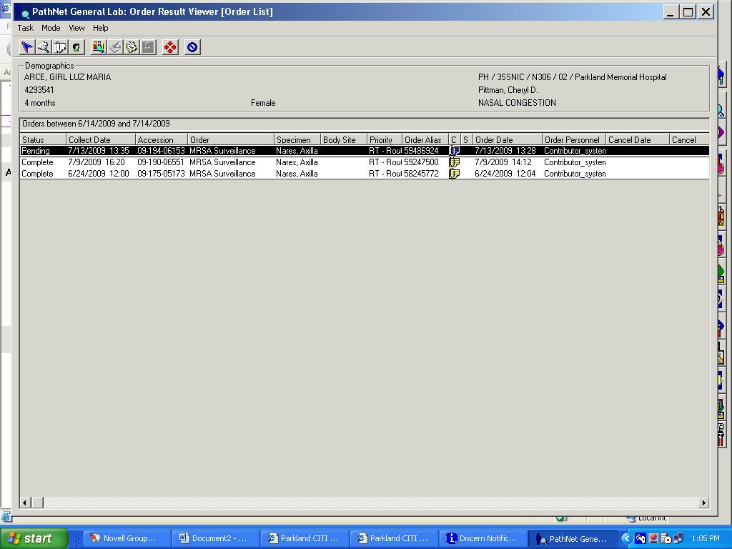
- Use an appropriate credit comment/cancel reason described in the following tables.
- Enter additional information regarding the reason for cancellation as an Order Note, using the MB Reject template:

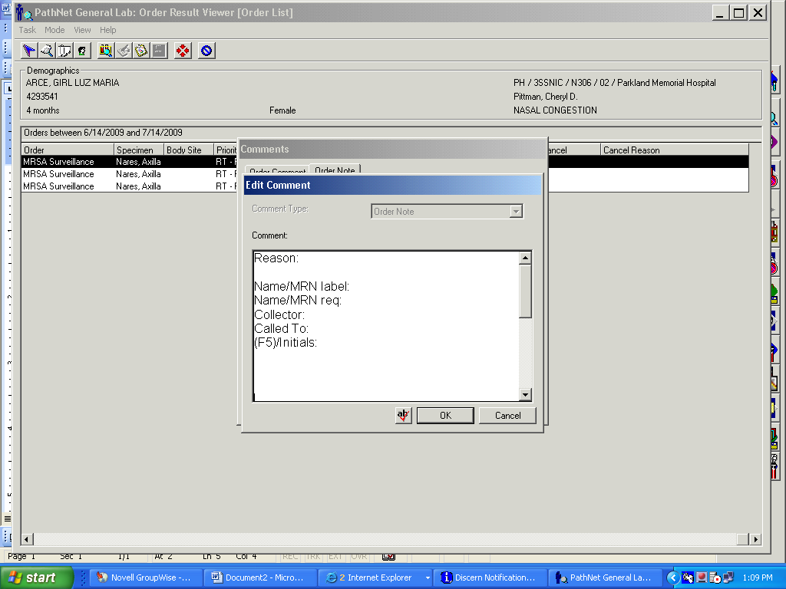

- For inpatient specimens, ER, and any other specimens arriving in the lab when the patient may still be on site, phone the patient care area to report unacceptable specimens. Document in the Order Note, the name of the person receiving the report, their Employee ID number, the phone number called, and date and time of call. See 1.a above.
- For misidentified samples from ER (no label, or mismatched specimen label and requisition), phone the Assistant Service Manager (formerly Charge Nurse) at extension 29105 or 29109.
- For outpatient locations, if the clinic is closed, or the patient is unlikely to be on site for recollection, do not phone the patient care area.
- A Canceled Specimen report from LIS is review by a supervisor for appropriateness of cancellation. Save rejected specimens at 2-8°C pending supervisor review.
- In the event of an extensive Cerner downtime (≤ 24 hrs), complete a manual Specimen Rejection Form (Appendix A). Phone the patient care area as instructed above, and document on the rejection form. The completed form is retained in the laboratory for reference, if needed.

Exceptions

- Clinicians may occasionally request processing of a sample that does not meet the lab’s acceptance criteria. Such requests must be approved individually by a Technical Supervisor (member of the lab management staff). Respond to requests for exception by following the “Specimen Rejection Script” Appendix B.
- Tell the person requesting the exception that you will have a supervisor contact them. Do not give the microbiology supervisor pager number to the requestor. The supervisor needs to confer with specimen processing staff before consulting with the clinician.
- The microbiology staff member receiving the request for exception will call the supervisor on duty (pager 214-786-2665). Record and supply the supervisor with the following information on the “Specimen Rejection Script” Appendix B:
- Name and contact number of the person seeking an exception
- Name and MRN of the patient
- Specimen type, test requested, and reason for rejection
- Preserve the sample until the supervisor has ruled on the request for exception. Supervisors may escalate requests to a Clinical Consultant (Medical Director) for final decision.
- If an exception to the specimen requirements is granted, the following procedure will be followed:
- The person requesting the exception will be required to assist with completion of a Patient Safety Net (PSN) report by providing their name, title and ID #, along with an explanation of the event. A supervisor will enter the PSN report into the database within one working day of the exception being granted.
- The supervisor or clinical consultant granting the exception will be identified in the PSN report, with the rationale for granting an exception.
- The specimen processing area will be advised of the exception, and directed to proceed with testing. Refer to 6. if the error involves misidentification of the patient.
- The “Specimen Rejection Script” Appendix B will be updated to indicate that an exception was made.
6. If testing will proceed on a misidentified specimen, do not order any testing on a real medical
record number. Instead, follow this procedure to assign a “dummy” identity to the sample.

a) Using ROE, register a new “patient” in the PHHS Path Microbiology Client account. Enter the OPI as MRN1-MRN2 (the two MRN’s of the patients involved in the mismatch). Make the “patient’s” name be MISIDENTIFIED, SPECIMEN (Misidentified is the Last Name).
b) Order the tests that have been approved for exceptional testing.
c) In MRE, issue a Preliminary Report, and enter Freetext the following information: Specimen identified as MRN1,Last,First. Label identified as MRN2, Last,First. Patient location is xxxx. Testing exception approved by xxxx on date at time. Send report to Dr. xxxx. Include any other information that may help later with routing a paper report to the requesting physician (location, mailing address, pager, etc.).
d) These results will not be available in Epic and will be mailed or delivered to the physician seeking the exception.
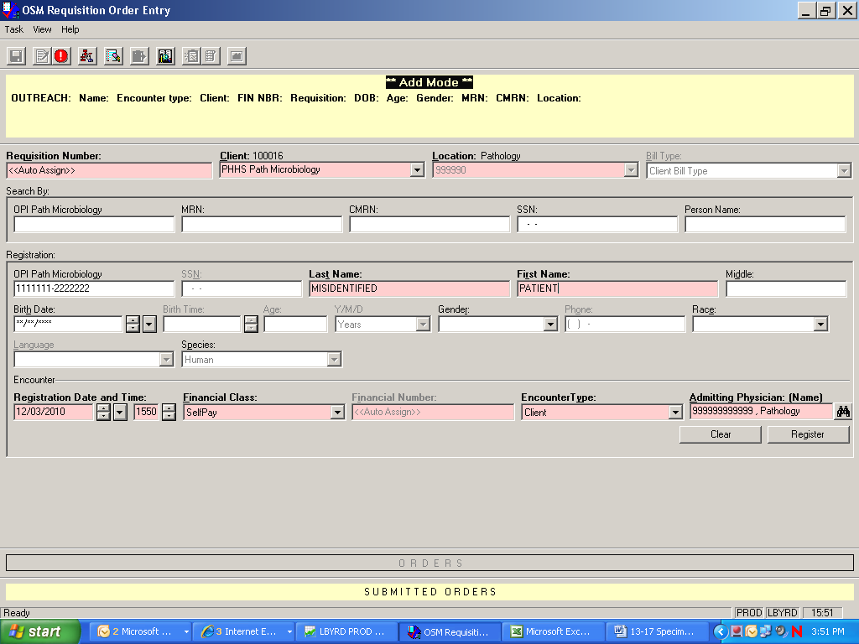

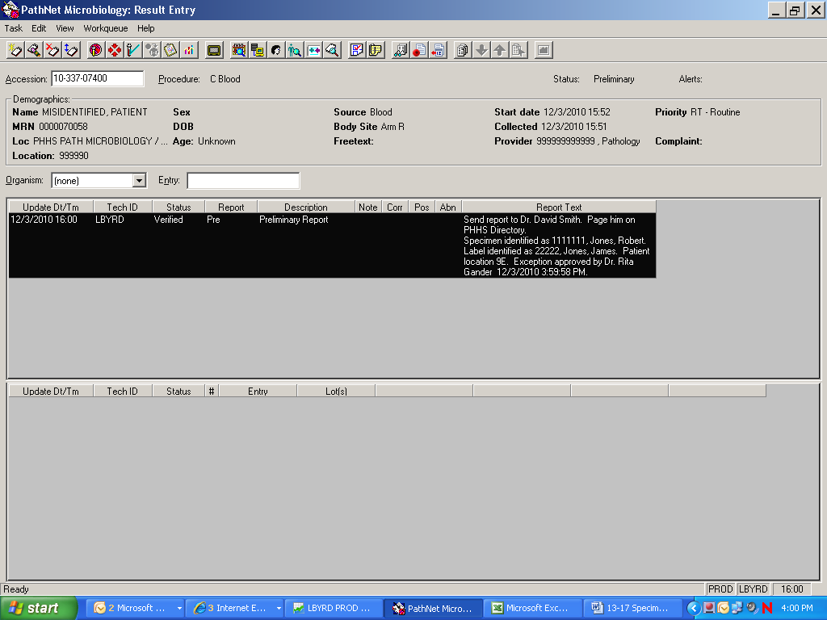

REPORTING RESULTS

Entering Results into LIS:
Tests are either credited or amended as indicated in the preceding tables.
- Table A: Complete List of Cerner Cancel Reasons
- Table B: Cancel Reasons – Microbiology
Refer to the laboratory procedure 16-01 Cerner General Use.

LIMITATIONS OF PROCEDURE

- Interfering substances: Not applicable, except as described in proceeding tables (e.g. kaolin in O&P specimens).
- Lab tests on specimens from Occupational Health Services (OHS), institutional or research clients are ordered in LIS using ROE. Select the appropriate client. Refer to procedure #16-04 Cerner ROE.

REFERENCES

Miller, J Michael, A Guide to Specimen Management in Clinical Microbiology, ASM Press, Washington, D.C., 1996

Murray, Patrick R., editor, Manual of Clinical Microbiology, 9th edition, ASM Press, Washington D.C., 2007,

TEST MANAGEMENT INFORMATION

Current Editor: | Donna Gaffney
Revision/Review History: | 7/10/03, 12/07, 3/08, 7/08, 7/09, 10/09, 10/10, 12/10, 12/23/10, 4/11/12, 5/14/12
Revision Summary: | Addressed rejecting GC/CT amp probes when multiple specimens are received in one biohazard bag.
Supersedes: | Specimen Collection Guidelines, 13-10
Procedure Locations: | Specimen Processing

