**GRAM-POSITIVE BACILLI  
(NON-SPORE-FORMING)**

***ACTINOMYCES***

[(under the microscope)](http://www.uaz.edu.mx/histo/pathology/ed/ch_9b/path/scan16.gif)  
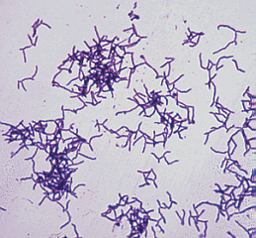Actinomycetes are fungus-like bacteria that form filamentous branches. These Gram-positive obligate anaerobes are known to reside in the mouth and in the intestinal tract. Pathogenic proliferation of the organisms, which is usually a result of trauma to the region of infection, can lead to actinomycosis. The patient will form abscesses and swelling at the site of infection. A diagnosis can be made upon microscopic examination of pus. The fluid will have a granular texture which is caused by sulfur granules. These sulfur granuules are actually composed of the bacterium and its waste. The species of *Actinomyces* which is most commonly associated with actinomycosis is *A. israelii*, but several other bacteria in this genus are capable of causing the disease as well. Actinomycosis can often be treated with large amounts of penicillin or tetracycline.

LABORATORY INDICATIONS:

* Indole -
* Catalase -
* Lipase -
* DNase -

***BIFIDOBACTERIUM***

[(under the microscope)](http://www.uaz.edu.mx/histo/pathology/ed/ch_9b/path/scan17.gif)  
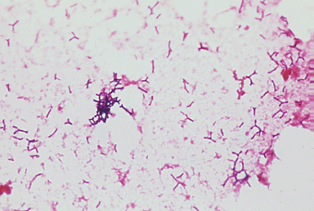Members of the genus *Bifidobacterium* are anaerobic, Gram-positive bacilli that is rarely associated with infection. The only pathogenic species of this genus is *Bifidobacterium dentium*, a normal inhabitant of the gut flora. Under the microscope, these bacteria appear to be bone shaped, which makes them easy to identify. As obligate anaerobes, they require a very low oxygen tension to survive and to achieve moderate growth.

LABORATORY INDICATIONS:

* Non-motile
* Catalase -
* Forms branching filaments

***EUBACTERIUM***

[(under the microscope)](http://www.uaz.edu.mx/histo/pathology/ed/ch_9b/path/scan18.gif)  
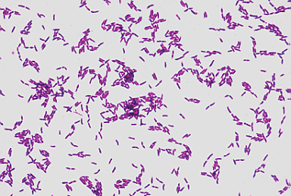*Eubacterium* are normal flora of the intestinal tract and may cause opportunistic infections. *E. lentum*, the most isolated species, has been linked to endocarditis and some wound infections. Biochemical testing can distinguish *Eubacterium* from the other Gram-positive, anaerobic rods. Because *Eubacterium* species are negative for many tests, results may be somewhat ambiguous. It is important to know, however, that these bacteria tend to form clumps under microscopic observation.

LABORATORY INDICATIONS:

* Indole -
* Catalase -
* Hydrogen sulfide -

***PROPIONIBACTERIUM***

[(under the microscope)](http://www.uaz.edu.mx/histo/pathology/ed/ch_9b/path/scan19.gif)  
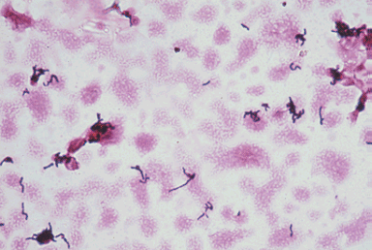*Propionibacterium* species are some of the most common Gram-positive anaerobes that are isolated in the laboratory. One particular species, *P. acnes*, is a usually harmless microbe that has pathogenic potential. It has been linked to certain cases of endocarditis, wound infections, and abscesses. Ironically, it can infect acne sites on the skin but it does not cause them. Under the microscope, *Propionibacterium* clump up and may show a slight tendency to branch. Also, they show uneven staining patterns following a Gram-stain procedure. Colonies grow best in an anaerobic or microaerophilic environment using blood agar.

LABORATORY INDICATIONS (*P. acnes*): Indole +

* Catalase +
* Glucose fermentation
* Gelatin hydrolysis