**Approved by:**

Medical Director

Dr. Michael Curry______________________ (Name) ______________________________ (Signature)

_______________ (Initials) _________________ (Date)

Section Director

Dr. William Thornton___________________ (Name) ______________________________ (Signature)

_______________ (Initials) _________________ (Date)

Laboratory Manager/Supervisor

Melissa Jennings_______________________ (Name) ______________________________ (Signature)

_______________ (Initials) _________________ (Date)

**Revision Record**

|  |  |  |  |
| --- | --- | --- | --- |
| Revision No. | Date | Responsable Person | Description of Change |
| 1 |  |  |  |
| 2 |  |  |  |
| 3 |  |  |  |
| 4 |  |  |  |
| 5 |  |  |  |
| 6 |  |  |  |
| 7 |  |  |  |
| 8 |  |  |  |
| 9 |  |  |  |
| 10 |  |  |  |

|  |  |
| --- | --- |
| **Archival Date:** | Department Supervisor/Manager : |

**Biennial Review**

_______________________ ____________________ _______

Signature Title Date

______________________ ____________________ _______

Signature Title Date

___________________ ____________________ _______

Signature Title Date

______________________ ____________________ _______

Signature Title Date

___________________ ____________________ _______

Signature Title Date

___________________ ____________________ _______

Signature Title Date

___________________ ____________________ _______

Signature Title Date

___________________ ____________________ _______

Signature Title Date

___________________ ____________________ _______

Signature Title Date

___________________ ____________________ _______

Signature Title Date

___________________ ____________________ _______

Signature Title Date

___________________ ____________________ _______

Signature Title Date

___________________ ____________________ _______

Signature Title Date

**Training Record and Signature Log**

The following laboratory staff have read and agree to follow the current procedure. In addition, these staff are responsible for signing and/or initialing laboratory records.

_____________________ ______________________ _______ _______

Signature Name Initials Date

_____________________ ______________________ _______ _______

Signature Name Initials Date

_____________________ ______________________ _______ _______

Signature Name Initials Date

_____________________ ______________________ _______ _______

Signature Name Initials Date

_____________________ ______________________ _______ _______

Signature Name Initials Date

_____________________ ______________________ _______ _______

Signature Name Initials Date

_____________________ ______________________ _______ _______

Signature Name Initials Date

_____________________ ______________________ _______ _______

Signature Name Initials Date

_____________________ ______________________ _______ _______

Signature Name Initials Date

_____________________ ______________________ _______ _______

Signature Name Initials Date

_____________________ ______________________ _______ _______

Signature Name Initials Date

_____________________ ______________________ _______ _______

Signature Name Initials Date

_____________________ ______________________ _______ _______

Signature Name Initials Date

**PURPOSE:**

**This procedure is intended to define a tracking system which follows, in real time, the origin of a sample until it reaches the testing laboratory. Assuring specimen integrity and eliminating missing and/or lost samples.**

**SCOPE:**

**The procedure applies to all pre-analytical phases of collection and transportation to Central Lab and other BBPL testing facilities.**

**RESPONSIBILITY:**

**This procedure applies to all staff involved in collection, implementation or coordination of packaging, shipping and receiving samples.**

**EQUIPMENT: GML (Guardian Medical Logistics) issued tablet and scanner.**

**SUPPLIES: GML issued generic barcodes.**

**SAFETY PRECAUTIONS: No special safety precautions are needed.**

**PROCEDURE INSTRUCTIONS:**

**When samples are ready for shipment, turn the tablet on. Log into the GML Smart Application using the appropriate log-in and password assigned to that specific location. If your location is a site that receives and ships samples, choose “Pack Totes”.**

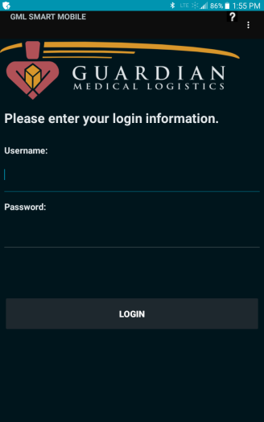

**Connect the scanner by touching the 3 small dots on the upper right hand corner of the tablet screen, then touch “Connect Scanner”. Simultaneously press and hold the smaller circle button on the scanner until you hear an audible tone. Soon after you will see a message display on the tablet that reads “Scanner is Connected”. There is also a scanner icon which appears green in the status bar at the top of the tablet anytime the scanner is connected.**

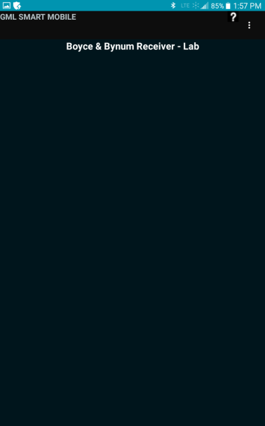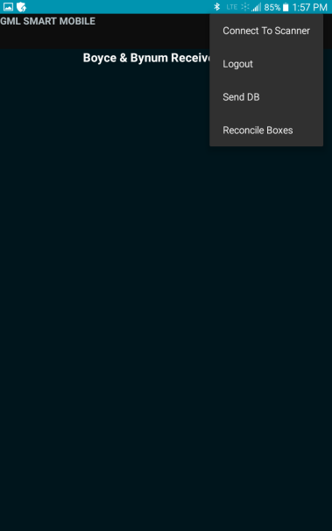 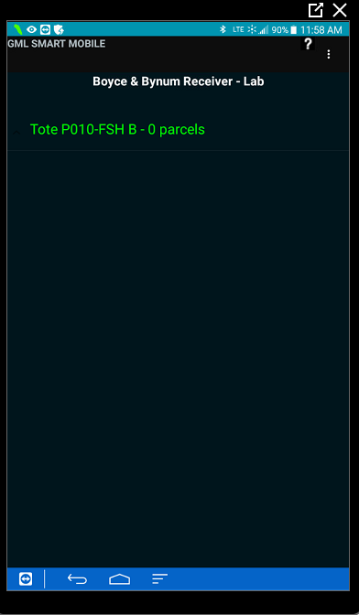

**Scan the first tote/flight box barcode (the scanner will slightly vibrate and beep), choose the appropriate parcel type (frozen, refrigerated or ambient), then begin to scan that specified temperatures reqs using the scanner and place them in the appropriate location of the tote or flight box.**

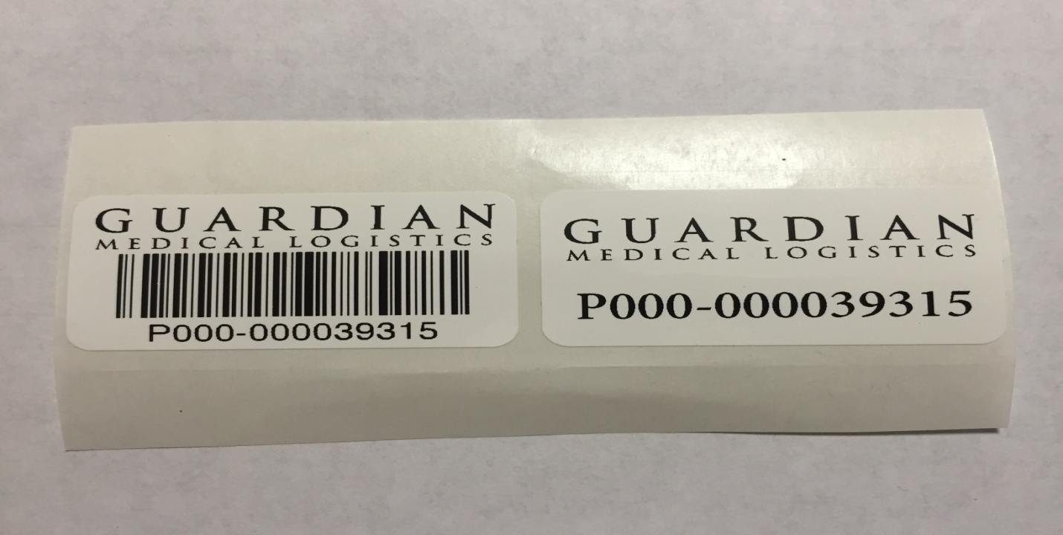

**If you have a req that does not have a barcode available to scan, affix one of the provided GML generic barcodes on the req (not covering any important information) and scan that generic barcode. Once all that specified temperature samples are scanned and packed, choose parcel type again and select the remaining temperatures on the tablet and scan those reqs, placing them in the appropriate location within the bag/flight box. As you are scanning you can see the req numbers populating on the tablet. After all samples are scanned into the tote/flight box hit Save. All the req numbers will change from white to blue, this meaning the data was saved.**

**If you have a requisition that has multiple temperatures, i.e. a refrigerated sample and a frozen; scan the original req as one temperature type, affix the non-barcoded GML generic sticker on that req and place the corresponding GML generic barcode inside the specimen bag pouch of the other temperature specimen bag. Select the proper temperature (parcel type) for the second sample and scan the generic GML barcode into the tablet, pack that sample accordingly at the proper temperature.**

**If you have any samples that need to be added, simply re-scan the tote/flight box barcode, select the proper temperature and follow the above directions. Making sure you hit Save again after any changes.**

**If you need to remove any req from the tote/flight box, simply re-scan the tote/flight box barcode and what is already scanned into that tote/flight box will populate on the tablet. Hold down on that particular req number you want to remove and an Undo option will appear on the tablet. Click Undo and that selected barcode will disappear. Remember to always hit Save anytime changes are made.**

**It is important to unplug the tablet and scanner in the morning and charge both overnight to maintain good battery life. In addition, turn the tablet off at night and restart every morning.**

**If questions or concerns arise contact BBPL Logistics Manager at 573-886-4565 or 1-800-786-4602 or GML at 314-576-7766 x 256.**

**REFERENCES: N/A**

**RELATED DOCUMENTS: N/A**

**APPENDIXES: N/A**