**Approved by:**

Medical Director

Dr. Michael Curry______________________ (Name) ______________________________ (Signature)

_______________ (Initials) _________________ (Date)

Section Director

Dr. William Thornton___________________ (Name) ______________________________ (Signature)

_______________ (Initials) _________________ (Date)

Laboratory Manager/Supervisor

Melissa Jennings_______________________ (Name) ______________________________ (Signature)

_______________ (Initials) _________________ (Date)

**Revision Record**

|  |  |  |  |
| --- | --- | --- | --- |
| Revision No. | Date | Responsable Person | Description of Change |
| 1 |  |  |  |
| 2 |  |  |  |
| 3 |  |  |  |
| 4 |  |  |  |
| 5 |  |  |  |
| 6 |  |  |  |
| 7 |  |  |  |
| 8 |  |  |  |
| 9 |  |  |  |
| 10 |  |  |  |

|  |  |
| --- | --- |
| **Archival Date:** | Department Supervisor/Manager : |

**Biennial Review**

_______________________ ____________________ _______

Signature Title Date

______________________ ____________________ _______

Signature Title Date

___________________ ____________________ _______

Signature Title Date

______________________ ____________________ _______

Signature Title Date

___________________ ____________________ _______

Signature Title Date

___________________ ____________________ _______

Signature Title Date

___________________ ____________________ _______

Signature Title Date

___________________ ____________________ _______

Signature Title Date

___________________ ____________________ _______

Signature Title Date

___________________ ____________________ _______

Signature Title Date

___________________ ____________________ _______

Signature Title Date

___________________ ____________________ _______

Signature Title Date

___________________ ____________________ _______

Signature Title Date

**Training Record and Signature Log**

The following laboratory staff have read and agree to follow the current procedure. In addition, these staff are responsible for signing and/or initialing laboratory records.

_____________________ ______________________ _______ _______

Signature Name Initials Date

_____________________ ______________________ _______ _______

Signature Name Initials Date

_____________________ ______________________ _______ _______

Signature Name Initials Date

_____________________ ______________________ _______ _______

Signature Name Initials Date

_____________________ ______________________ _______ _______

Signature Name Initials Date

_____________________ ______________________ _______ _______

Signature Name Initials Date

_____________________ ______________________ _______ _______

Signature Name Initials Date

_____________________ ______________________ _______ _______

Signature Name Initials Date

_____________________ ______________________ _______ _______

Signature Name Initials Date

_____________________ ______________________ _______ _______

Signature Name Initials Date

_____________________ ______________________ _______ _______

Signature Name Initials Date

_____________________ ______________________ _______ _______

Signature Name Initials Date

**PURPOSE:**

**This procedure is intended to define a tracking system which follows, in real time, the origin of a sample until it reaches the testing laboratory. Assuring specimen integrity and eliminating missing and/or lost samples.**

**SCOPE:**

**The procedure applies to all pre-analytical phases of collection and transportation to Central Lab and other BBPL testing facilities.**

**RESPONSIBILITY:**

**This procedure applies to all staff involved in collection, implementation or coordination of packaging, shipping and receiving samples.**

**EQUIPMENT: GML (Guardian Medical Logistics) issued tablet and scanner.**

**SUPPLIES: GML issued generic barcodes.**

**SAFETY PRECAUTIONS: No special safety precautions are needed.**

**PROCEDURE INSTRUCTIONS:**

**When samples reach their testing destination, turn the tablet on. Log into the GML Smart Application using the appropriate log-in and password assigned to that specific location. If your location is a site that receives and ships samples, choose “Receive Totes”.**

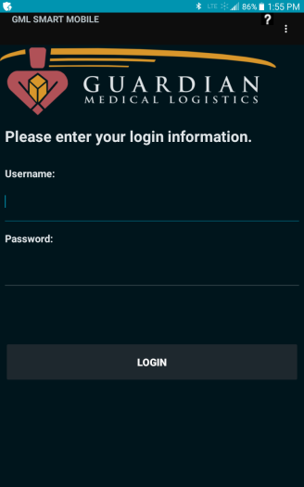

**Connect the scanner by touching the 3 small dots on the upper right hand corner of the tablet screen, then touch “Connect Scanner”. Simultaneously press and hold the smaller circle button on the scanner until you hear an audible tone. Soon after you will see a message display on the tablet that reads “Scanner is Connected”. There is also a scanner icon which appears green in the status bar at the top of the tablet anytime the scanner is connected.**

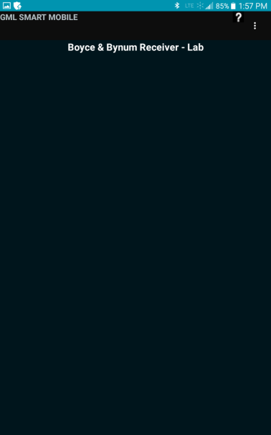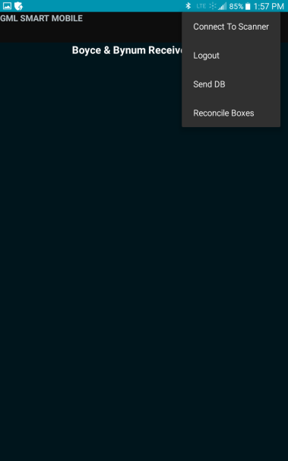

**Scan the first tote barcode (the scanner will slightly vibrate and beep), then begin to scan the contents within that tote; those barcodes will begin to appear on the tablet. Once all contents in that tote are scanned onto the tablet screen then touch “Reconcile” on the screen. A screen will populate on the tablet showing if the bag was successfully reconciled or a reconciliation failure. If the tote was a success touch, “Mark as Reconciled” on the screen and those samples are then cleared to be accessioned/tested.**

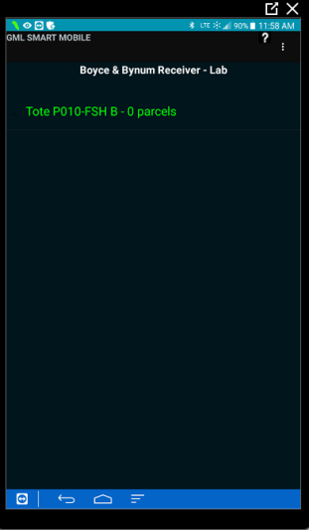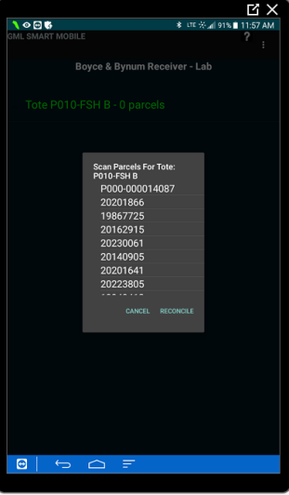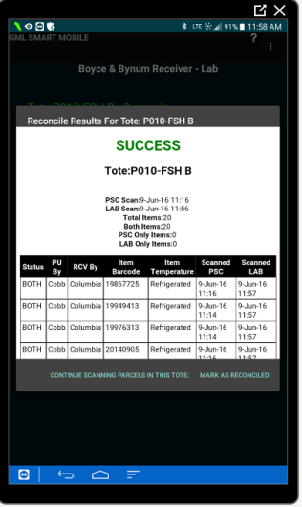

**If the following tote failures occur touch “Mark as Reconciled” on the tablet and those samples are cleared to be accessioned/tested:**

**-Barcode mis-reads which are easily visible and recognizable on the tablet.**

**-Specimen overages**

**-Totes scanned as parcels in error**

**If the following tote failures below occur, action should be taken immediately by contacting BBPL Logistics, GML Logistics, the involved PSC or the driver, depending upon the failure, before samples are cleared to be accessioned/tested:**

**-Missing sample(s)**

**-Any other unclear issue causing failures**

**With any failures BBPL Logistics and GML receives an email in real time and will be addressed.**

**The totes are to be scanned and reconciled independently using the barcodes on the totes. Once that specific bag is completely reconciled those samples within that tote may be sent for accessioning/testing. The only exception is the Oklahoma flight box, no matter number of boxes, this shipment is treated as one package. Therefore all the Oklahoma samples need to be scanned into the one barcode provided in Processing and at the Tulsa/OKC PSC’s, no samples should be sent for accessioning/testing until a successful reconciliation.**

**If you scan a bag or barcode incorrectly before you hit “Mark as Reconciled” there is an undo function. Simply hold down on the barcode you want to remove, an option will appear to undo. Once you touch “Undo” that barcode will be deleted.**

**It is important to unplug the tablet and scanner in the morning and charge both overnight to maintain good battery life. In addition, turn the tablet off at night and restart every morning.**

**If questions or concerns arise contact BBPL Logistics Manager at 573-886-4565 or 1-800-786-4602 or GML at 314-576-7766 x 256.**

**REFERENCES: N/A**

**RELATED DOCUMENTS: N/A**

**APPENDIXES: N/A**