Department | Laboratory
Laboratory | Laboratory System
Section | Hematology
Site(s) | FLMC, FNMC, FRH, FSH, UMMC EAST/WEST
Document # | S:#### v1
Subject | fluid cell counts, differential, Crystals
Method | Hemacytometer, Sysmex Instrumentation, Polarized Microscopy
Purpose | This procedure provides instruction for performing cell counts, differentials, and crystal identification on fluids. Standard procedures and protocols are used to produce quality laboratory results.
Specimen | ALL FLUIDS  - Cell counts should be performed promptly.  - Sub-optimal specimens are handled on a case-by-case basis. Body cavity fluids are difficult to obtain and often impossible to duplicate.  - Gel tubes are unacceptable  - If small amount of fluid, call physician to prioritize testing  - Document all actions/notifications (time/date/full name notified/location) in LIS and on worksheet  - When sample is significantly clotted, agitate/vortex/mix specimen, make a cytospin to screen for malignant cells. Slides with suspicious cells are sent to pathology. Cell counts and manual differential are not reported. See reporting section.  Cerebrospinal Fluid (CSF)>1 ml of fresh CSF in a sterile container  - < 1 ml is acceptable but not optimal  - Cell counts may be ordered on two tubes to differentiate a bloody tap from hemorrhage. Count both WBC and RBCs on first collected tube when two EHR orders released and RBC >50 on first count  Serous (pleural, peritoneal, pericardial) fluid  - >1 ml of fluid collected in K₂ EDTA, sterile plastic leak proof container, preferred  - < 1 ml is acceptable but not optimal.  Synovial Fluid and Crystals  - > 1 ml fluid usually in sterile container  - < 1 ml is acceptable but not optimal  - Prefer sterile container, syringe or EDTA  - Suboptimal specimen for crystal analysis: specimens collected in clot activator tubes  - Unacceptable lithium heparin and gel tubes  Other fluids (including amniotic, bronchial lavage, peritoneal dialysate, other fluids on case-by case basis)  - > 1 ml fluid usually in sterile container  - < 1 ml is acceptable but not optimal  - Bloody specimens should be collected in/transferred to a K₂ EDTA tube  - FSH does not process abscess or drainage fluids  - Acceptable but not optimal Na Heparin (manual count only)
Equipment | - Cytospin/Cyto-Tek/Cyto-centrifuge  - Differential/Hand tally counter  - Microscope  - Polarizer and compensator for crystals  - Humidity chamber  - Personal protective equipment  - Slide stainer/ manual stain  - Sysmex instrumentation: XE-2100, XE-5000, XT-2000, XN 3000  - Tube mixer  - Vortex
Supplies | Verify expiration dates of all supplies and reagents before using.  - Pipettes and tips; calibrated, disposable, plastic/glass, sterile and non-sterile  - Coverslips  - Cytospin/Cyto-Tek funnels and caps  - Filter paper  - Frosted end microscope/electrostatically charged slides  - Gauze  - Hemacytometer, disposable or glass (glass chambers must be clean and counting area free of scratches)  - Lens paper  - Parafilm  - Tubes, plastic/glass  - Wood applicator sticks  - Positive crystal control slides
Reagents | Follow Chemical Hygiene plan for storage, stability and disposal  - Albumin (blood bank)  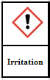  - Glacial Acetic Acid (do not use with synovial fluids, do not use on Sysmex)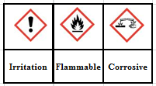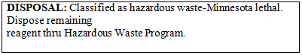  - Hyaluronidase (can be used on Sysmex)  - Not a hazardous substance or mixture  - Isopropyl Alcohol, 70%  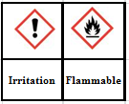  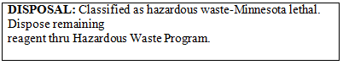  - New Methylene Blue (NMB)  - This product is not categorized as hazardous in any GHS hazard class  - Sysmex Reagents and QC (see Sysmex procedures)  - Wright Stain  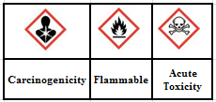  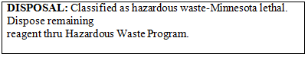
Quality Control Protocol | Hemacytometer  Cell counts performed manually must be counted in duplicate. Raw cell counts (before calculation) must agree within 20% (> 100 cells) or + 10 cells (<100 cells). If counts don’t match, replate the specimen.  - Verify count with cytospin using same dilution  - Color and clarity should correlate with cell count  - Check and document diluent’s background if used  Sysmex XT or XE  The same instrumentation is used for peripheral bloods. No additional controls are required for fluid testing.  Sysmex XN  Two levels of body fluid control are run per 24 hour period.  Both Hemacytometer and Sysmex  - It is good lab practice to have all math checked by a second tech.  - All counts are compared with a visual cytospin estimate. All specimens should have some cells on the cytospin slide. Remake slide if no cells are present.  - Document the comparison on body fluid worksheet.  - As a guideline, using low power/10x-  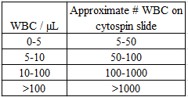  - If cytospins do not match the counts:  - Verify dilution  - Verify calculations  - Verify cytospin made with same dilution as cell count  - Prepare a new cytospin  - Repeat hemocytometer count  - Consult another technologist  - The EHR (electronic health record) is used to access current/past results and diagnoses in order to correlate unusual body fluid findings between departments.  - All fluids with unidentified or malignant cells are reviewed by a pathologist before reporting. Pathologists will reconcile any clinically important differences between diagnoses in the body fluid cell count specimen and the corresponding cytology specimen (ex. malignant vs. negative for malignancy)  - All fluids with unidentified microorganisms should be STAT gram stained on site. Order gram stain if positive. Notify the provider and IDDL. Document both notifications in LIS.  - Package in STAT bag and call STAT courier  - Notify tech specialist/supervisor if unable to resolve a problem. Document problems/actions taken on the body fluid worksheet.  - Slides are saved a minimum of 30 days.  Crystals (UMMC-East/FSH)  A control slide positive for crystals is used to verify that the polarizer and full wave retardation plate (compensator) have been properly installed on the microscope. A permanent cytospin control slide from a positive MSU and/or CPPD specimen is available next to the polarizing scope. Document on worksheet.  - FSH document once per 8 hours/tech  - UMMC East document with each specimen
Procedure | Both Sysmex and hemacytometer counts-  - Place a Sunquest label on the fluid worksheet.  - Record total volume (if site requires), specimen type and tube number (CSF).  - Record the appearance (color and clarity). Note if the specimen contains any clots.  - CSF- visually check for xanthochromia on the supernatant. Cells in the fluid may give the appearance of xanthochromia on an uncentrifuged specimen.  - CSF- Xanthochromia is only reported if present in the supernatant. Append the code SUPERN (supernatant) to xanthochromic.  - Place the tube on mixer for several minutes.  - Evaluate the specimen acceptability for running on the analyzer.  - Unacceptable fluids include:  - Clear colorless fluids as this type generally has few cells  - Amniotic fluids and bronchial lavages  - Any fluid that is not one of the following must be counted manually as they are not validated for the Sysmex analyzers  - Pleural  - peritoneal, ascites  - pericardial (Not FDA approved or validated on the XN)  - synovial  - spinal (CSF)  - Volume-low volume specimens need to be manually counted  - No viscous or clotted fluids as these can clog the analyzer  - It is best practice to prepare and scan a wet mount for cell clumps, debris and crystals prior to instrument analysis. Perform manual counts as needed.  - Aliquot specimens where the original container needs to remain sterile or manipulation of the specimen is needed (i.e. using methylene blue, glacial acetic or adding hyaluronidase)  - Label a disposable aliquot container  - Using sterile technique when needed, transfer only the amount of sample needed for testing to the aliquot container.  - Use the aliquot for testing.  - Viscous synovial fluids— Very viscous synovial fluid may need to be pretreated with hyaluronidase (lyophilized).  - Working in a hood where possible, put two dry sticks into the hyaluronidase  - Use the amount of hyaluronidase that adheres to the sticks and place the sticks into the aliquot  - Mix well  - Leave the aliquot at room temperature for several minutes. Mix again observing if the specimen is more fluid and usable. If not, incubate at 37ºC for 5-10 minutes (heat block) and/or add a little more hyaluronidase.  - Always mix the fluid well before plating or sampling on the analyzer.  - Cerebral Spinal Fluids  - Bloody spinal fluids may be analyzed on the Sysmex analyzers. Check instrument linearity before reporting analyzer result.  - Cloudy spinal fluids may be analyzed on the Sysmex. RBC count will probably need to be done by hemacytometer. Check linearity.  - Dilutions are made with Sysmex Cellpack EPK/DCL. Use certified pipettes for all dilutions. Perform and document a background check on the cellpack before using as diluent.  - RBCs are reported on CSF, peritoneal lavage, amniotic fluids and at physician request.  - When testing is completed  - Store additional fluid  - Keep an aliquot of properly labeled fluid when sending to other labs  Hemacytometer counts-  - To differentiate nucleated cells from RBCs, the specimen may be plated with a pipette/capillary tube rinsed with methylene blue or glacial acetic.  - Glacial acetic should not be used with synovial fluid.  - Methods available per site  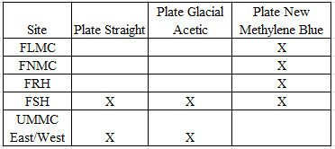  Plate Straight  - Insert the pipette into the well-mixed aliquot container and allow the specimen to fill most of the bore.  - Charge both sides of the chamber. Allow the cells to settle before counting the red cells and nucleated cells.  - Using the 10x objective, check both sides of the chamber for even cellular distribution. Replate chambers with uneven cell distribution.  - Red cells are smooth and have distinct outlines with halos and clear centers. If crenated, they have many fine-pointed projections. White cells are typical larger, appear granular and the nucleus may be mononuclear or lobed. It is important not to confuse lymphocytes with red cells.  Glacial Acetic Acid  The RBC count (plate straight method) must be completed before counting WBC. The glacial acetic acid destroys the red cells and emphasizes the nuclei of the white cells.  - Dip a pipette into the bottle of glacial acetic acid, drain carefully and wipe the outside dry.  - Dip the glacial acetic rinsed pipette into the fluid aliquot and partially fill the bore, then rotate to lyse the red cells. Complete destruction of red cells may take five minutes.  - Touch the tip of the pipette to the edge of a clean, dry hemacytometer counting chamber and mount both sides.  - Using the 10x objective, check both sides of the chamber for even cellular distribution. Replate chambers with uneven cell distribution.  - When adequately lysed, the nucleated cells should display a prominent nucleus and red cells should lyse or be ghosted. Newborn red cells tend to be lyse resistant.  New Methylene Blue  - Rinse a pipette with new methylene blue by filling the pipette one to two inches. Tip the pipette back and forth to coat the inside.  - Touch the tip of the pipette with gauze to remove all of the excess fluid. Wipe off the outside of the pipette.  - Insert the pipette into the well-mixed aliquot container and allow the specimen to fill most of the bore.  - Tip and rotate the pipette gently for 30 seconds to mix. Mix the pipette longer for more cellular fluids to get adequate staining.  - Charge both sides of the chamber. Prepare and place in humidity container. Allow the cells to settle before counting the red cells and nucleated cells.  - Using the 10x objective, check both sides of the chamber for even cellular distribution. Replate chambers with uneven cell distribution.  - When adequately stained red cells appear pinkish and nucleated cells will have a purple nucleus.  Areas to count-  If the specimen is a:  - Clear fluid  Using the 40x high dry objective, count the nucleated cells in 9 large squares on each side. If needed, do the same for RBCs. Exceptions may be made to count 5 squares per side by site. See site Hematology Technical Specialist/Supervisor.  - Hazy to slightly cloudy fluid  - A smaller area (fewer squares) maybe counted on each side as long as 100 or more nucleated cells (and if RBC count reported, 100 or more RBC) are counted per side.  - Count the same number and location of squares on each side.  - A different number of squares may need to be counted for nucleated cells than for RBCs to obtain at least 100 cells for that cell type.  - A calculation must be performed to obtain the number of cells/µL.  - 2 large squares counted—count 2 squares that are diagonally opposite.  - 3 large squares counted—count the 3 squares in a diagonal line.  - 4 large squares counted—count the 4 corner squares.  - 5 large squares counted—count the 4 corner squares and the center square.  - Cloudy to turbid fluid  - If the cells touch or overlap when plated straight and an instrument count is inappropriate, a dilution should be made.  - Use the lowest dilution required. The larger the dilution the more error introduced.  - Suggested dilutions are 1:2, 1:5, 1:10, 1:20, 1:50 or 1:100.  - The nucleated and RBC counts (if RBC count reported) may each need a different dilution.  - At least 100 cells of each cell type need to be counted on each side.  - 1 large square counted—use center square  - 2 large squares counted—count 2 squares that are diagonally opposite.  - 3 large squares counted—count the 3 squares in a diagonal line.  - 4 large squares counted—count the 4 corner squares.  - 5 large squares counted—count the 4 corner squares and the center square.  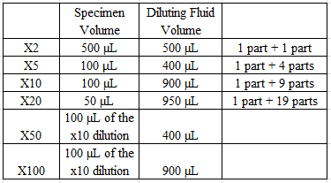  - Bloody fluid  - The nucleated and RBC counts may each need a different dilution.  - If the cells touch or overlap when plated straight and an instrument count is inappropriate, a dilution should be made. See work aid.  - Use the lowest dilution required. The larger the dilution the more error introduced.  - Suggested dilutions are 1:2, 1:5, 1:10, 1:20, 1:50 or 1:100  - RBC counts (report on CSF, peritoneal lavage, amniotic and at physician request)  - At least 100 RBCs are counted on each side in the same number and location of squares  - With dilution: within the center square at least 5 small squares and > 100 RBCs must be counted on each side of the chamber. See chamber notes #6.  - Nucleated counts  - At least 100 nucleated cells in the same number and location of squares need to be counted on each side  - Diluted or undiluted  - 1 large square counted—use center square  - 2 large squares counted—count 2 squares that are diagonally opposite.  - 3 large squares counted—count the 3 squares in a diagonal line.  - 4 large squares counted—count the 4 corner squares.  - 5 large squares counted—count the 4 corner squares and the center square.  - Within the center large square, count at least 5 small squares.  Chamber Notes  - Cell counts performed manually must be counted in duplicate. The same number of squares and squares in the same location are counted on each side.  - Raw cell counts (before calculation) must agree within 20% (>100 cells present) or + 10 cells (<100 cells present). If counts don’t match, replate the specimen.  - Boundary lines on hemacytometer  - Glass Chambers-If there are cells touching the boundary lines for a square, count only those cells touching the middle line of the triple lines on upper and left boundary lines.  - Disposable chambers do not have the triple line. Count only those cells touching the upper and left boundary lines.  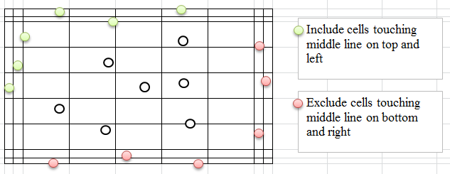  - Gently focus up and down using the microscope’s fine adjustment.  - Document each sides nucleated count, red cell count (if needed) and all math on worksheet. See Results section for calculations.  - The following will yield inaccurate counts:  - Counting too few cells in too small an area  - Over diluting the specimen  - Flooding the chamber  - Taking too long to count:  - Accelerates evaporation  - Concentrates cells  - Increases cell lysis  Automated Counts  - CSF, serous and non-viscous synovial fluids can be run on the Sysmex analyzers when results fall within linearity.  - No pericardial on the Sysmex XN  - Unacceptable specimens for automated counting:  - Bronchial lavages  - Clear and colorless spinal fluids  - Samples treated with acetic acid  - Fluids with a small volume  - Peritoneal dialysates  - Clotted specimens  - Evaluate cytospin before releasing counts.  Sysmex XE 2100, Sysmex XT 2000  - Run a background by selecting Auto Rinse. University-East runs an air background. Acceptable backgrounds are:  - WBC < 0.05 x 10³/ µL (50/µL)  - RBC <0.01 x 10⁶/ µL (10,000/µL)  - The acceptable background for a body fluid is lower than the acceptable background for peripheral blood. The instrument will not “flag” if unacceptable for a fluid count  - Run an Auto Rinse (background) between each fluid sample. University East runs an air background (i.e. aspirate air in the manual mode)  - Document the background  - Use the Browser Graph tab, XT: File Print or XE-2100: H-Copy  - On the fluid worksheet, complete “Bkgd check OK? Y/N” or attach the printout  - Run the fluid  - Check the instrument is in “Ready” status  - Press Manual Key or F2  - Barcode the specimen CID. Check the CID on the instrument matches the CID on the tube. Clearly identify the sample as a dilution when running a dilution.  - Select CBC + Diff in Discrete Testing  - Thoroughly mix the specimen/aliquot by gently tipping end-to-end  - Sample by placing the aspiration probe into the specimen/aliquot and pressing the green start switch  - Remove the specimen/aliquot when the instrument’s LED light stops blinking, the analyzer beeps twice and the wash cup starts descending.  - Display and print the results  - Select “Last 20” if the specimen has few cells  - In Explorer highlight the CID  - Switch to Browser and Print  - Service tab, drop down box select DIFF to obtain the WBC#(DIFFch) result XT: File, Print or XE: H-copy  - Graph tab XT: File, Print or XE H-Copy  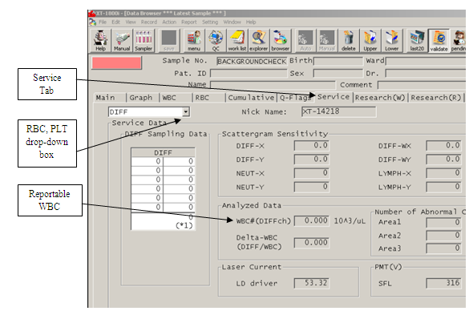  - Attach the printouts, labeled with patient name, to the worksheet  - Run a post specimen AutoRinse or air background (University-East) to clear the system  - Change Discrete Testing back to original settings  - Evaluate the results  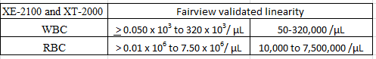  Evalutate the information provided by the analyzer for unacceptable flagging related to the WBC count (and RBC count if reported).  - The WBC/Nucleated count can be reported if:  - There isn’t an Error Flag  - The WBC# (DIFFch) count is used. WBC (from WBC/Baso channel) on graph tab is NOT reportable.  - XE/XT—Automated WBC result is > 0.05 to 320.0 x 10³/µL (50-320,000/µL)  - The WBC abnormal scattergram flag (WBC Abn Scg) is not present. If the flag is present, results must be confirmed  - WBC count > 200, dilute x2 and rerun  - WBC count <200, plate and check count on a hemacytometer  - There is no interference on the Diff scattergram. Interference is seen as dense grouping of points, which does not give a clear discrimination between cell populations  - There isn’t an @ symbol next to the result (linearity flag)  NOTE: WBC counts that do not meet guidelines must be manually counted using a hemacytometer.  - RBC counts may be reported if:  - There isn’t an Error flag  - The RBC is within the analyzer’s linearity limits ≥0.01 to 7.5 x10⁶/ µL (10,000 - 7,500,000/µL). If not, perform hemocytometer count.  - RBC counts are always reported on CSF, amniotic fluids, peritoneal lavage and on other fluids at the physician’s request.  - There isn’t a flag related to the RBC count  - Store remaining specimen appropriately  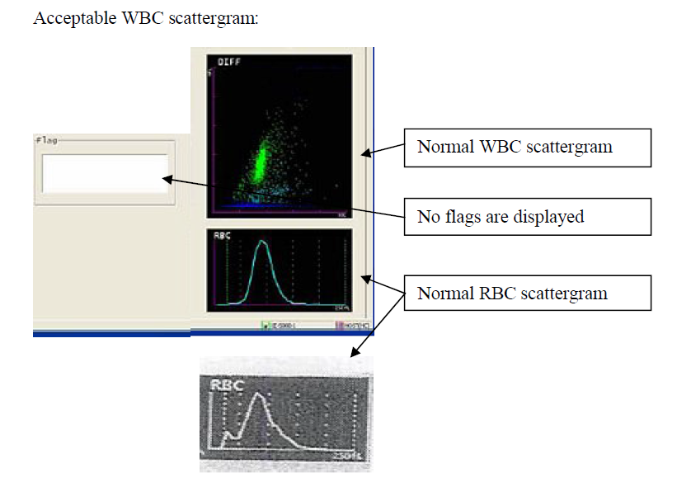  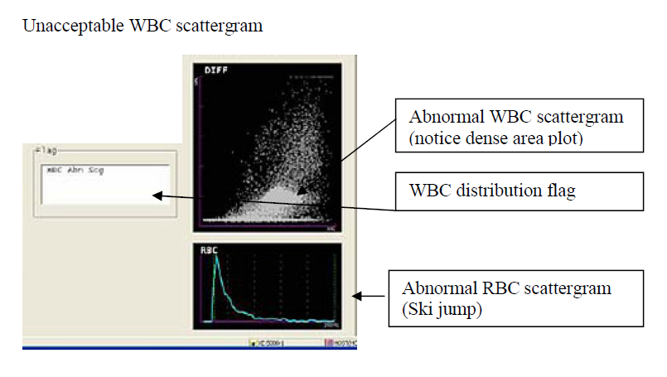  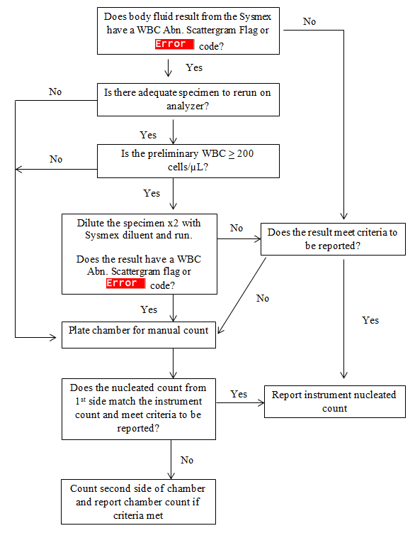  Sysmex XE 5000  - Set up  - Verify XE Main unit is in READY mode  - Press the MANUAL button on the XE LCD screen. Scan the CID or manually enter. If using a dilution, replace the “Y” with the dilution value. Arrow down to:  - Mode: select ‘1’ (manual)  - Pass through Discrete, it will automatically change to CBC+Diff when sample type body fluid is selected  - Sample: select ‘3’ (body fluid)  - Press Enter  - A background check is performed automatically and is repeated 2 more times if not within background acceptable limits. ‘Background Error’ will display if the instrument is unable to get the background within acceptable limits. Select B-Check to perform an additional background level. Acceptable background limits are:  - WBC-BF < 0.001 x 10³/µL  - RBC-BF < 0.003 x 10⁶/µL  - When the background is complete and acceptable, the LCD screen displays ‘BF Manual’ and ‘READY’ with the sample ID displayed in the upper right corner.  - Document the background: Explorer, highlight sample, reports, GP  - Run the fluid  The analyzer requires 130 µL of sample  - Mix the sample gently and thoroughly. Remove the cap and use sticks to check for clots. Do not run specimen if clots are detected.  - Place the sample under the manual aspiration pipette and press the grey start switch behind the pipette  - Remove the sample when aspiration is complete. The Ready LED stops blinking and 2 audible beeps are heard  - Perform a B-Check between samples AND after all body fluids have been tested  - When all fluids and the last B-Check have been performed:  - Select Manual  - Enter ‘1’ for sample number  - Arrow down to SAMPLE and select ‘1’ for NORMAL  - Arrow up to discrete and select ‘7’  - Select ENTER  - The analyzer is now ready to process a whole blood in either manual or sampler mode  - Display and print the results  - When complete, the results will display on the IPU in sample explorer with an “F” to the left of the CID  - Explorer, highlight sample, report GP  - Evaluate the results  - The TNC (total nucleated count) may be reported after evaluating:  - The TNC is > the site validated linearity (see below)  - The results are within linearity. If an @ symbol appears next to any result, the result is outside of linearity and a dilution is needed  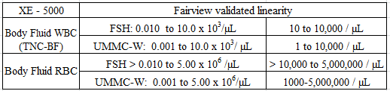  - There isn’t a * symbol. If * symbol present, the results are questionable and cannot be reported. A manual count must be performed.  - The WBC abnormal scattergram flag (WBC Abn Scg) is not present. If the flag is present, results must be confirmed  - WBC count > 200, dilute x2 and rerun  - WBC count <200, plate and check count on a hemacytometer  - RBC may be reported if:  - The RBC is within established linearity. If not, perform hemocytometer count  - RBC counts are always reported on CSF, amniotic fluids, peritoneal lavage and on other fluids at the physician’s request.  - There isn’t a flag related to the RBC count  - Store remaining specimen appropriately.  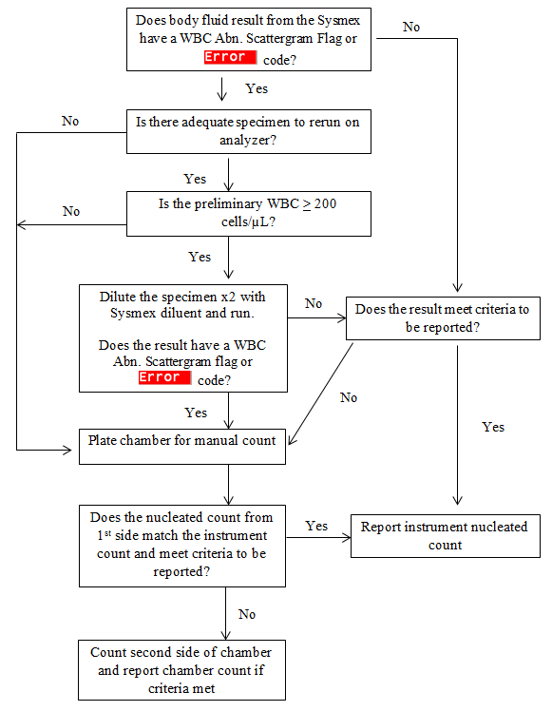  Sysmex XN 3000  - Set up (includes background)  - Verify the XN designated to run body fluids for the day is READY (solid green light)  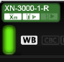  - Press the mode switch button to access the Manual Mode    - Press the Change Analysis button and select Body Fluids    - Press ok. The instrument automatically runs a background.  Acceptable background limits:  - WBC-BF < 0.001 x 10³/µL  - RBC-BF < 0.003 x 10⁶/µL  - When the background is complete and acceptable, the green READY light will be solid  - Document the background: Explorer, highlight sample, Output, Report for Lab Use Only  - When running multiple specimens at same time, run the clearest/least cellular fluids first. The XN 3000 will alarm after highly cellular fluids. Press “Execute” and the XN will automatically run up to 3 backgrounds.  - Run the fluid  - Check the sample for acceptability to run on analyzer:  - Press the Manual Analysis button on the control menu    - Confirm “Read ID” is unchecked to enter the sample ID manually (cap is off) or “Read ID” is checked if cap is left on (analyzer will spin tube and read the barcode)  - If needed, place a checkmark next to “Cap Open”  - Confirm selections – are settings correct for sample to be run?  - Click ‘OK’  - Mix the specimen making sure any cell button on the bottom of the tube/cup has been resuspended.  - Place the tube/cup in the appropriate sample tube holder.  - Press the start switch  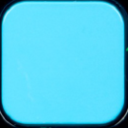  - After aspiration the tube holder will slide out. Remove the sample  - When all fluids have been run, press the mode switch to return to sampler/autoloader Mode  - Print the results: Explorer, highlight sample, Output, Report GP  - Results above instrument linearity must be repeated with a dilution  - Attach printouts to the worksheet  - Results outside of instrument linearity (@ displays next to results on instrument/printout) 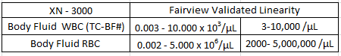  - Below instrument linearity – count on hemacytometer  - Above linearity – make dilution with cellpack DCL and rerun in body fluid mode  - Replace the Y of the CID with the dilution factor when entering on the instrument (for a x2 dilution, Y123456789 becomes 2123456789  - Print the result  - Multiply the results by the dilution factor  - Attach printout with calculation to fluid worksheet  - Evaluate the results  - WBC counts may be reported if:  - The TC-BF# count is used. The TC-BF# is a total nucleated count and includes mesothelial and malignant cells.  - TC-BF# result is > 0.003 x 10³/µL (3 cells) or manual count is performed  - TC-BF# results > 10,000 were run with a dilution or had manual count performed  - The WBC abnormal scattergram flag is not present. It the flag is present, results must be confirmed  - WBC count > 200, dilute x2 and rerun  - WBC count <200, plate and check count on a hemacytometer  - There isn’t a * symbol on TC-BF# results. The * symbol means results are questionable and cannot be reported. Perform a manual count.  - RBC counts may be reported if:  - The RBC is within established instrument linearity or manual count is performed  - The RBC background is 0.00 when fluid RBC count is 2,000-5,000.  - There isn’t flagging related to the RBC  - Upon completion of fluid counts return the analyzer to sampler/autoloader mode by pressing the switch mode button. The analyzer will autorinse.  - Store remaining specimen appropriately.  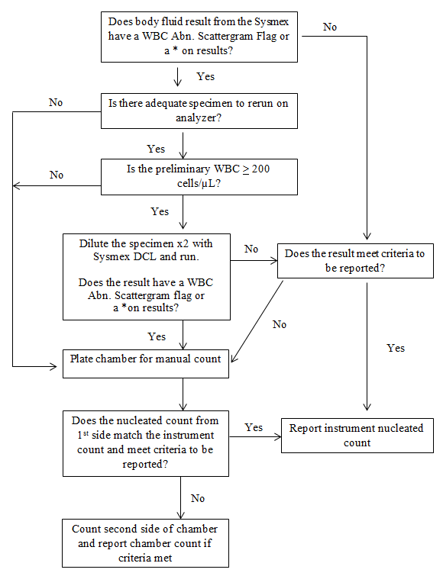  Cytospin/Cyto-Tek/Cyto-centrifuge Preparation  On rare occasions when the fluid resembles peripheral blood, a push smear can be made.  At FSH it is mandatory bronchial specimens be handled under a hood. For other sites having a hood, use of the hood is recommended for handling bronchial specimens.  - Label 1-2 frosted slides (minimum 2 patient identifiers or peon label)  - Assemble the slide, sample chamber and holder frosted side up and towards filter paper/funnel  - Place in cytospin  - Place 1 drop of albumin in the bottom of the cone, not down the side of the sample chamber  - Put the drops of fluid into the sample chamber making sure the fluid goes to the bottom of the cone, not down the side  - Use the same dilution for cell counts and cytospin prep  - Make all dilutions with Sysmex Cellpack DCL/EPK  - Use the following guidelines to determine the amount of fluid to place in the sample chamber  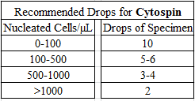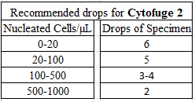  - Allowance needs to be made for fluids with small volumes.  - Where possible, place a cap on the sample chamber  - Balance the sample chambers, place sealed head into cytospin/cyto-tek and close the lid  - Spin per site protocol  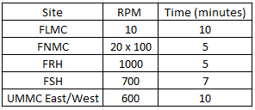  - Carefully remove the slide from the sample chamber  - Allow the slide(s) to dry before staining  - Stain the slide(s)  Differential  - Scan the cellular area using low power (10X objective) to evaluate:  - Stain quality and cell distribution  - The number of cells present match the chamber or instrument counts  - Document procedural control on site’s log or worksheet  Cytospin Correlation Guideline  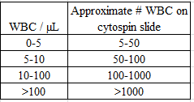  - Cytospin has enough cells to do differential, if not, remake the slide  - Remake any cytospin when no cells are seen on slide  - Cytospin is not too thick to count a differential, if it is, remake the slide  - Small numbers of abnormal or malignant cells are not overlooked  - Depending on the cell count and distribution, more than 100 cells may need to be counted  - Differentials are only done on spinal fluids with a WBC > 6 cells/µL  - Differentials are done on peritoneal dialysate fluids with a WBC > 50 cells/µL  - Differentiate the cells as PMN, lymph, monocyte/macrophage (reported together), eosinophil, basophil and other. Other includes:  - Malignant cells-frequently seen in clumps  - Lining cells  - Mesothelial cells-found in pleural, peritoneal and pericardial cavities. Seen in most effusions, they may clump together making them difficult to distinguish from malignant cells  - Synovial cells-found in joint cavities (may look like mesothelial cells)  - Epithelial cells-found in bronchial lavages (includes ciliated columnar)  - Ependymal cells-found in CSF  - Blasts-found in spinal fluids  - Monocyte/macrophage when found with mesothelial cells (UMMC/FRH)  - Atypical or unidentified cells  - Lakes/Northland: If lining cells present, group all mono/macro/lining cells under Other and send to pathologist. Do not report differential  - Do not report differential results until confirmed by pathology for  - Unidentified/questionable/malignant cells  - Abnormal findings (i.e. microorganisms, yeast)  - University - Any patient with a known or suspected hematologic malignancy (leukemia/lymphoma)  - When entering pathology comments and malignancy is present, the malignancy comment is entered first.  - Things to look for in bronchial lavages  - Pneumocystis jirovecii (formerly carinii) (See picture in work aid)  - CMV (See picture in work aid)  - Cytospin slides sent to pathology or cytology are accompanied by fluid worksheet and any other site specific paper work  - Slides are saved a minimum of 30 days  Amniotic Fluid  - Amniotic fluids frequently contain squamous epithelial cells and may not be analyzed on Sysmex instrumentation  - Report a RBC count on all amniotic fluids. This helps determine if an intrauterine bleed has occurred.  CSF  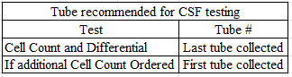  2 counts if RBC > 50 and second count order in EPIC is released  Crystals  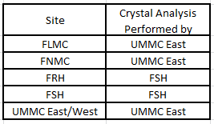  - Analysis  - Obtain one plain microscope slide and cover glass.  - Transfer a drop of synovial fluid from the container to the microscope slide with a disposable pipet.  - Apply cover glass and label with patient’s peon computer label or write the patient’s last name on the slide with grease pencil.  - Place the cover-slipped control slide on the microscope stage and using the 10X objective, bring the slide into a sharp focus using bright-field illumination. Adjust the diaphragm as necessary to visualize the cells.  - Set up scope  - UMMC East  - Usually the full wave plate assembly is locked in at the bottom of the scope. If the full wave assembly is not on the microscope, it is stored in the plastic container next to the microscope. Lock it into the bottom of the scope.  - Push in the polarizing lens on the microscope neck. The background will now be magenta.  - Rotate the full wave plate out and the background should now be black.  - Crystals from the control slide appear as silver against the black background.  - Rotate the wave plate assembly back into place.  - Southdale  - Install the polarizer (U-POT) on top of the light source (below the stage) with the notch and white hash mark facing upward.  - Rotate the polarizer so the notch and white hash mark are positioned on the left and right sides. It does not matter which mark is on which side.  - Insert the compensator (U-GAN), face up, into the slot (above the stage, below the oculars). It does not matter which of the two slots you use.  - While looking in the microscope using 10x or 40x, use the rotation lever on the compensator. Move it clockwise, then counterclockwise  - When the rotation lever is rotated fully in either direction, the background should be magenta. The slow wave direction is shown on the compensator depending on the location of the rotation lever. The color of crystals will change as the rotation lever is moved.  - When the rotation lever is positioned in the middle (at the ) of the compensator, the background should be gray-black. Crystals will appear as silver against the black background.  - Place QC slide on stage and verify the crystals are present and expected crystals characteristics are manifested. Document QC performed.  - Place the patient’s wet mount slide on the microscope stage.  - Systematically examine the whole area under the coverslip for the presence of crystals using both the black and magenta backgrounds.  - Use the 10x and 40x objectives as necessary  - Because CPPD is weakly birefringent and can be difficult to identify, scan the slide under 40x  - Look for the presence of crystals in the cytoplasm of neutrophils or macrophages and for the presence of extra-cellular crystals caught in fibrin clots.  - In less acute gout, only 1 or 2 cells may show crystals in a whole preparation.  - When a crystal is seen, positive identification requires testing a crystal in both positions of the slow axis  - Repeat a-d with cytospin slide. If there are any questions, consult with another technologist or with the technical specialist. If no one is available to help, inform the clinician of the problem and save the specimen for the next shift.  - For example, contamination with the corticosteroid triamcinolone diacetate (AristicortTM) may show tiny rhomboid crystals which polarize like monosodium urate in the wet mount. However, these are dissolved by the alcohol in the Wright’s staining procedure and are absent in the stained cytospin slide.  - See the tables below for:  - Characteristics of clinically significant birefringent crystals or substances and associated conditions  - Non-reportable synovial fluid crystals  - Non-reportable artifacts and contaminants  CHARACTERISTICS OF COMMONLY REPORTED SYNOVIAL FLUID CRYSTALS  Crystal Appearance Birefringence Color When Parallel to Slow Wave Color When Perpendicular to Slow Wave Condition Comments  Monosodium Urate (MSU) long slender needles (5-20 µm) strong yellow blue Seen in gout Intra- or extracellular  Calcium pyrophosphate dihydrate (CPPD) Short, chunky rectangles or rhomboids (1-20 µm) weak blue yellow Seen in pseudogout Intra- or extracellular  CHARACTERISTICS OF NON-REPORTABLE SYNOVIAL FLUID CRYSTALS  Presence of these crystals must be approved by the technical specialist prior to reporting.  Crystal Appearance Birefringence Color When Parallel to Slow Wave Approximate Crystal Size (μ) Comments  Hydroxyapatite Shiny clumps Difficult to detect N/A - seen in apatite gout - need electron microscope to visualize  Cholesterol plates large flat notched plates strong variable Seen in cholesterol gout (chronic effusion, rheumatoid arthritis) extremely rare  Calcium oxalate bi-pyramidal strong/variable N/A seen in oxalate gout, esp. with renal dialysis  Fat droplets (cholesterol) round spheres Maltese cross appearance strong blue/yellow Maltese cross Seen in trauma or fracture  Cartilage fragments irregular strong variable no definite crystal morphology  Polyethylene, methyl-metharylate or metallic “wear” fragments long threads look like cytospin filter paper fibers strong variable from joint implants observe wet prep only  Hematin vivid yellow brown diamond shape in brightfield weak might confuse with CPPD-use brightfield to avoid confusion Seen in post hemorrhage/ 2-4 weeks  Non-reportable artifacts and contaminants that polarize light and may be confused with clinically significant findings include:  Artifact/ Contaminant Appearance Birefringence Color When Parallel to Slow Wave Comments  Corticosteroids (betamethasone or triamcinolone diacetate) Variable morphology like MSU with blunt jagged edges like CPPD short chunky strong yellow - common artifact from injection - soluble in alcohol  Starch variable round globule with irregular edges & central dimple other forms also seen like tiny CPPD or hydroxyl-apatite weak blue/yellow Maltese cross yellow - common contaminant - Maltese cross appearance like cholesterol - use brightfield to ID  Lipids from cells tiny fat globules in cells or clusters strong blue/yellow Maltese cross indicate degeneration of cells  Cytospin Filter paper fibers long threads like polyester or “wear” fibers from artificial joints strong variable
Procedure Limitations | CSF-Patients receiving an intrathecal cytarabine injection in the form of Depocyt may demonstrate cell-like particles which can be confused with white blood cells. (See picture in work aid.)
Results | Specimens should have some white cells on the cytospin slide.  Calculations-  - Chamber counts  - If count > 100: Calculation to decide if chamber counts match within 20%  (Lower number/higher number) x 100 = percent match  - if > 80, matches and can be reported  - If < 80, doesn’t match. Replate and recount.  Example 1  WBC side 1 = 132, WBC side 2 = 153  (132-153) x 100 = 86.3% this is an acceptable match, > 80  Example 2  WBC side 1 = 276, WBC side 2 = 417  (276-417) x 100 = 79.6 this is not an acceptable match, < 80  - If count <100: Calculation to decide if chamber counts match within + 10 cells  Higher number – lower number = difference  Example 1  WBC side 1 = 81, WBC side 2 = 68  81 – 68 = 13 this is not an acceptable match, does not match within + 10 cells  Example 2  WBC side 1 = 3, WBC side 2 = 9  9 – 3 = 6 this is an acceptable match, matches within + 10 cells  - Calculation to obtain cells/µL (manual count) after checking duplicates for acceptability  # of cells x dilution = total cells / µL  # of sq. x vol. of sq.  Example:  9 large squares counted/side for wbc  5 small squares counted/side for rbc  Dilution = 2 for RBC  No dilution for WBC  Side 1 RBC = 150, WBC = 10  Side 2 RBC = 135, WBC = 12  Both counts meet the 20% or + 10 cell criteria  RBC= (150+135) x 2 = 285 x 2 = 570 = 14,250 rbc/µL  (5+5) (sq.) X 0.004 (vol.) 10 x 0.004 0.04  WBC= (10 +12) x 1 (no dilution)= 22 x 1 = 22 = 12.2 (rounded) 12 wbc/µL  (9+9) (sq.) X 0.1 (vol.) 18 x 0.1 1.8  - Counts are reported to whole numbers 12.2 = 12  - Instrument counts  - Use these calculations to obtain whole number for cells/µL  - WBC- multiply results of 10³/ µL by 1000 to obtain cells/µL  - RBC- multiply results of 10⁶/µL by 1,000,000 to obtain cells/µL  - Multiply the results by any dilution factor before reporting  - Examples  - WBC-0.773 x 10³/ µL X 1000 = 773/µL  - RBC-0.03 x 10⁶/ µL X 1,000,000 = 30,000/µL  - Analyzer result x dilution factor = reportable result  Example:  Dilution factor = 2:  30,000 X 2 = 60,000/µL  Correlate counts with cytospin preparation  - Cytospin Correlation Guidelines  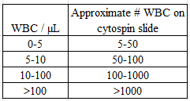  Sysmex Linearity  - XE-2100 and XT-2000  - XE-5000  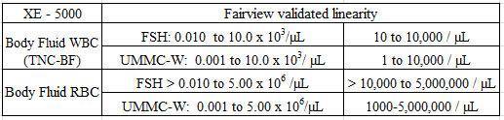  - XN-3000  Commonly used ETCs (English Text Codes)  - CPINAC- Clot(s) present, counts may be inaccurate  - DMGDIF – Cells too damaged to perform differential  - DPINAC- Cellular debris present, counts may be inaccurate  - FLDCLT- Fluid contains clot(s), count is invalid  - FLREFR – No reference ranges have been established. This result should be interpreted in the context of the patient’s clinical condition and compared to simultaneous measurement in the patient’s blood. Refer to Lab Guide for specific interpretive guidelines.  - NREDTA- Specimen not received in EDTA. Results may be affected.  - NOTMET- Test not performed. Criteria not met for second cell count. (spinal fluids)  - OTHMES-Other cells are monocytes, macrophages and mesothelial cells.  - OTHEPI-Other cells are monocytes, macrophages and epithelial cells.  - PATHRV – Sent for Pathologist review. Differential results will be updated after review.  - SRBP – Slide reviewed by pathologist  - STBR – Slide to be reviewed by pathologist  - SUPERN- Supernatant  - TFDIFF – Too few cells to do differential  - XAN-Xanthochromic  Use these ETCs only for commenting on smears from clotted specimens  - CLTSTP: Specimen clotted. Slide reviewed, sent to pathology for review.  - CLTNAC: Specimen clotted. Slide reviewed, no abnormal cells seen.
Critical Values | WBC, Peritoneal Dialysis Fluid >100 /µL  Document in the computer date/time of call, person/location notified, and initials of caller.
Significant Results | Notify provider of presence of abnormal findings to be confirmed by pathologist or IDDL.  - All fluids with unidentified microorganisms should be STAT gram stained on site. Order gram stain if positive. Notify the provider and IDDL. Document both notifications in LIS.  - Send suspected malignancy to Pathologist. Malignancy must be confirmed before it is reported.
Computer Entry | CSF  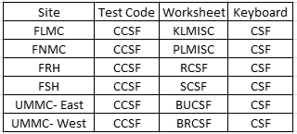  - In MEM enter worksheet  - Enter the CRBC and CWBC counts  - Do not enter anything at CTYP. This test code activates the CSF diff keyboard.  - Use the diff keyboard and select CSF  - Enter appearance, color and tube number on the Morph tab  - Bill for CCSF on the Morph tab  - If the WBC is < 5, bill as CNTCSF  - If the WBC is > 6, bill as DIFCSF and perform a differential using the Count tab.  - Check all results on the QA Review Tab  - Save / Hold / Reject as appropriate  - CSF not needing a second cell count, receive accession number and result.  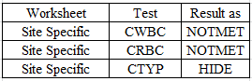  Do not enter anything on the CSF keyboard. No crediting needed.  - BFLD  Enter all results using the keyboard  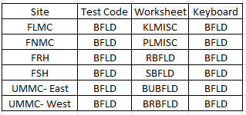  - Select diff keyboard BFLD  - On the Morph tab enter the Color and Appearance  - On the Morph tab select FWBC  - Edit/Comment  - In the Comment field type the result  - Add to List  - In the Text Code box enter FLREFR  - Add  - OK  - Repeat d-f, h and i if FRBC is reported.  - Use the Count tab to perform differential  - Check all results on the QA Review tab  - Save / Hold / Reject as appropriate  - CRYSTL - Synovial Fluid Crystals  If both intra- and extracellular crystals are present, use the ETC code below for intracellular only.  Observation ETC Code ETC Code Text  No reportable crystals present NOCRYS No clinically significant crystals seen.  Extracellular MSU PMSUE Positive for extracellular crystals, consistent with monosodium urate crystals.  Intracellular MSU PMSUI Positive for intracellular crystals, consistent with monosodium urate crystals.  Extracellular CPPD PCPPDE Positive for extracellular crystals, consistent with calcium pyrophosphate dihydrate crystals.  Intracellular CPPD PCPPDI Positive for intracellular crystals, consistent with calcium pyrophosphate dihydrate crystals.  - Slide Review by Pathologist  - For those specimens returning from Pathology, enter the differential and/or appropriate comments.  - Do not use CTYP or BTYP to enter the physicians’ comments. The CTYP and BTYP do not post to chart (EHR). Attach comments to the most appropriate result.  - Enter comments exactly as written; include the physician’s name/initials  - Clarity  - Clear-free of particles, not enough cells to be seen with naked eye  - Hazy-not quite clear, presence of cells barely seen with naked eye  - Slight Cloudy-presence of cells can be seen  - Cloudy-obscures light, contains many cells  - Turbid-obscures light, thick with disturbed sediment  - Purulent –obscures light, contains pus  - Clotted Specimen Reporting  - Enter color and clarity in keyboard  - Review the cytospin  - Enter one of the following comments at the FWBC or CWBC prompt  - CLTNAC - Specimen clotted, slide reviewed and no abnormal cells seen  - CLTSTP - Specimen clotted, slide reviewed and sent to pathology  - Credit the test
Reference Range | CSF  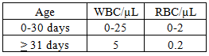  Body Fluids  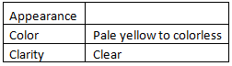  This comment added to fluid WBC results (except CSF) FLREFR-No reference ranges have been established. This result should be interpreted in the context of the patient’s clinical condition and compared to simultaneous measurement in the patient’s blood. Refer to Lab Guide for specific interpretive guidelines.  Lab Guide  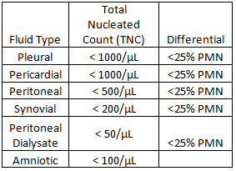  Crystals – Absence of clinically significant crystals
Calibration | Automated counts-the same instruments are used for peripheral blood counting. No additional calibration is required for body fluid testing.
Maintenance | - Fluid method correlation is performed semi-annually.  - At least two fluid specimens are used to compare nucleated and red cell counts.  - Chosen specimens must have counts within the instrument linearity.  - Acceptable performance:  - Instrument to hemacytometer is < 25% difference.  - Calculation for % difference:  (instrument count-chamber count) x100 = % difference  instrument count  Example:  Instrument nucleated count = 566  Chamber nucleated count = 627  (566 – 627) x100 = 61 x 100 = 0.107 x 100 = 10.8%  566  - Instrument to instrument is ≤15% difference  - Calculation for % difference:  (1st instrument count-2nd instrument count) x100 = % difference  1st instrument count  Example:  1st instrument nucleated count = 332  2nd instrument nucleated count = 328  (332 – 328) x100 = 4 x 100 = 0.012 x 100 = 1.2%  332 332  - Use site specific maintenance logs
Principle | Cerebrospinal Fluid-  A CSF count is performed to determine the presence and quantity of cell types in cerebrospinal fluid. An abnormal increase in these types may indicate a disease such as meningitis. CSF serves as a protective cushion for the nervous tissue and to circulate nutrients and collected waste. CSF volume is 90-150 ml in the adult, and 10-60 ml in neonates. Approximately 500-600 ml is produced every day, resulting in complete fluid replacement every 5-7 hours.  CSF Clinical Applications-  - In bacterial meningitis, the WBC count may be higher than 50,000/µL in the early stages of the disease, with more than 90% of the leukocytes being neutrophils.  - Viral meningitis may be associated with mild or severe leukocytosis that is predominantly composed of lymphocytes. The initial phase of viral meningitis may have a predominance of PMNs. This phase can last from a few hours to several days.  - When the CSF is pinkish red, this indicates the presence of blood, a condition that may have resulted from subarachnoid hemorrhage, intracerebral hemorrhage or traumatic tap. It is very important to differentiate pathologic bleeding and a traumatic tap. The following observations are used in differentiating between the two types of bleeding:  - A traumatic tap shows a maximum amount of blood in the first sample, with a progressive decrease in subsequent samples. In subarachnoid hemorrhage, the blood is generally evenly mixed in the three (or four) tubes.  - After the CSF is centrifuged, the supernatant fluid is clear with a traumatic tap but xanthochromic (pink or yellow due to breakdown of hemoglobin) with a subarachnoid hemorrhage. Crenated RBC's are NOT useful in distinguishing traumatic tap from bleeding.  - Subarachnoid bleeding is associated with erythrophagia (engulfment or consumption of RBC's by other cells) on microscopic examination.  - The presence of clots in the spinal fluid is also significant. In paresis (slight or incomplete paralysis), there are many small clots, in TB meningitis a web like clot is present, purulent meningitis may have a large clot and in blockage of the spinal fluid circulation there is a tendency to clot en masse.  - Examination of the CSF in cases of suspected demyelinating diseases such as multiple sclerosis may help support the clinical diagnosis.  Body Fluids-  Body fluids such as synovial fluids, serous fluids (namely peritoneal, pleural and pericardial), amniotic fluids and bronchoalveolar lavage (BAL) specimens may be examined to determine the presence and quantity of cell types. For synovial fluids, cell counts and a differential can be used to distinguish between non-inflammatory, inflammatory, septic, crystal induced and hemorrhagic processes. For serous fluids, cell counts and a differential can help distinguish transudates from exudates. For amniotic fluids, a cell count and differential can help to indicate infection.  Body Fluid Clinical Applications-  Synovial Fluids:  - Normal synovial fluid appears clear and pale yellow. The color becomes deeper yellow in the presence of inflammation and may have a greenish tinge with bacterial infection. Turbidity occurs when the cell count is elevated and is usually proportional to the number of cells present. However, a milky fluid may also indicate the presence of crystals.  - The degenerative disease of joints such as degenerative arthritis, neurogenic joint disturbances, and traumatic arthritis are associated with mild inflammatory reactions without an increase in the number of white cells. The severe inflammatory diseases of synovium such as rheumatoid arthritis, tuberculosis, pyogenic infection and gout show high white counts with high percentage of PMNs.  - Crystal analysis is significant in differentiating gout, characterized by monosodium urate (MSU) crystals and pseudogout, characterized by calcium pyrophosphate dihydrate (CPPD) crystals. In over 50% of gout cases, the patient is affected by MSU crystals in the great toe. MSU may also affect heels, ankles, knees, wrists or fingers. In pseudogout, CPPD crystals are most likely to affect larger joints such as the knees, wrists, ankles and shoulders. It is extremely rare, but not impossible, to have MSU and CPPD present in a single specimen.  - Birefringence is the characteristic of a crystal or substance enabling it to polarize light when viewed through crossed polarizing filters. That is, birefringence equals polarization. The degree (strength) of polarization varies, and is referred to as strong or weak birefringence. A full wave retardation plate (first order red filter) is added to the crossed polarizers and the crystal in question is classified based on its color when the long axis of the crystal is observed in relation to the direction of the slow wave of vibration of the compensator.  Serous Fluids-Pleural, Peritoneal, Pericardial:  - Pleural, peritoneal, and pericardial cavities are lined by two membranes and are referred to as serous membranes. One membrane lines the cavity wall and the other covers the organs within the cavity. The fluid between the membranes, which provides lubrication as the surfaces move against each other, is called serous fluid. Normally only a small amount of serous fluid is present because production and reabsorption take place at a constant rate.  - Effusions (the buildup of serous fluid) that form because of systemic disorder that disrupts the balance in the regulation of fluid filtration and reabsorption are called transudates (ex. congestive heart failure). Exudates are produced by conditions that directly involve the membranes of the particular cavity. (ex. infections and malignancies)  Amniotic Fluid:  - Amniotic fluid is found in the membranous sac that surrounds the fetus and provides a cushion to protect the fetus.  - In cases of premature or prolonged rupture of the amniotic membranes there is a concern over possible infection of the mother and fetus. Performing a fluid WBC count has been shown to be a good indicator of infection and is more rapid and cost effective than gram stain and culture. A WBC count greater than 50/μL is considered indicative of infection.  Bronchoalveolar Lavage (BAL):  - Macrophages, often containing a variety of phagocytized material are the cells most frequently seen on a differential.  - Lymphocytes are increased in interstitial lung disease, drug reactions, pulmonary lymphoma and non-bacterial infections.  - Neutrophils are increased in cigarette smokers, bronchopneumonia, toxin exposure, and diffuse alveolar damage.  - Eosinophils are elevated in asthma, hypersensitivity, pneumonitis, and eosinophilic pneumonia.  - Ciliated columnar bronchial epithelial cells and squamous epithelial cells may also be seen.
Notes | Terminology-  - Thoracentesis—procedure where fluid is aspirated from the pleural cavity  - Paracentesis—procedure where fluid is aspirated from the peritoneal cavity  - Ascites—accumulation of fluid in the peritoneal cavity  - Peritoneal fluid vs peritoneal dialysate – a dialysate is usually colorless vs a peritoneal fluid which is usually yellow dialysate
References | - Bentz, J., & Adams, B. (1994). Laboratory Examination of Synovial Fluids. In Clinical Laboratory Science (2nd ed., Vol. 7).  - Brunzel, N. (1994). Fundamentals of Urine and Body Fluids. 402-411: WB Saunders Company.  - CAP Hematology and Coagulation Checklist, July 2013  - CAP TODAY , Q & A, January 2012 and June 2012  - CLSI, H56-Body Fluid Analysis for Cellular Composition, 2005  - Galagan, Bloomberg, Cornblee, & Glassy. (2006). Color Atlas of Body Fluids. CAP.  - Harmening, D. (1992). Clinical Hematology and Fundamentals of Hemostasis (2nd ed.). FA Davis.  - Hettich Universal 320 user manual pgs26-46 Andreas Hettich GmbH & Co. KG 2005  - Iris Cytofuge 2 and Concentrator Filter package insert, 2008  - Kestenbaum, L et al: Pediatrics, Jan 2010  - Kjeldsberg, & Knight. (1993). Body Fluids (3rd ed.). Chicago: ASCP Press.  - Knight, K. a. (1986). Body Fluids.  - Krieg, A., & Kjeldsberg, C. (1991). Clinical Diagnosis and Management by Laboratory Methods. Philadelphia: WB Saunders Company.  - Ringsrud, K. (1994). Synovial Fluid Atlas and Procedure. In Atlas of Contaminants found in the Synovial Fluid. In house.  - Ringsrud, K., & Linne, J. (1992). Basic Techniques in Clinical Laboratory Science. St Louis: Mosby.  - Ringsrud, K., & Linne, J. (1995). Urinalysis and Body Fluids: A Color Text and Atlas. St Louis: Mosby.  - Sanford and Todd. (n.d.). Clinical Diagnosis and Management by Laboratory Methods. In Henry, & Davidson (Eds.).  - Sanford, T. a. (1991). Clinical Diagnosis and Management by Laboratory Methods.  - Sanford, T. a. (n.d.). Clinical Diagnosis and Management by Laboratory Methods. In Davidson, & Henry (Eds.).  - Strasinger, & Lorenzo, S. D. (2001). Urinalysis and Body Fluids (4th ed.). Philadelphia: FA Davis Company.  - Sysmex. (2004, 6). Customer Bulletin Document 61-1038. Sysmex XE-Series Analyzer, Body Fluid Analysis.  - Sysmex. (2006, 9). Customer Bulletin Document 61-1074. Sysmex XT-Series Analyzer, Body Fluid Analysis.  - Sysmex. (2009, 9). Customer Bulletin Document MKT-30-1004. Validation Protocols, Body Fluids.  - Sysmex. (2009, 7). Customer Bulletin Document MKT-70-1124, Rev. 1. XE-alphaN Quickguide.  - Sysmex. (2013, 3). Customer Bulletin Document 1013-LSS, Rev. 2. Sysmex XE-5000 Body Fluid Analysis, Sysmex XE Implementation Guide and Body Fluid Correlation Guidelines.
Associated Documents | Body Fluid Result Entry  CSF Result Entry  Workaid  Worksheet ??
Document Author | FV Hematology Standardization Committee 2017
Effective Date | 9/2017
Summary of Changes | New system procedure

Document History
Last Reviewed By: FV Hematology Committee | Date(s):
Last Revised and Reviewed by: | Date(s):

Medical Directors:
UMMC Mike Linden, Tony Killeen, Amy Karger
FSH: Bruce Trautman
FLMC: David Dexter
FNMC: Mona Marolt
FRH: Tim Kappel

